Text consolidated by Valsts valodas centrs (State Language Centre) with amending regulations of:
16 February 2010 [shall come into force from 20 February 2010];
8 October 2013 [shall come into force from 1 January 2014];
6 December 2016 [shall come into force from 10 December 2016].
If a whole or part of a paragraph has been amended, the date of the amending regulation appears in square brackets at the end of the paragraph. If a whole paragraph or sub-paragraph has been deleted, the date of the deletion appears in square brackets beside the deleted paragraph or sub-paragraph.

Republic of Latvia

Cabinet
Regulation No. 1071
Adopted 22 December 2008

Regulations Regarding the List of Unusual Transaction Indications and the Procedures for Submitting Reports on Unusual or Suspicious Transactions

Issued pursuant to
Section 30, Paragraph two of
the Law On the Prevention of Money Laundering and Terrorism Financing

1. This Regulation prescribes the list of unusual transaction indications and the procedures for submitting reports on unusual or suspicious transactions, and approves the report form.

2. The subjects of the Law On the Prevention of Money Laundering and Terrorism Financing (hereinafter – the Law) specified in the Law (hereinafter – the subjects of the Law) shall, in accordance with the Law, report to the Office for Prevention of Laundering of Proceeds Derived from Criminal Activity (hereinafter – the Control Service) without delay regarding each consulted, planned, proposed, commenced, deferred, executed or approved unusual transaction the indications of which conform to at least one of the indications referred to in this Regulation, or regarding such suspicious transaction.

3. The subjects of the Law must report regarding each transaction which conforms to the sum in euros specified in this Regulation or to their equivalent in another currency according to the reference exchange rate of euro published by the European Central Bank on the day of performing the transaction. If such foreign currency is used in the transaction for which the European Central Bank does not publish the reference exchange rate, the foreign currency market rate in relation to euro published in a periodic issue of a provider of financial information recognised by the global financial market or in its Internet resource shall be used for calculations.
[8 September 2013]

4. A report on the transactions referred to in Paragraph 2 of this Regulation shall be submitted in writing together with an accompanying letter in which the documents and electronic data carriers (if any) appended are indicated, or shall be submitted using the e-service “Provision of Information Regarding Unusual or Suspicious Financial Transactions” (hereinafter – the e-service) on the website www.zinojumi.kd.gov.lv maintained by the Control Service. The subjects of the Law (except the subjects of the Law referred to in Section 3, Paragraph four of the Law) have an obligation to submit a report on the transactions referred to in Paragraph 2 of this Regulation electronically.
[6 December 2016]

5. If the subject of the Law submits a report in printed form, it shall fill in the sample form specified in Annex 1 to this Regulation, but if the subject of the Law submits a report electronically, it shall fill in the report form specified in Annex 2 to this Regulation. The report form specified in Annex 2 to this Regulation shall be filled in in Excel software. If the subject of the Law submits a report using the e-service on the website www.zinojumi.kd.gov.lv maintained by the Control Service, it shall fill in the fields in online form or upload an XML (Extensible Markup Language) file in accordance with the requirements indicated in Annex 3 to this Regulation. The Control Service shall maintain the prepared XSD (XML Schema Definition) on its website, making it available to the subjects of the Law and their supervisory and control authorities.
[6 December 2016 / Paragraph shall be repealed from 1 January 2018. See Paragraph 9.⁴]

6. If, in filling in the report form specified in Annex 1 to this Regulation, there is no information to be indicated in any field group, it shall be filled in with a mark “Z”. If, in filling in the report form specified in Annex 2 to this Regulation, there is no information to be indicated in any field group, it shall be left blank. If the subject of the Law submits a report using the e-service on the website www.zinojumi.kd.gov.lv maintained by the Control Service and there is no information to be indicated in any field group, it shall be left blank, if permitted by the requirements indicated in Annex 3 to this Regulation.
[6 December 2016 / Paragraph shall be repealed from 1 January 2018. See Paragraph 9.⁴]

7. Upon submitting a report and the additional information requested to the Control Service, the subjects of the Law shall ensure their submission in person or with the intermediation of an authorised person so that the content of the report and additional information requested and the fact of submission would not become known to other persons.

8. A transaction shall be deemed an unusual transaction, if it conforms to at least one of the following indications:
8.1. in relation to all subjects of the Law – a transaction in which such customer is participating who is suspected of committing an act of terrorism or participation therein and is included in the list of such persons regarding which the Control Service has informed the subjects of the Law and their supervisory and control authorities;
8.2. in relation to credit institutions:
8.2.1. a transaction in which cash the sum of which is 60,000 euro and more is used (except disbursement of wages, pensions, and social benefits, credits, interbank settlement);
8.2.2. a transaction in the amount of 2,000 euro and more in which the coins or banknotes of small denomination are exchanged for banknotes with higher denomination (or vice versa) or for other banknotes of the same denomination;
8.2.3. a customer, using credit cards or other payment cards, withdraws 60,000 euro and more in cash within one month;
8.2.4. a customer who does not have an account in the relevant credit institution, purchases or sells foreign currency in cash for a sum the equivalent of which is 8,000 euro and more;
8.2.5. a customer or the beneficial owner of the customer and his transaction performed regarding which the credit institution has established, within the scope of the customer due diligence, publicly accessible information of negative nature which attests to a potential relation to proceeds of crime or their laundering or to terrorism or financing thereof;
8.3. in relation to insurance merchants, private pension funds, and insurance intermediaries – an insurance premium has been paid in or a payment to the pension plan has been performed by a legal person, association of persons or another alliance (for example, establishments, investment funds, trusts, groups of natural and legal persons established according to a contract or agreement or their representatives) which is located, has been created or established in a tax-free or low-tax country or territory which has been specified as such by the Cabinet, and the amount of the premium is 40,000 euro and more;
8.4. in relation to investment brokerage companies and credit institutions – a customer settles the accounts for the services received and in transactions with financial instruments, making a single payment in cash the sum of which is 15,000 euro and more;
8.5. in relation to organisers of lotteries and gambling:
8.5.1. the customer wins 8,000 euro and more;
8.5.2. the customer purchases means for participation in a game for the sum of 8,000 euro and more;
8.5.3. the customer, in purchasing the means for participation in a game, exchanges currency for the sum the equivalent of which is 8,000 euro and more;
8.6. in relation to capital companies which are engaged in the purchase and selling of cash in foreign currency – a customer buys or sells foreign currency for a sum the equivalent of which is 8,000 euros and more;
8.7. in relation to a provider of money orders and transfers which has the right to provide such services (except credit institutions) – a transaction for a sum of 40,000 euro and more, carrying out a transfer or order;
8.8. in relation to sworn auditors, commercial companies of sworn auditors (within the scope of audit scope and selection), tax advisors, external accountants – the sum total of cash loans received by a customer from natural persons (including the owner of a capital company) in the reporting period is 60,000 euro or more (for the owner of a capital company – the sum total of cash loans provided to a capital company exceeds the sum disbursed in dividends by 60,000 euro or more);
8.9. in relation to sworn notaries:
8.9.1. the customer transfers for storage cash for the sum of 15,000 euro and more;
8.9.2. upon fulfilling the official duties specified in the Notariate Law, a consultation has been provided or a certification for a transaction has been made the indications of which conform to at least one of the indications of an unusual transaction referred to in this Regulation and which applies to the activities referred to in Section 3, Paragraph one, Clause 4 of the Law;
8.10. in relation to sworn lawyers and other independent providers of legal services:
8.10.1. the customer transfers or receives cash for the sum of 15,000 euro and more, authorising to carry out financial intermediation;
8.10.2. a consultation has been provided for a transaction the indications of which conform to at least one of the indications of an unusual transaction referred to in this Regulation and which applies to the activities referred to in Section 3, Paragraph one, Clause 4 of the Law;
8.11. in relation to merchants who are engaged in trade of immovable properties or its intermediation:
8.11.1. a customer, upon purchasing an immovable property, enters into a contract which provides for payment in one or several instalments in cash for the sum of 20,000 euro and more;
8.11.2. a customer, upon entering into a co-operation contract regarding purchase of an immovable property, makes a payment in cash in the pay office of the merchant for the sum of 30,000 euro and more;
8.12. in relation to merchants who are engaged in trade of vehicles or its intermediation – a customer, upon purchasing a vehicle, on one or several occasions settles the payment in cash for the sum of 30,000 euro and more;
8.13. in relation to merchants who are engaged in trade of precious metals, precious stones, and their articles:
8.13.1. a customer, upon purchasing precious metals, precious stones, or their articles, settles the payment in cash for the sum of 15,000 euro and more;
8.13.2. a customer sells or offers to purchase precious metals, precious stones, or their articles for a price which does not exceed 50% of their market value which is to be determined according to the rate specified by the European Central Bank.
[8 October 2013; 6 December 2016 / Sub-paragraph 8.2.5 shall come into force on 1 January 2017. See Paragraph 9.²]

9. Cabinet Regulation No. 127 of 20 March 2001, Regulations Regarding List of Elements of Unusual Transactions and Procedures for Reporting (Latvijas Vēstnesis, 2001, No. 48), is repealed.

9.¹ The subjects of the Law have the right to provide a report by filling in the report form specified in Annex 2 to this Regulation and submitting it to the Control Service electronically by 31 December 2017 according to the following procedures:
9.¹ 1. a report on the transactions referred to in Paragraph 2 of this Regulation shall be sent electronically in an encrypted form according to the bilateral contract entered into between the Control Service and the subject of the Law;
9.¹ 2. if the subject of the Law submits a report electronically, it shall fill in the report form specified in Annex 2 to this Regulation. The abovementioned form shall be filled in in the Excel software;
9.¹ 3. if, in filling in the report form specified in Annex 2 to this Regulation, there is no information to be indicated in any field group, it shall be left blank.
[6 December 2016 / Paragraph shall be repealed from 1 January 2018. See Paragraph 9.⁴]

9.² Sub-paragraph 8.2.5 of this Regulation shall come into force on 1 January 2017.
[6 December 2016]

9.³ Paragraphs 5.¹ and 6.¹ of this Regulation shall come into force on 1 January 2018.
[6 December 2016 / The abovementioned amendments shall be included in the wording of the Regulation on 1 January 2018]

9.⁴ Paragraphs 5, 6, 9.¹ of and Annex 2 to this Regulation shall be in force until 31 December 2017.
[6 December 2016]

10. This Regulation shall come into force on 1 January 2009.

Prime Minister I. Godmanis

Minister for Finance A. Slakteris

Annex 1
Cabinet Regulation No. 1071
22 December 2008

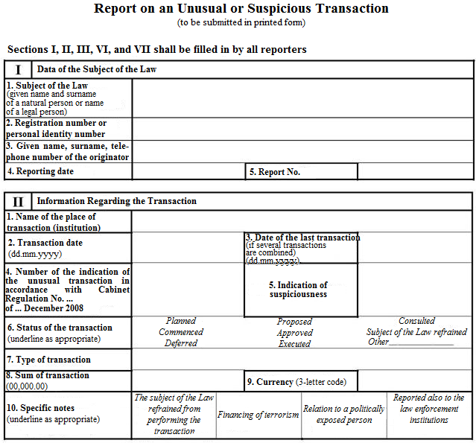

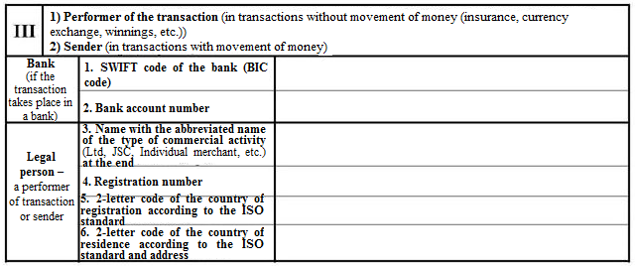

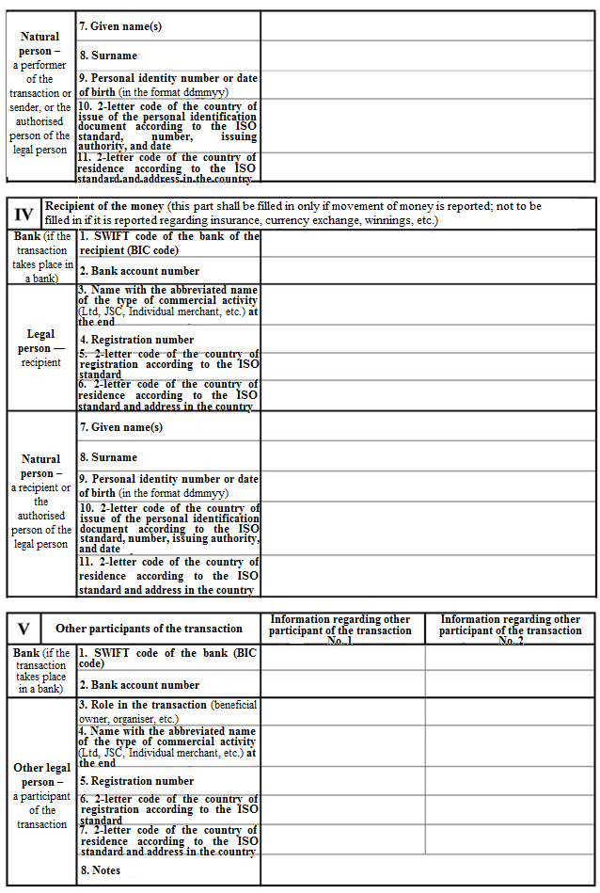

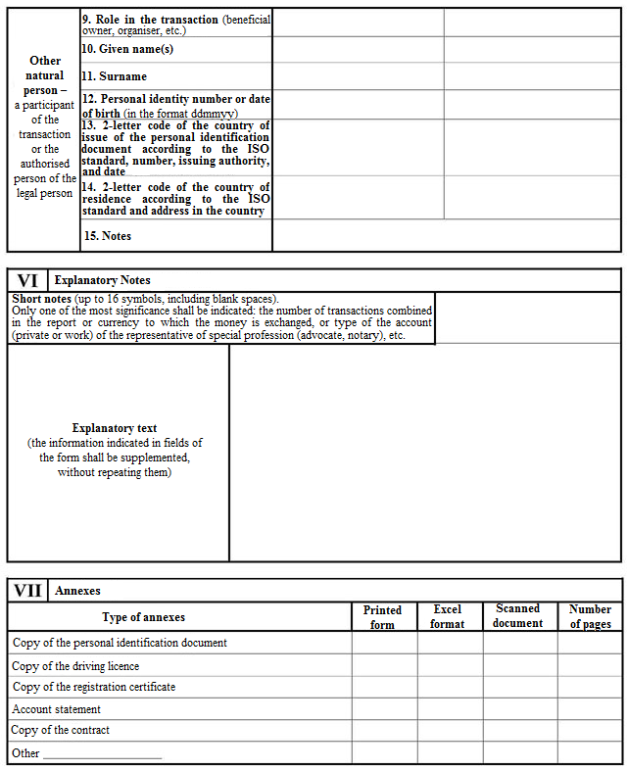

Minister for Finance A. Slakteris

Annex 2
Cabinet Regulation No. 1071
22 December 2008

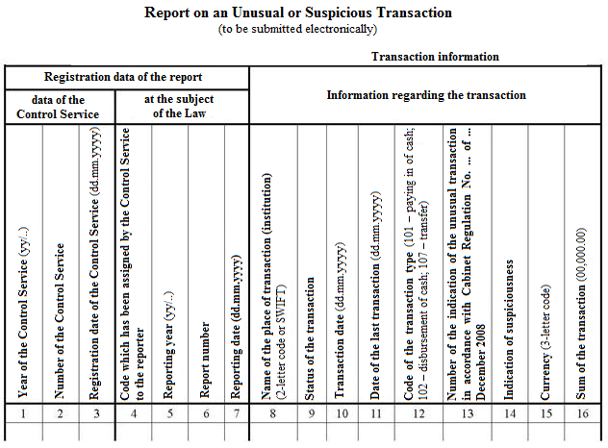

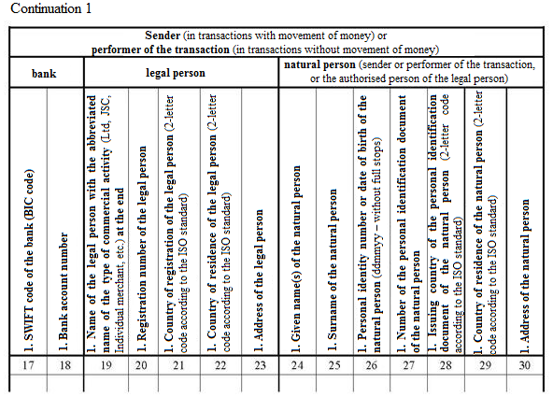

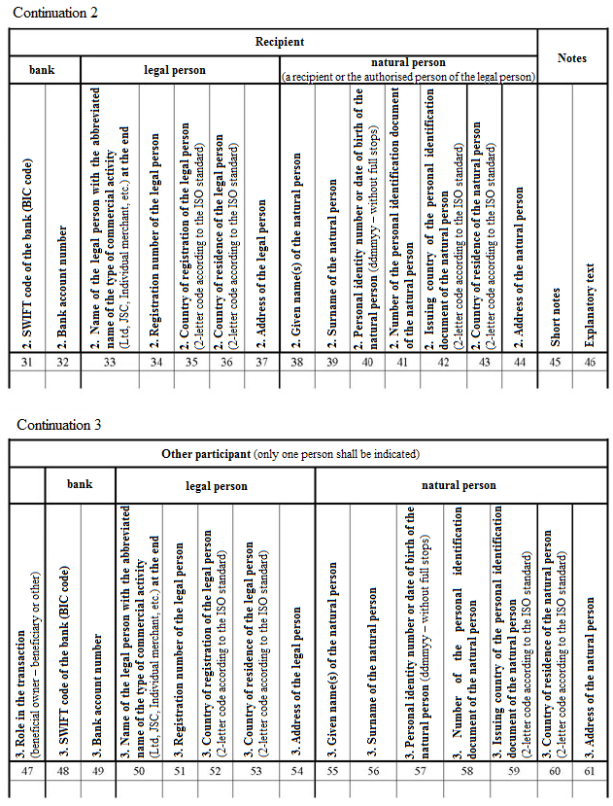

Minister for Finance A. Slakteris

Annex 3
Cabinet
Regulation No 1071
22 December 2008

Report on an Unusual or Suspicious Transaction
[6 December 2016]

Name of the field | Format of the data in a field (*) | Value of the field | Field value category | Name of the element | Parent element(s) | Manda- tory- X
1 | 2 | 3 | 4 | 5 | 6 | 7
Type of report | Max2(a) | Type of report – value Z | Text | <zinojuma_veids> | <informacija> | X
Reporter group | Max2(a) | Code of the reporter group according to the Classification | Text | <zinotaja_grupa> | <informacija> | X
Reporting year | Max2(n) | Last two digits of the year when the report was submitted | Number | <zinotaja_gads> | <informacija> | X
Reporting date | YYYY-MM-DD | Date of submitting the report in the date format of the international standard ISO 8601: YYYY-MM-DD | Date | <zinotaja_datums> | <informacija> | X
Reporter code | Max4(n) | Code of the regular reporter. One-time reporters need not fill in | Code | <zinotaja_kods> | <zinotajs> <regularais_zinotajs> | X
Name | Max128(x) | Name of the regular reporter – legal person in letters of Latvian or Latin alphabet without quotation marks or apostrophes | Text | <jp_nosaukums> | <zinotajs> <regularais_zinotajs> <zinotaja_identifikacija> <juridiska_persona> | X
Form | Max60(x) | Form of economic activity of the regular reporter – legal person according to the Classification | Text | <jp_forma> | <zinotajs> <regularais_zinotajs> <zinotaja_identifikacija> <juridiska_persona> | X
Registration number | Max32(x) | Registration number of the regular reporter – legal person in the public register | Code | <jp_reg_nr> | <zinotajs> <regularais_zinotajs> <zinotaja_identifikacija> <juridiska_persona>
Country | 2(a) | Country of registration of the regular reporter – legal person according to the standard LVS EN  ISO 3166-1:2007 | Code | <reg_valsts> | <zinotajs> <regularais_zinotajs> <zinotaja_identifikacija> <juridiska_persona> | X
Reporter SWIFT code | Max11(x) | SWIFT code of the regular reporter – legal person according to the SWIFT standard | Code | <swift> | <zinotajs> <regularais_zinotajs> <zinotaja_identifikacija> <juridiska_persona>
Given name | Max64(x) | Given name(s) of the regular reporter – natural person in letters of Latvian or Latin alphabet. Separator between words – space or hyphen (-) | Text | <fp_vards> | <zinotajs> <regularais_zinotajs> <zinotaja_identifikacija> <fiziska_persona> | X
Surname | Max32(x) | Surname of the regular reporter – natural person in letters of Latvian or Latin alphabet. Separator between words – space or hyphen (-) | Text | <fp_uzvards> | <zinotajs> <regularais_zinotajs> <zinotaja_identifikacija> <fiziska_persona> | X
Personal identity number | Max12(x) | Personal identity number of the regular reporter – natural person assigned in Latvia | Code | <fp_pers_kods> | <zinotajs> <regularais_zinotajs> <zinotaja_identifikacija> <fiziska_persona>
Date of birth | YYYY-MM-DD | Date of birth of the regular reporter – natural person in the date format of the international standard ISO 8601: YYYY-MM-DD | Date | <fp_dzims_datums> | <zinotajs> <regularais_zinotajs> <zinotaja_identifikacija> <fiziska_persona>
Passport country | 2(a) | Passport country of the regular reporter – natural person according to the standard LVS EN ISO 3166-1:2007 | Code | <pases_valsts> | <zinotajs> <regularais_zinotajs> <zinotaja_identifikacija> <fiziska_persona> | X
Name | Max128(x) | Name of the one-time reporter – legal person in letters of Latvian or Latin alphabet without quotation marks or apostrophes | Text | <jp_nosaukums> | <zinotajs> <vienreizejais_zinotajs> <zinotaja_identifikacija> <juridiska_persona> | X
Form | Max60(x) | Form of economic activity of the one-time reporter – legal person according to the Classification | Text | <jp_forma> | <zinotajs> <vienreizejais_zinotajs> <zinotaja_identifikacija> <juridiska_persona> | X
Country | 2(a) | Country of registration of the one-time reporter – legal person according to the standard LVS EN  ISO 3166-1:2007 | Code | <reg_valsts> | <zinotajs> <vienreizejais_zinotajs> <zinotaja_identifikacija> <juridiska_persona> | X
Registration number | Max32(x) | Registration number of the one-time reporter – legal person in the public register | Code | <jp_reg_nr> | <zinotajs> <vienreizejais_zinotajs> <zinotaja_identifikacija> <juridiska_persona>
Reporter SWIFT code | Max11(x) | SWIFT code of the one-time reporter – legal person according to the SWIFT standard | Code | <swift> | <zinotajs> <vienreizejais_zinotajs> <zinotaja_identifikacija> <juridiska_persona>
Given name | Max64(x) | Given name(s) of the one-time reporter – natural person in letters of Latvian or Latin alphabet. Separator between words – space or hyphen (-) | Text | <fp_vards> | <zinotajs> <vienreizejais_zinotajs> <zinotaja_identifikacija> <fiziska_persona> | X
Surname | Max32(x) | Surname of the one-time reporter – natural person in letters of Latvian or Latin alphabet. Separator between words – space or hyphen (-) | Text | <fp_uzvards> | <zinotajs> <vienreizejais_zinotajs> <zinotaja_identifikacija> <fiziska_persona> | X
Personal identity number | Max12(x) | Personal identity number of the one-time reporter – natural person assigned in Latvia | Code | <fp_pers_kods> | <zinotajs> <vienreizejais_zinotajs> <zinotaja_identifikacija> <fiziska_persona>
Date of birth | YYYY-MM-DD | Date of birth of the one-time reporter – natural person in the date format of the international standard ISO 8601: YYYY-MM-DD | Date | <fp_dzims_datums> | <zinotajs> <vienreizejais_zinotajs> <zinotaja_identifikacija> <fiziska_persona>
Passport country | 2(a) | Passport country of the one-time reporter – natural person according to the standard LVS EN ISO 3166-1:2007 | Code | <pases_valsts> | <zinotajs> <vienreizejais_zinotajs> <zinotaja_identifikacija> <fiziska_persona> | X
Correspondence address | Max128(x) | Correspondence address of the one-time reporter in letters of Latvian or Latin alphabet | Text | <korespondences_adrese> | <zinotajs> <vienreizejais_zinotajs> | X
E-mail | Max254(x) | E-mail address of the one-time reporter according to the structure: name of the user; symbol @; domain name of the e-mail server | Text | <epasts> | <zinotajs> <vienreizejais_zinotajs> | X
No. of the reporter in the year | Max6(n) | Transaction report number of the reporter in the year | Number | <zinotaja_nr_gada> | <zinojumi> <darijuma_zinojumi> <darijuma_zinojums> <darijuma_zinojuma_reg_dati> <registracijas_numurs> | X
Transaction institution SWIFT | Max11(x) | SWIFT code of the transaction institution according to the SWIFT standard | Code | <darijuma_iestade_swift> | <zinojumi> <darijuma_zinojumi> <darijuma_zinojums> <darijumi> <darijums> <darijuma_iestade> | X
Country of registration of the institution | 2(a) | Country of the transaction institution according to the standard LVS EN  ISO 3166-1:2007 | Code | <iestade_reg_valsts> | <zinojumi> <darijuma_zinojumi> <darijuma_zinojums> <darijumi> <darijums> <darijuma_iestade> <darijuma_iestade_cita> | X
Registration number of the institution | Max32(x) | Registration number of the transaction institution in the public register | Code | <iestade_reg_nr> | <zinojumi> <darijuma_zinojumi> <darijuma_zinojums> <darijumi> <darijums> <darijuma_iestade> <darijuma_iestade_cita> | X
Status of the transaction | Max64(x) | Status of the transaction according to the Classification | Code | <darijuma_stavoklis> | <zinojumi> <darijuma_zinojumi> <darijuma_zinojums> <darijumi> <darijums> | X
Transaction date | YYYY-MM-DD | Date of performing the transaction in the date format of the international standard ISO 8601: YYYY-MM-DD | Date | <darijuma_datums> | <zinojumi> <darijuma_zinojumi> <darijuma_zinojums> <darijumi> <darijums> | X
End date of the transaction | YYYY-MM-DD | End date of the transaction in case of several transactions in the date format of the international standard ISO 8601: YYYY-MM-DD | Date | <darijuma_beigu_datums> | <zinojumi> <darijuma_zinojumi> <darijuma_zinojums> <darijumi> <darijums>
Code of the transaction type | Max3(x) | Code of the transaction type according to the Classification | Code | <darijuma_veida_kods> | <zinojumi> <darijuma_zinojumi> <darijuma_zinojums> <darijumi> <darijums> | X
Indication of unusualness of the transaction | Max10(x) | Indication of unusualness of the transaction according to the Classification | Code | <darijuma_neparastuma_pazime> | <zinojumi> <darijuma_zinojumi> <darijuma_zinojums> <darijumi> <darijums> <pazime> | X
Indication of suspiciousness of the transaction | Max3(x) | Indication of suspiciousness of the transaction according to the Classification | Code | <darijuma_aizdomiguma_pazime | <zinojumi> <darijuma_zinojumi> <darijuma_zinojums> <darijumi> <darijums> <pazime> | X
Reported to the SRS | Max(2) | Whether it has been reported to the State Revenue Service: codes yes/no | Text | <zinots_vid> | <zinojumi> <darijuma_zinojumi> <darijuma_zinojums> <darijumi> <darijums> | X
Currency of the transaction | Max3(a) | Code of the transaction currency according to the ISO 4217 standard | Code | <darijuma_valuta> | <zinojumi> <darijuma_zinojumi> <darijuma_zinojums> <darijumi> <darijums> | X
Sum of transaction | Max16(d) | Transaction sum in one currency format 0.00 | Number | <darijuma_summa> | <zinojumi> <darijuma_zinojumi> <darijuma_zinojums> <darijumi> <darijums> | X
Sender SWIFT code | Max11(x) | SWIFT code of the sender according to the SWIFT standard | Code | <sutitajs_swift_kods> | <zinojumi> <darijuma_zinojumi> <darijuma_zinojums> <darijumi> <darijums> <sutitajs_klients> <sutitajs_klients_banka>
Sender account | Max21(x) | Sender account in IBAN format | Code | <sutitajs_konts> | <zinojumi> <darijuma_zinojumi> <darijuma_zinojums> <darijumi> <darijums> <sutitajs_klients> <sutitajs_klients_banka>
Sender account opened | YYYY-MM-DD | Date of opening the sender account in the date format of the international standard ISO 8601: YYYY-MM-DD | Date | <sutitajs_konts_atverts> | <zinojumi> <darijuma_zinojumi> <darijuma_zinojums> <darijumi> <darijums> <sutitajs_klients> <sutitajs_klients_banka>
Sender account closed | YYYY-MM-DD | Date of closing the sender account in the date format of the international standard ISO 8601: YYYY-MM-DD | Date | <sutitajs_konts_slegts> | <zinojumi> <darijuma_zinojumi> <darijuma_zinojums> <darijumi> <darijums> <sutitajs_klients> <sutitajs_klients_banka>
Name of the legal person of the sender | Max128(x) | Name of the sender – legal person in letters of Latvian or Latin alphabet without quotation marks or apostrophes | Text | <sutitajs_jp_nosaukums> | <zinojumi> <darijuma_zinojumi> <darijuma_zinojums> <darijumi> <darijums> <sutitajs_klients> <sutitajs_klients_identifikacija> <jp_identifikacija> | X
Form of the legal person of the sender | Max60(x) | Form of economic activity of the sender – legal person according to the Classification | Text | <sutitajs_jp_forma> | <zinojumi> <darijuma_zinojumi> <darijuma_zinojums> <darijumi> <darijums> <sutitajs_klients> <sutitajs_klients_identifikacija> <jp_identifikacija> | X
Country of registration of the legal person of the sender | 2(a) | Country of registration of the sender – legal person according to the standard LVS EN  ISO 3166-1:2007 | Code | <sutitajs_jp_reg_valsts> | <zinojumi> <darijuma_zinojumi> <darijuma_zinojums> <darijumi> <darijums> <sutitajs_klients> <sutitajs_klients_identifikacija> <jp_identifikacija> | X
Registration number of the legal person of the sender | Max32(x) | Registration number of the sender – legal person in the public register | Code | <sutitajs_jp_reg_nr> | <zinojumi> <darijuma_zinojumi> <darijuma_zinojums> <darijumi> <darijums> <sutitajs_klients> <sutitajs_klients_identifikacija> <jp_identifikacija>
Country of residence of the legal person of the sender | 2(a) | Country of residence of the sender – legal person according to the standard LVS EN  ISO 3166-1:2007 | Code | <sutitajs_jp_adr_valsts> | <zinojumi> <darijuma_zinojumi> <darijuma_zinojums> <darijumi> <darijums> <sutitajs_klients> <sutitajs_klients_identifikacija> <jp_identifikacija> | X
Address of the legal person of the sender | Max128(x) | Address of the sender – legal person in letters of Latvian or Latin alphabet | Text | <sutitajs_jp_adr> | <zinojumi> <darijuma_zinojumi> <darijuma_zinojums> <darijumi> <darijums> <sutitajs_klients> <sutitajs_klients_identifikacija> <jp_identifikacija> | X
Country of alternative address of the legal person of the sender | 2(a) | Country of alternative address of the sender – legal person according to the standard LVS EN ISO 3166-1:2007 | Code | <sutitajs_jp_sec_adr_valsts> | <zinojumi> <darijuma_zinojumi> <darijuma_zinojums> <darijumi> <darijums> <sutitajs_klients> <sutitajs_klients_identifikacija> <jp_identifikacija> <sutitajs_jp_citas_adreses> <sutitajs_jp_sec_adr> | X
Alternative address of the legal person of the sender | Max128(x) | Alternative address of the sender – legal person in letters of Latvian or Latin alphabet | Text | <sutitajs_jp_sec_adrese> | <zinojumi> <darijuma_zinojumi> <darijuma_zinojums> <darijumi> <darijums> <sutitajs_klients> <sutitajs_klients_identifikacija> <jp_identifikacija> <sutitajs_jp_citas_adreses> <sutitajs_jp_sec_adr>
Notes of the legal person of the sender | Max32(x) | Notes of the legal person of the sender in letters of Latvian or Latin alphabet without quotation marks or apostrophes | Text | <sutitajs_jp_piezimes> | <zinojumi> <darijuma_zinojumi> <darijuma_zinojums> <darijumi> <darijums> <sutitajs_klients> <sutitajs_klients_identifikacija> <jp_identifikacija>
Given name of the natural person of the sender | Max64(x) | Given name(s) of the sender – natural person in letters of Latvian or Latin alphabet. Separator between words – space or hyphen (-) | Text | <sutitajs_fp_vards> | <zinojumi> <darijuma_zinojumi> <darijuma_zinojums> <darijumi> <darijums> <sutitajs_klients> <sutitajs_klients_identifikacija> <fp_identifikacija> | X
Surname of the natural person of the sender | Max32(x) | Surname of the sender – natural person in letters of Latvian or Latin alphabet. Separator between words – space or hyphen (-) | Text | <sutitajs_fp_uzvards> | <zinojumi> <darijuma_zinojumi> <darijuma_zinojums> <darijumi> <darijums> <sutitajs_klients> <sutitajs_klients_identifikacija> <fp_identifikacija> | X
Personal identity number in Latvia of the natural person of the sender | Max12(x) | Personal identity number of the sender – natural person assigned in Latvia | Code | <sutitajs_fp_pers_kods_lv> | <zinojumi> <darijuma_zinojumi> <darijuma_zinojums> <darijumi> <darijums> <sutitajs_klients> <sutitajs_klients_identifikacija> <fp_identifikacija> <sutitajs_fp_dzim_dati> | X
Date of birth of the natural person of the sender | YYYY-MM-DD | Date of birth of the sender – natural person in the date format of the international standard ISO 8601: YYYY-MM-DD | Date | <sutitajs_fp_dzim_datums> | <zinojumi> <darijuma_zinojumi> <darijuma_zinojums> <darijumi> <darijums> <sutitajs_klients> <sutitajs_klients_identifikacija> <fp_identifikacija> <sutitajs_fp_dzim_dati> | X
Foreign ID of the natural person of the sender | Max32(x) | Personal identity number of the sender – natural person assigned in foreign countries | Code | <sutitajs_fp_arv_id> | <zinojumi> <darijuma_zinojumi> <darijuma_zinojums> <darijumi> <darijums> <sutitajs_klients> <sutitajs_klients_identifikacija> <fp_identifikacija>
Foreign ID country of the natural person of the sender | 2(a) | Country of the ID of the sender – natural person issued outside Latvia according to the standard LVS EN  ISO 3166-1:2007 | Code | <sutitajs_fp_arv_id_valsts> | <zinojumi> <darijuma_zinojumi> <darijuma_zinojums> <darijumi> <darijums> <sutitajs_klients> <sutitajs_klients_identifikacija> <fp_identifikacija> | X
Number of the personal identification document of the natural person of the sender | Max32(x) | Number of the personal identification document of the natural person – sender | Code | <sutitajs_fp_dok_nr> | <zinojumi> <darijuma_zinojumi> <darijuma_zinojums> <darijumi> <darijums> <sutitajs_klients> <sutitajs_klients_identifikacija> <fp_identifikacija>
Country of issue of the personal identification document of the natural person of the sender | 2(a) | Country of issue of the personal identification document of the sender – natural person according to the standard LVS EN  ISO 3166-1:2007 | Code | <sutitajs_fp_dok_valsts> | <zinojumi> <darijuma_zinojumi> <darijuma_zinojums> <darijumi> <darijums> <sutitajs_klients> <sutitajs_klients_identifikacija> <fp_identifikacija> | X
Country of residence of the natural person of the sender | 2(a) | Country of residence of the sender – natural person according to the standard LVS EN  ISO 3166-1:2007 | Code | <sutitajs_fp_adr_valsts> | <zinojumi> <darijuma_zinojumi> <darijuma_zinojums> <darijumi> <darijums> <sutitajs_klients> <sutitajs_klients_identifikacija> <fp_identifikacija>
Address of the natural person of the sender | Max128(x) | Address of the sender – natural person in letters of Latvian or Latin alphabet | Text | <sutitajs_fp_adr> | <zinojumi> <darijuma_zinojumi> <darijuma_zinojums> <darijumi> <darijums> <sutitajs_klients> <sutitajs_klients_identifikacija> <fp_identifikacija>
Country of alternative address of the natural person of the sender | 2(a) | Country of alternative address of the sender – natural person according to the standard LVS EN ISO 3166-1:2007 | Code | <sutitajs_fp_sec_adr_valsts> | <zinojumi> <darijuma_zinojumi> <darijuma_zinojums> <darijumi> <darijums> <sutitajs_klients> <sutitajs_klients_identifikacija> <fp_identifikacija> <sutitajs_fp_citas_adreses> <sutitajs_fp_sec_adr> | X
Alternative address of the natural person of the sender | Max128(x) | Alternative address of the sender – natural person in letters of Latvian or Latin alphabet | Text | <sutitajs_fp_sec_adrese> | <zinojumi> <darijuma_zinojumi> <darijuma_zinojums> <darijumi> <darijums> <sutitajs_klients> <sutitajs_klients_identifikacija> <fp_identifikacija> <sutitajs_fp_citas_adreses> <sutitajs_fp_sec_adr>
Notes of the natural person of the sender | Max32(x) | Notes of the natural person of the sender in letters of Latvian or Latin alphabet without quotation marks or apostrophes | Text | <sutitajs_fp_piezimes> | <zinojumi> <darijuma_zinojumi> <darijuma_zinojums> <darijumi> <darijums> <sutitajs_klients> <sutitajs_klients_identifikacija> <fp_identifikacija>
Given name of the authorised person of the sender | Max64(x) | Given name(s) of the sender – authorised person in letters of Latvian or Latin alphabet. Separator between words – space or hyphen (-) | Text | <sutitajs_pp_fp_vards> | <zinojumi> <darijuma_zinojumi> <darijuma_zinojums> <darijumi> <darijums> <sutitaja_pilnvarota_persona> | X
Surname of the authorised person of the sender | Max32(x) | Surname of the sender – authorised person in letters of Latvian or Latin alphabet. Separator between words – space or hyphen (-) | Text | <sutitajs_pp_fp_uzvards> | <zinojumi> <darijuma_zinojumi> <darijuma_zinojums> <darijumi> <darijums> <sutitaja_pilnvarota_persona> | X
Personal identity number in Latvia of the authorised person of the sender | Max12(x) | Personal identity number of the sender – authorised person assigned in Latvia | Code | <sutitajs_pp_fp_pers_kods_lv> | <zinojumi> <darijuma_zinojumi> <darijuma_zinojums> <darijumi> <darijums> <sutitaja_pilnvarota_persona> <sutitajs_pp_fp_dzim_dati> | X
Date of birth of the authorised person of the sender | YYYY-MM-DD | Date of birth of the sender – authorised person in the date format of the international standard ISO 8601: YYYY-MM-DD | Date | <sutitajs_pp_fp_dzim_datums> | <zinojumi> <darijuma_zinojumi> <darijuma_zinojums> <darijumi> <darijums> <sutitaja_pilnvarota_persona> <sutitajs_pp_fp_dzim_dati> | X
Foreign ID of the authorised person of the sender | Max32(x) | Personal identity number of the sender – authorised person assigned in foreign countries | Code | <sutitajs_pp_fp_arv_id> | <zinojumi> <darijuma_zinojumi> <darijuma_zinojums> <darijumi> <darijums> <sutitaja_pilnvarota_persona>
Foreign ID country of the authorised person of the sender | 2(a) | Country of the ID of the sender – authorised person issued outside Latvia according to the standard LVS EN  ISO 3166-1:2007 | Code | <sutitajs_pp_fp_arv_id_valsts> | <zinojumi> <darijuma_zinojumi> <darijuma_zinojums> <darijumi> <darijums> <sutitaja_pilnvarota_persona>
Number of the personal identification document of the authorised person of the sender | Max32(x) | Number of the personal identification document of the sender – authorised person | Code | <sutitajs_pp_fp_dok_nr> | <zinojumi> <darijuma_zinojumi> <darijuma_zinojums> <darijumi> <darijums> <sutitaja_pilnvarota_persona>
Country of issue of the personal identification document of the authorised person of the sender | 2(a) | Country of issue of the personal identification document of the sender – authorised person according to the standard LVS EN  ISO 3166-1:2007 | Code | <sutitajs_pp_fp_dok_valsts> | <zinojumi> <darijuma_zinojumi> <darijuma_zinojums> <darijumi> <darijums> <sutitaja_pilnvarota_persona>
Country of residence of the authorised person of the sender | 2(a) | Country of residence of the sender – authorised person according to the standard LVS EN  ISO 3166-1:2007 | Code | <sutitajs_pp_fp_adr_valsts> | <zinojumi> <darijuma_zinojumi> <darijuma_zinojums> <darijumi> <darijums> <sutitaja_pilnvarota_persona>
Address of the authorised person of the sender | Max128(x) | Address of the sender – authorised person in letters of Latvian or Latin alphabet | Text | <sutitajs_pp_fp_adr> | <zinojumi> <darijuma_zinojumi> <darijuma_zinojums> <darijumi> <darijums> <sutitaja_pilnvarota_persona>
Country of alternative address of the authorised person of the sender | 2(a) | Country of alternative address of the sender – authorised person according to the standard LVS EN ISO 3166-1:2007 | Code | <sutitajs_pp_fp_sec_adr_valsts> | <zinojumi> <darijuma_zinojumi> <darijuma_zinojums> <darijumi> <darijums> <sutitaja_pilnvarota_persona> <sutitajs_pp_fp_citas_adreses> <sutitajs_pp_fp_sec_adr>
Alternative address of the authorised person of the sender | Max128(x) | Alternative address of the sender – authorised person in letters of Latvian or Latin alphabet | Text | <sutitajs_pp_fp_sec_adrese> | <zinojumi> <darijuma_zinojumi> <darijuma_zinojums> <darijumi> <darijums> <sutitaja_pilnvarota_persona> <sutitajs_pp_fp_citas_adreses> <sutitajs_pp_fp_sec_adr>
Notes of the authorised person of the sender | Max32(x) | Notes of the sender – authorised person in letters of Latvian or Latin alphabet without quotation marks or apostrophes | Text | <sutitajs_pp_fp_piezimes> | <zinojumi> <darijuma_zinojumi> <darijuma_zinojums> <darijumi> <darijums> <sutitaja_pilnvarota_persona>
Recipient SWIFT code | Max11(x) | SWIFT code of the recipient according to the SWIFT standard | Code | <sanemejs_swift_kods> | <zinojumi> <darijuma_zinojumi> <darijuma_zinojums> <darijumi> <darijums> <sanemejs> <sanemejs_banka>
Recipient account | Max21(x) | Recipient account in IBAN format | Code | <sanemejs_konts> | <zinojumi> <darijuma_zinojumi> <darijuma_zinojums> <darijumi> <darijums> <sanemejs> <sanemejs_banka>
Recipient account opened | YYYY-MM-DD | Date of opening the recipient account in the date format of the international standard ISO 8601: YYYY-MM-DD | Date | <sanemejs_konts_atverts> | <zinojumi> <darijuma_zinojumi> <darijuma_zinojums> <darijumi> <darijums> <sanemejs> <sanemejs_banka>
Recipient account closed | YYYY-MM-DD | Date of closing the recipient account in the date format of the international standard ISO 8601: YYYY-MM-DD | Date | <sanemejs_konts_slegts | <zinojumi> <darijuma_zinojumi> <darijuma_zinojums> <darijumi> <darijums> <sanemejs> <sanemejs_banka>
Name of the legal person of the recipient | Max128(x) | Name of the recipient – legal person in letters of Latvian or Latin alphabet without quotation marks or apostrophes | Text | <sanemejs_jp_nosaukums> | <zinojumi> <darijuma_zinojumi> <darijuma_zinojums> <darijumi> <darijums> <sanemejs> <sanemejs_identifikacija> <jp_identifikacija> | X
Form of the legal person of the recipient | Max60(x) | Form of economic activity of the recipient – legal person according to the Classification | Text | <sanemejs_jp_forma> | <zinojumi> <darijuma_zinojumi> <darijuma_zinojums> <darijumi> <darijums> <sanemejs> <sanemejs_identifikacija> <jp_identifikacija> | X
Country of registration of the legal person of the recipient | 2(a) | Country of registration of the recipient – legal person according to the standard LVS EN  ISO 3166-1:2007 | Code | <sanemejs_jp_reg_valsts> | <zinojumi> <darijuma_zinojumi> <darijuma_zinojums> <darijumi> <darijums> <sanemejs> <sanemejs_identifikacija> <jp_identifikacija>
Registration number of the legal person of the recipient | Max32(x) | Registration number of the recipient – legal person in the public register | Code | <sanemejs_jp_reg_nr> | <zinojumi> <darijuma_zinojumi> <darijuma_zinojums> <darijumi> <darijums> <sanemejs> <sanemejs_identifikacija> <jp_identifikacija> | X
Country of residence of the legal person of the recipient | 2(a) | Country of residence of the recipient – legal person according to the standard LVS EN  ISO 3166-1:2007 | Code | <sanemejs_jp_adr_valsts> | <zinojumi> <darijuma_zinojumi> <darijuma_zinojums> <darijumi> <darijums> <sanemejs> <sanemejs_identifikacija> <jp_identifikacija> | X
Address of the legal person of the recipient | Max128(x) | Address of the recipient – legal person in letters of Latvian or Latin alphabet | Text | <sanemejs_jp_adr> | <zinojumi> <darijuma_zinojumi> <darijuma_zinojums> <darijumi> <darijums> <sanemejs> <sanemejs_identifikacija> <jp_identifikacija> | X
Country of alternative address of the legal person of the recipient | 2(a) | Country of alternative address of the recipient – legal person according to the standard LVS EN ISO 3166-1:2007 | Code | <sanemejs_jp_sec_adr_valsts> | <zinojumi> <darijuma_zinojumi> <darijuma_zinojums> <darijumi> <darijums> <sanemejs> <sanemejs_identifikacija> <jp_identifikacija> <sanemejs_jp_citas_adreses> <sanemejs_jp_sec_adr>
Alternative address of the legal person of the recipient | Max128(x) | Alternative address of the recipient – legal person in letters of Latvian or Latin alphabet | Text | <sanemejs_jp_sec_adrese> | <zinojumi> <darijuma_zinojumi> <darijuma_zinojums> <darijumi> <darijums> <sanemejs> <sanemejs_identifikacija> <jp_identifikacija> <sanemejs_jp_citas_adreses> <sanemejs_jp_sec_adr>
Notes of the legal person of the recipient | Max32(x) | Notes of the recipient - legal person in letters of Latvian or Latin alphabet without quotation marks or apostrophes | Text | <sanemejs_jp_piezimes> | <zinojumi> <darijuma_zinojumi> <darijuma_zinojums> <darijumi> <darijums> <sanemejs> <sanemejs_identifikacija> <jp_identifikacija>
Given name of the natural person of the recipient | Max64(x) | Given name(s) of the recipient – natural person in letters of Latvian or Latin alphabet. Separator between words – space or hyphen (-) | Text | <sanemejs_fp_vards> | <zinojumi> <darijuma_zinojumi> <darijuma_zinojums> <darijumi> <darijums> <sanemejs> <sanemejs_identifikacija> <fp_identifikacija> | X
Surname of the natural person of the recipient | Max32(x) | Surname of the recipient – natural person in letters of Latvian or Latin alphabet. Separator between words – space or hyphen (-) | Text | <sanemejs_fp_uzvards> | <zinojumi> <darijuma_zinojumi> <darijuma_zinojums> <darijumi> <darijums> <sanemejs> <sanemejs_identifikacija> <fp_identifikacija> | X
Personal identity number in Latvia of the natural person of the recipient | Max12(x) | Personal identity number of the recipient – natural person assigned in Latvia | Code | <sanemejs_fp_pers_kods_lv> | <zinojumi> <darijuma_zinojumi> <darijuma_zinojums> <darijumi> <darijums> <sanemejs> <sanemejs_identifikacija> <fp_identifikacija> <sanemejs_fp_dzim_dati> | X
Date of birth of the natural person of the recipient | YYYY-MM-DD | Date of birth of the recipient – natural person in the date format of the international standard ISO 8601: YYYY-MM-DD | Date | <sanemejs_fp_dzim_datums> | <zinojumi> <darijuma_zinojumi> <darijuma_zinojums> <darijumi> <darijums> <sanemejs> <sanemejs_identifikacija> <fp_identifikacija> <sanemejs_fp_dzim_dati> | X
Foreign ID of the natural person of the recipient | Max32(x) | Personal identity number of the recipient – natural person assigned in foreign countries | Code | <sanemejs_fp_arv_id> | <zinojumi> <darijuma_zinojumi> <darijuma_zinojums> <darijumi> <darijums> <sanemejs> <sanemejs_identifikacija> <fp_identifikacija>
Foreign ID country of the natural person of the recipient | 2(a) | Country of the ID of the recipient – natural person issued outside Latvia according to the standard LVS EN  ISO 3166-1:2007 | Code | <sanemejs_fp_arv_id_valsts> | <zinojumi> <darijuma_zinojumi> <darijuma_zinojums> <darijumi> <darijums> <sanemejs> <sanemejs_identifikacija> <fp_identifikacija>
Number of the personal identification document of the natural person of the recipient | Max32(x) | Number of the personal identification document of the recipient – natural person | Code | <sanemejs_fp_dok_nr> | <zinojumi> <darijuma_zinojumi> <darijuma_zinojums> <darijumi> <darijums> <sanemejs> <sanemejs_identifikacija> <fp_identifikacija>
Country of issue of the personal identification document of the natural person of the recipient | 2(a) | Country of issue the personal identification document of the recipient – natural person according to the standard LVS EN  ISO 3166-1:2007 | Code | <sanemejs_fp_dok_valsts> | <zinojumi> <darijuma_zinojumi> <darijuma_zinojums> <darijumi> <darijums> <sanemejs> <sanemejs_identifikacija> <fp_identifikacija>
Country of residence of the natural person of the recipient | 2(a) | Country of residence of the recipient – natural person according to the standard LVS EN  ISO 3166-1:2007 | Code | <sanemejs_fp_adr_valsts> | <zinojumi> <darijuma_zinojumi> <darijuma_zinojums> <darijumi> <darijums> <sanemejs> <sanemejs_identifikacija> <fp_identifikacija>
Address of the natural person of the recipient | Max128(x) | Address of the recipient – natural person in letters of Latvian or Latin alphabet | Text | <sanemejs_fp_adr> | <zinojumi> <darijuma_zinojumi> <darijuma_zinojums> <darijumi> <darijums> <sanemejs> <sanemejs_identifikacija> <fp_identifikacija>
Country of alternative address of the natural person of the recipient | 2(a) | Country of alternative address of the recipient – natural person according to the standard LVS EN ISO 3166-1:2007 | Code | <sanemejs_fp_sec_adr_valsts> | <zinojumi> <darijuma_zinojumi> <darijuma_zinojums> <darijumi> <darijums> <sanemejs> <sanemejs_identifikacija> <fp_identifikacija> <sanemejs_fp_citas_adreses> <sanemejs_fp_sec_adr>
Alternative address of the natural person of the recipient | Max128(x) | Alternative address of the recipient – natural person in letters of Latvian or Latin alphabet | Text | <sanemejs_fp_sec_adrese> | <zinojumi> <darijuma_zinojumi> <darijuma_zinojums> <darijumi> <darijums> <sanemejs> <sanemejs_identifikacija> <fp_identifikacija> <sanemejs_fp_citas_adreses> <sanemejs_fp_sec_adr>
Notes of the natural person of the recipient | Max32(x) | Notes of the recipient – natural person in letters of Latvian or Latin alphabet without quotation marks or apostrophes | Text | <sanemejs_fp_piezimes> | <zinojumi> <darijuma_zinojumi> <darijuma_zinojums> <darijumi> <darijums> <sanemejs> <sanemejs_identifikacija> <fp_identifikacija>
Given name of the authorised person of the recipient | Max64(x) | Given name(s) of the recipient – authorised person in letters of Latvian or Latin alphabet. Separator between words – space or hyphen (-) | Text | <sanemejs_pp_fp_vards> | <zinojumi> <darijuma_zinojumi> <darijuma_zinojums> <darijumi> <darijums> <sanemeja_pilnvarota_persona> | X
Surname of the authorised person of the recipient | Max32(x) | Surname of the recipient – authorised person in letters of Latvian or Latin alphabet. Separator between words – space or hyphen (-) | Text | <sanemejs_pp_fp_uzvards> | <zinojumi> <darijuma_zinojumi> <darijuma_zinojums> <darijumi> <darijums> <sanemeja_pilnvarota_persona> | X
Personal identity number in Latvia of the authorised person of the recipient | Max12(x) | Personal identity number of the recipient – authorised person assigned in Latvia | Code | <sanemejs_pp_fp_pers_kods_lv> | <zinojumi> <darijuma_zinojumi> <darijuma_zinojums> <darijumi> <darijums> <sanemeja_pilnvarota_persona> <sanemejs_pp_fp_dzim_dati> | X
Date of birth of the authorised person of the recipient | YYYY-MM-DD | Date of birth of the recipient – authorised person in the date format of the international standard ISO 8601: YYYY-MM-DD | Date | <sanemejs_pp_fp_dzim_datums> | <zinojumi> <darijuma_zinojumi> <darijuma_zinojums> <darijumi> <darijums> <sanemeja_pilnvarota_persona> <sanemejs_pp_fp_dzim_dati> | X
Foreign ID of the authorised person of the recipient | Max32(x) | Personal identity number of the recipient – authorised person assigned in foreign countries | Code | <sanemejs_pp_fp_arv_id> | <zinojumi> <darijuma_zinojumi> <darijuma_zinojums> <darijumi> <darijums> <sanemeja_pilnvarota_persona>
Foreign ID country of the authorised person of the recipient | 2(a) | Country of the ID of the recipient – authorised person issued outside Latvia according to the standard LVS EN  ISO 3166-1:2007 | Code | <sanemejs_pp_fp_arv_id_valsts> | <zinojumi> <darijuma_zinojumi> <darijuma_zinojums> <darijumi> <darijums> <sanemeja_pilnvarota_persona> | X
Number of the personal identification document of the authorised person of the recipient | Max32(x) | Number of the personal identification document of the recipient – authorised person | Code | <sanemejs_pp_fp_dok_nr> | <zinojumi> <darijuma_zinojumi> <darijuma_zinojums> <darijumi> <darijums> <sanemeja_pilnvarota_persona>
Country of issue of the personal identification document of the authorised person of the recipient | 2(a) | Country of issue of the personal identification document of the recipient – authorised person according to the standard LVS EN  ISO 3166-1:2007 | Code | <sanemejs_pp_fp_dok_valsts> | <zinojumi> <darijuma_zinojumi> <darijuma_zinojums> <darijumi> <darijums> <sanemeja_pilnvarota_persona> | X
Country of residence of the authorised person of the recipient | 2(a) | Country of residence of the recipient – authorised person according to the standard LVS EN  ISO 3166-1:2007 | Code | <sanemejs_pp_fp_adr_valsts> | <zinojumi> <darijuma_zinojumi> <darijuma_zinojums> <darijumi> <darijums> <sanemeja_pilnvarota_persona> | X
Address of the authorised person of the recipient | Max128(x) | Address of the recipient – authorised person in letters of Latvian or Latin alphabet | Text | <sanemejs_pp_fp_adr> | <zinojumi> <darijuma_zinojumi> <darijuma_zinojums> <darijumi> <darijums> <sanemeja_pilnvarota_persona>
Country of alternative address of the authorised person of the recipient | 2(a) | Country of alternative address of the recipient – authorised person according to the standard LVS EN ISO 3166-1:2007 | Code | <sanemejs_pp_fp_sec_adr_valsts> | <zinojumi> <darijuma_zinojumi> <darijuma_zinojums> <darijumi> <darijums> <sanemeja_pilnvarota_persona> <sanemejs_pp_fp_citas_adreses> <sanemejs_pp_fp_sec_adr>
Alternative address of the authorised person of the recipient | Max128(x) | Alternative address of the recipient – authorised person in letters of Latvian or Latin alphabet | Text | <sanemejs_pp_fp_sec_adrese> | <zinojumi> <darijuma_zinojumi> <darijuma_zinojums> <darijumi> <darijums> <sanemeja_pilnvarota_persona> <sanemejs_pp_fp_citas_adreses> <sanemejs_pp_fp_sec_adr>
Notes of the authorised person of the recipient | Max32(x) | Notes of the recipient – authorised person in letters of Latvian or Latin alphabet without quotation marks or apostrophes | Text | <sanemejs_pp_fp_piezimes> | <zinojumi> <darijuma_zinojumi> <darijuma_zinojums> <darijumi> <darijums> <sanemeja_pilnvarota_persona>
Role in the transaction | Max2(a) | Role of other participant in the transaction according to the Classification | Code | <cits_dalibas_loma> | <zinojumi> <darijuma_zinojumi> <darijuma_zinojums> <darijumi> <darijums> <cits_dalibnieks> | X
Name of the legal person of other participant | Max128(x) | Name of other participant – legal person in letters of Latvian or Latin alphabet without quotation marks or apostrophes | Text | <cits_jp_nosaukums> | <zinojumi> <darijuma_zinojumi> <darijuma_zinojums> <darijumi> <darijums> <cits_dalibnieks> <cits_dalibn_identifikacija> <cits_jp_identifikacija> | X
Form of the legal person of other participant | Max60(x) | Form of economic activity of other participant – legal person according to the Classification | Text | <cits_jp_forma> | <zinojumi> <darijuma_zinojumi> <darijuma_zinojums> <darijumi> <darijums> <cits_dalibnieks> <cits_dalibn_identifikacija> <cits_jp_identifikacija> | X
Country of registration of the legal person of other participant | 2(a) | Country of registration of other participant – legal person according to the standard LVS EN  ISO 3166-1:2007 | Code | <cits_jp_reg_valsts> | <zinojumi> <darijuma_zinojumi> <darijuma_zinojums> <darijumi> <darijums> <cits_dalibnieks> <cits_dalibn_identifikacija> <cits_jp_identifikacija> | X
Registration number of the legal person of other participant | Max32(x) | Registration number of other participant – legal person in the public register | Code | <cits_jp_reg_nr> | <zinojumi> <darijuma_zinojumi> <darijuma_zinojums> <darijumi> <darijums> <cits_dalibnieks> <cits_dalibn_identifikacija> <cits_jp_identifikacija>
Country of residence of the legal person of other participant | 2(a) | Country of residence of other participant – legal person according to the standard LVS EN ISO 3166-1:2007 | Code | <cits_jp_adr_valsts> | <zinojumi> <darijuma_zinojumi> <darijuma_zinojums> <darijumi> <darijums> <cits_dalibnieks> <cits_dalibn_identifikacija> <cits_jp_identifikacija> | X
Address of the legal person of other participant | Max128(x) | Address of other participant – legal person in letters of Latvian or Latin alphabet | Text | <cits_jp_adr> | <zinojumi> <darijuma_zinojumi> <darijuma_zinojums> <darijumi> <darijums> <cits_dalibnieks> <cits_dalibn_identifikacija> <cits_jp_identifikacija>
Country of alternative address of the legal person of other participant | 2(a) | Country of alternative address of other participant – legal person according to the standard LVS EN  ISO 3166-1:2007 | Code | <cits_jp_sec_adr_valsts> | <zinojumi> <darijuma_zinojumi> <darijuma_zinojums> <darijumi> <darijums> <cits_dalibnieks> <cits_dalibn_identifikacija> <cits_jp_identifikacija> <cits_jp_citas_adreses> <cits_jp_sec_adr>
Alternative address of the legal person of other participant | Max128(x) | Alternative address of other participant – legal person in letters of Latvian or Latin alphabet | Text | <cits_jp_sec_adrese> | <zinojumi> <darijuma_zinojumi> <darijuma_zinojums> <darijumi> <darijums> <cits_dalibnieks> <cits_dalibn_identifikacija> <cits_jp_identifikacija> <cits_jp_citas_adreses> <cits_jp_sec_adr>
Notes of the legal person of other participant | Max32(x) | Notes of other participant – legal person in letters of Latvian or Latin alphabet without quotation marks or apostrophes | Text | <cits_jp_piezimes> | <zinojumi> <darijuma_zinojumi> <darijuma_zinojums> <darijumi> <darijums> <cits_dalibnieks> <cits_dalibn_identifikacija> <cits_jp_identifikacija>
Given name of the natural person of other participant | Max64(x) | Given name(s) of other participant – natural person in letters of Latvian or Latin alphabet. Separator between words – space or hyphen (-) | Text | <cits_fp_vards> | <zinojumi> <darijuma_zinojumi> <darijuma_zinojums> <darijumi> <darijums> <cits_dalibnieks> <cits_dalibn_identifikacija> <cits_fp_identifikacija> | X
Surname of the natural person of other participant | Max32(x) | Surname of other participant – natural person in letters of Latvian or Latin alphabet. Separator between words – space or hyphen (-) | Text | <cits_fp_uzvards> | <zinojumi> <darijuma_zinojumi> <darijuma_zinojums> <darijumi> <darijums> <cits_dalibnieks> <cits_dalibn_identifikacija> <cits_fp_identifikacija> | X
Personal identity number in Latvia of the natural person of other participant | Max12(x) | Personal identity number of other participant – natural person assigned in Latvia | Code | <cits_fp_pers_kods_lv> | <zinojumi> <darijuma_zinojumi> <darijuma_zinojums> <darijumi> <darijums> <cits_dalibnieks> <cits_dalibn_identifikacija> <cits_fp_identifikacija> <cits_fp_dzim_dati> | X
Date of birth of the natural person of other participant | YYYY-MM-DD | Date of birth of other participant – natural person in the date format of the international standard ISO 8601: YYYY-MM-DD | Date | <cits_fp_dzim_datums> | <zinojumi> <darijuma_zinojumi> <darijuma_zinojums> <darijumi> <darijums> <cits_dalibnieks> <cits_dalibn_identifikacija> <cits_fp_identifikacija> <cits_fp_dzim_dati> | X
Foreign ID of the natural person of other participant | Max32(x) | Personal identity number of other participant – natural person assigned in foreign countries | Code | <cits_fp_arv_id> | <zinojumi> <darijuma_zinojumi> <darijuma_zinojums> <darijumi> <darijums> <cits_dalibnieks> <cits_dalibn_identifikacija> <cits_fp_identifikacija>
Foreign ID country of the natural person of other participant | 2(a) | Country of the ID of other participant – natural person issued outside Latvia according to the standard LVS EN  ISO 3166-1:2007 | Code | <cits_fp_arv_id_valsts> | <zinojumi> <darijuma_zinojumi> <darijuma_zinojums> <darijumi> <darijums> <cits_dalibnieks> <cits_dalibn_identifikacija> <cits_fp_identifikacija>
Number of the personal identification document of the natural person of other participant | Max32(x) | Number of the personal identification document of other participant – natural person | Code | <cits_fp_dok_nr> | <zinojumi> <darijuma_zinojumi> <darijuma_zinojums> <darijumi> <darijums> <cits_dalibnieks> <cits_dalibn_identifikacija> <cits_fp_identifikacija>
Country of issue of the personal identification document of the natural person of other participant | 2(a) | Country of issue of the personal identification document of other participant – natural person according to the standard LVS EN  ISO 3166-1:2007 | Code | <cits_fp_dok_valsts> | <zinojumi> <darijuma_zinojumi> <darijuma_zinojums> <darijumi> <darijums> <cits_dalibnieks> <cits_dalibn_identifikacija> <cits_fp_identifikacija>
Country of residence of the natural person of other participant | 2(a) | Country of residence of other participant – natural person according to the standard LVS EN ISO 3166-1:2007 | Code | <cits_fp_adr_valsts> | <zinojumi> <darijuma_zinojumi> <darijuma_zinojums> <darijumi> <darijums> <cits_dalibnieks> <cits_dalibn_identifikacija> <cits_fp_identifikacija>
Address of the natural person of other participant | Max128(x) | Address of other participant – natural person in letters of Latvian or Latin alphabet | Text | <cits_fp_adr> | <zinojumi> <darijuma_zinojumi> <darijuma_zinojums> <darijumi> <darijums> <cits_dalibnieks> <cits_dalibn_identifikacija> <cits_fp_identifikacija>
Country of alternative address of the natural person of other participant | 2(a) | Country of alternative address of other participant – natural person according to the standard LVS EN  ISO 3166-1:2007 | Code | <cits_fp_sec_adr_valsts> | <zinojumi> <darijuma_zinojumi> <darijuma_zinojums> <darijumi> <darijums> <cits_dalibnieks> <cits_dalibn_identifikacija> <cits_fp_identifikacija> <cits_fp_citas_adreses> <cits_fp_sec_adr>
Alternative address of the natural person of other participant | Max128(x) | Alternative address of other participant – natural person in letters of Latvian or Latin alphabet | Text | <cits_fp_sec_adrese> | <zinojumi> <darijuma_zinojumi> <darijuma_zinojums> <darijumi> <darijums> <cits_dalibnieks> <cits_dalibn_identifikacija> <cits_fp_identifikacija> <cits_fp_citas_adreses> <cits_fp_sec_adr>
Notes of the natural person of other participant | Max32(x) | Notes of other participant – natural person in letters of Latvian or Latin alphabet without quotation marks or apostrophes | Text | <cits_fp_piezimes> | <zinojumi> <darijuma_zinojumi> <darijuma_zinojums> <darijumi> <darijums> <cits_dalibnieks> <cits_dalibn_identifikacija> <cits_fp_identifikacija>
Short note | Max16(x) | Short notes on the transaction in letters of Latvian or Latin alphabet without quotation marks or apostrophes | Text | <piezime_isas> | <zinojumi> <darijuma_zinojumi> <darijuma_zinojums> <darijumi> <darijums>
Explanation | Max500(x) | Text in letters of Latvian or Latin alphabet without apostrophes and quotation marks regarding the essence of the transaction which is not reflected in other fields | Text | <paskaidrojums> | <zinojumi> <darijuma_zinojumi> <darijuma_zinojums> <darijumi> <darijums>
Name of the appended file | Max128(x) | Name of the file appended to the transaction report | Text | <pievienotais_fails> | <zinojumi> <darijuma_zinojumi> <darijuma_zinojums> <pievienotie_faili>
No. of the reporter in the year | Max6(n) | Non-transaction report number of the reporter in the year | Number | <zinotaja_nr_gada> | <zinojumi> <nedarijumu_zinojumi> <nedarijuma_zinojums> <nedarijuma_reg_dati> <registracijas_numurs> | X
Indication of unusualness of non-transaction | Max10(x) | Indication of unusualness of non-transaction according to the Classification | Code | <nedarijuma_neparastuma_pazime> | <zinojumi> <nedarijumu_zinojumi> <nedarijuma_zinojums> <nedarijumi> <nedarijums> <nedarijuma_pazime> | X
Indication of suspiciousness of non-transaction | Max3(x) | Indication of suspiciousness of non-transaction according to the Classification | Code | <nedarijuma_aizdomiguma_pazime> | <zinojumi> <nedarijumu_zinojumi> <nedarijuma_zinojums> <nedarijumi> <nedarijums> <nedarijuma_pazime> | X
Role | Max2(a) | Role of the non-transaction person in non-transaction according to the Classification. The role for the first person is “Customer” | Code | <loma> | <zinojumi> <nedarijumu_zinojumi> <nedarijuma_zinojums> <nedarijumi> <nedarijums> <persona> | X
Bank SWIFT | Max11(x) | SWIFT code of the bank of the non-transaction person according to the SWIFT standard | Code | <swift> | <zinojumi> <nedarijumu_zinojumi> <nedarijuma_zinojums> <nedarijumi> <nedarijums> <persona> <bankas_inf>
Account | Max21(x) | Account of the non-transaction person in IBAN format | Code | <konts> | <zinojumi> <nedarijumu_zinojumi> <nedarijuma_zinojums> <nedarijumi> <nedarijums> <persona> <bankas_inf>
Account opened | YYYY-MM-DD | Date of opening the account of the non-transaction person in the date format of the international standard ISO 8601: YYYY-MM-DD | Date | <konts_atverts> | <zinojumi> <nedarijumu_zinojumi> <nedarijuma_zinojums> <nedarijumi> <nedarijums> <persona> <bankas_inf>
Account closed | YYYY-MM-DD | Date of closing the account of the non-transaction person in the date format of the international standard ISO 8601: YYYY-MM-DD | Date | <konts_slegts> | <zinojumi> <nedarijumu_zinojumi> <nedarijuma_zinojums> <nedarijumi> <nedarijums> <persona> <bankas_inf>
Name of the legal person | Max128(x) | Name of the non-transaction legal person in letters of Latvian or Latin alphabet without quotation marks or apostrophes | Text | <jp_nosaukums> | <zinojumi> <nedarijumu_zinojumi> <nedarijuma_zinojums> <nedarijumi> <nedarijums> <persona> <pers_identifikacija> <jp_identifikacija> | X
Form of the legal person | Max60(x) | Form of economic activity of the non-transaction legal person according to the Classification | Text | <jp_forma> | <zinojumi> <nedarijumu_zinojumi> <nedarijuma_zinojums> <nedarijumi> <nedarijums> <persona> <pers_identifikacija> <jp_identifikacija> | X
Country of registration of the legal person | 2(a) | Country of registration of the non-transaction legal person according to the standard LVS EN  ISO 3166-1:2007 | Code | <jp_reg_valsts> | <zinojumi> <nedarijumu_zinojumi> <nedarijuma_zinojums> <nedarijumi> <nedarijums> <persona> <pers_identifikacija> <jp_identifikacija> | X
Registration number of the legal person | Max32(x) | Registration number of the non-transaction legal person in the public register | Code | <jp_reg_nr> | <zinojumi> <nedarijumu_zinojumi> <nedarijuma_zinojums> <nedarijumi> <nedarijums> <persona> <pers_identifikacija> <jp_identifikacija>
Country of residence of the legal person | 2(a) | Country of residence of the non-transaction legal person according to the standard LVS EN  ISO 3166-1:2007 | Code | <jp_adr_valsts> | <zinojumi> <nedarijumu_zinojumi> <nedarijuma_zinojums> <nedarijumi> <nedarijums> <persona> <pers_identifikacija> <jp_identifikacija>
Address of the legal person | Max128(x) | Address of the non-transaction legal person in letters of Latvian or Latin alphabet | Text | <jp_adr> | <zinojumi> <nedarijumu_zinojumi> <nedarijuma_zinojums> <nedarijumi> <nedarijums> <persona> <pers_identifikacija> <jp_identifikacija>
Country of alternative address of the legal person | 2(a) | Country of alternative address of the non-transaction legal person according to the standard LVS EN ISO 3166-1:2007 | Code | <jp_sec_adr_valsts> | <zinojumi> <nedarijumu_zinojumi> <nedarijuma_zinojums> <nedarijumi> <nedarijums> <persona> <pers_identifikacija> <jp_identifikacija> <jp_citas_adreses> <jp_sec_adr>
Alternative address of the legal person | Max128(x) | Alternative address of the non-transaction legal person in letters of Latvian or Latin alphabet | Text | <jp_sec_adrese> | <zinojumi> <nedarijumu_zinojumi> <nedarijuma_zinojums> <nedarijumi> <nedarijums> <persona> <pers_identifikacija> <jp_identifikacija> <jp_citas_adreses> <jp_sec_adr>
Notes of the legal person | Max32(x) | Notes of the non-transaction legal person in letters of Latvian or Latin alphabet without quotation marks or apostrophes | Text | <jp_piezimes> | <zinojumi> <nedarijumu_zinojumi> <nedarijuma_zinojums> <nedarijumi> <nedarijums> <persona> <pers_identifikacija> <jp_identifikacija>
Given name of the natural person | Max64(x) | Given name(s) of the non-transaction natural person in letters of Latvian or Latin alphabet. Separator between words – space or hyphen (-) | Text | <fp_vards> | <zinojumi> <nedarijumu_zinojumi> <nedarijuma_zinojums> <nedarijumi> <nedarijums> <persona> <pers_identifikacija> <fp_identifikacija> | X
Surname of the natural person | Max32(x) | Surname of the non-transaction natural person in letters of Latvian or Latin alphabet. Separator between words – space or hyphen (-) | Text | <fp_uzvards> | <zinojumi> <nedarijumu_zinojumi> <nedarijuma_zinojums> <nedarijumi> <nedarijums> <persona> <pers_identifikacija> <fp_identifikacija> | X
Personal identity number in Latvia of the natural person | Max12(x) | Personal identity number of the non-transaction natural person assigned in Latvia | Code | <fp_pers_kods_lv> | <zinojumi> <nedarijumu_zinojumi> <nedarijuma_zinojums> <nedarijumi> <nedarijums> <persona> <pers_identifikacija> <fp_identifikacija> <fp_dzim_dati> | X
Date of birth of the natural person | YYYY-MM-DD | Date of birth of the non-transaction natural person in the date format of the international standard ISO 8601: YYYY-MM-DD | Date | <fp_dzim_datums> | <zinojumi> <nedarijumu_zinojumi> <nedarijuma_zinojums> <nedarijumi> <nedarijums> <persona> <pers_identifikacija> <fp_identifikacija> <fp_dzim_dati> | X
Foreign ID of the natural person | Max32(x) | Personal identity number of the non-transaction natural person assigned in foreign countries | Code | <fp_arv_id> | <zinojumi> <nedarijumu_zinojumi> <nedarijuma_zinojums> <nedarijumi> <nedarijums> <persona> <pers_identifikacija> <fp_identifikacija>
Foreign ID country of the natural person | 2(a) | Country of the ID of the non-transaction natural person issued outside Latvia according to the standard LVS EN  ISO 3166-1:2007 | Code | <fp_arv_id_valsts> | <zinojumi> <nedarijumu_zinojumi> <nedarijuma_zinojums> <nedarijumi> <nedarijums> <persona> <pers_identifikacija> <fp_identifikacija>
Number of the personal identification document of the natural person | Max32(x) | Number of the personal identification document of the natural person | Code | <fp_dok_nr> | <zinojumi> <nedarijumu_zinojumi> <nedarijuma_zinojums> <nedarijumi> <nedarijums> <persona> <pers_identifikacija> <fp_identifikacija>
Country of issue of the personal identification document of the natural person | 2(a) | Country of issue of the personal identification document of the non-transaction natural person according to the standard LVS EN  ISO 3166-1:2007 | Code | <fp_dok_valsts> | <zinojumi> <nedarijumu_zinojumi> <nedarijuma_zinojums> <nedarijumi> <nedarijums> <persona> <pers_identifikacija> <fp_identifikacija> | X
Country of residence of the natural person | 2(a) | Country of residence of the non-transaction natural person according to the standard LVS EN  ISO 3166-1:2007 | Code | <fp_adr_valsts> | <zinojumi> <nedarijumu_zinojumi> <nedarijuma_zinojums> <nedarijumi> <nedarijums> <persona> <pers_identifikacija> <fp_identifikacija> | X
Address of the natural person | Max128(x) | Address of the non-transaction natural person in letters of Latvian or Latin alphabet | Text | <fp_adr> | <zinojumi> <nedarijumu_zinojumi> <nedarijuma_zinojums> <nedarijumi> <nedarijums> <persona> <pers_identifikacija> <fp_identifikacija>
Country of alternative address of the natural person | 2(a) | Country of alternative address of the non-transaction natural person according to the standard LVS EN ISO 3166-1:2007 | Code | <fp_sec_adr_valsts> | <zinojumi> <nedarijumu_zinojumi> <nedarijuma_zinojums> <nedarijumi> <nedarijums> <persona> <pers_identifikacija> <fp_identifikacija> <fp_citas_adreses> <fp_sec_adr>
Alternative address of the natural person | Max128(x) | Alternative address of the non-transaction natural person in letters of Latvian or Latin alphabet | Text | <fp_sec_adrese> | <zinojumi> <nedarijumu_zinojumi> <nedarijuma_zinojums> <nedarijumi> <nedarijums> <persona> <pers_identifikacija> <fp_identifikacija> <fp_citas_adreses> <fp_sec_adr>
Notes of the natural person | Max32(x) | Notes of the non-transaction natural person in letters of Latvian or Latin alphabet without quotation marks or apostrophes | Text | <fp_piezimes> | <zinojumi> <nedarijumu_zinojumi> <nedarijuma_zinojums> <nedarijumi> <nedarijums> <persona> <pers_identifikacija> <fp_identifikacija>
Short note | Max16(x) | Short notes on the non-transaction in letters of Latvian or Latin alphabet without quotation marks or apostrophes | Text | <piezimes_isas> | <zinojumi> <nedarijumu_zinojumi> <nedarijuma_zinojums> <nedarijumi> <nedarijums>
Explanation | Max500(x) | Text in letters of Latvian or Latin alphabet without apostrophes and quotation marks regarding the essence of the non-transaction which is not reflected in other fields | Text | <paskaidrojums> | <zinojumi> <nedarijumu_zinojumi> <nedarijuma_zinojums> <nedarijumi> <nedarijums>
Appended file | Max128(x) | Name of the file appended to the non-transaction report | Text | <pievienotais_fails> | <zinojumi> <nedarijumu_zinojumi> <nedarijuma_zinojums> <pievienotie_faili>

* a = letter; x = letter, digit, or symbol; d = decimal; n = digit.

