Text consolidated by Valsts valodas centrs (State Language Centre) with amending regulations of:
20 November 2007 [shall come into force from 6 December 2007];
13 July 2010 [shall come into force from 17 July 2010];
15 December 2015 [shall come into force from 18 December 2015].
If a whole or part of a paragraph has been amended, the date of the amending regulation appears in square brackets at the end of the paragraph. If a whole paragraph or sub-paragraph has been deleted, the date of the deletion appears in square brackets beside the deleted paragraph or sub-paragraph.

Republic of Latvia

Cabinet
Regulation No. 85
Adopted 30 January 2007

Regulations Regarding Diplomatic Passports of the Republic of Latvia

Issued in accordance with
Section 6, Paragraph three of the Law On the Diplomatic Passport

I. General Provision

1. This Regulation prescribes a sample diplomatic passport (hereinafter - the diplomatic passports), the procedures for its issuance and handing over, the terms of validity, and also the information to be additionally included in the diplomatic passport in order to improve it being safe against forgery, to expand its functionality and to facilitate its use.

II. Content and Term of Validity of the Diplomatic Passport

2. A diplomatic passport shall be manufactured in conformity with the content of a diplomatic passport and sample thereof laid down in Annex 1 to this Regulation.
[20 November 2007]

3. An invitation of the Ministry of Foreign Affairs to allow the holder of the diplomatic passport to travel freely and unhindered and provide necessary help and protection to him or her, an indication that the diplomatic passport is the property of the Republic of Latvia shall be included in the diplomatic passport, and also the number of pages shall be indicated therein.
[20 November 2007]

3.¹ A microchip of the diplomatic passport shall contain:
3.¹ 1. information from the machine readable zone regarding the person:
3.¹ 1.1. personal name without diacritical marks;
3.¹ 1.2. the code of the legal status in accordance with that laid down in the document No. 9303 “Machine Readable Travel Documents” of the International Civil Aviation Organisation;
3.¹ 1.3. the date of birth;
3.¹ 1.4. personal identity number;
3.¹ 1.5. the sex;
3.¹ 2. information from the machine readable zone regarding the diplomatic passport:
3.¹ 2.1. type;
3.¹ 1.2. the code of the issuing country in accordance with that laid down in the document No. 9303 “Machine Readable Travel Documents” of the International Civil Aviation Organisation;
3.¹ 2.3. number;
3.¹ 2.4. term of validity;
3.¹ 3. digital picture of the face;
3.¹ 4. digital picture of a person’s fingerprints for a person from the age of 12;
3.¹ 5. data for the examination of the authenticity of the micro-chip and of the integrity of the information saved in the micro-chip.
[20 November 2007]

4. The machine readable zone of the diplomatic passport shall be made in accordance with the document No. 9303, "Machine Readable Travel Documents" of the International Civil Aviation Organisation. The personal name shall be indicated in the machine readable zone, without diacritical marks (length marks and palatalisation marks).

5. Person's position or diplomatic rank shall be entered in the diplomatic passport, and also, where necessary, a note regarding changes in the position or diplomatic rank. The position indicated by the Saeima, the relevant sectoral ministry or the Bank of Latvia shall be entered in the diplomatic passport of a specialised attaché.

6. The diplomatic passport shall be issued for a time period not exceeding the time period for which the person is appointed to the office, according to which he or she has the right to receive a diplomatic passport, but for no less than two and no more than five years.
[20 November 2007]

III. Issue of a Diplomatic Passport

7. The diplomatic passport shall be issued by the Consular Department of the Ministry of Foreign Affairs (hereinafter – the Department). The diplomatic passport shall be manufactured by the Office of Citizenship and Migration Affairs.

8. The diplomatic passport shall be issued within three working days after submission of all necessary documents.

9. When accepting documents, an official shall ascertain the identity of the person.

10. In order to obtain a diplomatic passport, the persons referred to in Section 3 of the Law On the Diplomatic Passport or parents or guardians instead of minor persons shall sign an individual registration card for a diplomatic passport (Annex 2) completed by the official of the Department and submit the following documents to the Department:
10.1. [15 December 2015]
10.2. a photograph, which is made in accordance with the requirements referred to in Annex 3 to this Regulation, if:
10.2.1. the person or the legal representative of a child up to 15 years of age wishes to submit a photograph;
10.2.2. in photographing a child up to five years of age at the Department, it is not possible to obtain a good-quality digital picture;
10.3. if the diplomatic passport has become invalid for use, the appearance of the person has changed or the diplomatic passport is not valid for travelling (there is no more space for the notes of the competent foreign authorities regarding entry and residence permits in foreign countries or border crossing notes or its term of validity is less than the time period necessary for travel or receipt of a visa - the previous passport;
10.4. if data entered in the diplomatic passport has changed regarding a person or inaccuracies have been detected in the diplomatic passport - a documents provided for in the laws and regulations which attests the relevant changes;
10.5. if a previous diplomatic passport has been lost - a statement of the police or written explanation regarding circumstances of loss of the diplomatic passport.
[20 November 2007]

11. In addition to the documents referred to in Paragraph 10 of this Regulation a person shall submit the following documents:
11.1. [15 December 2015]
11.2. [15 December 2015]
11.3. the persons who have been authorised by the Saeima or the President for representation of the Republic of Latvia in foreign countries - a request signed by the Chairperson of the Saeima or the President;
11.4. the persons who have been authorised by the Cabinet to represent the government of Latvia in foreign countries - Cabinet Decision or Order to carry out the relevant activities in foreign countries and issue a diplomatic passport;
11.5. [15 December 2015]
11.6. the persons who in accordance with the law have the right to represent the Republic of Latvia in foreign countries - a letter of the consigning authority regarding the time of office of the person and position thereof;
11.7. the members of the European Parliament elected in the Republic of Latvia - the document certifying their status;
11.8. the Commissioner of the European Union nominated by the Republic of Latvia and approved by the European Parliament - the document certifying his or her status;
11.9. [15 December 2015]
11.10. persons in the diplomatic or consular service, the members of the European Parliament elected in the Republic of Latvia, adult children dependent of the Commissioner of the European Union nominated by the Republic of Latvia and approved by the European Parliament, if they reside together with the relevant person who is performing his or her office duties in foreign countries - a document which attests that a child is under the guardianship of the relevant person;
11.11. Parliamentary Secretaries - an order regarding appointment into the position or a letter of justification of the sectoral ministry;
11.12. the diplomats under supervision of the Ministry of Foreign Affairs, who have been approved, in the interests of diplomatic and consular service, for work in international organisations and their institutions, of which the Republic of Latvia is a Member State - approval of the organisation regarding the person's service time and position;
11.13. judges of international court or transnational court, who have been brought forward for the office by the Republic of Latvia - a certification regarding the time of office in foreign countries.
[13 July 2010]

11.¹ A digital picture of a person's fingerprints to be included in the diplomatic passport shall be obtained from the index fingers of the hands. If the person does not have an index finger or it has been damaged so that it is not possible to obtain a qualitative digital picture of the fingerprint, the middle finger, the ring finger or the little finger shall be used for the obtaining of the digital picture of the fingerprint. If the person does not have any fingers or they have been damaged so that it is not possible to obtain a qualitative digital picture of the fingerprints, the digital picture of the fingerprints of the person shall not be included in the micro-chip of the passport.
[13 July 2010]

12. A person shall certify the correctness of the submitted documents, and also information entered in the diplomatic passport with a signature. A picture of the signature shall be scanned in the passport.

13. A person shall receive the diplomatic passport in person.

IV. Handing over of a Diplomatic Passport

14. If legal basis for use of a diplomatic passport has been lost, a person shall hand over it for storage or cancellation to the department. Parents or guardians shall hand over a diplomatic passport instead of minor persons.

V. Closing Provisions
[20 November 2007]

15. Sub-clause 3.¹ of this Regulation shall come into force on 1 July 2008.

16. A diplomatic passport that has been issued within time period from 20 March 2002 until 20 December 2015 shall be valid until expiry of the term of validity indicated therein, if it has not become invalid for use due to other reason.
[15 December 2015]

Prime Minister A. Kalvītis

Minister for Foreign Affairs A. Pabriks

Annex 1
Cabinet Regulation No. 85
30 January 2007

Content and Sample of the Diplomatic Passport
[15 December 2015]

I. Cover of the passport (cover 1) (Picture 1)

Colour: green
EIROPAS SAVIENĪBA
LATVIJAS REPUBLIKA
Symbols of the State: the great coat of arms in golden colour
DIPLOMĀTISKĀ PASE
Symbol of microchip (in accordance with the ICAO)

II. First inside page of the cover of the passport (cover 2) (Picture 2. a)

III. Page 1 (other side of data page) (Picture 2. b)

Eiropas Savienība
Европейски Съюз
Unión Europea
Evropská unie
Europæiske Union
Europäische Union
Euroopa Liit
Еυρωπαϊκή ‘Ενωση
European Union
Union Européenne
An tAontas Eorpach
Unione Europea
Europos Sąjunga
Európai Unió
Unjoni Ewropea
Europese Unie
Unia Europejska
União Europeia
Uniunea Europeană
Európska únia
Evropska unija
Euroopan unioni
Europeiska Unionen
Europska Unija
Latvijas Republika
Република Латвия
República de Letonia
Lotyšská republika
Republikken Letland
die Republik Lettland
Läti Vabariik
Δημοκρατία της Λετονίας
Republic of Latvia
la République de Lettonie
Poblacht na Laitvia
Repubblica di Lettonia
Latvijos Respublika
Lett Köztársaság
Repubblika tal-Latvja
de Republiek Letland
Republika Łotewska
República da Letónia
Republica Letonă
Lotyšská republika
Republika Latvija
Latvian tasavalta
Republiken Lettland
Republika Latvija

Diplomātiskā pase
Дипломатически паспорт
Pasaporte diplomático
Diplomatický pas
Diplomatpas
Diplomatenpass
Diplomaatiline pass
Διπλωματικό διαβατήριο
Diplomatic Passport
Passeport diplomatique
Pas Taidhleoireachta
Passaporto diplomatico
Diplomatinis pasas
Diplomata útlevél
Passaport Diplomatiku
Diplomatiek paspoort
Paszport Dyplomatyczny
Passaporte Diplomático
Paşaport diplomatic
Diplomatický pas
Diplomatski potni list
Diplomaattipassi
Diplomatpass
Diplomatska putovnica

IV. Page 2 (data page) (Picture 3. a)

Data page — names of information areas in Latvian, English, French, index by the information areas — for information purposes and for detection of a conforming translation
DIPLOMĀTISKĀ PASE/DIPLOMATIC PASSPORT/
PASSEPORT DIPLOMATIQUE
Latvija/Latvia/Lettonie
Tips/Type/Type
PD
Valsts kods/Code of Issuing State/Code du pays
LVA
Pases Nr./Passport No./No de passeport
1. Uzvārds/Surname/Nom
2. Vārds(-i)/Given name(-s)/Prénom(-s)
3. Pilsonība/Nationality/Nationalité
4. Augums/Height/Taille
5. Dzimums/Sex/Sexe
6. Dzimšanas datums/Date of birth/Date de naissance
7. Personas kods/Personal No./Code d’identité
8. Izdevējiestāde/Authority/Autorité
9. Dzimšanas vieta/Place of birth/Lieu de naissance
10. Izdošanas datums/Date of issue/Date de délivrance
11. Paraksts/Holder’s signature/Signature du titulaire
12. Derīga līdz/Date of expiry/Date d’expiration

V. Page 3 (Picture 3. b)

Pases turētāja personvārda oriģinālforma latīņalfabētiskajā transliterācijā ir/
The original form of the name of the holder of this passport transliterated in Latin alphabet is/
La forme originale du nom du titulaire de ce passeport en translittération à l’alphabet latin est
PERSONAL NAME
Pases turētāja personvārda vai dzimtas uzvārda vēsturiskā forma ir/
The historical form of the given name or the family name of the holder of this passport is/
La forme historique du prénom ou du nom de famille du titulaire de ce passeport est
PERSONAL NAME
(Entries shall be made in the process of personalisation)

VI. Pages 4 and 5 (Pictures 4. a and 4. b)

Translation of the names of information areas of data page in the languages of the European Union states

BG

1. Фамилия 2. Имена 3. Гражданство 4. Ръст 5. Пол 6. Дата на раждане 7. Единен граждански номер 8. Издаден от 9. Място на раждане 10. Дата на издаване 11. Подпис на притежателя 12. Дата на валидност

ES

1. Apellido 2. Nombre(s) 3. Nacionalidad 4. Talla 5. Sexo 6. Fecha de nacimiento 7. Número de identidad 8. Autoridad 9. Lugar de nacimiento 10. Fecha de expedición 11. Firma del titular 12. Fecha de caducidad

CS

1. Přijmení 2. Jméno 3. Státní občanství 4. Výška 5. Pohlaví 6. Datum narození 7. Rodné číslo 8. Pas vydal 9. Místo narození 10. Datum vydání 11. Podpis držitele 12. Platnost do

DA

1. Efternavn 2. Fornavne 3. Nationalitet 4. Højde 5. Køn 6. Fødselsdato 7. Personnummer 8. Myndighed 9. Fødested 10. Udstedelsesdato 11. Indehaverens underskrift 12. Gyldigt indtil

DE

1. Name 2. Vornamen 3. Staatsangehörigkeit 4. Größe 5. Geschlecht 6. Geburtstag 7. Persönliche Identifizierungsnummer 8. Ausstellende Behörde 9. Geburtsort 10. Ausstellungsdatum 11. Unterschrift der Inhaberin 12. Gültig bis

ET

1. Perekonnanimi 2. Eesnimed 3. Kodakondsus 4. Pikkus 5. Sugu 6. Sünniaeg 7. Isikukood 8. Väljaandja 9. Sünnikoht 10. Välja antud 11. Kasutaja allkiri 12. Kehtiv kuni

EL

1. Επώνυμο 2.‘Ονομα 3. Ιϑαγένεια 4. Υψος 5. Φύλο 6. Ημερομηνία γέννησης 7. Προσωπική ταυτοποίηση 8. Εκδούσα Αρχή 9. Τόπος γεννήσεως 10. Ημερομηνία έκδοσης 11. Υπογραφή κατόχου 12. Ημερομηνία λήξης

GA

1. Sloinne 2. Réamhainm (neacha) 3. Náisiúntacht 4. Airde 5. Gnéas 6. Dáta breithe 7. Uimhir aitheantais phearsanta 8. Údarás eisiúna 9. Áit bhreithe 10. Dáta eisiúna 11. Síniú an tsealbhóra 12. As feidhm

IT

1. Cognome 2. Nome 3. Cittadinanza 4. Statura 5. Sesso 6. Data di nascita 7. Codice fiscale 8. Autorità di rilascio 9. Luogo di nascita 10. Data di rilascio 11. Firma del titolare 12. Data di scadenza

LT

1. Pavardé 2. Vardas(-ai) 3. Pilietybé 4. Ūgis 5. Lytis 6. Gimimo data 7. Asmens kodas 8. Išdavusi institucija 9. Gimimo vieta 10. Išdavimo data 11. Asmens parašas 12. Galioja iki

HU

1. Családi név 2. Utónév(-ek) 3. Állampolgárság 4. Magasság 5. Nem 6. Születési idö 7. Személyi szám 8. Kiállitó hatóság 9. Születési hely 10. Kiállítási dátum 11. Aláírás 12. Érvényességi idő

MT

1. Kunjom 2. Ismijiet 3. Ċittadinanza 4. Tul 5. Sess 6. Data tat-twelid 7. Numru ta ' identifikazzjoni personali 8. Uffiċċju min fejn inħareġ 9. Post tat-twelid 10. Data tal-ħruġ 11. Firma tad-detentur 12. Data meta jiskadi

NL

1. Naam 2. Voornamen 3. Nationaliteit 4. Lengte 5. Geslacht 6. Geboortedatum 7. Persoonsnummer 8. Instantie 9. Geboorteplaats 10. Datum van afgifte 11. Handtekening van de houder 12. De geldigheidsduur van dit paspoort eindigt op

PL

1. Nazwisko 2. Imię 3. Obywatelstwo 4. Wzrost 5. Płeč 6. Data urodzenia 7. Numer identyfikacyjny 8. Organ wydający 9. Miejsce urodzenia 10. Data wydania 11. Podpis posiadacza 12. Data upływu waźnośçi

PT

1. Apelido 2. Nome(-s) próprio(-s) 3. Nacionalidade 4. Altura 5. Sexo 6. Data de nascimento 7. Número de identificação pessoal 8. Autoridade 9. Local de nascimento 10. Data da emissão 11. Assinatura do titular 12. Válido até

RO

1. Numele 2. Prenumele 3. Naţionalitatea 4. Înălţimea 5.Înălţimea 6. Data naşterii 7. Cod numeric personal 8. Organul emitent 9. Locul naşterii 10. Data eliberării 11. Semnătura titularului 12. Data expirării

SK

1. Priezvisko 2. Meno 3. Štátna príslušnost 4. Výška 5. Pohlavie 6. Dátum narodenia 7. Rodné čislo 8. Pas vydal 9. Miesto narodenia 10. Dátum vydania 11. Podpis držitel’a 12. Dátum platnosti

SL

1. Priimek 2. Ime 3. Državljanstvo 4. Višina 5. Spol 6. Rojstni datum 7. EMŠO 8. Pristojni organ 9. Rojstni kraj 10. Datum izdaje 11. Lastnoročni podpis 12. Velja do

FI

1. Sukunimi 2. Etunimet 3. Kansalaisuus 4. Pituus 5. Sukupuoli 6. Syntymäaika 7. Henkilötunnus 8. Myöntävä viranomainen 9. Syntymäkotikunta 10. Myönnetty 11. Haltijan nimikirjoitus 12. Viimeinen voimassaolopäivä

SV

1. Efternamn 2. Förnamn 3. Nationalitet 4. Längd 5. Kön 6. Födelsedatum 7. Personnummer 8. Utfärdande myndighet 9. Födelseort 10. Utfärdat 11. Innehavarens namnteckning 12. Sista giltighetsdag

HR

1. Prezime 2. Ime(-na) 3. Nacionalnost 4. Visina 5. Spol 6. Datum rođenja 7. OIB 8. Izdana od 9. Mjesto rođenja 10. Datum izdavanja 11. Potpis vlasnika 12. Datum isteka valjanosti

VII. Pages 6, 7, and 8 (for entries regarding the service status)

RANGS VAI AMATS/RANK OF OCCUPATION/RANG OU QUALITE
(Pictures 5. a, 5. b, and 6. a)

VIII. Page 9 (blank, without any entries) (Picture 6. b)

IX. Page 10 and the Following Pages (Pictures 7. a and 7. b)

VĪZAS/VISAS/VISAS

X. Page 34 (Picture 8. a)

Latvijas Republikas vārdā Ārlietu ministrija lūdz un aicina visus, no kuriem tas atkarīgs, atļaut šīs diplomātiskās pases turētājam brīvi un netraucēti ceļot, kā arī sniegt viņam nepieciešamo palīdzību un aizsardzību saskaņā ar starptautiskajām tiesībām. Šī pase ir Latvijas Republikas īpašums.
On behalf of the Republic of Latvia, the Ministry of Foreign Affairs requests and requires all those whom it may concern to allow the holder of this diplomatic passport to pass freely without let or hindrance, and to afford the holder such assistance and protection as may be necessary according to International Law. This passport is the property of the Republic of Latvia
Au nom de la République de Lettonie le Ministère des Affaires Etrangères demande à tous ceux qui peuvent être concernés de bien vouloir laisser passer librement et sans entraves le titulaire du présent passeport et de lui prêter en cas de besoin aide et protection nécessaires conformément au droit international. Ce passeport est la propriéte de la Republique de Lettonie

XI. Inside page of the cover 2 (cover 3) (Picture 8. b)

Šajā pasē ir 34 lappuses
Този паспорт съдържа 34 страници
Este pasaporte contiene 34 páginas
Tento pas obsahuje 34 stran.
Dette pas består af 34 sider
Dieser Pass enthält 34 Seiten
Passis on 34 lehekülge
Αυτό το διαβατήριο περιέχει 34 σελίδες
This passport contains 34 pages
Ce passeport contient 34 pages
Tá 34 leathanach sa phas seo.
Questo passaporto contiene 34 pagine
Šiame pase 34 numeruoti puslapiai
Az útlevél 34 oldalt tartalmaz
Dan il-passaport fih 34 paġna
Dit paspoort bevat 34 bladzijden
Ten paszport zawiera 34 stron
Este passaporte contém 34 páginas
Acest paşaport conţine 34 de pagini
Tento pas obsahuje 34 strán
Ta potni list vsebuje 34 strani
Tämä passi sisältää 34 sivua
Detta pass innehåller 34 sidor
Ova putovnica sadrži 34 stranice

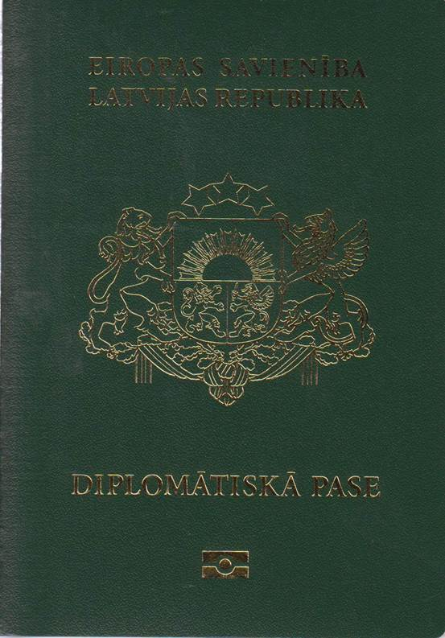

Picture 1

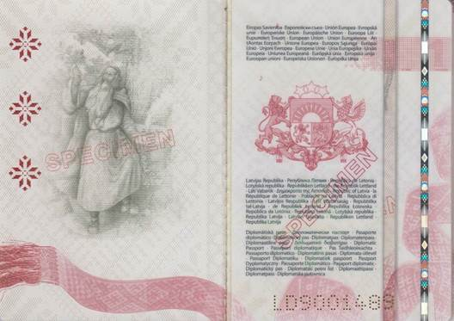

Pictures 2. a and 2. b

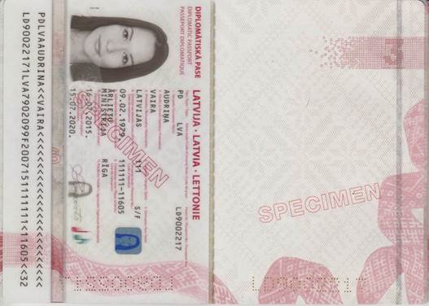

Pictures 3. a and 3. b

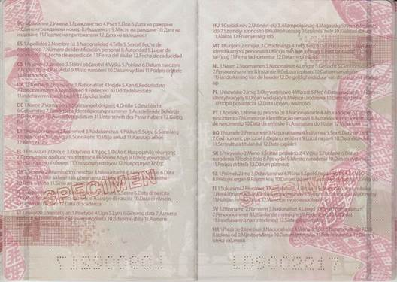

Pictures 4. a and 4. b

Pictures 5. a and 5. b

Pictures 6. a and 6. b

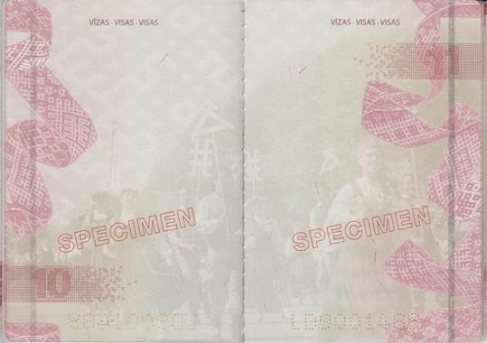

Pictures 7. a and 7. b

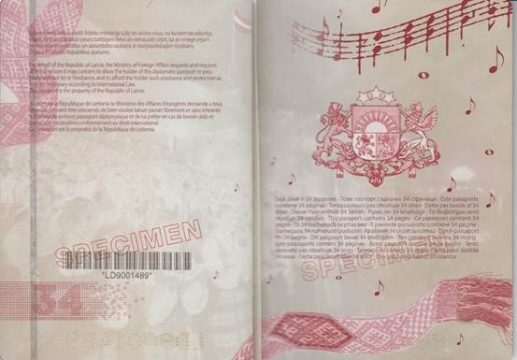

Pictures 8. a and 8. b

Annex 2
Cabinet Regulation No. 85
30 January 2007

Individual Registration Card for a Diplomatic Passport of the Republic of Latvia

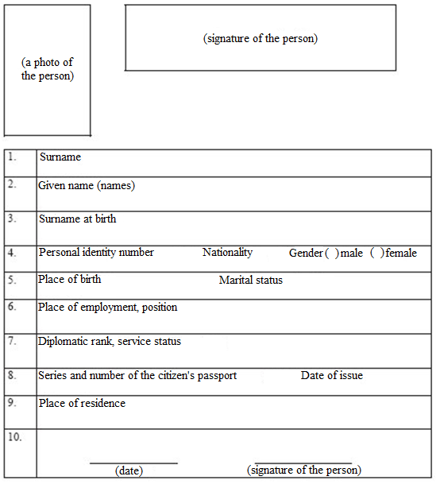

Minister for Foreign Affairs A. Pabriks

Annex 3
Cabinet Regulation No. 85
30 January 2007

Indications Regarding Photograph for Preparation of a Diplomatic Passport
[20 November 2007]

In order to ensure a qualitative preparation of a diplomatic passport, a photograph shall meet the following requirements:
1. Quality of the photograph:
1.1. a smooth, bright or semi-matt photographic paper of high quality shall be used;
1.2. the picture shall be clear;
1.3. the picture shall be of good resolution;
1.4. the picture shall be clear;
1.5. the picture shall be bright;
1.6. the picture shall be in natural colours.
2. A person has been photographed not earlier than three months before submission of documents for obtaining a diplomatic passport.
3. A photograph may not be used for manufacture of the previous diplomatic passport.
4. Specifications of a photograph:
4.1. the size of the photograph shall be from 1 to 3 mm bigger than 35x45mm;
4.2. the supposed line through the midpoints of the eyes shall be parallel with the horizontal side of the picture;
4.3. the picture of the face of the person from the chin line until the hair line (also the supposed hair line if the person does not have any hair) shall occupy 70-80 % from the height of the picture;
4.4. there are no smears on the photograph, it is without the white corner;
4.5. the seal of the photographer's studio shall be on the other side of the photograph, in which the date of taking the photograph shall be indicated;
4.6. the seal of the photographer's studio shall not be visible through the photograph;
4.7. the picture of the person shall be in the centre of the photograph;
4.8. the picture of the person may not be retouched.
5. Background:
5.1. light, homogeneous;
5.2. other persons or objects may not be in the background;
5.3. without shadows.
6. Appearance of the person in a photography:
6.1. position of the head - front view or tiny turn of the head;
6.2. the eyes shall be open, not covered by hair;
6.3. facial expression — natural, ordinary, a smile permissible;
6.4. look — neutral, directed at the camera;
6.5. shoulder line shall be visible, straight;
6.6. both sides of the face shall be illuminated equally and equally clearly visible;
6.7. hair shall not cover the both sides of the face;
6.8. photography lighting may not reflect on the face;
6.7. there shall be no shadow on the face.
7. Glasses, headgear, clothes:
7.1. eyes are seen clearly, they may not be covered by the frame of glasses;
7.2. the frame of glasses may not be heavy, thick;
7.3. the lenses of glasses may not have reflection of flash;
7.4. the lenses of glasses may not be tinted;
7.5. the glasses may not be slipped down on the nose;
7.6. the person shall be without any headgear, except the case if the person daily wears a headgear due to religious reasons and the headgear does not cover the face or a part thereof;
7.7. the person shall be in an everyday, businesslike, proper indoor attire;
7.8. the clothing of the person may not cover the face or a part thereof.
7.9. the colour of the clothing of the person shall differ from the background colour.

