Text consolidated by Valsts valodas centrs (State Language Centre) with amending laws of:

8 June 2006 [shall come into force on 11 July 2006].

If a whole or part of a section has been amended, the date of the amending law appears in square brackets at the end of the section. If a whole section, paragraph or clause has been deleted, the date of the deletion appears in square brackets beside the deleted section, paragraph or clause.

The *Saeima*1 has adopted and

the President has proclaimed the following law:

**Law on the Rīga Cathedral and Monastery Ensemble**

**Section 1. Purpose and Task of the Law**

(1) The purpose of this Law is to ensure the preservation and protection of the Rīga Cathedral and Monastery ensemble and the cultural and historical value thereof.

(2) The task of the Law is to determine the procedures for the maintenance, use, management, and financing of the Rīga Cathedral and Monastery ensemble and other matters related thereto, and also the legal affiliation of the Rīga Cathedral.

**Section 2. Cultural and Historical Value of the Rīga Cathedral and Monastery Ensemble**

(1) The Rīga Cathedral and Monastery ensemble with the art values contained therein is a part of the cultural and historical heritage of Latvia. The Rīga Cathedral and Monastery ensemble is a cultural monument of State significance which is included in the list of State protected cultural monuments with the State protection number 6537. The art monuments contained therein are included in the list of State protected cultural monuments with the State protection number 7077, 7079 – 7085, 7090, 7095, 7099, 7103 – 7148, 7150 – 7153, 7155 – 7165.

(2) The Rīga Cathedral and Monastery ensemble is a sacred site of national significance and is located in the historic centre of Rīga which is included in the World Heritage List of the United Nations Educational, Scientific and Cultural Organisation.

(3) The protection, maintenance, and use of the Rīga Cathedral and Monastery ensemble shall be governed by this Law, the law On Protection of Cultural Monuments, and other laws and regulations.

**Section 3. Rīga Cathedral and Monastery Ensemble and the Borders Thereof**

(1) The Rīga Cathedral and Monastery ensemble is formed by the immovable properties belonging to the State of Latvia and the Evangelical Lutheran Church of Latvia.

(2) The borders of the Rīga Cathedral and Monastery ensemble are specified in Annex 1 to this Law. The legal affiliation and address of the immovable properties forming the Rīga Cathedral and Monastery ensemble (except for the Rīga Cathedral and the land beneath it) are indicated in Annex 2 to this Law.

**Section 4. Legal Affiliation of the Rīga Cathedral**

(1) This Law restores the property rights of the Evangelical Lutheran Church of Latvia to the immovable property – the Rīga Cathedral and land in the area of 3883 square metres [until 1940 the location of the immovable property in Rīga, Dome Square (number not indicated), Jauniela 12, on 15 May Square (number not indicated), Group 7, No. 50, property rights corroborated to the Rīga Cathedral], and also land in Rīga in the area of 1647 square metres is transferred into ownership without compensation (until 1940 – parcels of land in Rīga, Jauniela 12, Group 7, No. 55, Jauniela 8, Group 7, No. 57, Jauniela 4, Group 7, No. 59, and part of Group 7, No. 200).

(2) The immovable properties referred to in Paragraph one of this Section shall be combined into one immovable property which shall be entered in the Land Register in the name of the Evangelical Lutheran Church of Latvia with the land cadastre number 01000070050, address: Rīga, Herdera Square 6,

the total area of 5530 square metres. The borders of immovable property (Rīga Cathedral and the land beneath it) are indicated in Annex 3 to this Law and may be updated following the measuring of the parcel of land in real life and the preparation of the land border plan.

(3) In corroborating the property rights to the immovable property referred to in Paragraph two of this Section, a notation shall be made in the Land Register that this immovable property is a cultural monument of State significance.

**Section 5. Functional Operation of the Rīga Cathedral and Monastery Ensemble**

(1) The religious activity in the objects of the Rīga Cathedral and Monastery ensemble belonging to the Evangelical Lutheran Church of Latvia shall be governed by the Law on Religious Organisations and other laws and regulations.

(2) In accordance with Section 8, Paragraphs one and two of this Law, the State of Latvia is given the right, with this Law, to use the Rīga Cathedral free of charge as the venue for religious services and events of official significance.

(3) The Rīga Cathedral shall be used as a place for the performance of concerts and an international cultural tourism object.

(4) The Rīga Cathedral may be used for other purposes, not referred to in this Law, agreeing thereon with the Evangelical Lutheran Church of Latvia, in conformity with the requirements of this Law and other laws and regulations.

**Section 6. Protection Zone of the Rīga Cathedral and Monastery Ensemble**

The protection zone of the Rīga Cathedral and Monastery ensemble shall be determined by the Cabinet in the regulations for the protection of the Rīga Cathedral and Monastery ensemble.

**Section 7. Protection of the Rīga Cathedral and Monastery Ensemble**

(1) Any activity which may result in the destruction or damage of the cultural and historical values contained in the Rīga Cathedral and Monastery ensemble are prohibited in the Rīga Cathedral and Monastery ensemble, and also in the protection zone thereof.

(2) The preservation, maintenance, conservation, and restoration of the Rīga Cathedral and Monastery ensemble (including the inventory, technical equipment) shall be carried out by the owners of the immovable properties forming this cultural monument. The preservation, maintenance, use, conservation, and restoration of the cultural monument shall take place in conformity with the regulations for the protection of the Rīga Cathedral and Monastery ensemble issued by the Cabinet.

(3) The Cabinet shall determine the regulations regarding the course of public events, economic activity, the placement of advertising in the protection zone of the Rīga Cathedral and Monastery ensemble. The following may be included in the Cabinet regulations:

1) the procedures for the maintenance of the buildings and structures in the protection zone of the Rīga Cathedral and Monastery ensemble;

2) the regulations regarding construction in the protection zone of the Rīga Cathedral and Monastery ensemble;

3) the restrictions in relation to trade in alcoholic beverages, other goods intended for entertainment, and advertising of such goods, the installation, advertising, operation of various types of entertainment sites;

4) the measures to be taken in order to ensure public order in the protection zone of the Rīga Cathedral and Monastery ensemble.

**Section 8. Financing of the Maintenance, Research, Conservation, Restoration, and Renovation of the Rīga Cathedral and Monastery Ensemble**

(1) The expenditures necessary for the maintenance of the Rīga Cathedral shall be financed by the Evangelical Lutheran Church of Latvia and the State of Latvia in equal parts.

(2) The State of Latvia shall participate in the financing of the research, conservation, restoration, and renovation of the Rīga Cathedral and Monastery ensemble in the amount of financial resources intended for these purposes in the annual State Budget Law.

(3) Local governments may participate in the maintenance of the Rīga Cathedral and Monastery ensemble, and also in the financing of the research, conservation, and restoration thereof.

[*8 June 2006*]

**Section 9. Administrative Body of the Immovable Properties Belonging to the Evangelical Lutheran Church of Latvia**

(1) The Evangelical Lutheran Church of Latvia shall establish a separate administrative body for the management of the part of the Rīga Cathedral and Monastery ensemble belonging to the Evangelical Lutheran Church of Latvia, the cultural values contained therein, and the financial resources of the Rīga Cathedral (hereinafter – the administrative body of the Rīga Cathedral).

(2) The procedures for the establishment of the administrative body of the Rīga Cathedral and the operation thereof shall be governed by the Evangelical Lutheran Church of Latvia.

(3) The administrative body of the Rīga Cathedral shall provide a report to the Rīga Cathedral Council on the use of the State budget resources specified in Section 8 of this Law according to the intended purpose.

**Section 10. Rīga Cathedral Council**

(1) In order to supervise the course of the research, restoration, and renovation of the Rīga Cathedral and Monastery ensemble and the use of the allocated State budget funding, the Rīga Cathedral Council is established the by-laws of which shall be approved by the Cabinet.

(2) The composition of the Rīga Cathedral Council shall include seven members – two representatives of the Evangelical Lutheran Church of Latvia (one of them a representative of the administrative body of the Rīga Cathedral), one representative each from the Ministry of Economics, the Ministry of Finance, the Ministry of Justice, and Rīga City Council.

(3) The following shall be within the competence of the Rīga Cathedral Council:

1) to assess the programme of research, restoration, and renovation of the Rīga Cathedral and Monastery ensemble developed by the owners of the ensemble;

2) to assess the annual estimate of expenditures necessary for the maintenance of the Rīga Cathedral;

3) to prepare proposals for the Ministry of Culture and the Ministry of Finance for the amount of State financing for the current year;

4) to assess the reports on the course of the research, restoration, and renovation of the Rīga Cathedral and Monastery ensemble and on the use of the State budget resources and to submit opinions thereon to the Ministry of Culture and the Ministry of Finance;

5) to invite experts.

(4) The financial resources provided for in Section 8, Paragraphs one and two of this Law for the maintenance, research, conservation, restoration, and renovation of the Rīga Cathedral and Monastery ensemble shall not be used on the remuneration of the Cathedral Council.

[*8 June 2006*]

**Section 11. Transactions with the Rīga Cathedral and Monastery Ensemble**

(1) In order to preserve the Rīga Cathedral and Monastery ensemble as a complex cultural monument, the owner of the immovable properties forming it (the State of Latvia or the Evangelical Lutheran Church of Latvia) have the right of first refusal for any of the immovable properties forming this cultural monument, if any of them are alienated. If the owner does not exercise the right of first refusal, this shall transfer to the local government of the City of Rīga. In exercising the right of first refusal, the provisions of the Civil Law regarding the right of first refusal granted to joint owners are applied.

(2) It is prohibited to transfer the immovable property forming the Rīga Cathedral and Monastery ensemble to another person without remuneration or through exchange, except for the cases where the immovable property is transferred to the other owner of the immovable property forming the cultural monument, and also it is prohibited to pledge or otherwise encumber with the property rights.

**Transitional Provisions**

1. Within three months after coming into force of this Law, the Museum of the History of Riga and Navigation shall hand over and the Evangelical Lutheran Church of Rīga shall take into ownership the immovable property referred to in Section 4 of this Law, drawing up a deed of transfer and acceptance thereof.

2. In relation to the immovable properties forming the Rīga Cathedral and Monastery ensemble for which a notation has not been made in the Land Register that they are cultural monuments, the State Inspection for Heritage Protection shall, within one month of the coming into force of this Law, submit requests for corroboration to the Land Register Office of the City of Rīga for making a relevant notation.

3. Technical and technological equipment which is joint for the immovable property in the possession of the Rīga Cathedral and the Ministry of Culture is maintained and operated based on a written agreement of the Evangelical Lutheran Church of Latvia and the Museum of the History of Riga and Navigation which shall be entered into within one month after coming into force of this Law and in which the proportionate part of each shall be specified.

4. Within three months after coming into force of this Law, the Cabinet shall approve the by-laws and composition of the Rīga Cathedral Council.

5. Within four months after coming into force of this Law, the Cabinet shall issue the regulations provided for in this Law.

The Law has been adopted by the *Saeima* on 9 June 2005.

President V. Vīķe-Freiberga

Rīga, 22 June 2005

Law on the Rīga Cathedral and Monastery Ensemble

**Annex 1**

**Territorial Border of the Rīga Cathedral and Monastery Ensemble**

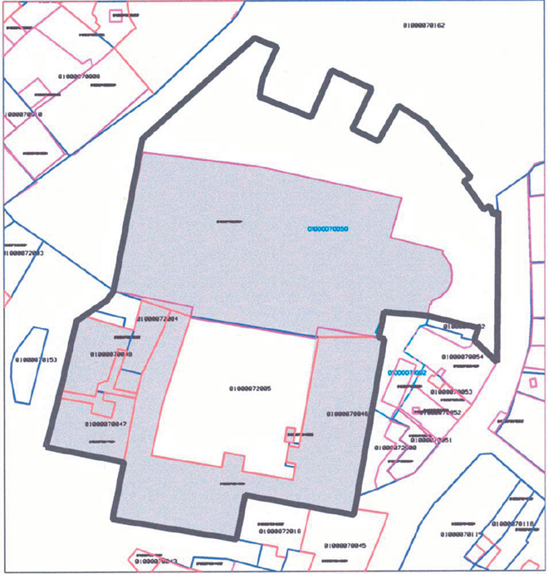

Law on the Rīga Cathedral and Monastery Ensemble

**Annex 2**

**Legal Affiliation and Address of the Immovable Properties Forming the Rīga Cathedral and Monastery Ensemble (Except for the Immovable Property – the Rīga Cathedral and the Land Beneath it):**

[*8 June 2006*]

1) immovable property in Rīga, Herdera laukums 2, cadastre number 01000072004, owner – the Evangelical Lutheran Church of Latvia;

2) immovable property in Rīga, Herdera laukums, cadastre number 01000072005, owner – the Evangelical Lutheran Church of Latvia;

3) immovable property in Rīga, Palasta iela 4, cadastre number 01000070046, owners – the State of Latvia in the person of the Ministry of Finance of the Republic of Latvia and the Evangelical Lutheran Church of Latvia;

4) immovable property in Rīga, Palasta iela 2, cadastre number 01000070047, owner – the State of Latvia in the person of the Ministry of Finance of the Republic of Latvia;

5) immovable property in Rīga, Herdera laukums 4, cadastre number 01000070048, owner – the State of Latvia in the person of the Ministry of Finance of the Republic of Latvia.

Law on the Rīga Cathedral and Monastery Ensemble

**Annex 3**

**Borders of the Immovable Property – the Rīga Cathedral and the Land Beneath it**

