Text consolidated by Valsts valodas centrs (State Language Centre) with amending laws of:
30 April 2009 [shall come into force on 3 June 2009];
16 December 2010 [shall come into force on 1 January 2011].
If a whole or part of a section has been amended, the date of the amending law appears in square brackets at the end of the section. If a whole section, paragraph or clause has been deleted, the date of the deletion appears in square brackets beside the deleted section, paragraph or clause.

The Saeima ¹ has adopted and
the President has proclaimed the following law:

Moricsala Strict Nature Reserve Law

Section 1.

The Moricsala Strict Nature Reserve (hereinafter – the Reserve) is a specially protected nature territory of State significance.

Section 2.

The Reserve has been established for the purpose of preserving of historically formed natural ecosystems in an untouched state and studying the processes occurring therein, and also for ensuring the protection of endangered and rare plants, fungi, lichens, and animals.

Section 3.

The total area of the Reserve is 818 hectares (bay of Luziķērte with the aquatorium – 702 hectares, Moricsala island – 83 hectares, and the island Lielā Alkšņu Sala – 33 hectares) and its borders have been determined in accordance with the Moricsala Strict Nature Reserve plan (Annex 1) and the description of borders of the Moricsala Strict Nature Reserve (Annex 2).

Section 4.

(1) In order to ensure the protection of natural ecosystems and sustainable use of natural resources, the territory of the Reserve shall be divided into the following functional zones (Annexes 1 and 2):
1) the strict regime zone;
2) the regulatory regime zone.
(2) The territory protection measures are taken in accordance with the nature protection plan and individual protection and use regulations of the Reserve.
(3) It is prohibited within the territory of the Reserve to:
1) stay without an authorisation issued by the administration of the Reserve;
2) use any chemical plant protection products;
3) carry out forest management.

Section 5.

The administration of the Reserve shall be implemented by the Nature Conservation Agency (hereinafter – the Agency) that is an institution of direct administration subordinate to the Minister for Environmental Protection and Regional Development.
[30 April 2009; 16 December 2010]

Section 6.

The nature protection interests and economic activity at the Moricsala Strict Nature Reserve shall be harmonised by the Advisory Council of Slītere National Park.

Transitional Provisions

1. With the coming into force of this Law, Cabinet Regulation No. 422, Regulations Regarding the Moricsala Strict Nature Reserve (Latvijas Republikas Saeimas un Ministru Kabineta Ziņotājs, 2000, No. 2), issued in accordance with Section 81 of the Constitution is repealed.

2. Amendment to Annex 2 to this Law regarding the replacement of the word “district” with the word “municipality” shall come into force on 1 July 2009.
[30 April 2009]

3. The administration of the Reserve shall be implemented by the administration of Slītere National Park until 1 June 2009.
[30 April 2009]

The Law has been adopted by the Saeima on 16 March 2000.

President V. Vīķe-Freiberga

Rīga, 5 April 2000

Moricsala Strict Nature Reserve Law
Annex 1

Moricsala Strict Nature Reserve Plan

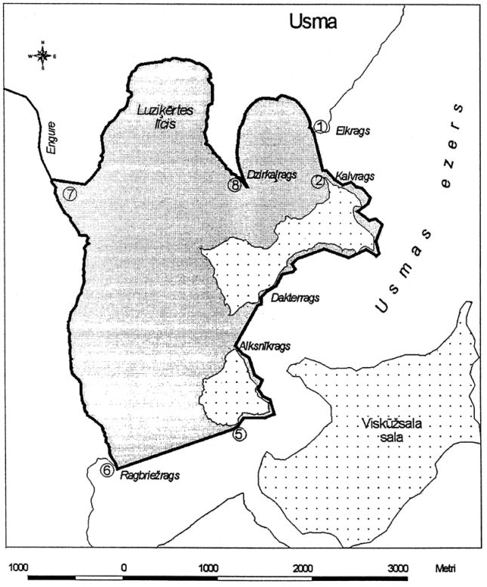

Moricsala Strict Nature Reserve Law
Annex 2

Description of Borders of the Moricsala Strict Nature Reserve

Ventspils municipality

Usma rural territory

I. Strict regime zone

1. The strict regime functional zone includes the entire island Moricsala and island Lielā Alkšņu Sala.

II. Regulatory regime zone

2. The regulatory regime functional zone includes the following parts of Lake Usma aquatorium:

from 1 to 2 - | from the southernmost point of Elkrags on the shore of Lake Usma directly to Kalvrags to Moricsala shoal line;
from 2 to 3 - | from Kalvrags along Moricsala east shore shoal line to Dakterrags;
from 3 to 4 - | from Moricsala shoal line against Dakterrags directly to Alksnītrags to the shoal line of the island Lielā Alkšņu Sala;
from 4 to 5 - | along the eastern shore of the island Lielā Alkšņu Sala shoal line to the southernmost point of the shoal line of the island Lielā Alkšņu Sala;
from 5 to 6 - | from the southernmost point of the shoal line of the island Lielā Alkšņu Sala directly south-west to the southernmost point of Ragbriežrags on the shore of Lake Usma;
from 6 to 7 - | from the southernmost point of Ragbriežrags on the shore of Lake Usma to the north along the shore of Lake Usma to the source of the River Engure;
from 7 to 8 - | from the source of the River Engure along the shore of Lake Usma to the southernmost point of Dzirkaļrags;
from 8 to 1 - | from the southernmost point of Dzirkaļrags along the shore of Lake Usma to the starting point at Elkrags.

3. The border of the Reserve at the shore of Lake Usma corresponds to the perennial mean water level in the lake.

