Text consolidated by Valsts valodas centrs (State Language Centre) with amending regulations of:
27 August 2019 [shall come into force on 30 August 2019].
If a whole or part of a paragraph has been amended, the date of the amending regulation appears in square brackets at the end of the paragraph. If a whole paragraph or sub-paragraph has been deleted, the date of the deletion appears in square brackets beside the deleted paragraph or sub-paragraph.

Republic of Latvia

Cabinet
Regulation No. 664
Adopted 28 October 2014

Procedures for the Protection of the Specially Protected Cultural Monument – Turaida Museum Reserve

Issued pursuant to
Section 16 of the law On Protection of Cultural Monuments

1. The Regulation prescribes the procedures by which the protection of the specially protected cultural monument – Turaida Museum Reserve (hereinafter – the Museum Reserve) – is ensured and also the borders of the territory of the Museum Reserve.

2. The Museum Reserve is a complex and ensemble of specially protected cultural monuments with a special historical, scientific, and cultural value, it is a component of the national wealth of the Republic of Latvia and is under special State protection. Cultural monuments are located in the historical environment – the site where they had occurred.

3. The purpose for the establishment of the Museum Reserve in national and international sense is to preserve one of the most ancient national formations of Latvia – the historical centre of Turaida – for future generations, comprising the preservation and popularisation of the research of the county cultural heritage, national crafts and traditions.

4. The purpose for the establishment of the Museum Reserve shall be implemented by the authority of State direct administration Specially Protected Cultural Monument – Turaida Museum Reserve.

5. The Museum Reserve encompasses the natural and cultural monuments of Turaida historical centre of the 11th–20th century which form four complex objects:
5.1. Turaida hillfort with the foundation of a wooden castle of the Livonians and Turaida stone castle with a castle-front area;
5.2. Turaida Church Hill with a cemetery and an ancient site for building churches, the grave of Rose of Turaida, Turaida church, and the State protected nature object – linden;
5.3. the centre of household buildings of Turaida manor and the pond system;
5.4. the ancient settlement site of the Livonians of Gauja with the Folk Song Park.

6. The borders of the territory of the Museum Reserve are specified in accordance with Annexes 1 and 2 to this Regulation.

7. Any such activities are prohibited in the territory of the Museum Reserve which may destroy or endanger the cultural monuments, cultural and historical values of the Museum Reserve and alter the environment which serves for the purposes of the cultural heritage preservation.

8. The viewpoints available to the public and of landscape significance shall be preserved and protected in the territory of the Museum Reserve. Covering of views towards historical buildings from the street or road and the viewpoints available to the public shall not be permitted.

9. The characteristic roads and the historical or analogous materials of roads shall be preserved and renewed in the territory of the Museum Reserve. Construction of new buildings shall not be permitted in the territory of the Museum Reserve. Reconstructive renewal of previously lost buildings on historical foundations and renewal of other objects shall be permitted in the territory of the Museum Reserve.

10. The research, conservation, restoration, and repair works in the territory of the Museum Reserve shall be carried out in accordance with the procedures laid down in the law On Protection of Cultural Monuments. In taking the decisions specified in the law On Protection of Cultural Monuments, the National Heritage Board shall coordinate them with the authority of State direct administration Specially Protected Cultural Monument – Turaida Museum Reserve.
[27 August 2019]

11. Cabinet Regulation No. 61 of 1 March 1994, On the Specially Protected Cultural Monument – Turaida Museum Reserve (Latvijas Vēstnesis, 1994, No. 36), is repealed.

Acting for the Prime Minister, Minister for Transport Anrijs Matīss

Minister for Culture Dace Melbārde

Annex 1
Cabinet Regulation No. 664
28 October 2014

Border of the Specially Protected Cultural Monument – Turaida Museum Reserve

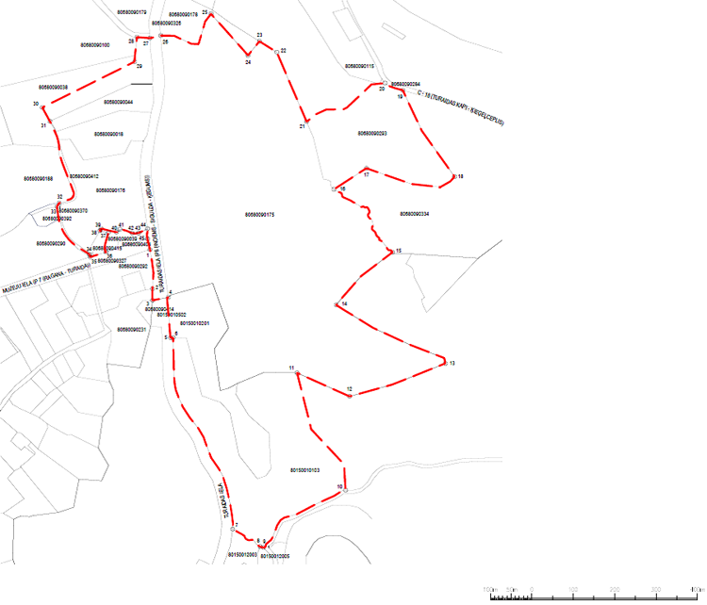
Scale 1:5000

Designations | Name
 | Border of the unit of land
80680090179 | Cadastre designation of the unit of land
 | Border of the Turaida Museum Reserve (as amended)
°¹ | Turning point of the border of the Turaida Museum Reserve (as amended)

Minister for Culture Dace Melbārde

Annex 2
Cabinet Regulation No. 664
28 October 2014

Borders of the Protective Zone

No. | x coordinate | y coordinate
1. | 338,475.57 | 551,164.83
2. | 338,380.34 | 551,170.85
3. | 338,352.57 | 551,170.87
4. | 338,359.44 | 551,209.03
5. | 338,261.64 | 551,214.39
6. | 338,261.45 | 551,220.65
7. | 337,797.33 | 551,364.74
8. | 337,754.81 | 551,431.26
9. | 337,752.78 | 551,438.98
10. | 337,891.74 | 551,637.45
11. | 338,176.37 | 551,520.56
12. | 338,119.40 | 551,647.21
13. | 338,199.31 | 551,878.29
14. | 338,341.18 | 551,615.15
15. | 338,469.16 | 551,751.11
16. | 338,621.34 | 551,609.22
17. | 338,672.92 | 551,687.89
18. | 338,652.27 | 551,900.95
19. | 338,862.05 | 551,775.68
20. | 338,879.42 | 551,732.61
21. | 338,786.05 | 551,543.55
22. | 338,954.24 | 551,471.75
23. | 338,980.81 | 551,429.46
24. | 338,946.95 | 551,402.06
25. | 339,047.42 | 551,312.38
26. | 338,994.64 | 551,190.56
27. | 338,988.50 | 551,164.69
28. | 338,990.85 | 551,133.47
29. | 338,931.23 | 551,127.62
30. | 338,820.18 | 550,904.97
31. | 338,787.08 | 550,923.04
32. | 338588.60 | 550945.53
33. | 338579.56 | 550939.94
34. | 338463.49 | 551019.08
35. | 338457.60 | 551020.34
36. | 338469.38 | 551058.54
37. | 338516.06 | 551064.17
38. | 338521.04 | 551043.78
39. | 338526.38 | 551046.86
40. | 338517.99 | 551083.94
41. | 338525.01 | 551092.33
42. | 338515.53 | 551121.69
43. | 338516.09 | 551137.61
44. | 338525.73 | 551159.06
45. | 338501.61 | 551158.54

Minister for Culture Dace Melbārde

