Republic of Latvia

Cabinet
Regulation No. 674
Adopted 27 July 2010

Regulations Regarding the State Border Zone, the Borderland and the Border Area, as well as Samples of Indication Signs and Information Signs of the Border Area, the Borderland and the State Border Zone and the Procedure for Installation Thereof

Issued pursuant to
Section 13, Paragraph one, Section 15, Paragraph one
Section 19, Paragraph one and Section 21 of the
State Border Law of the Republic of Latvia

I. General Provision

1. These Regulations prescribe the State border zone, the borderland of the external land border and the border area of the Republic of Latvia, as well as samples of indication signs and information signs of the state border zone, the borderland and the border area and the procedure for installation.

II. Territories of the State Border Zone, Borderland and
Border Area of the Republic of Latvia

2. The width of the State border zone of the Republic of Latvia is:
2.1. 12 metres with the Republic of Byelorussia;
2.2. 12 metres with the Russian Federation;
2.3. 6 metres with the Republic of Estonia; and
2.4. 5 metres with the Republic of Lithuania.

3. The borderland is determined in the following administrative territories and territorial units of the border area along the external land border of the Republic of Latvia:
3.1. in the municipality of Alūksne:
3.1.1. in the rural territory of Liepna;
3.1.2. in the rural territory of Pededze;
3.2. in the municipality of Baltinava;
3.3. in the municipality of Cibla:
3.3.1. in the rural territory of Blonti;
3.3.2. in the rural territory of Līdumnieki;
3.4. in the municipality of Dagda:
3.4.1. in the rural territory of Bērziņi;
3.4.2. in the rural territory of Ķepova;
3.4.3. in the rural territory of Šķaune;
3.5. in the municipality of Daugavpils:
3.5.1. in the rural territory of Demene;
3.5.2. in the rural territory of Saliena;
3.5.3. in the rural territory of Skrudaliena;
3.6. in the municipality of Kārsava:
3.6.1. in the rural territory of Goliševa;
3.6.2. in the rural territory of Malnava;
3.6.3. in the rural territory of Salnava;
3.7. in the municipality of Krāslava:
3.7.1. in the rural territory of Indra;
3.7.2. in the rural territory of Kaplava;
3.7.3. in the rural territory of Piedruja;
3.7.4. in the rural territory of Robežnieki;
3.8. in the municipality of Ludza, in the rural territory of Briģi;
3.9. in the municipality of Viļaka:
3.9.1. in the rural territory of Medņeva;
3.9.2. in the rural territory of Šķilbēni;
3.9.3. in the rural territory of Vecumi;
3.9.4. in the rural territory of Žīguri;
3.10. in the municipality of Zilupe:
3.10.1. in the rural territory of Pasiene; and
3.10.2. in the rural territory of Zaļesje.

4. The border area is determined in the following administrative territories and territorial units of the border area along the State land border of the Republic of Latvia:
4.1. in the municipality of Aknīste:
4.1.1. in the town of Aknīste;
4.1.2. in the rural territory of Aknīste;
4.1.3. in the rural territory of Gārsene;
4.2. in the municipality of Aglona:
4.2.1. in the rural territory of Grāveri;
4.2.2. in the rural territory of Šķeltova;
4.3. in the municipality of Aloja:
4.3.1. in the town of Staicele;
4.3.2. in the rural territory of Staicele;
4.4. in the municipality of Ape:
4.4.1. in the town of Ape;
4.4.2. in the rural territory of Ape;
4.4.3. in the rural territory of Gaujiena;
4.4.4. in the rural territory of Trapene;
4.5. in the municipality of Alūksne:
4.5.1. in the town of Alūksne;
4.5.2. in the rural territory of Anna;
4.5.3. in the rural territory of Alsviķi;
4.5.4. in the rural territory of Jaunanna;
4.5.5. in the rural territory of Jaunlaicene;
4.5.6. in the rural territory of Jaunalūksne;
4.5.7. in the rural territory of Liepna;
4.5.8. in the rural territory of Mārkalne;
4.5.9. in the rural territory of Maliena;
4.5.10. in the rural territory of Mālupe;
4.5.11. in the rural territory of Pededze;
4.5.12. in the rural territory of Veclaicene;
4.5.13. in the rural territory of Ziemera;
4.6. in the municipality of Auce:
4.6.1. in the town of Auce;
4.6.2. in the rural territory of Bēne;
4.6.3. in the rural territory of Ukri;
4.6.4. in the rural territory of Vītiņi;
4.6.5. in the rural territory of Vecauce;
4.7. in the municipality of Balvi:
4.7.1. in the town of Balvi;
4.7.2. in the rural territory of Balvi;
4.7.3. in the rural territory of Briežuciems;
4.7.4. in the rural territory of Bērzpils;
4.7.5. in the rural territory of Bērzkalne;
4.7.6. in the rural territory of Krišjāņi;
4.7.7. in the rural territory of Kubuļi;
4.7.8. in the rural territory of Lazduleja;
4.7.9. in the rural territory of Tilža;
4.7.10. in the rural territory of Vectilža;
4.7.11. in the rural territory of Vīksna;
4.8. in the municipality of Baltinava;
4.9. in the municipality of Bauska:
4.9.1. in the rural territory of Brunava;
4.9.2. in the rural territory of Ceraukste;
4.9.3. in the rural territory of Gailīši;
4.9.4. in the rural territory of Īslīce;
4.10. in the municipality of Cibla:
4.10.1. in the rural territory of Blonti;
4.10.2. in the rural territory of Cibla;
4.10.3. in the rural territory of Līdumnieki;
4.10.4. in the rural territory of Pušmucova;
4.10.5. in the rural territory of Zvirgzdene;
4.11. in the municipality of Daugavpils:
4.11.1. in the rural territory of Ambeļi;
4.11.2. in the rural territory of Biķernieki;
4.11.3. in the rural territory of Demene;
4.11.4. in the rural territory of Kalkūne;
4.11.5. in the rural territory of Laucesa;
4.11.6. in the rural territory of Medumi;
4.11.7. in the rural territory of Maļinova;
4.11.8. in the rural territory of Naujene;
4.11.9. in the rural territory of Saliena;
4.11.10. in the rural territory of Skrudaliena;
4.11.11. in the rural territory of Svente;
4.11.12. in the rural territory of Tabore;
4.11.13. in the rural territory of Višķi;
4.11.14. in the rural territory of Vecsaliena;
4.12. in the municipality of Dagda:
4.12.1. in the rural territory of Asūne;
4.12.2. in the rural territory of Andrupene;
4.12.3. in the rural territory of Andzeļi;
4.12.4. in the rural territory of Bērziņi;
4.12.5. in the town of Dagda;
4.12.6. in the rural territory of Dagda;
4.12.7. in the rural territory of Ezernieki;
4.12.8. in the rural territory of Ķepova;
4.12.9. in the rural territory of Konstantinova;
4.12.10. in the rural territory of Svariņi;
4.12.11. in the rural territory of Šķaune;
4.13. in the municipality of Grobiņa, in the rural territory of Bārta;
4.14. in the municipality of Ilūkste:
4.14.1. in the rural territory of Bebrene;
4.14.2. in the rural territory of Eglaine;
4.14.3. in the town of Ilūkste;
4.14.4. in the rural territory of Pilskalne;
4.14.5. in the rural territory of Prode;
4.14.6. in the town of Subate;
4.14.7. in the rural territory of Šēdere;
4.15. in the municipality of Jelgava:
4.15.1. in the rural territory of Eleja;
4.15.2. in the rural territory of Lielplatone;
4.15.3. in the rural territory of Sesava;
4.15.4. in the rural territory of Vilce;
4.16. in the municipality of Kārsava:
4.16.1. in the rural territory of Goliševa;
4.16.2. in the town of Kārsava;
4.16.3. in the rural territory of Malnava;
4.16.4. in the rural territory of Mežvidi;
4.16.5. in the rural territory of Mērdzene;
4.16.6.in the rural territory of Salnava;
4.17. in the municipality of Krāslava:
4.17.1. in the rural territory of Auleja;
4.17.2. in the rural territory of Indra;
4.17.3. in the rural territory of Izvalta;
4.17.4. in the town of Krāslava;
4.17.5. in the rural territory of Krāslava;
4.17.6. in the rural territory of Kalnieši;
4.17.7. in the rural territory of Kaplava;
4.17.8. in the rural territory of Piedruja;
4.17.9. in the rural territory of Kombuļi;
4.17.10. in the rural territory of Skaista;
4.17.11. in the rural territory of Ūdrīši;
4.17.12. in the rural territory of Robežnieki;
4.18. in the municipality of Ludza:
4.18.1. in the rural territory of Briģi;
4.18.2. in the rural territory of Cirma;
4.18.3. in the rural territory of Isnauda;
4.18.4. in the rural territory of Istra;
4.18.5. in the town of Ludza;
4.18.6. in the rural territory of Nirza;
4.18.7. in the rural territory of Ņukši;
4.18.8. in the rural territory of Pilda;
4.18.9. in the rural territory of Pureņi;
4.18.10. in the rural territory of Rundēni;
4.19. in the municipality of Priekule:
4.19.1. in the rural territory of Gramzda;
4.19.2. in the rural territory of Kalēti;
4.19.3. in the town of Priekule;
4.19.4. in the rural territory of Priekule;
4.19.5. in the rural territory of Virga;
4.20. in the municipality of Nereta:
4.20.1. in the rural territory of Mazzalve;
4.20.2. in the rural territory of Nereta;
4.20.3. in the rural territory of Pilskalne;
4.20.4. in the rural territory of Zalve;
4.21. in the municipality of Naukšēni:
4.21.1. in the rural territory of Naukšēni;
4.21.2. in the rural territory of Ķoņi;
4.22. in the municipality of Mazsalaca, in the rural territory of Ramata;
4.23. in the municipality of Rēzekne:
4.23.1. in the rural territory of Bērzgale;
4.23.2. in the rural territory of Dricāni;
4.23.3. in the rural territory of Gaigalava;
4.23.4. in the rural territory of Ilzeskalns;
4.23.5. in the rural territory of Lendži;
4.23.6. in the rural territory of Nautrēni;
4.23.7. in the rural territory of Stružāni;
4.24. in the municipality of Rugāji:
4.24.1. in the rural territory of Lazdukalns;
4.24.2. in the rural territory of Rugāji;
4.25. in the municipality of Rundāle:
4.25.1. in the rural territory of Rundāle;
4.25.2. in the rural territory of Svitene;
4.26. in the municipality of Rucava:
4.26.1. in the rural territory of Dunika;
4.26.2. in the rural territory of Rucava;
4.27. in the municipality of Rūjiena:
4.27.1. in the rural territory of Ipiķi;
4.27.2. in the rural territory of Lode;
4.27.3. in the town of Rūjiena;
4.27.4. in the rural territory of Vilpulka;
4.28. in the municipality of Saldus:
4.28.1. in the rural territory of Ezere;
4.28.2. in the rural territory of Jaunauce;
4.28.3. in the rural territory of Kursīši;
4.28.4. in the rural territory of Nīgrande;
4.28.5. in the rural territory of Pampāļi;
4.28.6. in the rural territory of Ruba;
4.28.7. in the rural territory of Vadakste;
4.28.8. in the rural territory of Zaņa;
4.29. in the municipality of Salacgrīva:
4.29.1. in the town of Ainaži;
4.29.2. in the rural territory of Ainaži;
4.30. in the municipality of Tērvete:
4.30.1. in the rural territory of Augstkalne;
4.30.2. in the rural territory of Bukaiši;
4.31. in the municipality of Vaiņode:
4.31.1. in the rural territory of Embūte;
4.31.2. in the rural territory of Vaiņode;
4.32. in the municipality of Valka:
4.32.1. in the rural territory of Ērģeme;
4.32.2. in the rural territory of Kārķi;
4.32.3. in the town of Valka;
4.32.4. in the rural territory of Valka;
4.32.5. in the rural territory of Zvārtava;
4.33. in the municipality of Vecumnieki:
4.33.1. in the rural territory of Kurmene;
4.33.2. in the rural territory of Skaistkalne;
4.34. in the municipality of Viesīte:
4.34.1. in the rural territory of Elkšņi;
4.34.2. in the rural territory of Rite;
4.35. in the municipality of Viļaka:
4.35.1. in the rural territory of Medņeva;
4.35.2. in the rural territory of Kuprava;
4.35.3. in the rural territory of Susāji;
4.35.4. in the rural territory of Šķilbēni;
4.35.5. in the town of Viļaka;
4.35.6. in the rural territory of Vecumi;
4.35.7. in the rural territory of Žīguri;
4.36. in the municipality of Zilupe:
4.36.1. in the rural territory of Lauderi;
4.36.2. in the rural territory of Pasiene;
4.36.3. in the town of Zilupe;
4.36.4. in the rural territory of Zaļesje.

III. Samples of the Indication Signs of the State Border Zone, the Borderland and
Border Area of the Republic of Latvia and the Procedure for Installation thereof

5. The beginning and the end of the border area shall be indicated with appropriate road signs on roads in accordance with the regulatory enactments regulating the field of road traffic.

6. The beginning and the end of the borderland shall be indicated:
6.1. on roads - in accordance with the regulatory enactments regulating the field of road traffic; and
6.2. in the locality - with information signs "Borderland!" (Annex 1).

7. The borderland shall be indicated in the locality, taking into account the location of the populated areas, sites for public events, roads and sites of active commercial activities in the immediate vicinity of the State border, as well as observing the administrative-territorial division.

8. Information signs which mark the borderland shall be installed by the State Border Guard taking into account the peculiarities of the locality, the relief, the network of roads, firebreaks and paths, natural and man-made landmarks or constructions in such a way they would ensure unmistakable visual identification of the borderland in the locality.

9. The State border zone of the Republic of Latvia shall be marked with the following information signs (Annex 2):
9.1. a tape “STOP! State border”;
9.2. a plate “STOP! State border”;
9.3. a pole “STOP! State border”; and
9.4. a buoy “STOP! State border”.

10. The information signs of the State border zone shall be installed directly by the border zone in those places where the State land border is determined, or by the banks of rivers, streams and canals along which the State border is determined.

IV. Closing Provision

11. The following Regulations shall be repealed:
11.1. Cabinet Regulation No.503 of 29 December 1998 “On the Determination of the State Border Zone of the Republic of Latvia and the Russian Federation" (Latvijas Vēstnesis 1999, No.1; 2000, No. 435/437);
11.2. Cabinet Regulation No. 43 of 30 January 2001, “Regulations Regarding the Determination of the State Border Zone of the Republic of Latvia and the Republic of Byelorussia” (Latvijas Vēstnesis, 2001, No. 19); and
11.3. Cabinet Regulation No.499 of 4 November 2002 “Regulations Regarding Border Area Regime and Borderland Regime of the Republic of Latvia” (Latvijas Vēstnesis, 2002, No.162; 2003, No.5, 2009, No.71).

Acting for the Prime Minister –
Minister for Transport K.Gerhards

Minister for the Interior L. Mūrniece

Annex 1
Cabinet Regulation No. 674
27 July 2010

Information Signs “Borderland”

1. Tape with the inscription in Latvian "PIEROBEŽAS JOSLA AIZLIEGTS UZTURĒTIES BEZ PASES UN CAURLAIDES" (see Fig. 1) at the border of the Republic of Latvia with the Russian Federation and with the Republic of Byelorussia. The tape shall be yellow and 150mm wide. The inscription “PIEROBEŽAS JOSLA” shall be on the upper part of the tape in one line in black letters, the height of the letters shall be 30mm; the inscription “AIZLIEGTS UZTURĒTIES BEZ PASES UN CAURLAIDES” shall be on the lower part of the tape in two lines in red letters, the height of the letters shall be 18mm.
PIEROBEŽAS JOSLA
AIZLIEGTS UZTURĒTIES
BEZ PASES UN CAURLAIDES
Fig.1.

2. Tape with the inscription in Russian "ПРИГРАНИЧНАЯ ПОЛОСА БЕЗ ПАСПОРТА И ПРОПУСKА НАХОДИТЬСЯ
ЗАПРЕЩЕНО" (see Fig. 2) at the border of the Republic of Latvia with the Russian Federation and with the Republic of Byelorussia. The tape shall be yellow and 150mm wide. The inscription “ПРИГРАНИЧНАЯ ПОЛОСА” shall be on the upper part of the tape in one line in black letters, the height of the letters shall be 30mm; the inscription “БЕЗ ПАСПОРТА И ПРОПУСKА НАХОДИТЬСЯ ЗАПРЕЩЕНО” shall be on the lower part of the tape in two lines in red letters, the height of the letters shall be 18mm.
ПРИГРАНИЧНАЯ ПОЛОСА
БЕЗ ПАСПОРТА И ПРОПУСKА
НАХОДИТЬСЯ ЗАПРЕЩЕНО
Fig. 2.

3. Tape with the inscription in English "BORDERLAND FORBIDDEN TO STAY WITHOUT PASSPORT AND PERMIT" (see Fig. 3) at the border of the Republic of Latvia with the Russian Federation and with the Republic of Byelorussia. The tape shall be yellow and 150mm wide. The inscription “BORDERLAND” shall be on the upper part of the tape in one line in black letters, the height of the letters shall be 30mm; the inscription “FORBIDDEN TO STAY WITHOUT PASSPORT AND PERMIT”shall be on the lower part of the tape in two lines in red letters, the height of the letters shall be 18mm.
BORDERLAND
FORBIDDEN TO STAY WITHOUT
PASSPORT AND PERMIT
Fig. 3.

Minister for the Interior L. Mūrniece

Annex 2
Cabinet Regulation No. 674
27 July 2010

Information Signs “Stop! State border”

1. Tape with the inscription in Latvian, Russian and English "STĀT! Valsts robeža”, "СТОЙ! Государственная граница", "STOP! State” (Fig. 1) at the border of Latvia with Russia and with Byelorussia. The tape shall be yellow and 150mm wide. The inscription in Latvian and English shall be in two lines in black letters. The inscription in Russian shall be in three lines in black letters. The height of the letters of the upper text shall be 40 mm, the height of the first letter of the lower text - 18 mm and the height of the remaining letters - 13 mm. The distance between the inscriptions shall be 50 cm.
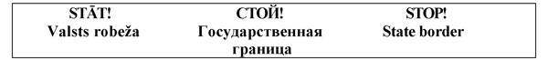
Fig. 1.

2. Plate with the inscription on both sides in Latvian, Russian and English “STĀT! Valsts robeža”, "СТОЙ! Государственная граница", "STOP! State border” (Fig. 2) at the border of Latvia with Russia and with Byelorussia. The plate shall be orange and 80 x 60 cm. A picture of a red hand shall be on the upper part of the plate and beneath the inscriptions in Latvian, Russian and English in black letters. The inscription in Latvian and English shall be in two lines. The inscription in Russian shall be in three lines. The height of the letters of the upper text shall be 70 mm, the height of the first letter of the lower text - 50 mm and the height of the remaining letters - 40 mm. The height of the picture of the hand shall be 150 mm. Three prohibition signs with a diameter of 9 cm each shall be shown on the lower part of the plate.
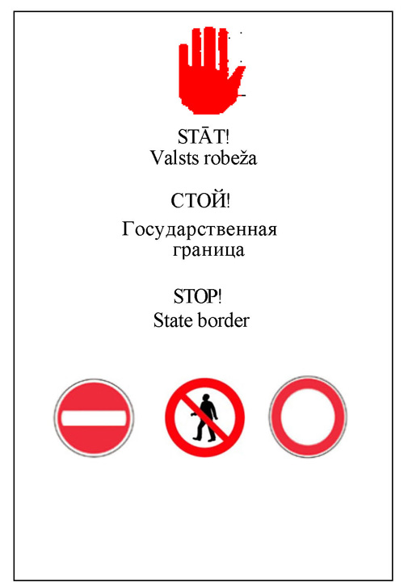
Fig. 2.

3. Pole (Fig. 3) at the border of Latvia with Russia and with Byelorussia. The pole shall be cylindrical (height – 200 cm, diameter 5-10 cm), triangular (200 x 5-10 cm) or square (200 x 5-10 cm), without any inscriptions. Two red bands - each 5 cm wide shall be on the surface of the pole, one band at a distance of 15 cm from the top of the pole and the other at a distance of 100 cm from the top of the pole.
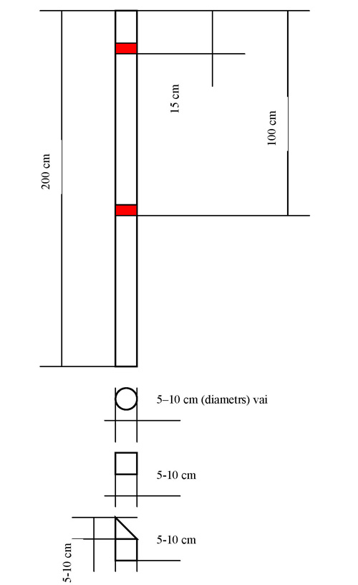
Fig. 3.

4. Buoy with the inscription in Latvian “STĀT! Valsts robeža” or in Russian "СТОЙ! Граница" (Fig. 4) at the border of Latvia with Russia and with Byelorussia. The buoy shall be yellow and cylindrically shaped. Two red bands – each 5 cm wide shall be on the surface of the buoy. One band shall be at a distance of 15 cm from the top of the buoy and the other at a distance of 130 cm from the top of the buoy. The inscription “10 m” or “10 ?” shall be above the upper red band. The vertical inscription in Latvian “STĀT! Valsts robeža ” or in Russian "СТОЙ! Граница" in black letters shall be placed between the red bands; the height of the large letters shall be 70 mm and the height of the small letters - 40 mm.
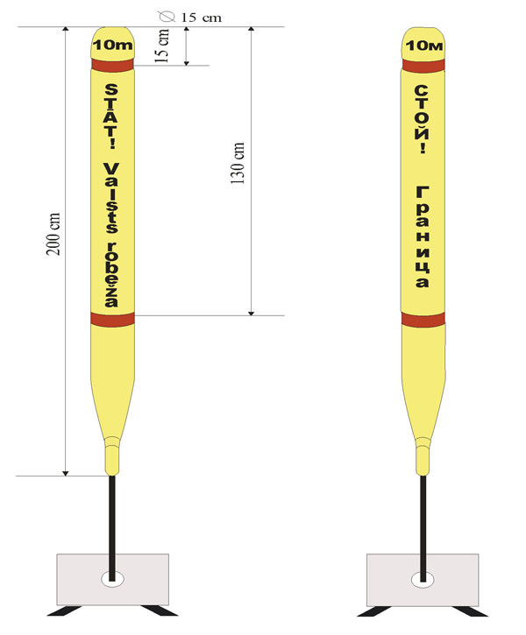
Fig. 4.

Minister for the Interior L. Mūrniece

