Guidelines for the Identification of Human Trafficking for the Purpose of Labour Exploitation

Guidelines for the Identification of Human Trafficking for the Purpose of Labour Exploitation (hereinafter – Guidelines) are intended for the law enforcement institutions – the State Police, the State Labour Inspectorate, the State Border Guard, the Municipal Police and non-governmental organisations, which have been granted the right to provide services for victims of human trafficking, to be able to determine, to full extent, the cases of human trafficking for the purpose of labour exploitation and the victims, as well as to perform accordingly the necessary measures for holding the persons at fault liable as provided for by regulatory enactments.
The State Police shall, upon having determined a potential case of labour exploitation, initiate criminal proceedings, or carry out departmental examination, if information regarding the potential criminal offence is not sufficient in order to conclude that criminal proceedings or record-keeping of the administrative violation is to be initiated. Where it is found out later that labour exploitation had not occurred but a violation of employment legal relations or labour protection norms has occurred, information shall be forwarded to the State Labour Inspectorate for adjudication in accordance with the administrative procedures.
The State Border Guard shall, upon having determined a potential case of labour exploitation when immediate action is required for recording of proof or detention of a person who has committed a crime, carry out emergency investigatory activities in compliance with the competence specified in regulatory enactments.
The Municipal Police shall, upon having determined a potential case of labour exploitation, act in compliance with the competence specified in regulatory enactments and inform the employees of the State Police respectively.
The State Labour Inspectorate shall, upon having determined a potential case of labour exploitation, in compliance with the competence specified in regulatory enactments, inform the employees of the State Police or carry out settlement of the employment legal relations in accordance with the administrative procedures (where it is determined later that labour exploitation has not occurred within the meaning of Section 154.² of the Criminal Law).
A non-governmental organisation, which has been granted the right to provide services for victims of human trafficking, upon having determined a potential case of labour exploitation, must inform the employees of the State Police respectively.
The Guidelines shall be of recommendatory nature, namely compliance of a person (a potential victim) to any of identifiers indicates only to a potential case of labour exploitation, but in no way gives any legal status to the victim or brings an accusation against a person who probably has committed an offence. Respectively, upon determining the compliance with any of the characteristics indicated in the Guidelines, the employee would have the basis only to carry out additional inspection, finding out the most important circumstances and substance of the case, or to transfer the information obtained to the competent authority respectively. There is also a possibility that the situation of one person concurrently complies with several identifiers – in such case labour exploitation risk is higher.
Section 154.¹ of the Criminal Law stipulates criminal liability for human trafficking for the purpose of labour exploitation. The concept of human trafficking is determined in Section 154.² of the Criminal Law respectively, namely:
(1) Human trafficking is the recruitment, transportation, transfer, concealment or reception of persons for the purpose of exploitation, committed by using violence or threats or by means of deceit, or by taking advantage of the dependence of the person on the offender or of his or her state of helplessness, or by the giving or obtaining of material benefits or benefits of another nature in order to procure the consent of such person, upon which the victim is dependent.
(2) The recruitment, transportation, transfer, concealment or reception of a minor for the purpose of exploitation shall be recognised as human trafficking also in such cases, if it is not connected with the utilisation of any of the means referred to in the Paragraph one of this Section.
(3) Within the meaning of this Section, exploitation is the involvement of a person in prostitution or in other kinds of sexual exploitation, the compulsion of a person to perform labour or to provide services, the holding of a person in slavery or other similar forms thereof (debt slavery, serfdom or the compulsory transfer of a person into dependence upon another person), and the holding a person in servitude or also the illegal removal of a person’s tissues or organs.

The Guidelines specify identifiers for the cases when persons with capacity to act are employed in violation of regulatory enactments and there is a very high possibility that the persons are victims of human trafficking for the purpose of labour exploitation, namely, are to be classified according to Section 154.² of the Criminal Law.
Identifiers should not be assessed separately, they must be assessed in interconnection with several specified identifiers. If any of the identifiers is looked at apart from the others, for example, low-risk identifier – employment relations are terminated without a warning and remuneration for work – then such case shall not be classified as labour exploitation but it is a dispute to be settled in accordance with the civil legal procedures.
In practice it is necessary to separate the cases of human trafficking for the purpose of labour exploitation from civil legal disputes that have arisen in employment relations. Often the above mentioned may be determined only during the course of investigation because a person, in willing to regain the promised remuneration, may inadequately interpret the facts, circumstances and action of other persons. In order to prevent leading questions, the person should be questioned progressively.

Distribution of competences (see more detailed schematic distribution of competences in Annexes 1 and 2)

1. In case when the rights of an employee are violated, the person has a possibility to address a submission the State Labour Inspectorate (hereinafter – SLI) written in a free form, specifying the data on himself or herself, the employer and the essence of the violation. The SLI shall have an anonymous hotline and a possibility to notify regarding non-registered employment on the SLI homepage.
2. If the rights of an employee are violated and violence has occurred, a person shall turn to the State Police (the 3rd Unit of the Organised Crime Enforcement Board or the 1st Division of the Criminal Police Bureau of the Regional Police) [hereinafter – SP].
3. If fraud has occurred, a person shall turn to the SP (to the Bureau for Combating Economic Crimes or the 2nd Division of the Criminal Police Bureau of the Regional Police).

The most essential issues to be ascertained at first are the following:

1. Was there a possibility for the person to receive help from the police or other State authorities?
2. Did the person not use the possible help in order to avoid problems and thus still hoped to receive the earned?

Violence or threat of violence

- physical violence has been directed against a person, including beating;
- a person has faced threats of violence or of physical abuse, including threats against others, such as family members of the person, other employees;

Objective characteristics (visual appearance and communication)

- bruising or other traces of physical violence are visible on the person’s body;
- the person looks unkempt, exhausted;
- the person is trying to escape;
- the person is nervous;
- the person is very sensitive;
- the person looks intimidated;
- the person shows signs of depression;
- the person is restrained in relations with other employees;
- the person replies to questions unwillingly, tries to answer in compliance with someone’s instructions, speaks learned text;
- the person does not know the official language (in case of a foreigner).

Working conditions

High-risk criteria
(Priority of the State Police, the State Border Guard, the Municipal Police)

- the person is employed against his or her will;
- the employer fails to observe essential conditions of the employment contract, or the employer has forced the person to sign a new contract upon arrival of the person in the host country (with conditions different than in the initial contract);
- the person is employed without an employment contract, or he or she is not informed regarding conditions of the employment contract (if any), or the employment contract is in a language incomprehensible for the person;
- disproportionate deductions are made from the person’s salary (such as payment for lease, travel, transport, mediation for the provision of employment, for food, clothes and other services), or the employer collects a substantial part of the income for the benefit of any third party;
- every day (week, month) the person has to earn a certain sum of money, otherwise debt incurs with increasing penalty interest that the person cannot repay;
- the person is prohibited from keeping and/or using the earned funds or savings;
- the person is not entitled to decide on how to spend his or her income or to choose food, clothes, but some other person does that for him or her;
- the person is dependent on his or her employer (due to the family, kinship, rental relationship or indebtedness);
- the person is threatened with expulsion or notification of the relevant authorities, if
- he or she will try to escape (in case of a foreigner);
- the person is accommodated and is living at the workplace;
- the person may not leave his or her workplace or apartment upon his or her free will or he or she may do it only under someone’s supervision. The person is constantly supervised at the workplace (guards, video surveillance cameras, dogs, closed doors) in order to make the escape impossible. If the person attends a medical treatment institution, State institution, he or she is accompanied by a person posing as the interpreter, friend, companion;
- the person must work in unsanitary, harmful to health conditions, prohibiting the satisfaction of the basic needs of a human being, i.e., the person is being kept without water, food, sleep or possibilities to satisfy other basic needs;

Low-risk criteria (priority of the SLI)

- in case of necessity the person is not ensured with medical care or it is insufficient (information regarding health care and health care services is not available or does not comply with the person’s needs);
- the person is forced to perform duties for the performance of which he or she was not hired, and/or which have not been stipulated in the employment contract;
- the person is employed for an unlimited period of time, including overtime work, and the above mentioned is occurring without a consent by the employee. The person is not ensured with a sufficient rest time;
- the person is subjected to such working environment risk that may cause substantial damage to the person’s health and safety. Employee is not ensured with equipment intended for labour protection;
- the person is not ensured with training in the field of labour protection in the language which the person should understand according to all circumstances, or the information and training provided have been insufficient;
- the person’s salary is disproportionately low in comparison with the salary that the employer has promised, or in comparison with the minimum salary of the relevant country;
- a salary is paid to the person by avoiding taxes, or it is transferred directly to his or her country of origin;
- social guarantees are not ensured for the person;
- employment relations are terminated without warning and remuneration for work;
- the right to seek and receive objective information is prohibited for the person.

Documents and properties of the person

- the person’s passport and/or other travel or identity documents have been taken away.
- personal belonging of the person have been taken away.
- a personal identification, employment and/or travel document(s) have been falsified for the person.

Annex 1
Guidelines for the Identification of Human Trafficking for the Purpose of Labour Exploitation

Distribution of Competences in Latvia

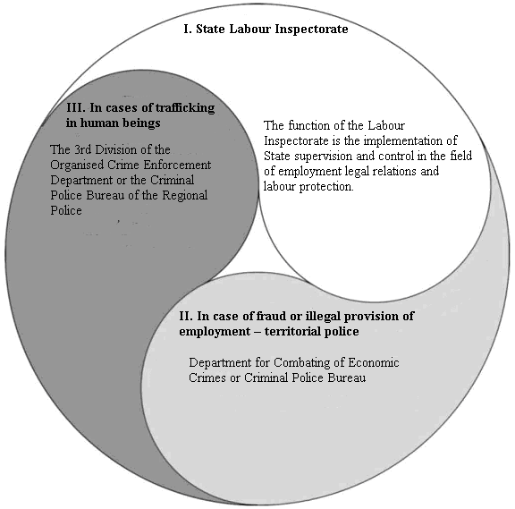

Annex 2
Guidelines for the Identification of Human Trafficking for the Purpose of Labour Exploitation

Distribution of Competences in Foreign Countries

