 | PHA  PUBLIC HEALTH AGENCY

EQUITY AND SOLIDARITY IN THE FIELD OF HEALTH

REPORT ON ACHIEVEMENT OF OBJECTIVE 2 OF THE PUBLIC HEALTH STRATEGY

Riga 2008

EQUITY AND SOLIDARITY IN THE FIELD OF HEALTH

Authors: Iveta Gigele State agency “Public Health Agency”
Gunta Rozentāle State agency “Public Health Agency”
Jolanta Skrule State agency “Public Health Agency”
Margita Štāle State agency “Public Health Agency”

The report is accessible electronically on the Internet home page of the State agency “Public Health Agency” www.sva.gov.lv

Published
State agency “Public Health Agency”
Klijānu iela 7
Rīga, LV-1012
Latvia

© 2008, State agency “Public Health Agency”, Latvia

TABLE OF CONTENTS:

TABLE OF CONTENTS: 3

LIST OF FIGURES 4

COMMUNICATION 5

INTRODUCTION 6

OUTLINE OF THE SITUATION 9

HEALTH INDICATORS 9
ACCESSIBILITY OF HEALTH CARE SERVICES 17
CHILDREN 22
PEOPLE WITH SPECIAL NEEDS 24
ETHNIC MINORITY – GYPSIES 24
VICTIMS OF HUMAN TRAFFICKING 25
POVERTY – CAUSE OF POOR HEALTH 25

POLICY INITIATIVES 29

CONCLUSIONS AND PROPOSALS 32

COMMENTS REGARDING DATA 34

EXPLANATION OF MAIN TERMS AND CONCEPTS 36

ABBREVIATIONS 40

REFERENCES 41

LIST OF FIGURES

1. Figure 1. MAIN DETERMINING FACTORS FOR HEALTH 6

Figure 2. PROPORTION OF RESPONDENTS WHO EVALUATE THEIR HEALTH AS GOOD OR FAIRLY GOOD, ACCORDING TO EDUCATION, IN PER CENT 9

Figure 3. AVERAGE LIFE EXPECTANCY OF NEWBORN INFANTS, IN YEARS, IN LATVIA AND THE EU 10

Figure 4. AVERAGE LIFE EXPECTANCY OF NEWBORN INFANTS, IN YEARS, BROKEN DOWN BY GENDER, IN THE COUNTRYSIDE AND IN CITIES 11

Figure 5. MORTALITY FROM EXTERNAL CAUSES OF DEATH, PER 100 000 CITY RESIDENTS AND RURAL RESIDENTS OF THE RESPECTIVE AGE IN 2004 11

Figure 6. MORTALITY FROM VIOLENCE IN CITIES AND THE COUNTRYSIDE, PER 100 000 RESIDENTS 12

Figure 7. MORTALITY FROM INTENTIONAL SELF-INFLICTED HARM IN CITIES AND THE COUNTRYSIDE, PER 100 000 RESIDENTS 13

Figure 8. MORBIDITY RATE (INCIDENCE) WITH TUBERCULOSIS, DISTRIBUTION OF TUBERCULOSIS (PREVALENCE) PER 100 000 RESIDENTS IN 2006, BROKEN DOWN BY DEPARTMENTS OF THE HCISA (HEALTH COMPULSORY INSURANCE STATE AGENCY) 14
Figure 9. FUNDS FOR HEALTH CARE, PER CENT OF THE GDP 17

Figure 10. NUMBER OF FAMILY DOCTORS, PER 100 000 RESIDENTS 18

Figure 11. REASONS FOR RESTRICTED ACCESSIBILITY OF MEDICAL EXAMINATIONS IN THE
EU, PROPORTION OF RESPONSES, IN PER CENT 20

Figure 12. PROPORTION OF RESPONDENTS WHO HAVE LACKED RESOURCES FOR A VISIT TO A DOCTOR DURING THE LAST YEAR, ACCORDING TO THE TYPE OF POPULATED AREA, 2005, IN PER CENT 21

Figure 13. MAIN REASON WHY EXAMINATION BY A MEDICAL SPECIALIST OR MEDICAL TREATMENT WAS NOT CONDUCTED , BY QUINTILES, 2005, IN PER CENT 21

Figure 14. FIRST-TIME DISABILITY FOR CHILDREN, BY REGIONS, 2006, PER 100 000 RESIDENTS 23

Figure 15. GINI COEFFICIENT 26

COMMUNICATION

Inequality exists in the field of health, which is confirmed by the various health indicators of different groups of residents.
High level of poverty and economic inequality is related to unequal opportunities in the maintenance and improvement of health, including the opportunities to receive the necessary health care services.
Significant socio-economic factors affecting health are education, employment and the level of income. People whose income and level of education are higher have better appreciation of their health.
The place of residence is also a significant factor affecting health, which is demonstrated by the average life expectancy of newborn infants. In comparing this indicator in Latvia and the European Union, it is evident that in Latvia it is lower by 7 years than on average in the EU. Such situation testifies regarding inequality in the field of health.
Inequality exists not only between states, but also between different territories of one state, for example, the average life expectancy of newborn infants for rural residents in Latvia is 2 years shorter than for people living cities.
The mortality rate from diseases of the circulatory system, external causes of death and diseases of the respiratory system is higher in the countryside than in cities, whereas from other causes of death – lower.
The place of residence is closely linked with the accessibility of health care services that is affected not only by geographical attainability, but also the financial situation of residents. Data of different studies confirm that the accessibility of health care services is restricted by financial resources of residents. In comparison with residents of cities, rural residents have indicated more often that they have delayed examination by a medical specialist or medical treatment because they could not afford it (too expensive) or the great distance to a medical treatment institution and the lack of transport was mentioned as an obstacle.
Latvia has one of the highest patient co-payments in Europe that increases the risk of inequality between different socio-economic groups even more in terms of accessibility of health care services.
The reduction of the differences of health indicators between different socio-economic groups of residents is one of the basic principles of solidarity and equity in the field of health care.

Introduction
Differences in the health condition among different social groups have already been described in the 16th century. However, only the population registration in the 19th century gave the opportunity to calculate the mortality indicators. The work of several researchers allowed the conclusion that social status and working conditions are very significant determining factors for health.
In the 20th century social and working conditions, water and food supply, immunisation and prophylaxis have improved together with the development of public health. Life expectancy has increased significantly. However, social inequality in relation to health has not decreased – the relative differences in mortality indicators in different social groups have not only remained unchanged, but at the end of the 20th century they have even increased in spite of welfare, social protection and health care. Only the structure of the causes of diseases and death has changed, with non-communicable diseases being dominant.,
Health of residents is affected not only by biological (gender, age) factors, the lifestyle and behaviour of people, but also the conditions in which a person lives. The main determining factors for health are evident in the model presented (Figure 1).

Figure 1. Main Determining Factors for Health

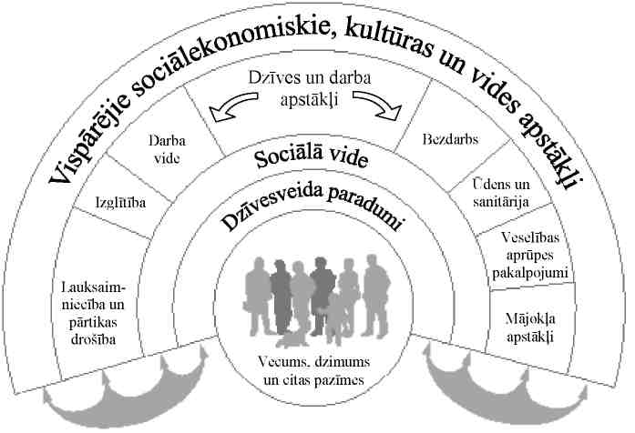
General socio-economic, cultural and environmental conditions
Agriculture and food safety
Education
Work environment
Living and working conditions
Unemployment
Water and sanitation
Health care services
Housing conditions
Social environment
Lifestyle habits
Age, gender and other features

Source: Dahlgren and Whitehead, 1993

Socio-economic conditions are related to the living environment and lifestyle of a person, thereby also significantly affecting health.
Socio-economic differences between groups of residents are mainly reflected, using different socio-economic indicators: the level of education, the level of income, marital status, the place of residence (countryside, cities), ethnic origin, the level of employment etc. Health indicators of residents are closely linked with socio-economic indicators, for example, poverty may directly affect the accessibility of health care services and the opportunities to invest personal resources in the solution of health problems.
Many indicators of morbidity, mortality and health risk factors may be evaluated more negatively among lower socio-economic groups of people. The level of mortality in these groups is often higher (25-50% or more) than in the highest socio-economic groups. Low level of income is usually related to inferior health indicators.6
Although the overall health of residents of European states is improving, health of higher socio-economic groups of people is improving more quickly, resulting in differences in the health condition of different social groups. The situation is also similar in Latvia where individual health indicators of lower social groups are deteriorating, wherewith the overall health indicators of residents are also deteriorating.
Provision of equal health opportunities is important for each state in order to retain such values as social equity and solidarity. These basic principles are set down in all treaties of the EU Member States because the objective of the EU is to promote social unity and to ensure sustainable development.⁷

According the Joint Social Inclusion Memorandum of Latvia, the main groups of residents subject to poverty and social exclusion are:
• large families;
• one-parent families;
• disabled people;
• people of pre-retirement and retirement age;
• children and young persons at social risk;
• long-term unemployed persons;
• homeless people;
• persons released from places of imprisonment;
• ethnic minorities;
• victims of human trafficking.

Taking into account the connection of the high level of poverty and economic inequality with unequal opportunities in relation to the maintenance and improvement of health, including the opportunities to receive the necessary health care services, the previously specified groups of residents are also subject to the risk of health inequality. It is also indirectly confirmed by different statistical and research data analysed in this report.

In order to implement the public health policy and to improve public health indicators, on 6 March 2001 the Cabinet of the Republic of Latvia accepted the Public Health Strategy which is currently the main policy planning document. Objectives (21 objectives in total) and tasks in the field of public health are defined therein. The general objective of the Public Health Strategy is to achieve the improvement of the health condition of the population of Latvia, approaching the best health indicators of European states, consequently to reduce the differences among health indicators of residents of different states, thereby reducing inequality.

A case study is provided in this report regarding the achievement of Objective 2 of the Public Health Strategy “by 2010 the differences in health indicators among different socio-economic groups in Latvia shall be reduced at least by one fourth, significantly improving health condition of such groups, which are currently in the most unfavourable situation”, analysing different indicators characterising health of residents.
The following sub-objectives are brought forward for achievement of the objective “Equity and Solidarity in the Field of Health”:
1) the most important differences in morbidity, disability and mortality indicators in different socio-economic groups shall be reduced;
2) people with special needs, which are determined by specific health, social or economic conditions, shall be protected from social isolation, and they shall be provided with more simple access to education, health care, social and other necessary services; and
the proportion of poor residents shall be significantly reduced.

In order to evaluate the achievement of the proposed objectives and to analyse the differences in health indicators among different socio-economic groups, the main indicators were defined as follows:
• the average life expectancy of newborn infants, in years;
• mortality from diseases of the circulatory system, per 100 000 residents;
• mortality from external causes of death, per 100 000 residents;
• mortality from tumours, per 100 000 residents;
• morbidity rate with tuberculosis, per 100 000 residents;
• incidence (prevalence) of tuberculosis, per 100 000 residents;
• morbidity with syphilis, per 100 000 residents;
• number of family doctors, per 100 000 residents;
• level of unemployment, in per cent;
• emerging disability of children, per 100 000 residents;
• self-evaluation of the health condition of residents, in per cent;
• index of the poverty risk; and
• Gini coefficient.

OUTLINE OF THE SITUATION

Health Indicators

The mortality, life expectancy and health problems of residents may be analysed from several aspects – socio-economic, demographic, sociological, medical, biological, philosophical etc. In this report, more attention is paid to the socio-economic aspect, analysing the connection of the health condition of residents with different socio-economic factors, for example, level of education, place of residence, level of employment, level of income etc.
Health surveys of residents confirm the significant differentiation of health condition of the residents of Latvia in division by demographic and socio-economic groups,,, indicating the inequality in the field of health existing in Latvia.
The socio-economic situation is characterised by such indicator as the satisfaction of residents with life . Data from a study conducted in the spring of 2008 “Eurobarometer 69” confirm that in Latvia 63% of respondents are generally satisfied with their lives. In Latvia, satisfaction with life still does not reach the average EU indicators (77%). Significant differences are observed in the evaluation of one’s life in division by regions: comparably more people dissatisfied with their lives are in Riga – 42% and in Latgale – 41%.
One of the public health indicators that reflects the subjective opinion of people regarding their health is the self-evaluation of health condition of residents. In 2006 41% of the surveyed residents regarded their health condition as good or even very good, 39% have described it as satisfactory (average), but 19% of respondents described their health condition as poor or very poor.¹⁰
The self-evaluation of the health condition is affected by the level of education. It is evident in Figure 2 that there is a higher proportion of persons who evaluate their health condition as good among respondents with higher education.

Figure 2. Proportion of Respondents who Evaluate Their Health as Good or Fairly Good,
According to Education, in Per cent
(FINBAL T data)

Percentage | 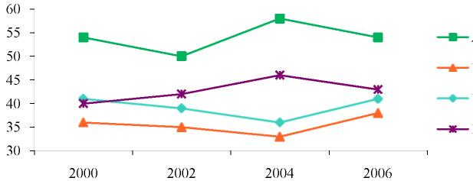 | Higher
Percentage |  | General secondary
Percentage |  | Specialised secondary
Percentage |  | Basic education
Percentage | Year

It should be noted that since 2000 the proportion of respondents who have acquired basic education and evaluate their health condition as good or fairly good has increased. The possible explanation is that respondents having basic education are of younger age (taking into account that the persons surveyed are from 15 years of age) and they evaluate their health as better than the respondents who are of older age.
An important aspect of the quality of life is health and social security of the population. The average life expectancy of newborn infants is used as an indicator for evaluation thereof. In comparing the average life expectancy of newborn infants in Latvia and in the European Union, it is evident that this indicator in Latvia is lower than on average in the EU by almost 7 years (see Figure 3). Data confirm that differences in health indicators exist both among different groups of states, as well as states, including also among states of the European Union, for example, in 2006 the average life expectancy in the Netherlands was 80 years, but in Lithuania – only 71 years. Such situation testifies regarding inequality in the field of health.

Figure 3. Average Life Expectancy of Newborn Infants, in Years, in Latvia and the EU
(WHO data)

Percentage | 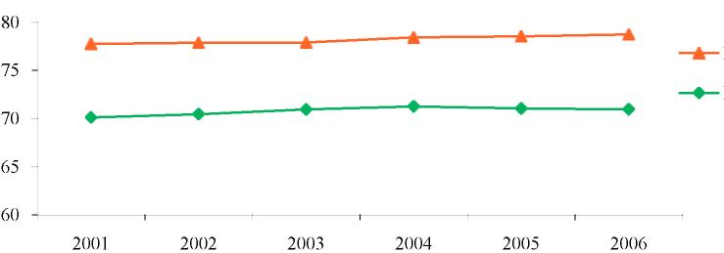
Percentage |  | EU
Percentage |  | LV
Percentage | Year

Studies conducted in Latvia confirm the existence of socio-economic and territorial differentiation in mortality, life expectancy and health indicators.¹⁰
During the last decade the average life expectancy of newborn infants has increased slightly, however, it is consistently shorter for rural residents than for residents of cities by approximately 2 years.
In Latvia not only differences in the life expectancy between residents of cities and rural residents are observed, but significant differences also exist between genders in relation to life expectancy. Life expectancy of men is shorter than for women by approximately 11 years (see Figure 4).
The indicator of the average life expectancy of newborn infants is mainly affected by mortality indicators in the state, as well as the average age of death. However, there are factors such as, for example, the place of residence that indirectly affects the mortality indicators and therefore they are analysed according to groups of city residents and rural residents.

Figure 4. Average Life Expectancy of Newborn Infants, in Years, Broken Down by Gender, in the Countryside and in Cities
(CSB data)

Age (in years) | 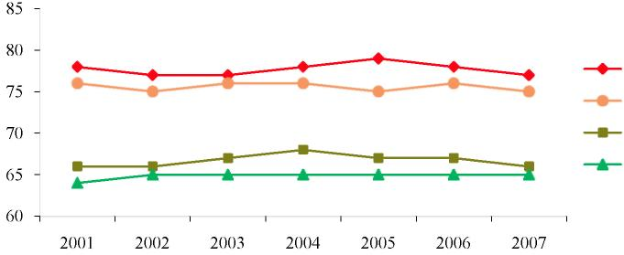 | Women in cities
Age (in years) |  | Women in the countryside
Age (in years) |  | Men in cities
Age (in years) |  | Men in the countryside
Age (in years) | Year

The main causes of death for residents of Latvia are diseases of the circulatory system, tumours and external causes of death. According to data of the CSB, it is evident that rural residents die more often from external causes of death (by 26%), diseases of the circulatory system (by 16%) and diseases of the respiratory system (by 13%) in comparison with residents of cities. The highest mortality is in the region of Latgale.¹⁰ It may be explained with the age structure (the ageing of residents) and the socio-economic condition (higher level of unemployment and poverty) in the region.
Hypertension is in the first place among the risk factors that influence mortality from diseases of the circulatory system, and it increases the risk of dying from diseases of the circulatory system by almost 6 times. The second place among risk factors is taken by the level of education. It can be explained by the fact that the level of education determines the lifestyle to a great extent, including the attitude towards one’s own health and unhealthy habits (smoking, excessive use of alcohol etc.), which, in turn, affects the development of diseases of the circulatory system.
Indicators of the average life expectancy of newborn infants for residents of Latvia are most significantly negatively affected by external causes of death.

Figure 5. Mortality from External Causes of Death in Cities and in the Countryside, 2004,
per 100 000 Residents
CSB data

per 1000000 residents | 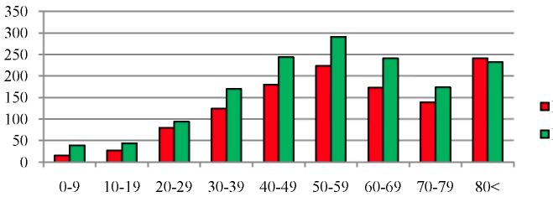 | Cities
per 1000000 residents |  | Countryside
per 1000000 residents | Age

In analysing mortality from external causes of death according to age groups, the number of the deceased per 100 000 residents in the countryside is higher than in the cities (see: Figure 5). Mortality of children (up to 9 years of age) due to external causes in 2004 was 3 times higher in the countryside than in cities. It confirms that the environment is less safe in the countryside, particularly for children. Two main external causes of death in 2005 for children who were 5-9 years of age were drowning (57%) and road traffic accidents (27%), which is probably related to a less safe environment and children being left unattended by adults.
Such children who live in a one-parent family, are raised by very young parents, whose parents have a low level of education, who live in a poor family, who live in very large families or whose parents use alcohol and drugs are more subject to the risk of trauma.
One of the most significant external causes of death in Latvia is violence. Violence is the third main cause of death for young people who are from 15 to 29 years of age and, live in European states and have low and average income.

Figure 6. Mortality from Violence in Cities and
in the Countryside, per 100 000 Residents
(CSB data)

Per 1000000 residents | 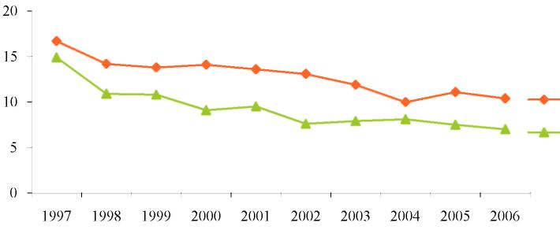 | In cities
Per 1000000 residents |  | In the countryside
Per 1000000 residents | Year

In Figure 6 it is evident that mortality due to violence is higher in cities than in the countryside. During the last decade mortality from violence is reducing.
8% of residents have suffered from physical aggression inflicted by relatives during the last two years. Research data confirm that people of younger age are at greater risk of becoming a victim of violence. In the group of residents from 15 to 24 years of age, 13% have suffered from violence. The people living in Riga have suffered from aggression more often (11%) than residents from other large cities and rural regions (6%). Indicator of the level of education is also very important – a person with a lower level of education has more potential of becoming a victim of violence.
Economic situation of a person is of significant importance. There is greater potential for unoccupied persons – unemployed persons and persons who do not work and do not seek work – to become victims of aggression. During the last two years 17% of unemployed persons, 16% of those residents who do not work and do not seek work and 7% of employed residents have suffered from physical violence.
In 2006 intentional self-harming (suicide) was the cause of death in 15% of cases among external causes of death.

Figure 7. Mortality from Intentional Self-inflicted Harm in Cities and in the Countryside, per 100 000 Residents
(CSB data)

Per 1000000 residents | 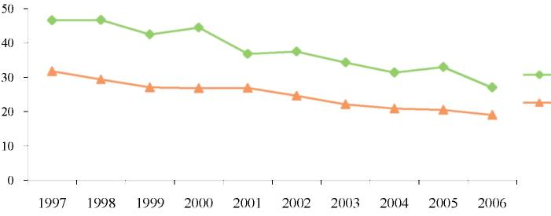 | In cities
Per 1000000 residents |  | In the countryside
Per 1000000 residents | Year

7. In Figure 7 it is evident that mortality due to suicide is higher for rural residents than for residents of cities. It may be explained by the wider prevalence of factors promoting suicide in the countryside: social circumstances (unemployment, poverty), higher prevalence of addictions and restricted opportunities of receiving assistance in crisis situations.
In turn, mortality from tumours in the countryside is lower than in cities (accordingly, 237 in the countryside and 258 per 100 000 residents in cities, in 2004). Both in cities and in the countryside mortality from malignant tumours is most often caused by tracheal, bronchial and lung cancer, moreover, mortality from such tumours in the countryside exceeds the mortality indicators in cities. One of the most significant risk factors in the development of malignant tumours of such localisation is smoking.
In studies of many states it has been concluded that morbidity rate with tumours, as well as many other diseases is not equal in all socio-economic groups. It might be explained by different financial opportunities for using health care services.
It has been determined that in many states suicide is observed less in the middle class, but the incidence thereof is much higher both in the higher and the lower sections of society. Moreover, the connection of a disease with a particular socio-economic group may change in the course of time. For example, one hundred years ago tuberculosis (TB) was sufficiently prevalent in all sections of the population, but in parallel with the overall improvement of the standard of living, particularly since comprehensive introduction of the BCG (Bacillus Calmette-Guerin) vaccination and chemotherapy, new cases of the disease in the developed countries are increasingly concentrated in the poorest groups of population. Tuberculosis and sexually transmitted diseases may be deemed as social diseases.⁵ One of the most widespread sexually transmitted infections in Latvia is syphilis, 13,2 cases of contracting the disease per 100 000 residents were registered in 2007.
As regards the second so called social disease – tuberculosis – as confirmed by data of the State Register of TB Patients, almost half of those suffering from tuberculosis are people without specific employment or unemployed persons.

Figure 8. Morbidity Rate (Incidence) with Tuberculosis, Distribution of Tuberculosis (Prevalence) per 100 000 Residents in 2007, Broken down by Departments of the HCISA (Health Compulsory Insurance State Agency)
(data of the HSMTSA)

Per 1000000 residents | 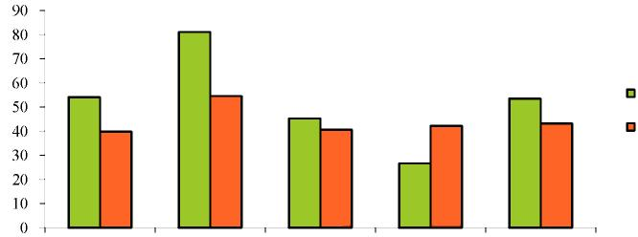 |  |  |  |  |  | Prevalence
Per 1000000 residents |  |  |  |  |  |  | Incidence
Per 1000000 residents |  | Kurzeme | Latgale | Vidzeme | Zemgale | Riga
Per 1000000 residents | Departments of the HCISA

In 2007 the highest number of registered new cases of TB and the highest prevalence of TB in Latvia was in Latgale (in Latgale Department of the HCISA). Similar situation was also observed in previous years.
People without a permanent place of residence, unemployed persons, convicted persons, patients addicted to alcohol, as well as people with immunodeficiency syndrome (HIV) and AIDS have an increased risk of becoming ill with tuberculosis. For example, in 2007 56 patients with the dual infection – HIV/TB – were registered.²⁰
In 2005 in Latvia, the number of new HIV cases per one million residents was almost two times higher than the EU average indicator. The prevalence of HIV in places of imprisonment is 36 times higher than in the remaining section of society. Every sixth case of infection with HIV is detected in places of imprisonment.
Convicted persons are a risk population for many problems of public health: not only communicable diseases (HIV, Hepatitis C, TB), but also the use of addictive substances and mental and behavioural disorders are prevalent in prisons. In 2007, 55% of prisoners were diagnosed with mental and behavioural disorders in prisons of Latvia Drugs are used in prisons of Latvia on average by 10-30% of prisoners.²¹ The connection between the use of (injectable) drugs and the prevalence of infections carried by blood in prisons confirmed by the information that 98% of prisoners infected with HIV/AIDS, HCV and HBV have used narcotic substances in the past.²¹ The poor health condition of prisoners may affect health of wider community when drug users leave the prison and renew contacts with their family and other members of society.
11-20% of prisoners use drugs, but according to the information provided by prison employees almost all prisoners have an addiction to psychotropic substances. WHO guidelines determine that the prisoners who received a replacement therapy prior to imprisonment, shall also be provided with an option of receiving it in the place of imprisonment. , Treatment programmes for prisoners addicted to drugs would not only improve health of prisoners but also, possibly, promote the prevention of subsequent violations of law.
The use of addictive substances, especially drugs, is a health problem of not only prisoners but the whole society. The use of drugs creates high overall social costs for society. In Latvia, there are approximately 15 000 intravenous drug users.²¹ Costs related to the use of drugs can be divided into two categories: direct and indirect costs. Direct costs are related to payments and usually these are expenses in such fields as prophylaxis, treatment, reduction of damage and ensuring the fulfilment of legal acts. Indirect costs are the value of the services non-provided due to the drug use, and usually they are formed by the productivity lost due to morbidity and mortality related to the use of drugs. The price of materially immeasurable pain and suffering can also be added to the price of the drug use, which is usually expressed as measurements of the standard of living, however, this category of costs is not usually recorded because it is difficult make precise calculations thereof in terms of money.
Only some states notify regarding social costs caused due to the use of drugs, for example, estimated indirect costs of drug use in Finland, including abuse of drugs, have been approximately 400 to 800 million euros, of which 306 to 701 million euros are attributable to the lives lost due to premature death, but 61 to 102 million euros – to the loss of productivity.
The opportunities to obtain narcotic substances and the use thereof cause different health problems and may cause death at a premature age. In Europe, overdosing on opioids is one of the main causes of death of people of younger age, particularly men living in an urban environment. It has been revealed in a study conducted in the Czech Republic that the standardised indicator of mortality among users of opioids is 9-12 times higher than among the whole population (reports of the Reitox network of states, 2005).²⁷ The use of narcotic substances in Latvia is also more characteristic to people of younger age who live in the largest cities of Latvia.
Alcohol is also a psychoactive substance that may result in addiction, particularly if it is used often and/or in large quantities. Studies testify that the earlier the age when an individual has started using addictive substances, the greater the chance that the use of addictive substances becomes a significant problem in later life. For adolescents premature use of alcohol may be related to several psycho-social problems – absence from school and deterioration in achievements, disagreements in the family and with peers etc.
Biological, social and psychological factors are at the root of the development of alcoholism. The wider the access to alcoholic beverages, the more often problems related to alcohol are encountered. Advertisements that encourage young people in particular to use alcohol have great significance. ¹⁸
Habits in the use of alcohol by adolescents has a connection with the place of residence. Pupils in small towns and parishes have used alcohol the least both during their life, as well as during the last year or month, in turn young persons have used alcohol most often during the last month in large cities, including Rīga. Possibly, partial explanation thereof is the evaluation provided by young persons that it is more difficult for pupils to access alcohol in parishes than for pupils in large cities.¹⁸
Results of a study regarding the prevalence of substances causing addiction among adult residents testify that the use of alcohol (during the last month), as well as the frequency (1-2 times a week) is more characteristic to residents of Riga, which is explained by different social events where the use of alcohol is accepted. In analysing in particular hazardous use of alcohol (five doses or 50 g of pure alcohol on one occasion) according to the place of residence, it is evident that it is more typical in cities (except Riga); however, for women hazardous use of alcohol is more characteristic to female residents of Riga.²⁸
Habits in the use of alcohol are not related only to the place of residence, but also to the level of education. The use of alcohol during the last month is more characteristic to residents with a higher level of education, which may be explained by the participation of such residents in different social events where alcohol is used.
More harmful use of alcohol is more characteristic to residents with a lower level of education, which is indicated by morbidity data. Of the first-time patients with alcohol addiction the largest part had secondary or specialised secondary education – 69%, 25% – basic education, 1% – an unfinished basic education, 5% – higher education.
Excessive use of alcohol is often related to socio-economic factors, such as unemployment, poverty etc. It was established in a study conducted by the State Employment Agency in 2006, “Regional Studies regarding Socio-psychological Portrait of Unemployed Persons”, that in Latvia almost every fourth unemployed person has been diagnosed with an average or high risk of alcohol addiction and every seventh – an average or high risk of addiction to narcotic substances. In total 15% of women and 38% of men among unemployed persons belong to an addiction risk group. The greatest proportion of risk among the regions of Latvia is in Latgale. The risk of addiction among unemployed men is equally high in all groups of education, except in the group of higher education in which the addiction problem is observed the least. The risk of addiction for women with general secondary education or vocational education is much lower than for unemployed women with basic education.
One of the most disadvantaged sections of the society are residents with mental health disorders (in 2006 – 3%). The income of such residents is mainly the disability pension, the level of which does not reach the subsistence minimum or the minimum wage determined in the State.³¹
In 2006 77% of patients with mental health disorders lived in families, 11% – lived alone, 7% – lived in social care institutions, 1,4% or 900 were without a definite place of residence.
According to the data of psycho-neurological offices, in 2006 economic problems (poverty, lack of nutrition, low income etc.) affected the health condition and care for 5% of patients. The possible explanation is that the level of education of patients with mental and behavioural disorders is lower than on average in the population. 58% of the patients being in active care of the psychiatric assistance service have an unfinished basic education or basic education, often they have studied in special educational establishments for children with intellectual development disorders or also have not studied at all, 2% are illiterate.

Accessibility of Health Care Services

To a great extent, indicators of morbidity, disability and mortality are affected by the accessibility of health care services.
Access to health care is determined by organisation of health care, resources (human resources, funding), transport, accessibility of health care workers and freedom of patient’s choice, availability of information, quality of care, as well as the existence of modern technologies. Each year in Latvia the amount of funds allocated by the State (in lats) for health care increases. In comparison with 2001, financing for health care has increased 3 times in 2007, however, in calculating the proportion of the GDP, it is consistently only 4% of the GDP (see Figure 9). In comparison, this indicator is on average 6% in other EU states and more of the GDP (in 2004 5,5% in Estonia, 6% in Lithuania).

Figure 9. Funds for Health Care, in Per cent of the GDP
(Data of the Ministry of Health)

Percentage of GDP | 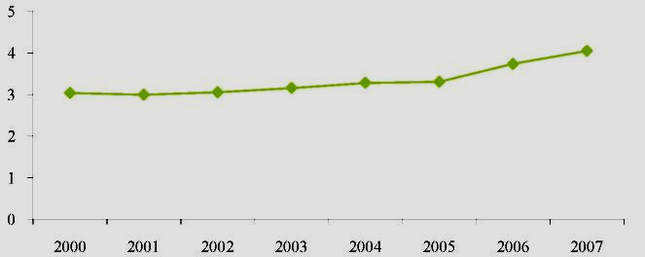
Percentage of GDP | Year

Availability of health care workers is characterised by the number of medical practitioners, the division of specialists by regions, as well as the procedures for provision of emergency medical assistance and the opportunity to choose freely a family doctor.
Insufficient number of medical practitioners and uneven division of specialists among regions is a reason why a range of services is accessible only partially to patients. The largest number of doctors is in Riga and in Jūrmala – more than 35 per 10 000 residents, the smallest number is in the regions of Krāslava, Aizkraukle, Bauska. Kuldīga and Tukums – less than 15 doctors per 10 000 residents. The smallest number of doctor’s assistants is in Riga – less than 5 per 10 000 residents, but the largest number is in Krāslava – more than 15 per 10 000 residents. Thus it must be concluded that health care services provided by doctors to residents are less accessible in the furthest rural regions in comparison with cities and health care services provided by doctor’s assistants must be relied upon more. In Riga there are more than 60 nurses per 10 000 residents, but in the districts of Bauska, Ogre and Riga – less than 20 nurses per 10 000 residents, which is three times less than in Riga. The lack of specialists in State regions is already negatively affecting the quality of medial treatment services. 25% of doctors from the total number of doctors who are included in the Register of Medical Practitioners do not currently work in the health care system.
Emergency medical assistance services are available to residents free of charge if the victim (patient) is in a condition that is critical to his or her life and health. In cities emergency medical assistance must be provided not later than within a time period of 15 minutes from the time of receipt of a call, but in other (rural) territories – within a time period of 25 minutes from the time of receipt of a call.²⁶
From 2005 the fee specified in regulatory enactments for an unjustified call of emergency assistance and the payment introduced for the service received (from 7 up to 40 lats) caused additional problems to the poorest groups of residents because interpretation of the term “unjustified call” was not clear to residents and part of patients avoid calling emergency medical assistance even in life-threatening cases.
Each person has the right to choose a family doctor. More than 2000 patients or 900 children may be registered with one family doctor, however, the number of family doctors in regions is insufficient and frequently much larger number of patients is registered with one family doctor than the number specified in regulatory enactments.

Figure 10. Number of Family Doctors, per 100 000 Residents
(WHO data)

Per 100000 residents | 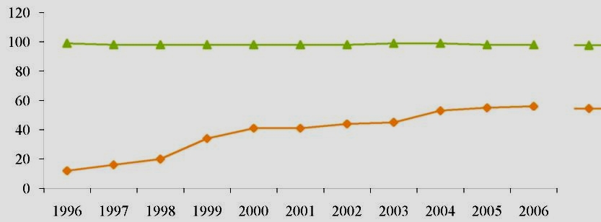 | EU  LV
Per 100000 residents | Year

In Figure 10 it is evident that the number of family doctors in Latvia per 100 000 residents has increased by almost 5 times within the last decade. However, in comparison with the average EU indicator it is still almost 2 times lower.
One of the indicators of accessibility of health care services is the number of outpatient visits to a doctor. In Latvia the total number of outpatient visits to doctors has increased by 5,5 percentage points in 2007 in comparison with the previous year. The number of outpatient visits has also increased per 1 resident (from 4,8 visits in 2001 to 5,8 – in 2007), but the number of home visits and proportion thereof from the total number of outpatient visits is reducing (from 7% in 2001 to 3% – in 2007).²⁰
A significant component of the health care system is the reimbursement scheme towards the purchase of medicinal products, which ensures that patients with specific diagnoses are reimbursed the expenses towards the purchase of medicinal products in amount of 50-100%. Thus it has both social and economic significance.
In order to ensure the accessibility of health care to all residents, categories of residents exist which, upon receipt of health care services, are exempted from patient co-payment. Such categories are, for example, children up to 18 years of age, poor persons etc.²⁶
However, exemptions are not applied to many patients who have low income and accessibility of health care services is significantly restricted due to the co-payment. According to the WHO data, one of the highest patient co-payments in Europe is also in Latvia. Moreover, the co-payment is not proportionally applied to a person’s income.
In 2007 health expenses for one member of a household per month were approximately 8 lats in the countryside and 11 lats in cities. In 2007 consumption expenses for health have increased most rapidly – by 70%, including expenses towards the purchase of medicinal products – by 64% and expenses towards dental services increased by 2,6 times.¹⁴ The largest part of expenses towards health in the consumption basket is formed by medicinal products (3-4%).
The accessibility problems of health care reveal themselves not only in routine statistical data, but also in resident polls.
Results of the EU-SILC study in 2005 testify that in general residents of Latvia evaluate the accessibility of health care services as poor. Of the EU states, the largest proportion of residents who have had to decline from receipt of medical assistance due to restricted accessibility is in Latvia (Figure 11).
A significant socio-economic factor is the place of residence and the services and opportunities available in the vicinity thereof. As confirmed by data of the “Research about Legal Capacity in Regions, 2005”, residents regard the opportunity to receive medical services as one of the three most significant factors in choosing a place of residence.⁴²
The research “About Legal Capacity in Regions 2005” demonstrates that such respondents whose income is higher have evaluated their health as better. Respondents from the region of Riga have given the best evaluation for their health. The lowest self-evaluation of health is in Latgale region.
Health indicators of persons who live in the central section of state in vicinity of Riga are better than on average in Latvia, and it is influenced not only by accessibility of health care services, but also the level of employment, income and education.
There are differences in income both between cities and the countryside and between Riga and the region thereof and other regions. The distribution of residents in the territory of Latvia is uneven – one third of the state residents live in the rural territory. The largest concentration of residents is in Riga – approximately 32% of the total number of residents, which is related to better employment opportunities and higher remunerations.¹⁴
Accessibility of health care is significantly affected by the financial situation of residents. In Figure 11 it is evident that the proportion of respondents who have responded in resident polls of the EU-SILC that they are not able to afford medical examinations financially (16%) is especially large.

Figure 11. Reasons for Restricted Accessibility of Medical Examinations in the EU, Proportion of Responses, in Per cent
(EU-SILC data)

Proportion of answers | 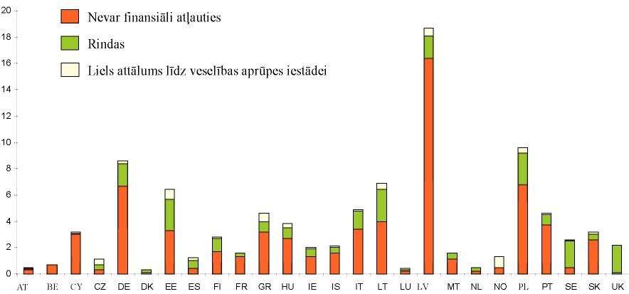
Proportion of answers | State
Are not able to afford financially
Waiting lists
Large distance to the health care institution

Respectively, households with the lowest level of income are subject to the risk of not receiving the necessary medical assistance to a greater extent than others. In the EU-SILC study 30% of respondents gave an affirmative answer to the question “Has it been necessary for you to conduct an examination by a medical specialist or undergo medical treatment during the last 12 months, but you have not done so?”. Data of the survey “Research about Legal Capacity in Regions, 2005” also testify regarding a similar situation – approximately one third of respondents have restricted themselves or their family in relation to receipt of health care services due to the lack of resources.
According to the data of EU-SILC studies, in the countryside where the opportunities to receive medical assistance are fewer than in cities³⁸, , the proportion of respondents who pointed at such cases was lower than in the cities (26% of rural respondents and 32% of city respondents). At the same time, it was revealed in other studies conducted in Latvia, that due to the lack of resources residents of rural regions decline health care services more often (see Figure 12).
In division by gender women are in the most unfavourable situation – they have indicated more often that they have lacked resources for a visit to a doctor during the last year (41% women, 29% men).⁴⁵

12. Figure 12. Proportion of Respondents Who have Lacked Resources for a Visit to a Doctor during the Last Year, According to the Type of Populated Area, 2005, in Per cent
(Report On Development of the Population 2004/2005: Legal Capacity in Regions)

Proportion of responses, % | 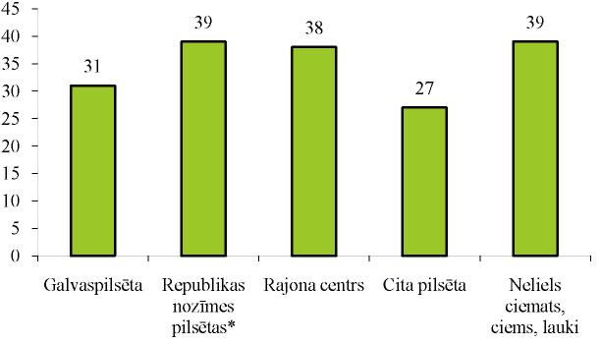
Proportion of responses, % | Capital | Republic city | District centre | Other city | Small community, village, countryside

* Daugavpils, Liepāja, Jelgava, Ventspils, Jūrmala, Rēzekne

In grouping respondents according to their income in 5 quintiles, it is evident (Figure 13) that a close connection exists between the level of income and the ability to cover expenses towards health care services. Other studies also confirm that people with lower income (per family member) have often been forced to decline medical assistance. In the EU-SILC survey it is also revealed that the lower the income per family member, the more often hospitalisation occurs, which indicates towards delayed treatment of disease.

13. Figure 13. Main Reason why Examination by a Medical Specialist or Medical Treatment was not Conducted, by Quintiles According to Household Income
Level, 2005, in Per cent
(EU-SILC data)

Percentage | 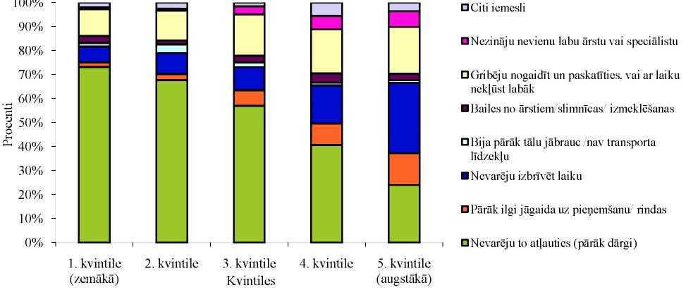 |  |  |  |  |  |  | Other reasons  Did not know any good doctor or specialist  Wanted to wait and see if I do get better with time  Afraid of doctors / hospitals / examinations  Too far to drive/no means of transport  Could not free any time  Too long to wait for reception/waiting lists  Could not afford it (too expensive)
 |  | Quintile 1  (the lowest) | Quintile 2 | Quintile 3 | Quintile 4 | Quintile 5  (the highest)
 |  | Quintiles

Rural residents in comparison with city residents have indicated more often that they have delayed examination by a medical specialist or medical treatment as they could not afford it (too expensive) or the excessive distance to a medical treatment institution and the lack of transport has been mentioned as an obstacle.
Interconnections exist between the distance to a medical treatment institution and the types of use of health care services – the greater the distance to the medical treatment institution, the lesser proportion of the use of health care services^{46,}.
Unequal conditions for different groups of residents are created by existing waiting lists in order to receive State financed health care services. People with higher income, paying for health care services from their resources, receive medical treatment straightaway, but the poor have to wait in the waiting list and they are at greater risk of delayed medical treatment.
Accessibility of health care services is also promoted to a great extent by existence of health insurance policies; people with a voluntary health insurance policy use private health services more often and purchase prescribed medicinal products more regularly^{46, 44,} . Health survey of residents (2003) reveals that residents with a higher education insure their health more voluntarily (26% with higher education, 10% with basic education). A study regarding accessibility of health care services⁴⁴ of the same year testifies that 79% of respondents do not have a health insurance policy whatsoever, and 12% of respondents have purchased policies, using their own resources. There are more policy holders in regions of Latvia than in Riga. Riga is vastly different because of the fact that policies are covered entirely by employers significantly more often (12% against 3-4%), social assistance services have more important role in the purchase of policies in regions.
The distance to health care centres, the lack of transport, as well as organisational accessibility – inconvenient reception schedule of doctors and long waiting lists – restrict the access to primary health care doctors^{48,,,}. The most frequently mentioned reasons for dissatisfaction with services provided by a family doctor are: availability of the doctor; carelessness, neglect, negligence; the level of competence of the doctor; the high prices of services and prescribed medicinal products. Residents of Riga have been more critical, demanding and, subsequently, dissatisfied. Residents of Riga have expressed their dissatisfaction more often regarding the issue of availability of the doctor outside direct working hours, as well as regarding the opportunities of requesting home visits. 28% of respondents argue that reception within a time period of half an hour following the appointed time is almost never ensured. This problem is observed more rarely in district cities and rural territory.⁴⁸

Children

One of the groups of residents subject to the risk of poverty and social exclusion is children. Those children who live in large families, one-parent families, as well as children with an established disability are in the most disadvantaged situation.
The acquired education is regarded as an important socio-economic factor and thus largely the poverty risk for children depends on the level of education. In 2005 in Latvia, 7% of parents of all the children subject to the poverty risk had higher education, 74% – secondary education, 19% – basic education.
One of the groups with high proportion of poor households (21%) is large families.
The common level of welfare and income in a family per one person is also affected by the number of children in the family. It is not possible for children themselves to improve their quality of life, and the welfare of children is dependent on financial resources available to parents and the use thereof. Lack of finances for parents of a child significantly affects both the opportunities for a healthy living environment of the child and the accessibility of health care. Children from families with 3 and more children, families with one provider or disadvantaged families, children living in the countryside and children whose parents are disabled are more subject to social exclusion. Children from such families, in particular children of the countryside, have more lingering chronic illnesses because transport expenses make the receipt of health services significantly more expensive for them when travelling to the city to specialists. Children in disadvantaged families are often born prematurely and they have a lower birth weight and more inherited anomalies.
Health problems of poor children are often caused and aggravated by unfavourable social conditions: an unwholesome diet, minimum opportunities to use vitamins, poor living conditions, alcoholism, etc.
There is a high prevalence of child traumatism in Latvia. Data of the study “Priorities for Child Safety in the EU” confirm that the largest number of child traumas is usually in the poorest groups of society. Large number of socially disadvantaged and low-income families promotes an increase in jeopardy to children, including violence. At least 4% of children live in disadvantaged families.
Disabled children are also a socially excluded group. During the last three years the number of children for whom disability was established for the first time per 10 000 children has reduced 3 times – in 2006 the intensity indicator of first-time disability was 37. The lowest intensity indicator of first-time disability for children, similarly as for adults, was in Riga.

14. Figure 14. First-time Disability for Children, by Regions, 2006, per 100 000 Residents
(SMCAHCWA data)

Per 10000 residents | 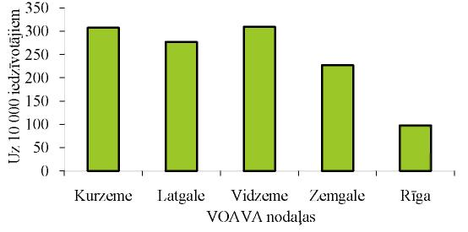
 |  | Kurzeme | Latgale | Vidzeme | Zemgale | Riga
 |  | HCISA departments

In order to improve the social condition of disabled children and their family, since 2008 one of the parents of the child or also another person who takes care of a disabled child will have the right to an allowance for disabled child care in the amount of 50 lats regardless of whether or not this person is employed. Similarly in 2008 the allowance for taking care of a disabled child with severe functional disorders has increased from 50 to 150 lats a month.

People with Special Needs

In Latvia, disabled people are one of the groups subject to the risk of poverty and social exclusion. 10% of families in which there is a disabled person are poor households. 10% of disabled people have higher education, but 19% have only basic education.⁵⁴
According to data of the SSIA, approximately 5% of the total number of residents of Latvia are people with a disability. In 2006 the largest proportion of disabled people was of pre-retirement age, almost 12% – in the age group from 55 to 59 years.
One of the risk factors of social exclusion of disabled people is a low level of employment. Disabled persons and their families lack social services aimed towards the compensation of disability – assistants, attendants, sign language interpreters, etc. The “more severe” the group of disability, the larger the proportion of unemployed persons in this category of residents. The largest part of income for these persons is made up by State social benefits or pensions, thus their level of income is below the average level which limits their possibilities to cover expenses towards health care, using their own means. Thus, in order to improve the social conditions of disabled people, disbursement of a new monthly benefit is commenced since 1 January 2008 – 100 lats for disabled people with severe functional disorders of organ systems who have exceeded the age of 18 years and who need special care. Concurrently, this group of disabled people also receives State social security benefit or pension.

Ethnic Minority – Gypsies

Gypsies (Roma) are another group of residents subject to the risk of social exclusion in Latvia who have an extremely low level of education due to several reasons. According to data of the State Employment Agency, the largest part of gypsies registered as unemployed persons were illiterate.
According to statistical data of the Population Register of the Office of Citizenship and Migration Affairs, at the beginning of 2008 0,3% of residents of Latvia were gypsies, however, leaders of gypsy NGOs expressed an assumption that there could be at least 0,6% representatives of the nationality of gypsies in Latvia. Gypsies usually have low income and a lack of social insurance as there are no official employment relationship. This prevents gypsies from receiving health care services of good quality, as well as creates risk factors to health due to the poor living conditions. At the same time the gypsies surveyed regarding health care admit that they use health care services, particularly services of family doctors and are satisfied with the quality of this care⁵⁴.
Although no information is available in the state regarding different public health indicators (the frequency of diseases, mortality rate of infants, lifespan and disability) according to division of nationalities, there is a reason to think that the low level of education of gypsies, unemployment and living conditions thereof (overpopulation, unhealthy nourishment, etc.) ranks gypsies with risk groups both in relation to morbidity with communicable diseases (for example, tuberculosis) and in relation to neglected diseases. Gypsies predominantly live in houses without amenities and even in the so-called emergency houses that have been recognised as inappropriate for residence. Overpopulation is also typical of gypsies, promoting the spreading of communicable diseases. According to data of the State Register of HIV/AIDS Cases, the morbidity of gypsies is disproportionately large for the number thereof. The main cause of HIV infection of gypsies is the use of intravenous drugs which is a considerably prevalent occurrence among male gypsies.

Victims of Human Trafficking

Studies of international organisations testify that social exclusion and economic migration due to the search of a better life in wealthier states are the main factors promoting human trafficking. Exploitation of people may manifest as forced labour, forced provision of sexual services and use of people in trade of organs. The most widespread type of human trafficking is exploitation of people, forcing them to provide sexual services which causes severe social and psychological traumas, as well as health problems.
In accordance with data of the International Migration Organisation, each year approximately 2000 residents of the Baltic States become victims of human trafficking.
Victims of human trafficking in Latvia have the right to receive social rehabilitation, using funds from the State budget. In 2007, only 12 persons received it.⁶⁵

Poverty – Cause of Poor Health

Low socio-economic condition mainly affects the health of residents indirectly. A connection exists between a low socio-economic condition and the risk of poor health. The socio-economic condition affects the habits of residents and thus also their health. The level of education influences a healthier lifestyle to a great extent, for example, the prevalence of smoking is considerably lower upon the increase of the level of education. Data of studies confirm that 39% of respondents with basic education are daily smokers but 18% – with a higher education.⁶⁷
People with a low education, low income and professions of low prestige have poorer health and higher mortality indicators than people with a higher education, higher income and professions with high prestige. The lower the level of education, the higher the risk of poverty. Therefore – education is an important determining factor for health.⁷⁰
Poverty – regardless of whether it is determined by the amount of income, socio-economic condition, living conditions or level of education – is a significant determining factor for poor health. Living in poverty is often related to an increased use of psychoactive substances (tobacco, alcohol, prohibited medicinal products), depression, anti-social behaviour and delinquency, with an increased consumption risk of unsafe food products and a wide spectrum of somatic problems.
A family (person) is deemed poor in Latvia if income thereof per one family member during the last three months does not exceed 50% of the minimum wage in the state in force on 1 January of the respective year (for example, 80 lats in 2008). The proportion of poor persons (families) in the total number of residents of Latvia is 5%. The largest number of poor persons (36%) resides in the region of Latgale. The division of poor persons in other regions is similar (10-16%).⁵⁴
Inequality in distribution of the income of residents is characterised by the Gini coefficient (index), which varies from 0 to 100%. It is equal to zero if absolute equality in the distribution of income or consumption resources exists but as it draws closer to 100% (or further away from 0), the situation is completely opposite – greater inequality.

Figure 15. Gini Coefficient.
(CSB data)

Percentage | 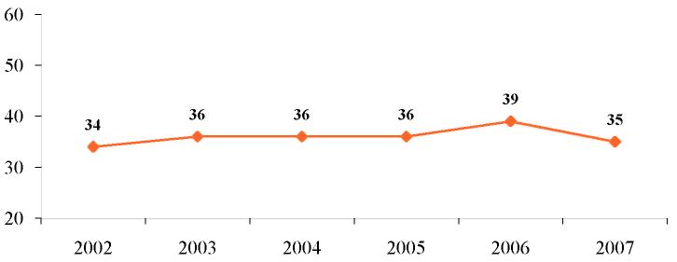
 | Year

In Figure 15, it is evident that Gini coefficient has increased since 2002 up to 2006, however, it decreased in 2007. Such inequality is promoted by the “particularly wealthy” as a separate group of residents and the high proportion of the poor people.
16% of residents in Latvia live below the threshold of the poverty risk, in turn, almost every third resident (30%) lives below the subsistence minimum determined in the state. The highest proportion of households below the threshold of the poverty risk is in Latgale – 36%. More than half of residents (56%) live below the subsistence minimum in the region of Latgale.⁵⁴
According to the CSB data, the index of the poverty risk in Latvia was 21% in 2007, which is by 2 per cent points less than in 2006. In 2005, the highest index of the poverty risk in the EU in division by the types of household was in households containing one adult with children – 32%, but the highest index of the poverty risk in Latvia was in the household with one person – 41% (of all households 25%)., In 2007 one-parent families (with at least one dependent child) also had a high poverty risk index (34%) in Latvia.¹⁴
The inability to ensure the basic necessities and services is typical of poor families. Due to a shortage in finances during the last year 15% of the poor families have not been able to provide the necessary food products, 26% – have been unable to receive the necessary health care services. 30% of the poor families are unable to pay for dental services.¹⁴
Poverty in Latvia has a distinct gender division. In 2007, the poverty risk index was lower for men than for women.¹⁴ One-parent families, containing minors where the provider is a woman are subject to the greatest risk of poverty. As in the majority of cases following the divorce of parents, the responsibility and care for children is assumed by women, feminisation of poverty is observed.
In 2008, the average gross monthly remuneration of women comprised 86% of the average gross monthly remuneration of men.¹⁴ It might be related to the fact that women work in sectors and professions where remuneration is lower. Thus poverty for women may last throughout their lifetime because the low remuneration, from which social security contributions are made, is also reflected in lower pensions in old age.
Poverty is usually related to unemployment. 70% of all persons seeking employment live below the subsistence minimum, 54% live below the threshold of the poverty risk and 29% are poor⁵⁴.
A direct connection exists between the level of poverty and the number of employed persons in a household. Of all the poor families, half are households where there are no employed persons, 35% – households where one person is employed. 26% of the poor families have at least one unemployed person. The inaccessibility of transport or the inability to afford it is specified as a significant obstacle for the involvement of poor persons in the labour market.⁵⁴
The main groups of residents having an increased risk of unemployment are as follows:
• disabled persons;
• ex-convicts; and
• women after a parental leave.

In November 2008 the registered level of unemployed persons in the state was 6% (the number of unemployed persons in the total number of economically active residents).
The highest level of unemployment is observed among residents with basic and lower education, the lowest – among residents with higher education. Long-term unemployment is one of the most current problems in the labour market of Latvia: Between 2002-2005, 48% of all persons seeking employment were without work for over a year.⁵⁴
At the beginning of 2008, long-term unemployed persons comprised 18% of all unemployed persons, from which 13% were young people (from 15 to 25 years of age), 6% – persons with a disability, up to 1% – persons after serving a sentence in a place of imprisonment, 7% – persons after a parental leave, 11% – unemployed persons of pre-retirement age.
Work does not always manage to ensure workers with the necessary resources, in particular if it is related to a low remuneration, low qualification, uncertain working conditions or insufficient training.
Poverty has a distinct regional character. In Riga not only more residents are employed, but the average remuneration is more than twice as high as the remuneration received by persons working in the rural districts.⁵⁴
One of the indicators characterising poverty are the commodities of a dwelling. A connection exists between the size of the overall living area per one household member and whether the household lives below the threshold of the poverty risk.
Almost every third household below the threshold of the poverty risk (32%) has less than 15 square metres per one member of the family. There is a cold water supply in 83% of households living below the threshold of the poverty risk, hot water – in 55%, sewerage – in 76%, shower or bath – in 62%, heating by firewood – in 56%, propane tanks – in 55%, as well as 10% of all the premises of a dwelling are damp and difficult to heat.⁵⁴ An inadequate microclimate in rooms, overpopulation, lack of sanitary premises and facilities (no shower or bath) not only largely affects the risk of residents to catch communicable diseases, but also creates a negative psychological climate and unsafe environment from the point of view of injuries.
In Latvia, similarly as in most other European states, the ageing of residents, that is, the increase of the average age and of the proportion of elderly residents, as well as the reduction in the proportion of children and young persons, has become a serious socio-demographic challenge. Taking into account that the highest poverty risk index is for residents who are more than 65 years of age, the ageing process of residents may increase the proportion of the poor residents. As the proportion of the old people increases, each year the financial amount that is used in local governments for measures in areas of social support, including payment for health care services, increases in Latvia. In 2007 almost 6% from the social budget of local governments provided for measures of social assistance were disbursed for this purpose.
Since 2004 inflation and rise of prices is consistently regarded as the most important problem in Latvia (in 2008 – 71% of respondents). The second most significant problem mentioned was – economic situation of the state (in 2008 – 31% of respondents). The standstill in the rapid economic growth observed in 2007-2008 promotes an increase in unemployment and credit burden, an increase in the proportion of poverty and deterioration of other economic indicators. As the socio-economic situation in the state affects both the accessibility of health care services and health indicators of residents, deterioration of many indicators (for example, depression, suicides, increase in the frequency of alcoholism), as well as an increase in inequality in the field of health may be anticipated.

POLICY INITIATIVES

The principles of social equity and solidarity are defined in many international and Latvian regulatory enactments.
Since 2005, the Commission on Social determinants of Health is operating in the WHO, and one of the objectives thereof is to help in creation of long-term global activities in the field of factors promoting health equality and social health.
In Latvia there are several regulatory enactments in the health and social field, which determine equality, as well as different measures in relation to socially less protected groups of residents.
Article 111 of the Constitution of the Republic of Latvia (15.02.1922) prescribes that the State shall protect human health and guarantee a basic level of medical assistance for everyone.
The Law On Local Governments (19.05.1994) prescribes that local governments shall ensure accessibility of health care, as well as promote healthy lifestyle of residents; shall ensure social assistance to residents (social assistance for poor families and socially vulnerable persons, ensuring places for old people in old-age homes, ensuring places for orphans and children without parental care in training and educational institutions and provision of overnight shelters for the homeless etc.).
The Medical Treatment Law (12.06.1997) regulates the field of medical treatment in order to ensure qualified prophylaxis and diagnosis of diseases or injury, as well as medical treatment and rehabilitation of patients. The Law also prescribes that everyone has a duty to take care of and everyone is responsible for his or her own health, the health of the nation, and the health of his or her relatives and dependants.
Cabinet Regulation No. 1046 “Procedures for the Organisation and Financing of Health Care” adopted on 19 December 2006 prescribe the procedures for the organisation and financing of health care, the types and amounts of medical treatment services that shall be paid from the State budget and the resources of the recipient of services, the procedures for the payment of the referred to services, as well as the procedures by which centralised queues of applicants for the receipt of systematic health care services shall be formed.
Cabinet Regulation No. 899 adopted on 31 October 2006
“Procedures for the Reimbursement of Expenditures for the Acquisition of Medicinal Products and Medical Devices Intended for Out-patient Medical Treatment” prescribe the procedures for the reimbursement of expenditures for the purchase of medicinal products and medical devices intended for out-patient medical treatment
On 10 March 2008 the Cabinet issued Order No. 116 “On Medium-term Budgetary Objectives and Priority Development Directions in 2009-2011”, which prescribes the priority development directions, including:
an improvement in the quality, availability and cost-effectiveness of health care services, in developing human resources in health care, a modern infrastructure of medical treatment institutions and primary health care system;
the development of social security system and an improvement of accessibility of social services, including improvement of the living conditions of retired persons; and
an increase in the State benefit for families with children and the promotion of birth rate.

One of the most significant socio-economic factors is the education acquired. On 23 February 2007 the Cabinet approved “Guidelines for Lifelong Learning Policy for 2007-2013”, objective of which is to ensure the accessibility of education to residents regardless of their age, gender, previous education, place of residence, level of income, ethnic origin, as well as functional disorders.
The Social Services and Social Assistance Law (31.10.2002) establishes principles for the provision and receipt of social work, social care, social rehabilitation, professional rehabilitation services and social assistance, the range of persons who have the right to receive these services and assistance, as well as the principles for payment and financing of social care, social rehabilitation and professional rehabilitation services.
The Law On Medical and Social Protection of Disabled Persons (29.09.1992) regulates the procedures for determining disability, as well as the procedures by which medical and social assistance is provided to disabled persons.
The Law On Social Security (07.09.1995) prescribes the principles for the structure and operation of a social security system, the main social rights and duties of a person, the basic conditions for its implementation, as well as regulates the types of social services, including social and instructional assistance, and promoting social equity and social security.
The purpose of the Law On State Social Benefits (31.10.2002) is to determine the types of State social benefits, the range of those persons who have the right to the State social benefits, the conditions for the granting thereof, the procedures for the granting and disbursement, as well as the appeal procedures for decisions related to these benefits.
Latvia has recognised or ratified several international documents relating to the fight against human trafficking, as well as the Cabinet has approved “Regulations Regarding the Procedures by which Victims of Human Trafficking Receive Social Rehabilitation Services and the Criteria for Recognising Persons as Victims of Human Trafficking” (31.10.2006), which prescribe the procedures by which a person who is recognised as a victim of human trafficking shall receive social rehabilitation services from State budget funds and the criteria for recognising a person as a victim of human trafficking.
The main objectives for the solution of poverty and social exclusion issues are defined in the Law On the Joint Social Inclusion Memorandum (Latvia) (17.06.2004).
In 2005 the Cabinet approved the Policy Guidelines Regarding Reduction of Disability and Consequences Caused by It for 2005-2015,
in which the guiding principles, objectives and priorities of the State policy of disability prophylaxis and social protection of disabled persons are included. According to the guidelines an Action Plan for the Implementation of the Policy Guidelines for Reduction of Disability and Consequences Caused by It for 2005-2015 was developed in 2006 in order to perform the four main tasks:
1) the development and implementation of a complex of prophylactic measures in respect of disability;
2) the improvement of the disability determination system;
3) the promotion of employment of disabled persons; and
4) the improvement of the social security system in respect of disabled persons.

The achievement of Objective 2 “Equity and Solidarity in the Field of Health” of the Public Health Strategy depends not only on the implementation of the health care policy in the state, but also on all the other 17 fields of policy, including budgetary and financial policy, employment and social policy, environmental policy, education and science policy, policy of tourism, sports and leisure time, domestic policy, etc.

CONCLUSIONS AND PROPOSALS

Conclusions

• A connection exists between a low socio-economic condition and a risk of poor health.

• In Latvia a fairly large part of residents is subject to the risk of inequality, improvement of health indicators of this particular group of residents might promote the improvement of health of all residents.

• Many health indicators are worse in poor and socially excluded groups of residents, as well as in groups depending on the socio-economic factor affecting health, for example, low level of income, low level of education and living in the countryside.

• The average life expectancy of newborn infants for rural residents is shorter than for residents of cities by 2 years.

• The level of mortality from diseases of the circulatory system, external causes of death and diseases of the respiratory system is higher in the countryside than in cities.

• Health habits are related to socio-economic factors that accordingly have unequal effect on health condition, for example, the proportion of smokers is smaller and the nourishment habits are healthier in the group of residents with a higher level of education.

• The insufficient number of medical practitioners and the unequal division of specialists among regions is a reason why several services are only partly available to patients.

• A significant factor restricting the accessibility of health care services for residents is the lack of financial resources.

Almost every third resident of Latvia lives below the subsistence minimum.

• The poverty risk index is higher for women than for men.

• Information regarding the connection of socio-economic factors with health indicators of residents is lacking in the register of morbidity, disability and mortality indicators.

Proposals

• To reduce health inequality by improving indicators in the groups of residents subject to the risk of social exclusion in order to promote the improvement of health indicators of all residents.

• To plan and take measures promoting health, which are aimed towards specific risk groups, for example, to ensure accessibility of the environment, including accessibility of health care services, to people with a disability.
• To study those residents who are in the most disadvantaged situation and to provide them with the necessary support, implementing measures that are aimed towards a specific problem in the relevant risk group.

• To promote inter-sectoral co-operation and responsibility in the field related to reduction of health inequality, for example, by developing policy planning documents, to include activities and responsibilities for all sectors involved.

• To take measures in order to reduce the differences between the average life expectancy of newborn infants among rural residents and city residents, for example, by reducing the differences in accessibility of health care services between cities and the countryside.

• To specify the responsibility and functions of local governments in the field of health of residents, reducing inequality among different local governments.

• To compile data and study the influence of socio-economic factors on health indicators of residents, for example, establishing the causes of death due to which the mortality rate of rural residents is higher than the mortality rate of city residents.

• To find an opportunity for analysing data, combining them from different databases, for example, the database of the causes of death and the results of the population census, put together, would allow to evaluate the connection between the mortality rate and education and other socio-economic factors.

• To evaluate the influence of different policies on health of residents, for example, how tax policy affects health of residents (for example, the increase of excise duty for cigarettes).

COMMENTS REGARDING DATA

Routine statistical data from databases of the World Health Organisation (for international comparison), the Central Statistics Bureau, the State Social Insurance Agency, the results of different studies, as well as reports prepared by other institutions regarding the situation in Latvia were used in the report.
Information is lacking in the register of health indicators regarding the connection of socio-economic factors with morbidity and mortality, for example, mortality from diseases of the circulatory system in relation to social problems: individual indicators for poverty, unemployment etc. are available according to division by regions or the type of the place of residence (countryside, cities), for example, the average life expectancy of newborn infants (CSB data). However, the availability of data in such division is limited. The latest data regarding mortality, except mortality from violence and mortality from intentional self-harming, in the division “countryside, cities” are available only in relation to year 2004.
In analysing data regarding the mortality and morbidity of residents of Latvia according to division by regions, the impeding fact is that the statistical regions of the CSB differ from the division of the departments of the HCISA, for example, in one division the Balvi district is located in Latgale region, in the other – already in Vidzeme region.
The data quality according to division by regions also has a negative effect on the procedures of registration, for example, it is not possible to analyse the registered mortality with addiction to alcohol according to division by regions or districts because one patient may be registered in several districts.
Indicators for evaluation of the prevalence of poverty are lacking. Currently there are several methodologies for determination of the level of subsistence, which allow the widest interpretations and opportunities to speculate with data. A poverty line is not defined in regulatory enactments, therefore the threshold used by Eurostat– 60% of the median equivalent income – is utilised for measurements and comparisons. Determination of the poverty line would allow to calculate the number of poor residents, to evaluate the depth of poverty, as well as to evaluate the amount and scale of the necessary measures.
In analysing the situation in Latvia in relation to disability indicators, data of the SSIA were used regarding number of the disabled persons who have had or have been granted one of the types of social insurance services due to disability, as well as data of the SMCAHCWA were used regarding emerging and repeated disability. Since 2004 data regarding disabled children are compiled by the SMCAHCWA. Unfortunately, it is not possible to include disabled children from 16 to 18 years of age who receive social security benefit (due to registration problems it is not possible to separate their number from the number of all recipients of the benefit) in the total number of disabled children.
Information is lacking not only regarding health indicators but also regarding socio-economic factors, for example, there are no credible and comparable data regarding such children who do not attend and finish school.
There is no unbiased information regarding homeless persons. The only available data regarding such persons are the statistics of the visitors registered in shelters. However, it should be taken into account that part of homeless persons does not visit shelters but reside in temporarily abandoned houses and garden houses.
It is not possible to acquire precise data regarding the number of victims of human trafficking, because: 1) one of the greatest obstacles in determination of victims remains the weak skill of identifying them both among professionals and in the society at large; 2) human trafficking is the hidden form of crime, which significantly hinders the coming of victims to the attention of law enforcement authorities; 3) professional and general principles of ethics provide for ensuring confidentiality of victims, thus also the recognised victims are not always included in one or another registration system.

EXPLANATION OF MAIN TERMS AND CONCEPTS

Alcoholism – excessive consumption of alcoholic beverages, which has adverse effects on health and is detrimental to the conditions of work, social life and material welfare.

Level of unemployment – the number of unemployed persons/number of residents of working age x 100. It shows the proportion of human resources, which are unused in the national economy and are already available in short-term, in the total number of economically active residents in the age group from 15 to 74 of age in the respective period of time.

Unemployed person – a jobless permanent resident of Latvia of working age who has no earnings or other income at least in the amount of the minimum wage due to reasons independent of him or her and who is seeking work and is registered in a State employment institution according to the place of registration.

Homeless persons – persons who are unable to obtain a permanent dwelling or retain a permanent place of residence due to social circumstances.

People with special needs – groups of people whose special needs are determined by specific health, social or economic circumstances.

Human trafficking –recruitment, transportation, transfer, hiding or receipt of persons carried out for the purpose of exploitation, using violence or threats, or abduction by fraud or taking advantage of the dependence of the person on the guilty party or of his or her helpless condition, or also giving or receiving benefits of tangible or other nature in order to obtain a consent of such person for trafficking, on whom the victim is dependent.

Victims of human trafficking – persons who have been caused harm – a moral injury or physical suffering – by a criminal offence – human trafficking.

Persons seeking employment – all unemployed persons regardless of whether or not they have registered with the State Employment Agency.

Quality of life — a welfare indicator of a person, family, group of persons, or society which includes physical and mental health, free time and spending thereof, work, link with the society, the right to take and fulfil decisions independently, as well as material security.

Large families – families with three and more children.

Gini coefficient (index) – characterises the equality of division of the income mass in state. It varies from 0 to 100. The larger the number, the higher the inequality.

Ethnic minorities – nationalities, representatives of which are in minority among the residents of the relevant territory, a minority.

Gross domestic product – the total value of end products and services produced in the territory of state during one year. It may be calculated, using data regarding domestic production, demand (consumption) and income in the actual and comparable prices.

Long-term unemployed persons – unemployed persons who are registered with the SEA for more than one year.

Disabled person – a person who needs additional medical and social assistance due to illness, trauma or functional disorders of organ systems caused by inherited defects and who have been specified as having disability according to the procedures prescribed by regulatory enactments.

Disability – long-term or non-transitional restriction of physical or mental abilities, which is not related to the ageing of organism and hinders integration of a person in the society, completely deprives or partially restricts his or her ability to work and take care of himself or herself.

Disabled child – a person in the age group from 0-15 years of age who needs additional medical and social assistance due to illness, trauma or functional disorders of organ systems caused by inherited defects and who have been specified as having disability according to the procedures prescribed by regulatory enactments. Disability of children up 16 years of age is determined without division into groups.

The first disability group is established if a person has very distinctive restrictions of physical or mental abilities, integration in the society is not possible without permanent assistance corresponding to the needs of person, the working capacity and the ability to take care of oneself is very limited.

The second disability group is established if a person has distinctive restrictions of physical or mental abilities, integration in the society is not possible without assistance corresponding to the needs of person, the working capacity and the ability to take care of oneself is restricted.

The third disability group is established if a person has moderate restrictions of physical or mental abilities, integration in the society is hindered without assistance corresponding to the needs of person, the working capacity and the ability to take care of oneself is restricted.

Average life expectancy of newborn infants – the number of years that newborn infants born in the respective year would have lived on average if, during their lifetime, death rate at each age remained the same as in their year of birth.

Quintile – one fifth of the number of the surveyed households, which are grouped in ascending order according to the income at their disposal per one household member. Quintile 1 is the poorest and Quintile 5 is the wealthiest household.

Household – is a person or a group of persons who live in one dwelling and jointly cover household expenses.

Poverty – insufficient income and resources (economic, social and cultural), which are so limited that the level of living of a person is lower than the one recognised by society.

Index of poverty risk – the number of residents who live below the relative level of poverty, in per cent (the proportion of the persons whose equivalent total net income is less than 60% of the national median income).

Cause of death – disease, pathological condition or trauma that has caused or promoted death, as well as an accident or an act of violence resulting in death.

Emergency medical assistance – provision of first aid in case of sudden falling ill or trauma resulting in threats to the life of the victim.

One-parent families – families, in which a child/children is/are being brought up by just one parent.

City residents and rural residents – the division of residents into city residents and rural residents are established according to the declared place of residence. City residents are persons who live in cities. The list of cities is approved by the Cabinet. All other residents are rural residents.

Primary health care – the first stage of contact between a patient and a provider of health care services (family doctor, doctor’s assistant, nurse, midwife, dentist, dental assistant, dental nurse and hygienist).

Region – the concept of region is perceived differently in Latvia and in practice various regions exist: statistical regions, planning regions, moreover, many State administrative institutions, activities of which take place in all territory of the State, have introduced their regional division. Currently there is a situation where tens of administrative territories of regional level exist (the State Revenue Service, sickness funds, environmental boards, etc.), however, borders thereof often do not concur.

Secondary health care – specialised outpatient and inpatient health care that is orientated towards emergency, acute or systematic health care (which is provided in an outpatient medical treatment institution, the outpatient department of a hospital, an emergency medical assistance institution, an inpatient day station or a hospital).

Social exclusion – the inability of an individual or a group of people to fit in the society due to poverty, insufficient education, unemployment, discrimination or other circumstances.

Social inclusion – a process that ensures the opportunities and resources for people with special needs, which are necessary in order to fully participate in economic, social and cultural life of the society, to ensure a standard of living and welfare recognised by the society, as well as greater opportunities for participation in decision-making and access to the basic human rights.

Children and youths at social risk – children and youths from disadvantaged families, with functional disorders, children of ethnic minorities (mainly Roma), children released from places of imprisonment, orphans, former pupils of children’s home, unemployed youths, with different types of addictions etc.

Solidarity – community of interests, objectives and attitudes and unity of actions of members of a group.

Equity – equal opportunities for anyone to achieve the highest level of their health.

Health – physical, mental and social welfare, the natural basis of the existence and survival of the State and the nation.

Health care – the complex of measures for ensuring and maintaining health.

Determining factor for health – a spectrum of individual, social, economic and environmental factors that determine the health condition of an individual and society.

ABBREVIATIONS:

AIDS | Acquired immunodeficiency syndrome – the final stage of HIV infection when the organism is no longer able to resist carriers of illnesses.
CSB | Central Statistics Bureau
EU | European Union
Eurostat | Statistical Office of the European Communities
EU-SILC | European Union Statistics on Income and Living Conditions
FINBALT | Research on Health Behaviour among Latvian Adult Population
HIV | Human immunodeficiency virus
GDP | Gross domestic product
LV | Latvia
Cabinet | Cabinet
SEA | State Employment Agency
WHO | World Health Organisation
STSID | Sexually transmitted and skin infectious diseases
PHA | s/a “Public Health Agency”
TB | Tuberculosis
SMCAHCWA | State Medical Commission for the Assessment of Health Condition and Working Ability
HBV | Hepatitis B virus
HCV | Hepatitis C virus
MoH | Ministry of Health
SSIA | State Social Insurance Agency
HSMTSA | Health Statistics and Medical Technologies State Agency
HCISA | Health Compulsory Insurance State Agency

M. Eglīte. Darba medicīna. Riga 2000
Rich man, poor man: The life expectancy gap. Economic Policy Institute, 2008; http://www.epi.org/content.cfm
Disease In Human Evolution: The Re-Emergence Of Infectious Disease in The Epidemiological Transition. Department of Anthropology Smithsonian Institution, 1996; http://anthropolog.si.edu
NEW DRUGS, NEW VACCINES, NEW DISEASES USIA Electronic Journals, November, 1996; http://usinfo.state.gov/journals
J. Mackenbach, W. J. Meerding, A. Kunst. Macroeconomic Impications of Health Inequalities, 2007
WHO, G.D Dahlgren, M. Whitehead, European Strategies for trackling social inequalities in health: Levelling up Part 2, 2007
6 WHO, G.D Dahlgren, M. Whitehead, European Strategies for trackling social inequalities in health: Levelling up Part 2, 2007
DETERMINE consortium, “Action Summary. Improving Health Equity via Social Determinants of Health in the EU”, 2008
TREATY ON EUROPEAN UNION. Maastricht, 7 February 1992
Informative report “National Report on the Social Security and Social Inclusion Strategy for 2006-2008 (26.09.2006)
Commission of Strategic Analysis, Zinātniski pētnieciskie raksti No.3(9)/2006 “Demographic Development in Latvia at the Early 21st Century”
Public Health Agency, KTL-National Public Health Institute, Research on Health Behaviour among Latvian Adult Population, 2006
Central Statistical Bureau, results of the 2003 health survey of residents of Latvia, 2004
European Commission, Eurobarometer 69, spring 2008
Database of the Central Statistics Bureau, www.csb.gov.lv
K. Rinkužs, V. Dzērve, E. Pahomova-Strautiņa, I. Markoviča, N. Bricina, G. Mitjuševa, Risk Factors for Cardiovascular Diseases in Depopulation Aspect, 2006
Child Safety Good Practice Guide, European Cld safety alance, Eurosafe, 2006
Violence and health. Report on Situation in Latvia. Ministry of Health, World Health Organisation. Riga 2007
Public Health Agency, Sociological Research Institute “Research On Alcohol Use in Relation to Injuries and Violence”, Riga 2008
M. Baltiņš. Lietišķā epidemioloģija. 2003
Health Statistics and Medical Technologies State Agency, Yearbook of Health Care Statistics in Latvia, 2007, 9th edition, Riga 2008
H. Štovers, M. Lēmans, S. Olsena, .Upmace, .Skripste, F. Trautmans, K. Veilande, Infection Surveillance and Prophylaxis in Places of Imprisonment of Latvia, 2007
Public Health Agency, Mental Health of Residents of Working Age, Riga 2008
Cabinet, Guidelines “Improvement of Mental Health of Residents in 2009-2014” (06.08.2008)
WHO, Guidelines on HIV infection and AIDS in prisons, 1993
Cabinet Regulation No 429 of 24 September 2002 429 “Procedures for the Treatment of Patients Addicted to Alcohol, Narcotics, Psychotropic and Toxic Substances”
Cabinet Regulation No.1046 of 1 January 2007 “Regulations for the Organisation and Financing of Health Care”
European Monitoring Centre for Drugs and Drug Addiction, The State of the Drugs Problem in Europe, 2007
Public Health Agency, The Use of Drugs in Entertainment Sites, Riga 2008
Public Health Agency, “Prevalence of the Use of Addictive Substances among Residents, Research Results”, Riga 2008
Public Health Agency, Prevalence of the Use of Addictive Substances and Consequences Thereof in Latvia, 15th edition, Riga 2007
Public Health Agency, Mental Health Care in Latvia 2006. Statistical Yearbook. 7th edition. 2007
Central Statistics Bureau, Statistical Yearbook of hHealth in Latvia, 2005. Riga 2005
Ministry of Health, Informative Report on Regulatory Enactments to which Amendments must be Made in Order to Reduce the Requirements for Acquisition of Medical Education and to Efficiency of Retraining of Medical Practitioners, 2008
Cabinet Order No. 870 of 6 November 2006, “Programme “Development of Human Resources in Health Care for 2006-2015””
Ministry of Health, Ministry of Health, Informative Report on Regulatory Enactments to which Amendments must be Made in Order to Reduce the Requirements for Acquisition of Medical Education and to Efficiency of Retraining of Medical Practitioners, 2008
Institute of Philosophy and Sociology of the University of Latvia, Society “Baltic International Centre for Economic Policy Studies”, “Institute of Sociological Studies” Ltd., “Reasons for Unemployment and Social Exclusion and Duration Thereof”, Riga 2007
Data of the Health Statistics and Medical Technologies State Agency
Cabinet Regulation No. 899 of 31 October 2006, “Procedures for the Reimbursement of Expenditures for the Acquisition of Medicinal Products and Medical Devices Intended for Out-patient Medical Treatment”
Transforming the Latvian Health System. Accessibility of health services from pro-poor perspective. German Development institute, 2004
V. Ozoliņa. Studies on Self-medication and Pharmaceutical Care in Latvia: Analysis of Tendencies, Benefits and Risks. Doctorate work, RSU, 2006
EU-SILC Survey on Income and Living Conditions. Proposal for indicators to measure potential and self-report unmet care needs and barriers to access. Discussion paper for the ISG meeting, 2007
UNO Development Programme in Latvia, Institute of Social and Political Studies of the University of Latvia, Latvia. National Human Development Report 2004/2005. Capacity to Act in Regions, 2005
Proposal for indicators to measure potential and self-report unmet care needs and barriers to access. Discussion paper for the ISG meeting, 2007
V. Boroņenko. Access to Health Care Services. Riga 2003
UNO Development Programme in Latvia, Institute of Social and Political Studies of the University of Latvia, Latvia. National Human Development Report 2004/2005. Capacity to Act in Regions, 2005
J. Karaškēvica. Healthcare System Reform and Population Health in Latvia, 1993-2003. RSU, Riga 2005
S. Zelmene, Frequency of Visits to a Family Doctor in the Age Group of Residents of Latvia from 35 to 64 Years of Age in Relation to the Reachability of Primary Health Care Institutions, Health Statistics and Medical Technologies State Agency, RSU (Masters paper), 2004
University of Latvia, Access to Health Care in Riga and Vidzeme, Riga 2006
Central Statistics Bureau, Health Survey Results of Population of Latvia, 2003
Health Compulsory Insurance State Agency, Statistics of Waiting Lists, 2007 http://www.voava.gov.lv/lat/veseliba/statistika/
Health Care of Latvia – the Worst in the EU. Health Consumer Powerhouse, Brussels, 1 October 2007
GfK Custom Research Baltic, Research on Family Doctor’s Motivation upon Deciding on the Need for Referral to a Specialist, Riga 2007
Social Protection Committee of the European Commission, Child Poverty and Well-being in the EU, 2008
Institute of Philosophy and Sociology of the University of Latvia, Society “Baltic International Centre for Economic Policy Studies”, “Institute of Sociological Studies” Ltd., “Reasons for Unemployment and Social Exclusion and Duration Thereof”, Riga 2007
Child Poverty and Well-Being in the EU. Current status and way forward. The Social Protection Committee, EC, 2008
Ministry of Welfare, Identification of Social Assistance Risk Factors for Children from Poor Families, 2002
J. Mackenbach, W. J. Meerding, A. Kunst. Macroeconomic Implications of Health Inequalities, 2007
I. Straume, The Dynamics of the Number of Children and Child Care in Latvia, 2006
Ministry of Welfare, Disabled Persons in Latvia. Most Important Socio-economic, Demographic and Sectoral Indicators. Statistical Bulletin 2002-2006, Riga 2007
Cabinet, Guidelines for Policy of Lifelong Learning for 2007-2013 (23 February 2007)
Situation of Gypsies in Latvia, Centre for Human Rights and Ethnic Studies, Riga 2003
Cabinet, National Programme for Prevention of Human Trafficking, 2004-2008 (approved on 3 March 2004)
Baltic Institute of Social Sciences, Efficiency of Social Services for Reintegration of Victims of Human Trafficking, Riga 2007
Ministry of the Interior, www.cilvektirdznieciba.lv
Ministry of the Interior, Informative Report on the Process of implementation of the “National Programme for Prevention of Human Trafficking, 2004-2008” in 2007 (25 April 2008)
European Commission Health & Consumer Protection Directorate-General, Economic implications of socio-economic inequalities in health in the European Union, 2007
Public Health Agency, KTL-National Public Health Institute, Research on Habits Affecting Health of the Population of Latvia, 2006
Ch. Monden. Socio-economic Health Inequalities in Latvia: Descriptive and Explanatory Analyses. Nijmegen University, 2001
Research of non-governmental education policy centres from Albania – CDE, Kazakhstan – EPAC-Bilim, Latvia – PROVIDUS, Mongolia – MEA, Slovakia – EPC Orava Association, Tadzhikistan – ERSU on the Pulse project “Monitoring of Persons with Unfinished Basic Education”, 2006
WHO, Health for All: Policy Framework for the WHO European Region “Health – 21”, 1999
Social Protection Committee of the European Commission, Child Poverty and Well-being in the EU, 2008
Central Statistics Bureau, EU-SILC survey 2005
Law On the Joint Social Inclusion Memorandum (Latvia) (adopted on 17 June 2004)
Ministry of Welfare, Informative Report “National Action Plan of Latvia for Reduction of Poverty and Social Exclusion (2004-2006)”, Process of Implementation in 2005, 2006
Data of the State Employment Agency
Public Health Agency “Environmental Influence on Health” results of the survey of residents of Latvia, Riga 2008
Ministry of Children and Family Affairs, Report on the Issuance of Local Government Benefits to Poor Persons and Families with Vhildren, 2008;
European Commission, Eurobarometer 69, spring 2008
Description of Situation regarding Resolving of Poverty and Health Issues in Latvia. In accordance with the WHO Resolution EU/RC52/R7, 2007
Baltic Institute of Social Sciences, Efficiency of Social Services in Reintegration of Victims of Human Trafficking, Riga 2007

