The Ministry of Health of the Republic of Latvia

CONCEPT
of Improving the Quality of Health Care and Patient Safety
Quality Management or Management Quality

Content

1. Quality of Health Care System 2
2. Strategic Objectives 3
3. Model of Health Care Delivery offered by the Concept 4
4. Structure – Problem Solving 5
4.1. Common Understanding of the Quality of Medical Treatment Processes, Patient Safety and Implementation of a Patient Safety System 5
4.2. Maintaining and Enhancing Competencies of Health Care Professionals 6
4.3. Ensuring the Integrity of Clinical Practice Guidelines and Algorithms 7
4.4. Improving of Monitoring and Supervision Mechanism of Medical Treatment Institutions 8
4.5. Handling Patient Complaints and Grievances and Decision-Making 10
4.6. Administration of Treatment Risk Fund 10
4.7. Cross-sectoral Cooperation 11
4.8. Organisation of Legislation 11
4.9. Identification of Policy and Strategy, Allocation of Resources 11
5. Process – the Quality of Medical Treatment and Care Processes and Patient Safety 12
5.1. Quality Assurance of Medical Treatment Institution Processes 12
5.2. Patient Safety 16
6. Outcome 20
7. Sources: 21

1. Quality of Health Care System
Without spending any time on the analysis of the present situation which is characterised by the dissatisfaction of the inhabitants and health care professionals of Latvia with the present state of the health care system, the results of the studies of the World Bank and World Health Organisation, and also particular indicators, including those included in the OECD report of 2016, by analysing and being aware of the weaknesses of the present system, the Concept has been developed in order to organise the system within the dimensions of the elements and dimensions affecting its quality.
What is health care quality?

Health care quality dimensions

The quality of health care services may be characterised with simple words: to correctly do a work determined correctly or to take the right decisions which are justified with correct information; to correctly carry out the right manipulations, for the right patient, at the right place and time; to use the right medicinal products for the right patient at the right time and similar and at minimal costs.

In turn the quality of the health care system should be examined in several dimensions:

Safety: not to harm the patient! Safety is freedom of a patient from unnecessary or potential harm associated with health care. Patient safety case (incident) is a case as a result of which unintentional (accidental, unintentional, including due to mistake or failure) harm to a patient has occurred or could have occurred when carrying out work duties or as a result of lack of action. It is also important to ensure safety of the information of personnel, visitors – all involved parties – and other safety elements.

Effectiveness: to achieve the result with the available means/resources. Effectiveness is the optimal, rather than maximal care for patients and society in general which may be assessed by performing the specified data analysis.

Availability, timeliness: the availability of health care services must not depend on geographical, economic, social, cultural or language barriers, whereas the health care professionals must have access to resources for the performance of medical treatment and care. Timeliness is characterised by the availability of health care services in conformity with the condition of the patient in the right time when it is necessary by complying with continuity of medical treatment and care services (diagnostics, medical treatment, monitoring, rehabilitation).

Technical competence is the skills, abilities of the personnel to carry out medical treatment and care, and also to respond in irregular situations. It concerns not only the issues of education, certification/recertification and further education, but also practical experience and continuous training of skills.

Objectivity: equal medical treatment for equal needs. Will the selected medical treatment lead to the desired outcome? Clinical guidelines and standard approaches to standardised tasks – clinical algorithms for the diagnostics of determined diseases and similar may help to answer this question.

Efficiency: to carry out only the necessary procedures or manipulations rather than all procedures or manipulations possible in medicine or in the particular medical treatment institution according to the principle “As little as possible, as much as necessary”.

Continuity: a patient receives continuous and full necessary medical care by ensuring succession of medical services for a patient in all stages and health care levels thereof that may be implemented through mutual cooperation of medical practitioners and institutions, exchange of information.

It must be noted that medicine is not 100 % safe and a health care quality level is never up to and cannot reach 100 %, because a human who is an integral part of this system has always been the source of variations: both as a professional of the health care system and the human – patient with his or her health condition peculiarities, requirements, desires and expectations. The understanding of human factor has been used in the development of the Concept, and the approach of Avedis Donabedian, the founder of quality studies and theory in the field of health care, “structure – process – outcome” has been used for the health care system quality improvement, and also the principles:
  - patient and his or her family is in the centre of all processes;
  - involvement of all interested parties in the health care system improvement;
  - to identify a good practice of the functioning of the health care system of the European Union and to introduce it in the health care system of Latvia;
  - to standardise to maximum the items and approaches to be standardised in process management;
  - to measure effectiveness, efficiency, availability, quality and patient safety levels – outcomes, and also to monitor outcomes in their dynamics.

2. Strategic Objectives
Strategic objectives are ambitious, however reachable on the condition that all interested parties will be involved in reaching the objectives, the necessary financial resources will be provided, the development of human resources and maintaining thereof in sufficient number and competence will be achieved.
One of the most important factors of success is transparency, communication with the public. and publicity in the course of the health care system improvement, and use of resources, and also involvement of inhabitants – patients and their families – in the supervision and result of health care system operation, establishment of partnerships between health care professionals, supervisory authorities, policy and strategy developers and patients – inhabitants.

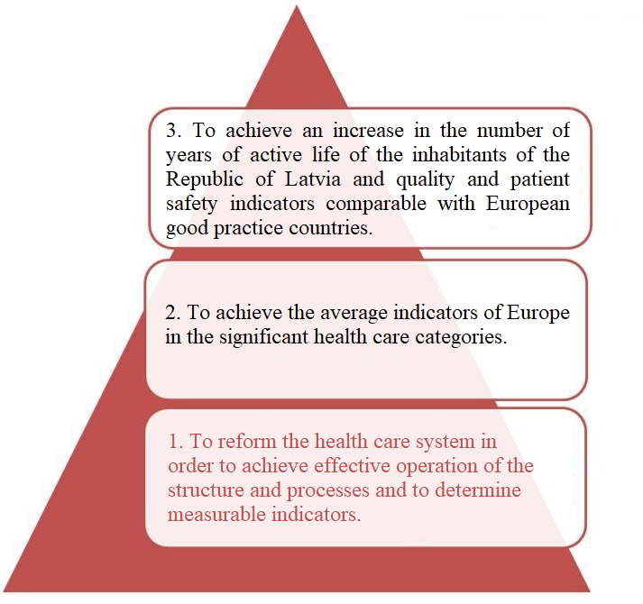

Figure 1. Strategic objectives

The following is planned to be achieved in the result of implementation of the Concept:
1. improvement of patient safety;
2. improvement of confidence of patients in the health care system;
3. formation of a unified understanding of the health care system and quality of medical treatment processes.

3. Model of Health Care Delivery offered by the Concept
The institutions which by implementing the functions laid down by the State in the laid down amount and according to the laid down methods ensure functioning of the system are necessary for efficient and useful operation of the health care system.
Preconditions for effectiveness and efficiency are co-ordinated action and cooperation between these institutions. By applying the approach of Donabedian “structure – process –outcome” to the health care system in general, those forming the structure may be identified:
  - the institutions providing health care strategy, policy and planning, allocation, recording and analysis of financial resources;
  - the institutions which carry out the registration of medical treatment institutions and medical practitioners, supervisions and control of the quality and safety of medical treatment services, and also examine complaints of patients;
  - the institutions which ensure operation of the Treatment Risk Fund;
  - the institutions which co-ordinate and implement the measures and programmes in relation to epidemiological safety, implement disease prevention programmes;
  - the educational institutions which prepare new health care system professionals;
  - the institutions which process the data related to medical treatment and care processes which are used for decision-making;
  - the professional associations which take care of further education of professionals and maintaining competences, certification of medical practitioners, and also ensure development of clinical and methodological documents;
  - the institutions which defend patient rights and public organisations of patients;
  - the institutions for special assignments: for the provision of emergency medical care and ensuring blood preparations;
  - the medical treatment institutions which ensure the implementation of medical treatment and care process.

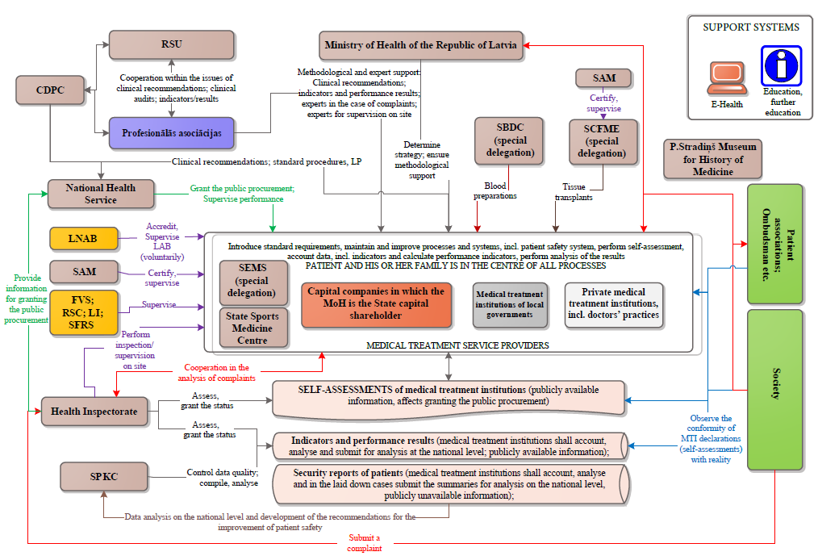

Figure 2. The model for functioning of the health care system

The Concept offers changes in functioning the health care system which may be achieved by a function analysis of structure institutions, introduction of new operational methods, wider involvement of patients and inhabitants, promoting culture and thinking based on modern patient safety principles.

4. Structure – Problem Solving

4.1. Common Understanding of the Quality of Medical Treatment Processes, Patient Safety and Implementation of a Patient Safety System
For the formation of a common understanding of the quality of medical treatment, patient safety information is necessary – the information which methodologically explains the definitions, requirements and recommendations which are available not only for all health care professionals, but also for all the persons involved in the health care system – policy makers, finance planners, supervisory authorities etc., and which is always up-to-date, and also training of all the persons working in the health care sector and public education.

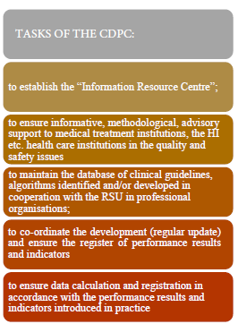
In the Centre for Disease Prevention and Control (CDPC) “Information Resource Centre” will be established with a view to ensure co-ordination and support for continuous improvement of the quality of medical treatment processes and patient safety:
- identification, development and distribution in the e-environment of the clinical guidelines and methodological materials, good practice examples for the increase of the quality of medical treatment services and patient safety in medical treatment institutions;
- ensuring methodological support for the analysis of complaints and patient safety cases for medical treatment institutions and the HI;
- administration of clinical guidelines, database of algorithms (a function will be taken over from NHS);
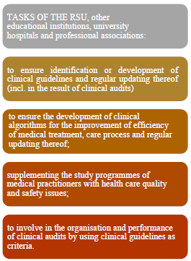
- development and maintenance of the range of performance results and indicators for the analysis of the operation and results of medical treatment institutions and comparison thereof on the national level and in the European and international environment; Accumulation of data on the performance results and indicators and carrying out the analysis of the laid down data on the national level.
- to accumulate certain data on patient safety cases and provide recommendations to medical treatment institutions;
- to implement training activities;
- to provide data/information to theNHS, the MoH for the implementation of changes in financing policy and strategy etc.;
- to cooperate with Riga Stradiņš University (RSU), other educational institutions, university hospitals and professional organisations in the issues of clinical guidelines and process standardisation (clinical algorithms);
- etc.

4.2. Maintaining and Enhancing Competencies of Health Care Professionals
It is very difficult to change the way the adults think, common practice, the principles of activity, therefore it is important to encourage RSU and all educational institutions which are carrying out the educational processes of medical practitioners, in co-operation with professional organisations and university hospitals, to introduce the necessary changes in study programmes in order to include the elements affecting the medical treatment and care quality and patient safety.
It is important to activate cooperation of educational institutions with university hospitals for the training of skills and competences (technical competences) in the issues affecting the quality of medical treatment processes and patient safety (performance of manipulations, communication with patients and their families, including in difficult situations), and also to use the identified clinical guidelines and algorithms in the education process. It is recommended to purposefully activate research activity in the quality issues of medical treatment processes and patient safety and involve students, residents in the performance of clinical audits in hospitals.

4.3. Ensuring the Integrity of Clinical Practice Guidelines and Algorithms
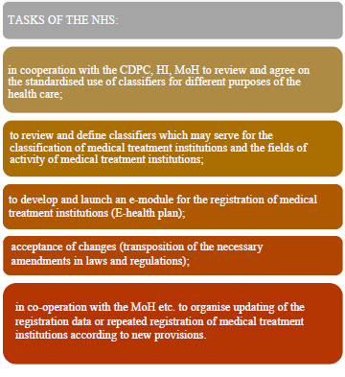
It is known and proven for a long time ago that standardisation and process automation with necessary protective mechanisms help to reduce the possible mistakes. Especially in large (in terms of employees) medical treatment institutions it is almost impossible to do without process standardisation because the level of quality depends on what one and the same manipulation is carried out up to equal quality by performance of different persons – employees. It fully applies to care process manipulations (patient care standard): to perform equally a manipulation by all under equal circumstances of a medical treatment institutions and with certain equal materials. Many things can be standardized: administration of appointments with a specialist, preparation of medicinal products, medical devices, incl. use of devices etc. However, there is a part of the process which may not be fully standardized. The decisions taken by a physician, actions of the physician and assignments will never be standardised based on diagnosis, gender of a patient or other principle in 100 % of cases that corresponds to the title of “clinical guidelines”. The clinical guidelines have very important role in the education of new physicians, medical treatment process, analysis of clinical results and ensuring clinical audits, but the physician always has a possibility to take another reasoned decision. The clinical guidelines are developed by professionals based on the good practice and professional conclusions justified by research or statistics. There are data bases with clinical guidelines of different diseases in the developed European countries. Latvian professionals choose the guidelines to which they could follow by taking into account their competences, resources and possibilities. There are also innovative approaches the authors of which are and will be the physicians of Latvia (the clinical guidelines developed as a result of research and introduction of innovations). In such cases it would be right to help to register the clinical guidelines developed in Latvia in the European databases. In both cases it is necessary to ensure access to clinical guidelines – files (hyperlinks to EU clinical guidelines or those present in the databases of other countries which according to the opinion-decision of professional organisations now comply with the good practice principles of the medicine based on evidence) that in conformity with the data submitted by professional organisation will be applied by the CDPC.

What are clinical algorithms: the descriptions of standard action – algorithms that determine the requirements for medical treatment institutions for the purpose of maintaining and improving the quality of medical treatment services and patient safety (algorithms for the action of practices of family doctors if there are suspicions of oncological disease; transfusion of blood components etc.).

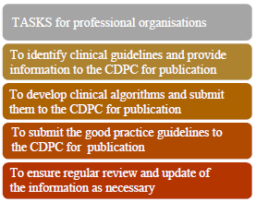
Good practice guidelines: the guidelines developed by professional organisations,in cooperation with medical treatment institutions and public organisations – standards for the distribution and introduction of the good practice in the field of health care (for ex., the Guidelines for Good Practice of Family Doctors) or internationally recognised good practice guidelines.

Thus, the Concept suggests to withdraw from the present practice in the development, registration and approval of clinical guidelines and medical technologies, to trust manufacturers of medicinal products and medical devices and their instructions for the use of medicinal products and medical devices
and to activate professional organisations of medical practitioners in the identification or development of clinical guidelines, clinical algorithms and good practice guidelines and regular update thereof, to ensure centralised access to the information on the base of the CDPC.

4.4. Improving of Monitoring and Supervision Mechanism of Medical Treatment Institutions
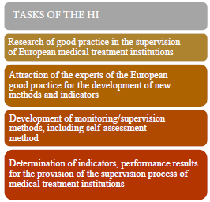
Supervision of medical treatment institutions is one of the functions of the Health Inspectorate (HI).

In order to ensure effective and efficient supervision of medical treatment institutions, recording of medical treatment institutions is required which includes updated information about medical treatment institutions and their fields of activity, including about changes. It is necessary to achieve that the registration of a medical treatment institution in the State register and timely registration of changes in the field of activity of the medical treatment institution (including provision of new service) is made before the institution starts to operate and before the provision of services is started. The Concept provides for changes in the registration of medical treatment institutions by clearly defining the field of activity of the institutions and improving the technical possibilities for the submission of the application for registration/changes. By taking into account the plans for E-health project, this task is intended for the NHS in cooperation with the HI which currently maintains the register of medical treatment institutions and medical practitioners. By analogy with the register of medical treatment institutions, the register of medical practitioners and medical support persons is also subject to changes in order to ensure the necessary information about natural persons and specialisation of medical practitioners.
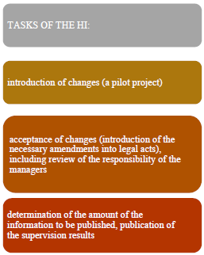
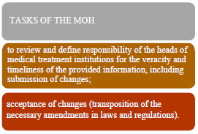
The responsibility of the managers of medical treatment institutions for the veracity and timeliness of the provided information (to the State registers and upon other official requests), including the submission of changes, must be determined/clarified. The Concept provides for the development of monitoring/supervision methods and publication of inspection results on the public environment accessible to inhabitants, and also performance of monitoring/supervision activities at such regularity (frequency) that actually may ensure monitoring of the operation of a medical treatment institution, quality of medical treatment services and level of safety activities of patients in dynamics, including by applying certain performance results and indicators to medical treatment institutions. In the development of the methods,it is worth for the HI to consult with medical treatment institutions, CDPC, NHS by including in the criteria the most important according to which not only literal conformity with the requirements of laws and regulations, but also the quality of medical treatment can be identified. The concept of “supervision” also provides for the provision of advisory support to medical treatment institutions which may ensure the introduction of continuous improvement principle in the process of supervision of medical treatment institutions.
Voluntary involvement of patients, patient associations and foundations and general public which will be achieved by publication of the supervision results of the HI in the form accessible by the public and to the specified extent of information will be regarded as principal changes in the monitoring/supervision process of medical treatment institutions.

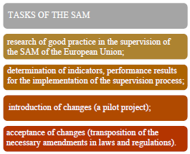
In addition to the monitoring/supervision function of the HI in the specified regulated spheres the monitoring and control shall be be also ensured by the State Agency of Medicines (SAM) (circulation of blood preparations, tissues, cells and organs), the Food and Veterinary Service (water quality and catering services), the State Fire and Rescue Service, the Labour Inspectorate, LNAB (the accredited medical laboratories) etc. As a result of the implementation of the Concept, the monitoring methods will also be reviewed in the SAM with the view to increase the objectivity of the monitoring results through the use of the performance results and indicators.

4.5. Handling Patient Complaints and Grievances and Decision-Making
Any person has the right to submit a complaint – express his or her dissatisfaction with the quality and safety of medical treatment or other dissatisfaction with the provided services to the HI, MoH, medical treatment institution, Ombudsman or other authority. In the health care system, the examination of the complaints of patients and their family members is defined as the function of the HI.

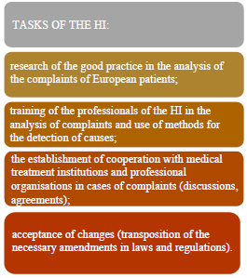
The analysis of the practice of the developed European Union countries in the examination of complaints indicates that we need to change the principles, thinking and process so that in the result objectivity and added value is ensured instead of the detection of “guilty persons”. An analytical approach is needed where the violations and harm which are or are not punishable are clearly defined. Unfortunately, now the analysis of complaints most often is focused on proving the guilt of a particular medical practitioner, it takes place without involvement of a medical treatment institution, thus without understanding of a medical treatment service as complex correlation between several system elements: teamwork of humans-professionals, mutual cooperation and communication, patient, environment, technologies and other elements. There is no doubt that in the field of health care, analogically to other fields, actual violations may also be detected – failing to comply with the requirements of laws and regulations, illegal action carried out intentionally and similar, however the most part of complaints must be examined in cooperation with a medical treatment institution by addressing the examination results of the complaint to the management of the medical treatment institution, because only the management may take decisions on corrective activities necessary for the mitigation of risk and improvement of processes. By immediate involvement (informing) of the medical treatment institution in the analysis of the complaint and search of causes, a meaningful result may be achieved and other patients may be safeguarded from the reoccurrence of the situation. The cooperation of the HI with professional organisations of medical practitioners is necessary for the attraction of experts in the analysis of complaints. Analysis of complaints is necessary for the application of certain tools of analysis for cause detection.

4.6. Administration of Treatment Risk Fund
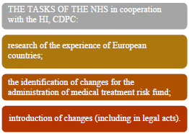
When a unified understanding is reached on what is harm to a patient associated to the health care process, only then we will be able to understand whether changes are necessary in the administration of Treatment Risk Fund.
Compensation may be received for the harm caused by the health care process to life or health of a patient, and also for the expenditure related to the medical treatment in order to prevent or reduce adverse effects of the harm caused.
The Concept provides for the review of the existing practice and, probably, introduction of the necessary changes upon consulting with the specialists of the European countries.

4.7. Cross-sectoral Cooperation
Without prejudice to the responsibility of medical treatment institutions for all safety aspects of patients and their families, visitors and personnel, it must be noted that there are several safety spheres where the supervision is performed by other sectors: fire safety, civil defence, water and food safety, information technology and information system security, data security, radiation and nuclear safety, labour safety.
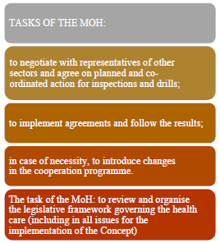
Effective cross-sectoral cooperation and regular training of practical skills in the specified issues according to the laid down scenarios (for example, evacuation drills in case of fire or disaster).

4.8. Organisation of Legislation
The health care sector is strictly regulated sector which is proven by the range and number of legal acts. Authorisations, update and determination of the requirements are necessary for the implementation of the Concept. Which means that the plan is necessary for gradual and systematic review and organisation of the legislative framework.

4.9. Identification of Policy and Strategy, Allocation of Resources
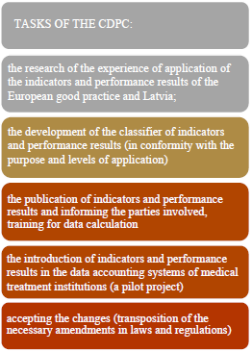
Determination of policy, objectives, strategy and tactics is the task of the Ministry of Health of the Republic of Latvia.
For the decision-making in the policy making process and change management information and credible data are necessary – performance results and indicators, the analysis of such data in dynamics. Changes are needed in this field – review of the range of the current recording data, performance results and indicators, calculation formulas, quality of the principal data and other aspects, the development of recommendations for the improvement of the quality of the principal data and updating of the list of performance results and indicators and classification thereof in conformity with the purpose and level of use (medical treatment institutions, the State – national and European Union levels). Changes in the range of performance results and indicators will be entrusted and implemented by the CDPC in cooperation with the NHS and other interested parties.
It is important to note that credible initial principal data and correct application of the correct calculation formula is necessary for the calculation of nearly any indicators or performance results. Generally, the initial data source is in a medical treatment institution and, if the initial data will not be registered, then also the indicators may not be calculated with a sufficient veracity (for example, surgical complications, the side-effects associated with administering medicinal products or blood components). It must be kept in mind that for example the non-existence of surgical complications may not be regarded as high level of surgical manipulations, but will be regarded as the non-existence of data registration or data hiding.
Results of the monitoring/supervision process of medical treatment institutions (see Paragraph 4.4) that will be implemented by the HI with new methodsshall serve for the decision-making to grant resources (the public procurement fro the provision of services to be paid from the State budget, purposeful granting the additional resources etc.)

The NHS shall ensure the financial resource management function of the health care system: resource planning, data registering, analysis, administration of resource distribution etc. Upon gradual change of the entire system, changes will be introduced also in the activities of the financial resource management. The purpose for changes in the financial management is the allocation of financial resources which is understandable, transparent and substantiated by objective data, and increase of use effectiveness and efficiency that is certified by particular performance results and indicators.
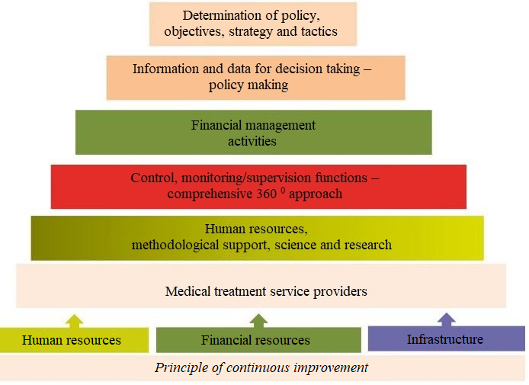
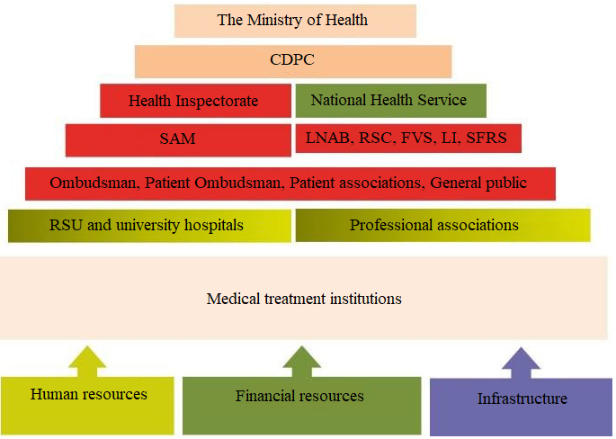

Figure 3. Distribution of function – the model offered by the Concept

5. Process – the Quality of Medical Treatment and Care Processes and Patient Safety

5.1. Quality Assurance of Medical Treatment Institution Processes
The basic element of the health care system is medical treatment institutions which provide health care services – from the primary health care up to secondary and tertiary health care providers, from every outpatient medical practitioners practice to university hospitals.

The approach of Donabedian “structure – process – outcome” within the context of a medical treatment institution may be defined by elements which are classified in the Table 1.

Table 1. “Structure–process–outcome” in a medical treatment institution

Structure | 1. Resources: financial resources, human resources, information resources  2. Infrastructure: buildings and premises; medical equipment and other technical devices for ensuring and support of the processes of the main operation; including software of information technology  3. Materials: medical devices; medicinal products; other materials which may affect the quality of medical treatment and care processes and patient safety and other materials and goods for ensuring operation of a medical treatment institution
Process | 1. Management processes: planning and management of the development and operation; change management  2. Resource management processes: management of financial, human resources, infrastructure, materials  3. Medical treatment processes:  3.1. administration of medical treatment services;  3.2. outpatient care;  3.3. Outpatient care in a day hospital;  3.4. emergency medical care and observation;  3.5. inpatient care (in conformity with medical treatment profiles);  3.6. rehabilitation services;  3.7. care.  4. Medical treatment support processes:  4.1. infection control;  4.2. circulation of blood preparations;  4.3. circulation of tissues, cells and organs;  4.4. circulation of medicinal products;  4.5. laboratory investigations;  4.6. radiological investigations;  4.7. endoscopy investigations;  4.8. functional diagnostics investigations;  4.9. pathological-anatomical investigations;  4.10. other investigations;  4.11. palliative care services;  4.12. social services;  4.13. catering services (for the purpose of medical treatment)  4.14. etc..  5. Support processes: document management; quality and patient safety management; data and information management; environmental management processes, including waste management, catering services etc.  6. Science and research  7. Undergraduate and postgraduate education  8. Etc.
Outcome | 1. Performance results of the operation of the medical treatment institution  2. Performance results of processes  3. Indicators  4. Results of clinical audits  5. Results of clinical case studies  6. Results of other internal inspections  7. Results of external inspections/audits  8. Results of complaint analysis  9. Results of the measurements of patient satisfaction  10. Results of plan recording  11. Etc.

The quality of the structure of a medical treatment institution is characterised by balanced and continuous availability, renewal, and also efficient use of the resources. Donabedian characterises the outcome as changes in the state of health of a patient before and after medical treatment and care services. The state of health of a patient and changes therein are registered in medical entries (preferably in electronic form). Donabedian indicates that the correlation between the following three elements is very important: structure-process-outcome. By increasing the quality level in each of the elements, high quality result can be achieved. For the arrangement, maintenance and improvement of processes with a view to increase the quality and patient safety, the Concept offers to gradually review and update the laws and regulations (within the context of minimum mandatory requirements) and to use professional international and European standards intended for medical treatment institutions as guidelines for the improvement of their own activity and results (the CDPC will ensure informative, methodological and advisory support).

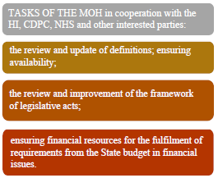
The Concept provides that the national legal framework in Latvia defines the minimum mandatory requirements for medical treatment institutions in the field of quality and patient safety. The requirements laid down in Cabinet Regulation No. 60 of 20 January 2009, Regulations Regarding Mandatory Requirements for Medical Treatment Institutions and Their Structural Units, in respect of qualitative and safe provision of health care services are binding on each and every medical treatment institution, including medical laboratories. Cabinet Regulation No. 611 of 25 July 2006, Procedures for Ensuring Birth Assistance, determines the quality and safety requirements for the institutions of birth assistance profile. Cabinet Regulation No. 1037 of 27 December 2005, Regulations Regarding Quality and Safety Standards for the Collection, Testing, Processing, Storage and Distribution of Human Blood and Blood Components, and Compensation for the Expenses for the Renewal of the Lost Amount of Blood, defines the quality and safety standards for the State Blood Donor centre, blood preparation divisions, blood banks of medical treatment institutions. Cabinet Regulation No. 1176 of 22 October 2013, Procedures for the Use of Human Tissues and Cells, determines the quality and safety standards for the use of tissues and cells of an alive donor or dead person. There are several legal acts that determine the quality and safety requirements for separate medical treatment processes and elements.

The requirements of Cabinet Regulation No. 60 of 20 January 2009 declare patient safety as a priority for the first time based on the defined international patient safety objectives which cover the following fields:
- correct identification of a patient;
- effective communication;
- safe administration of high risk medicinal products;
- safe surgery and anaesthesia;
- infection control and hand hygiene;
- prevention of patient falling;
and provides that medical treatment institutions shall implement measures for the mitigation of risks in these fields in conformity with the field of activity of a medical treatment institution, the range of health care services provided and the size of the medical treatment institution.
Information Resource Centre of CDPC will provide centralised informative, methodological and consultative support for the risk management, determination of risk mitigation activities, management of structure, processes and outcomes. To provide the support, the Information Resource Centre shall use examples of good practice of the European countries and Latvia which comply with the requirements of the group of standards of Det Norske Veritas Interpretive Guidelines and Surveyor Guidance for Health Care organizations, “Det Norske Veritas Standard for Managing Infection Risk”, Joint Commission International Accreditation Standards for Health Care organizations. A medical treatment institution may apply the recommendations of the Information Resource Centre in conformity with the field of activity, processes and size of the institution.

The Information Resource Centre plans to emphasize such promotion of medical treatment quality and patient safety activities in providing the support, as for example:
  - quality and safety risk identification and management;
  - non-condemning reporting – introduction of the learning system in a medical treatment institution;
  - organisation of processes oriented to patients and their families;
  - informed consent of patients as a process;
  - communication with patients and their families;
  - safe identification of patients;
  - surgery safety;
  - anaesthesia safety;
  - safety of medicinal product circulation;
  - infection control and risk management of infections related to health care;
  - safety of medicinal devices;
  - high-risk processes, medicinal products, patients;
  - quality of the medical entries;
  - educating patients and their families;
  - performance of clinical audits and case studies;
  - maintaining of the competences of the personnel, incl. internal training programme for the personnel;
  - personnel safety, incl. vaccination programme of the personnel;
  - vigilance – biovigilance: hemovigilance and vigilance of tissues, cells, organs; pharmacovigilance; vigilance of medical devices;
  - selection and introduction in the practice of a medical treatment institution of performance results and indicators;
  - etc.
The Concept supports the accreditation of medical treatment institutions according to the standards recognised internationally and at the level of the European Union. Accreditation of the medical treatment institution is a voluntary decision of the medical treatment institution.

5.2. Patient Safety
“First, do no harm!”

An integral part of the quality of medical treatment and care services is the ensuring of patient safety. We can read the following on the Public Health portal of the European Commission: “In the European Union 8–12 % of patients admitted to hospital suffer from adverse events whilst receiving healthcare. Such events can be healthcare-associated infections (approximately 25 % of adverse events); medication-related errors; surgical errors; medical device or instrument failures; errors in diagnosis; or failure to act on the results of tests.”

In conformity with the definition of the World Health Organisation patient safety is the reduction of risk of unnecessary harm to an acceptable minimum (WHO-ICPS, 2009), harm means the outcome of health care which has an adverse effect on the health of a patient, and/or the quality of life – causes or prolongs hospitalization, causes permanent disability or death.

In the recommendations on patient safety, the Council of the European Union indicates that poor patient safety represents both a severe public health problem and a high economic burden on limited health care resources by concurrently emphasizing that a large proportion of adverse events in medical treatment institutions are preventable, as they are mostly caused by systemic factors.
Health care is not 100 % safe, harm may be caused to patients. 17 years have passed since the publication of the work of the U.S. Institute of Medicine “To Err is Human” that launched significant changes in the area of patient safety by transitioning from blaming and punishing health care professionals to a systematic approach in the management of failures and mistakes, by accepting that undesirable events occur not because medical professionals knowingly or due to negligence cause harm to patients, but rather due to complexity of health care system, as the medical treatment and care depends on many factors, not only the competence and diligence of the health care service providers.
Failures should be discussed, their causes should be searched for, what is made impossible by the environment where complete denial of errors and opinion that errors and violations are negligence for which a punishment is to be received dominate, thus prohibiting from invaluable possibility – to learn from mistakes. In order to achieve safer care, reduce the possibility of mistakes and harm, also the recommendations of the Council of the European Union suggest to transition from blaming and punishing health care professionals to a systematic approach which means creating the understanding of patient safety culture and causal links of undesirable outcome by educating both the medical and administrative personnel.

The approach of the system to risks, incl. risks which have already turned into undesirable event and harm to a patient, is to admit that it is part of the human nature to make mistakes, that people make mistakes, and mistakes occur even in the best organisations, however mistakes should be regarded as consequences rather than causes originating mostly from systemic and neglected factors, not deficiencies of the human nature. Within the framework of the system model, the corrective measures are focused on the prevention and improvement of organisational, systemic deficiencies, on proactive approach to risks in health care in order to avoid the possible harm to a patient.

In Latvia there are no data on undesirable events and the level of harm, but we can use the information source of the Joint Commission International and defined international patient safety objectives in order to minimise the risks in those fields where studies of many countries show the most significant risks for patient safety (international patient safety objectives are incorporated as requirements for medical treatment institutions – for risk management in Paragraph 17 of Cabinet Regulation No. 60 of 20 January 2009).
At the moment separate fragmentary activities are implemented within the field of patient safety in Latvia (for example, the requirements for informed consent and patient participation in his or her medical treatment process have been laid down in the Law on the Rights of Patients, the basic requirements for hygienic and counter-epidemic regimen in a medical treatment institution have been laid down in Cabinet Regulation No. 104 of 16 February 2016, Regulations Regarding the Basic Requirements for a Hygienic and Counter-Epidemic Regimen in a Medical Treatment Institution, etc.). Considering the abovementioned, it is necessary to improve the field of patient safety by providing specific measures to be implemented for the achievement of the abovementioned objective, and also in formulation of the necessary measures by involving specialists and patient associations/organisations of the relevant field.
Measures which are to be implemented for the improvement of patient safety in accordance with the recommendations of the Council of the European Union, and also by taking into account the international experience:
1) the development and improvement of the State policy and programmes in the field of patient safety: the Concept provides for:
a. defining the CDPC as the competent institution to provide support for the introduction of patient safety system;
b. amendments to Paragraph 17 of the Cabinet Regulation No. 60 of 20 January 2009 defining the mandatory requirements for the mitigation of patient safety risks;
c. plans for reviewing legal acts in order to specify the responsibility and obligations in the field of patient safety;
d. education and training of professionals;
e. the involvement of the public and patients, and their families and establishment of a partnership;
f. the introduction of indicators and performance results;
g. the identification of good practice and exchange of experience etc.;
2) involvement of patients and patient organisations: the Concept provides for:
a. the involvement of patient organisations and representatives thereof in the development of policy programmes for patient safety in all levels,
b. for the distribution of information to patients through CDPC, MoH, HI and health care organisations about the applicable patient safety standards; risk and safety measures applied to reduce or prevent mistakes and harm, including about the rights to deliberate consent for medical treatment in order to facilitate the choice of a patient and decision-making; about complaint procedures and corrective measures, and also about compensation possibilities;
c. the improvement of the basic skills of patients in the field of patient safety, namely basic knowledge, attitude and necessary competences in order to achieve safer care – in accordance with the needs identified by patient organisations and organisations of health care professionals, including by developing and improving educating materials of chronic patients and providing training for maintaining, controlling their health condition;
3) the development of such non-condemning reporting and training system for undesirable events and introduction thereof in practice in both the health care organisations and in certain cases at the national level that:
a. provides information about the level of the prevalence of errors, undesirable events and incidents , types and causes thereof;
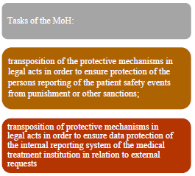
b. encourages health care employees to actively report by using the developed reporting instruments which are transparent, fair and do not provide for any sanctions due to which the reporting and training system must be separated from disciplinary systems and procedures in respect of health care employees by clarifying legal issues in relation to the responsibility of health care employees;
c. provides possibilities for patients and their families to report their experience;
d. supplements other reporting systems for safety, for example for pharmacovigilance and medical devices, by concurrently avoiding from duplication of reporting as much as possible.
4) to promote education and training of the health care employees on appropriate level in the field of patient safety by taking the recommendations developed by the European Commission’s working group on patient safety and quality of care for education and further education in the patient safety:
a. by developing study programmes, seminars as further education measures for the training of health care specialists working in the health care institutions, other health care employees and relevant administrative personnel in the field of patient safety;
b. by including patient safety in undergraduate and post-graduate studies and training at work place,
c. by improving the competence of all health care employees, including CDPC, HI etc. and the relevant management and administrative personnel in the field of patient safety;
d. to cooperate with the organisations involved in the professional education of health care (RSU, LU, colleges, professional associations) in order to ensure that sufficient attention is paid to patient safety in order to improve patient safety by changing the system.
5) to mutually cooperate with the European Commission, OECD, EPSO, International Patient Forum:
a. in order to develop joint definitions and terminology;
b. in order to develop credible and comparable set of indicators with the objective to identify safety problems and promote learning of the Member States from each other;
c. in order to collect and jointly use comparable data and information on the results in the field of patient safety in terms of type and number, thus simplifying mutual learning and informing about the defined priorities. Etc.;

Patient safety system at the national level is not possible without active involvement of medical treatment institutions. The objective of the system for the management of the quality of medical treatment and care services and patient safety is the establishment of a continuous improvement mechanism by forecasting and effectively managing risks of medical treatment and care, and also by introducing and maintaining a confidential internal patient safety reporting – learning system which ensures collection of the information about the cases as a result of which harm has been caused or could have been caused to a patient (patient safety cases), analysis thereof and introduction of risk mitigation measures in order to reduce the possibilities for the recurrence of patient safety cases and to ensure feedback to the practitioner involved in the patient safety case.

If the medical treatment institution has implemented the internal reporting – learning system, it significantly promotes patient safety culture, understanding of causal link in accident mechanism which helps in the creation of effective proactive approach through identification of proactive risks and creation of corresponding protective mechanisms. The Concept recommends to integrate in the reporting system of patient safety cases also elements of vigilance – biovigilance, pharmacovigilance and vigilance of medical devices in order to create a unified culture and comprehensive approach to all risks affecting the quality and safety, and also to separately ensure the possibility to report on the patient safety cases also to patients and their families.

Proactive approach – risk identification and analysis in the system and processes of a medical treatment institution system, and also implementation of internationally recognised risk mitigation strategies and achievement of international patient safety objectives provide a much greater responsibility for managers of different levels in the improvement of patient safety which is very important for the restriction of those foreseeable costs which are related to requesting patient compensations in the cases of harm – not working with the system, the number of errors, failures cannot be restricted.
Both the system approach oriented incident analysis and proactive risk analysis help to make the planning and use of resources more purposeful, and also in forecasting further cost perspectives because it provides for the implementation of clear activities or risk mitigation measures.
The introduction of patient safety system requires a programme which with the support of the CDPC may be implemented by any medical treatment institution in the amount necessary for its field of activity and which is included:
    - in training of managers of different levels, training of personnel in patient safety, in science of human factor, case analysis principles;
    - the development of reporting-training process of patient safety cases and introduction in medical treatment institutions;
    - the establishment of patient safety culture through educating and case analyses targeted to finding the reasons, not guilty persons, through feedback and learning from the reported cases;
    - the involvement of clinical personnel in the improvement processes, quality improvement;
    - the involvement of patients in reporting on patient safety cases within the framework of medical treatment institution;
    - the compilation of results (reports, cases, introduced corrective activities), statistical processing, development conclusions about trends and improvements and distribution – establishment of feedback;
    - comparative analysis of results by medical treatment institutions at the national level by strictly complying with the confidentiality – non-disclosure principles of personal data;
    - voluntary participation of medical treatment institutions in benchmarking programmes on the European Union and international level etc.

Certain and measurable results may be reached in the course of the programme implementation: the number of trained personnel, reporting tools established and similar. However, the main objective of the programme is to change the way of thinking, to form the patient safety philosophy and culture where medical personnel and that of other professions voluntarily, without any concerns and fear for punishment would even report on their own mistakes, where the managers react to the reported cases with gratefulness to reporters, with understanding of the fact that each report may help us to protect patients from risks and several medical practitioners from similar mistakes. The first step that may be taken by any person working in the health care system is to understand and accept the basic principles of the patient safety system:

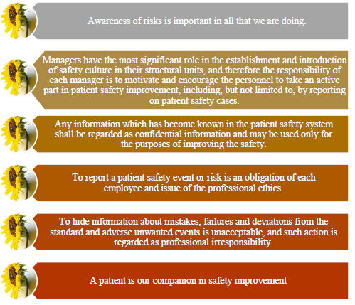

Figure 4. Basic principles of patient safety

6. Outcome

The credibility of any results and indicators calculated by a medical treatment institution or at the national level will be dependent on the initial data of basic sources. Unfortunately the quality of medical entries may be evaluated only when such data will be provided in electronic form. Only e-format entries could be processed in sufficient amount for making statistically justified decision without spending much time for data compilation. This statement is binding on all medical treatment institutions. Most of the performance results and indicators of activities, processes and systems of medical treatment institutions may be calculated only according to the following provisions:
  - there is a clear, understandable and available data classification system (classifiers of institutions, fields of activity, specialities, diagnosis, manipulations, services, performance results and indicators etc.);
  - institutions of the the health care system have reached an agreement between themselves on the results and indicators that will be used, the institutions and levels in which they will be used, and the purposes for which they will be used;
  - for the initial data recording such electronic format has been provided which includes data control mechanism;
  - the actual entering of initial data has been achieved;
  - at the very beginning of the process there is assurance that the selected/laid down system of results and indicators may operate and may be continuously maintained, incl. for data analysis in dynamics.

As a result of the implementation of the Concept, the quality of the health care system management will be improved to be followed by an improvement of patient safety, increase of the confidence of patients, their families and public in the health care system together with a unified understanding of the quality of the health care system and medical treatment processes.

7. Sources:

1. WHO Quality of Care. A process for making strategic choices in Health Systems; http://www.who.int/management/quality/assurance/QualityCare_B.Def.pdf?ua=1;
2. Directive 2011/24/EU of the European Parliament and of the Council on the application of patients’ rights in cross-border healthcare;
3. European Commission. Patient Safety. Policy. http://ec.europa.eu/health/patient_safety/policy/index_lv.htm (retrieved: 25.07.2016)
4. WHO. The Conceptual Framework for the International Classification for Patient Safety; 2009.
http://www.who.int/patientsafety/implementation/taxonomy/publications/en/
5. Council Recommendation on patient safety, including the prevention and control of healthcare associated infections (2002/C 151/01)
6. Key findings and recommendations on Reporting and learning systems for patient safety incident across Europe. Report of the Reporting and learning subgroup of the European Commission (PSQCWG); May 2014
7. Comprehensive Accreditation Manual for Hospitals, Joint Commission International, January 2013.
8. Final Technical Report for The Conceptual Framework for the International Classification for Patient Safety v.11
9. Technical Annex 2 - Glossary of Patient Safety Concepts and References.
10. http://ec.europa.eu/health/systems_performance_assessment/docs/sowhat_en.pdf
11. Resources regarding the practice of the HI: http://www.doh.wa.gov/LicensesPermitsandCertificates/FacilitiesNewReneworUpdate/Hospitals/InspectionProgram; http://www.epsonet.eu/peer-evaluations.html;
12. https://www.ncbi.nlm.nih.gov/books/NBK20586/
13. OECD Reviews of Health Systems: Latvia 2016 and Health at a Glance: Europe 2016. http://webexchanges.oecdcode.org/vTxMA5wv/8116231e_light.pdf
14. Key findings and recommendations on Reporting and learning systems for patient safety incident across Europe; Report of the European Commission (PSQCWG), May 2014.

OECD – The Organisation for Economic Co-operation and Development
The Concept does not include recommendations and solutions for the classification and structure of medical treatment institutions and also territorial placement, the Concept does not include recommendations and solutions for the increase of financial resources of the health care sector up to the EU level, and also ensuring human resources in the health care sector.
WHO Quality of Care. A process for making strategic choices in Health Systems; http://www.who.int/management/quality/assurance/QualityCare_B.Def.pdf?ua=1
Medical Treatment Law: Clinical guidelines – taking into account medical principles based upon evidence, an established systematic description of the medical treatment process for particular patient groups in which the necessary activities are specified, the procedures for the performance thereof and the essential criteria for the selection of tactics for the medical treatment of a patient to achieve the best medical treatment result.
RSU – Riga Stradiņš University; SEMS – State Emergency Medical Service; LNAB –Latvian National Accreditation Bureau; FVS – Food and Veterinary Service; RSC –Radiation Safety Centre; LI – Labour Inspectorate; SFRS – State Fire and Rescue Service; SAM – State Agency of Medicines; CDPC – Centre for Disease Prevention and Control; NHS – National Health Service; SBDC – State Blood Donor Centre.
The supervision is advisory support in the issues related to work and professional activity.
Good practice, source: www.epsonet.eu European Platform for Supervisory Organizations (EPSO)
Directive 2011/24/EU of the European Parliament and of the Council of 9 March 2011 on the application of patients’ rights in cross-border healthcare;
Each medical treatment institution applies the Concept guidelines and recommendations of the Information Resource Centre of the CDPC in conformity with its own field of activity, own resources and size of the institution.
European Commission. Patient Safety. Policy. http://ec.europa.eu/health/patient_safety/policy/index_lv.htm (retrieved: 25.07.2016)
WHO. The Conceptual Framework for the International Classification for Patient Safety; 2009. http://www.who.int/patientsafety/implementation/taxonomy/publications/en/
Council Recommendation on patient safety, including the prevention and control of healthcare associated infections (2009/C 151/01)
EPSO – European Platform for Supervisory Organizations

