APPROVED
By order No. 212
of the Ministry of Health
of 24 November 2017

Energy and Nutrition Recommendations to the Population of Latvia

Energy intake by a human being from food products in daily nutrition, traditionally expressed in kilocalories or kcal, is required for the functioning of the body and daily activities. The required daily energy intake mainly depends on the age, sex, body mass, and height, as well as physical activity of a human being. Continuously insufficient intake of energy which is necessary to ensure the basic functioning of the body and physical activities is compensated with body reserves as a result of what a human being is gradually losing body mass and various health disorders may develop in the longer term. However, excessive energy intake where the energy is not expended could provoke an excessive body mass for a human being and develop into obesity. In the longer term the overweight and obesity along with a sedentary lifestyle cause the development of various chronic noncommunicable diseases, e.g., cardiovascular diseases, type 2 diabetes, cancer, as well as causes additional load on the musculoskeletal system.
A human being obtains energy from nutrients present in food – carbohydrates, fat, and protein. Carbohydrates and fat contribute to the greatest amount of energy intake by a human being, whereas the majority of protein and some unsaturated fatty acids are used to produce and regenerate body cells, as well as to ensure various reactions and other functions. It is essential to ensure the intake of nutrients in correct balance, diversifying the diet and including in each meal such food products which contain carbohydrates, fat, and protein.
In order to ensure biochemical reactions of the body, in addition to the daily diet it is necessary to ensure the intake of vitamins and minerals that are important in body enzyme reactions, transmission of neural impulses, and other processes. However, increased amount of certain vitamins and minerals in the diet can be toxic, therefore it is recommended to ensure age, gender and health condition-appropriate daily vitamin and mineral intake.
Energy and nutrition recommendations to the population of Latvia, as well as vitamin and mineral intake has been calculated for a human being of an average body mass who is practically healthy on the basis of the Nordic Nutrition Recommendations 2012.
In cases where a certain disease has been diagnosed to a human being and adjustments in the diet are required, as well as in the event of an increased physical activity, reduced or increased body mass or pregnant females with health disorders, a medical practitioner by assessing the specific situation can specify an appropriate energy and nutrient quantity, as well as vitamin and mineral doses.

1. Nutrition recommendations to the population of Latvia*

Age | Sex | Average body mass, kg | Average height, cm | Energy  kcal/d | Protein, E% | Fat,  E% | Carbohydrates,  E%
0-6 months | boys | 6 | 60 | 590 | - | - | -
0-6 months | girls | 6 | 60 | 520 | - | - | -
7-12 months | boys | 9 | 71 | 730 | 7-15 | 30-40 | 45-60
7-12 months | girls | 9 | 71 | 720 | 7-15 | 30-40 | 45-60
1-3 years | boys | 13 | 90 | 1040-1290 | 10-15 | 30-40 | 45-60
1-3 years | girls | 13 | 90 | 960-1220 | 10-15 | 30-40 | 45-60
4-6 years | boys | 20 | 112 | 1280-1680 | 10-15 | 30-35 | 45-60
4-6 years | girls | 20 | 112 | 1200-1570 | 10-15 | 35-35 | 45-60
7-10 years | boys | 28 | 132 | 1520-2280 | 10-20 | 30-35 | 45-60
7-10 years | girls | 28 | 132 | 1400-2120 | 10-20 | 30-35 | 45-60
11-14 years | boys | 45 | 157 | 2040-2740 | 10-20 | 30-35 | 45-60
11-14 years | girls | 46 | 157 | 1920-2430 | 10-20 | 30-35 | 45-60
15-18 years | boys | 66 | 176 | 2630-3230 | 10-20 | 30-35 | 45-60
15-18 years | girls | 55 | 163 | 2240-2560 | 10-20 | 30-35 | 45-60
18-30 years | males | 75 | 175 | 2460-3150 | 10-20 | 25-30 | 45-60
31-60 years | males | 75 | 175 | 2290-2960 | 10-20⁴ | 25-30 | 45-60
>61 years | males | 75 | 175 | 2030-2600 | 10-20⁴ | 25-30 | 45-60
18-30 years | females | 65 | 165 | 1960-2510 | 10-20⁴ | 25-30 | 45-60
31-60 years | females | 65 | 165 | 1840-2360 | 10-20⁴ | 25-30 | 45-60
>61 years | females | 65 | 165 | 1700-2170 | 10-20⁴ | 25-30 | 45-60
Females during pregnancy | females | - | - | First trimester +100  Second trimester +300  Third trimester +300 | 10-20 E%  or 1.1 g/kg | 30 | 45-60
Females during lactation period | females | - | - | +500-600 | 10-20 | 25-30 | 45-60

*Recommended energy and nutrient intake is defined from the minimum up to the maximum amount, taking into account the level of physical activity of a human being (low, average, high).

The energy intake (kcal) recommended to the population varies, taking into account the physical activity of a human being (low, average, high). Typically the individually required energy intake for a human body is calculated by multiplying the energy required for basal metabolism with the coefficient of the physical activity (FA):



Basal metabolism is calculated, using the Harris-Benedict equation:

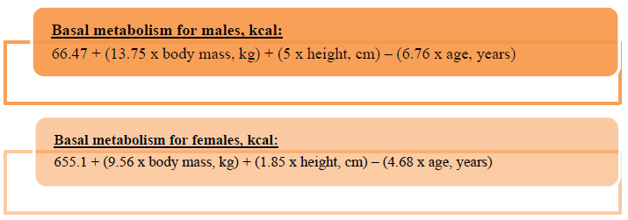

Upon determining the physical activity coefficient, energy expended both at work and leisure time is taken into account and as a result it is possible to obtain an approximate individual physical activity coefficient:

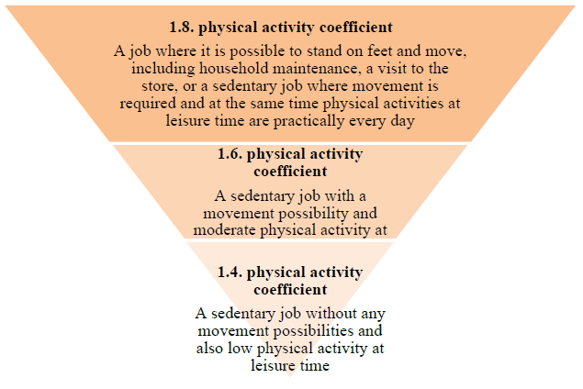

2. Examples of energy required to an organism according to the physical activity coefficient, and age

 |  |  | Physical activity coefficient
Sex | Age | Basal metabolism* | 1.4 (sedentary) | 1.6 (semi-active) | 1.8 (active)
Males |  |  | 2535 | 2897 | 3259
Males | 31-60 years | 1665 | 2332 | 2665 | 2998
Males | >61 years | 1517 | 2124 | 2427 | 2730
Females | 18-30 years | 1469 | 2057 | 2351 | 2645
Females | 31-60 years | 1369 | 1916 | 2190 | 2464
Females | >61 years | 1266 | 1772 | 2025 | 2279
*Basal metabolism calculations include: average body mass in Latvia for females – 65 kg, for males – 75 kg, average height in Latvia for females – 165 cm, for males – 175 cm.

In addition, depending on the type, frequency, and intensity of individual physical activities, it is recommended to balance the energy intake with appropriate percentage ratio of carbohydrates, protein, and fat. For example, for people with high physical activity it is recommended to increase the intake of protein and carbohydrates. It is also necessary to take into account that the required nutrients are included in the diet in percentage in order to achieve 100 % in total.
Meanwhile additional calculations are made in order to understand the required daily intake of protein, carbohydrates, and fat in grams. For example, upon calculating the required intake of protein in the diet of an adult person, first, it is calculated how much of energy (kcal) is 10-20 % of the total energy required per day. Then, taking into account that one gram of protein contains four kcal, the obtained number is divided by four and the recommended amount of protein in grams is calculated.



Similar calculations are made also for the amount of carbohydrates in grams, initially calculating how much is 45-60 % of the total daily energy and then dividing the obtained number by four. Meanwhile one gram of fat contains nine kcal and, therefore, when calculating the required amount of fat in grams, the multiplication is divided by nine:



3. Average recommended daily intake of minerals*

Age | K  mg | Ca  mg | P  mg | Mg  mg | Fe  mg | Zn  mg | J  µg | Se  µg | Cu  mg
7-12 months | 1100 | 550 | 420 | 60 | 8 | 5 | 70 | 15 | 0.3
1-3 years | 1600 | 600 | 470 | 100 | 8 | 6 | 90 | 22 | 0.3
4-6 years | 1900 | 600 | 505 | 160 | 8 | 7 | 90 | 27 | 0.4
7-10 years,  boys | 2650 | 800 | 540 | 240 | 10 | 9 | 120 | 35 | 0.5
girls | 2450 | 800 | 620 | 240 | 10 | 8 | 120 | 35 | 0.6
11-14 years,  boys | 3400 | 900 | 700 | 315 | 11 | 11 | 150 | 50 | 0.8
girls | 3000 | 900 | 700 | 280 | 11 | 9 | 150 | 45 | 0.8
15-18 years,  boys | 3500 | 1200 | 700 | 350 | 11 | 10 | 200 | 60 | 0.9
girls | 3100 | 1200 | 700 | 280 | 15 | 8 | 200 | 50 | 0.9
Adults:
males | 3500 | 800 | 600 | 350 | 9 | 9 | 200 | 60 | 0.9
females | 3100 | 800 | 600 | 280 | 15 | 7 | 200 | 50 | 0.9
Females during pregnancy | 3100 | 1000 | 700 | 280 | 15 | 10 | 150-250 | 60 | 1.1
Females during lactation period | 3100 | 900 | 900 | 280 | 15 | 11 | 150-250 | 60 | 1.3
* The recommended intake of sodium for children and adults is 2000 mg or not more than 5 g of salt per day
4. Average recommended daily intake of vitamins

Age | A  µg | D  µg | E  mg | C  mg | B1  mg | B2  mg | B6  mg | Folic acid  µg | B12  µg
7-12 months | 300 | 10 | 3 | 20 | 0.4 | 0.5 | 0.4 | 50 | 0.5
1-3 years | 325 | 10 | 4 | 27 | 0.5 | 0.7 | 0.6 | 70 | 0.7
4-6 years | 375 | 10 | 5 | 35 | 0.8 | 0.9 | 0.9 | 105 | 1.0
7-10 years,  boys | 500 | 10 | 7 | 45 | 1.0 | 1.2 | 1.1 | 165 | 1.7
girls | 500 | 10 | 6 | 45 | 0.8 | 1.2 | 1.0 | 165 | 1.7
11-14 years,  boys | 750 | 10 | 9 | 63 | 1.3 | 1.5 | 1.4 | 250 | 2.0
girls | 650 | 10 | 8 | 63 | 1.1 | 1.3 | 1.2 | 250 | 2.0
15-18 years,  boys | 900 | 10 | 10 | 75 | 1.4 | 1.7 | 1.6 | 300 | 2.0
girls | 700 | 10 | 8 | 75 | 1.2 | 1.4 | 1.3 | 350 | 2.0
Adults:
males | 900 | 10  (20 µg>75 years) | 10 | 75 | 1.4  (1.2 mg > 61 years) | 1.5  (1.3 mg > 75 years) | 1.5 | 300 | 2.0
females | 700 | 10⁸  (20 µg>75 years) | 8 | 75 | 1.1  (1.0 mg > 61 years) | 1.5 | 1.3 | 400 | 2.0
Females during pregnancy | 800 | 10 | 15 | 85 | 1.4 | 1.6 | 1.9 | 400 | 2.0
Females during lactation period | 1100 | 10 | 11 | 100 | 1.6 | 1.7 | 1.5 | 500 | 2.0

https://www.norden.org/en/theme/nordic-nutrition-recommendation/nordic-nutrition-recommendations-2012
It is recommended not to exceed 10 % of saturated fatty acids in the total daily energy intake.
In accordance with the recommendations by the World Health Organisation, it is recommended not to exceed 10 % of sugars (glucose, fructose, sugar and also honey, syrups, fruit juice and juice concentrate) in the total daily energy intake, whereas to help promote health it is recommended to reduce sugar intake to 5 % of the total daily energy intake
It is possible to specify an individual required amount of protein by multiplying 1-1.5 g of protein per one kilogram of body weight. The recommended amount of protein per one kilogram of weight is determined individually, depending on the physical activity and age of a human being.
It is recommended that teenage pregnant females and also females starting from the second trimester consume 1300 mg of calcium.
Additional necessity of iron for pregnant females is determined individually by a medical practitioner
It is recommended that infants up to 6 months would consume 10 micrograms of vitamin D per day
10 µg of vitamin D corresponds to 400 SV units
It is recommended that females in post-reproductive age would consume 300 µg of folic acid per day
It is recommended that in the winter period pregnant females would consume 15 µg of vitamin D per day

