
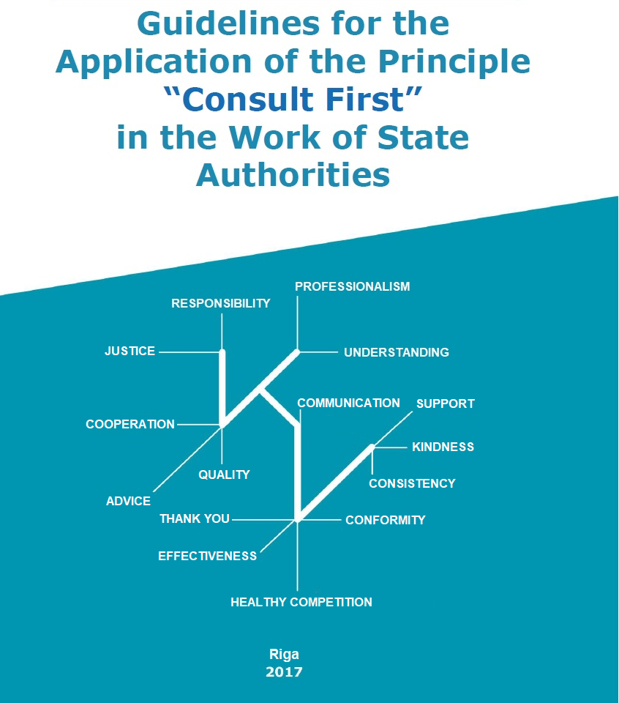

Content

Introduction 3
I. Supervision Effectiveness 6
1. Strategy of the authority for effective supervision 6
2. Indicative results 8
3. Risk assessment based supervision 9
4. Supervision policy based on the achievement of compliance 11
II. Customer oriented activity 14
1. Provision of information and consulting 14
1.1. Explanation of applicable requirements and e-tools 14
1.2. Special offer for new entrepreneurs 17
2. Service oriented customer servicing culture 19
3. Assessment of an authority (customer satisfaction) 21
Conclusion 23

Introduction

One of the economic development priorities is the creation of an excellent entrepreneurial environment in Latvia. The task to introduce the principle “Consult First” in the work of the authorities supervising undertakings was included within the framework of the section “Efficient Public Administration and E-services Thereof” of the Action Plan for the Improvement of the Business Environment approved by the Cabinet on 21 February 2017.
The purpose of the “Consult First” principle is to reach mutual understanding between entrepreneurs and supervisory authorities by promoting the fulfilment of the laid down requirements, rather than the imposition of penalties.
The national supervisory authorities, when coming into direct contact with the market and players thereof, creates the national “image” for the most of the market participants. Considering the costs of the public administration and supervisory measures, a great responsibility is put on the shoulders of inspectors of the authorities for both the exercise of effective supervision and establishment of successful communication with the sector.
The State is obliged to protect public interests and the health, safety and environment of its inhabitants. The effectiveness of the public administration to ensure protection of the abovementioned interests by concurrently shaping a favourable environment for conducting business and by ensuring equal competition depends on the capacity of policy makers to develop a qualitative regulatory framework and work quality of supervisory authorities, when implementing the regulation in practice, carrying out examinations and other measures. On the basis of good supervision practice summaries it can be concluded that a good supervision system is characterised by the following criteria:
1) ensuring of maximum conformity by providing clear and justified requirements;
2) reduction of legal uncertainties and supervision risks for entrepreneurs by implementing transparent and lawful supervision activities;
3) reduction of costs for entrepreneurs and optimisation of the State budget costs, supervision established on the basis of risk analysis principles by using the resources in an effective manner for the prevention of the biggest risks;
4) combat against corruption risks by excluding possibilities for the abuse of the powers of officials.

The improvement of inspections must be considered as a part of the public and private sector cooperation mechanism which is necessary for good market regulation. Creation of a stable legal environment and implementation of legal norms form the basis for conformity improvement. A supervisory system cannot operate in a long-term on the basis of fear and compulsion mechanism. On the contrary – the operations of supervisory authorities should facilitate conformity by shaping a transparent and communication-based cooperation with the business environment which is supplemented by supervision powers as one of the elements of cooperation.
In conformity with the public administration principles stipulated in the State Administration Structure Law the principle “Consult First” must be already complied with in the communication between the public administration and a private person. The State Administration Structure Law provides that public administration shall act in the public interest (Section 10, Paragraph three), shall observe the principles of good administration in its activities (Section 10, Paragraph five), and shall regularly examine and improve the quality of services provided to the public (Section 10, Paragraph six), and also that the public administration shall be organised in a manner that is as convenient and accessible to private individuals as possible (Section 10, Paragraph eight) and effective (Section 10, Paragraph ten).
A qualitative regulatory framework for ensuring various public interests and its effective introduction and supervision are preconditions for the functioning of the national economy. A good supervision strategy which promotes compliance with the regulation and is oriented to the reduction of the internal administrative burden of an authority is a way how, by reducing the resources allocated for supervision, it is, however, possible to achieve compliance with the regulatory framework. The principle “consult first” is an essential instrument within the framework of good supervision strategy that facilitates compliance with the regulatory framework in practice. Concurrently, when shaping the supervision policy, it is essentially to take into account the elements characteristic to each type and to choose the most appropriate supervision methodology accordingly.
In order to promote the putting into practice of the principle “consult first”, the Ministry of Economics in cooperation with supervisory authorities and sectoral associations has developed the guidelines for the application of the principle “Consult First” in the work of State authorities.
Considering the wide range of competences, different authorisations of supervisory authorities, knowledge and skills, procedures and equipment necessary for the performance of inspections, the purpose of these guidelines is to summarise good practice of supervisory authorities for promoting customer-oriented operation which authorities can use as a tool for the change of supervision culture.
In order to ensure customer-oriented and friendly communication with undertakings of the sector in the supervision process, the guidelines provide recommendations for supervisory authorities which are based on the following principles.

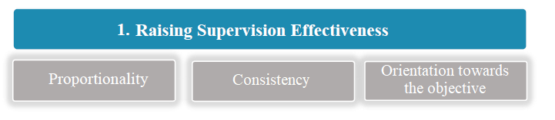

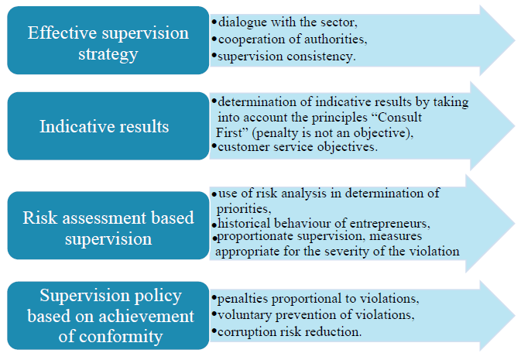
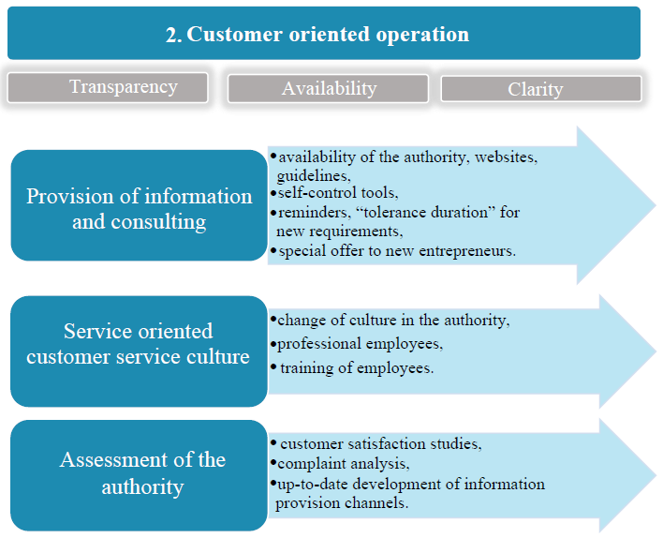

I. Supervision Effectiveness

1. Strategy of the authority for effective supervision

- clearly formulated supervision strategy of which the public is informed;
- the main task is to raise the level of conformity with the requirements determined in the sector;
- supervisory authorities shall assess on regular basis the supervision results and evaluate which methods are the most effective;
- in cooperation with NGO – a dialogue for the determination of supervision priorities, identification of the biggest problems in the sector. The sector is interested in having the field organised and having a fair competition;
- promotion of mutual cooperation of authorities, exchange of information;
- use of a common approach in supervision activities, especially among different structural units of authorities.

The biggest challenge for supervisory authorities is to develop and introduce a supervision strategy for the execution of laws and regulations by achieving the highest possible conformity level and concurrently retaining the costs and administrative burden as low as possible. Well formulated supervision strategy which is made available also to the public provides the necessary motivation to the persons to be supervised, provides sufficient guidelines to the staff of the authority, reduces expenses for the State and gives a possibility to reach a higher level of conformity by using the available resources in a more effective manner. In order to achieve it, a clear vision of the factors facilitating the conformity is necessary.
Increasing significance is attached to supervision stage and facilitating proportionality in the implementation thereof which means both the distribution of supervision resources according to the risk level and proportionality of supervision measures with the severity of the violation. Implementation of such principles not only reduces the burden on sectors and inhabitants, but also releases resources for the performance of more productive works by concurrently improving the achievement of the desirable result. Effectiveness can be improved by reviewing both the work policy and structure of the authority, as well as the employed work methods. The authorities must mutually focus on risk analysis and more purposeful use of inspections and other supervision means in their work for the achievement of the objective – ensuring compliance.
The authorities shall carry out assessment of supervision results on regular basis – which of the selected risk fields have improved and which have not, and also assess the supervision means used, and which of the methods have better effect on raising the level of compliance.

Supervisory authorities of the United Kingdom are following the Enforcement Concordat developed by its government in their supervision activities and communication with the involved parties which determines common Principles of Good Enforcement: introduction of transparent standards, openness, helpfulness, complaint examination procedures, proportionality and consistency in activities of authorities. The Concordat is a support to both the supervisory authorities and entrepreneurs, as it provides a clear and foreseeable cooperation model which is based on common principles known to all parties involved.

Dialogue with the sector
It is significant for entrepreneurs to know and understand the supervision policy of the authority, therefore the principles and control quality standards laid down by supervising authorities and shall be made known to the general public. It is also significant to cooperate with non-governmental organisations and sectors by trying to find cooperation forms in order to combat the problems found in the sector, and also to identify supervision priorities. Entrepreneurs who are complying with the obligations imposed by legal norms are interested in having the field organised and provision of fair competition. Organisations of entrepreneurs also may provide opinion on the supervision means used and their influence on motivation of entrepreneurs.

The Competition Council shall consult with non-governmental organisations on the supervision priorities and developments of the authority, annually report on assignments performed thereby and acquire assessment on the work quality of the authority. Participation of the public is a mutually directed process – by maintaining an active dialogue with entrepreneurs and association of Latvia, the Competition Council shall ensure understanding of the legal norms in force, promote compliance with them, and also it shall itself obtain a more comprehensive information on the situation in the market which enables to develop the competition policy in conformity with the public interests.

Mutual cooperation of authorities
Mutual cooperation of authorities in supervision work, exchange of information, and also in certain cases, when common supervision interests can be identified, performance of joint inspections are one of the methods for the optimisation of supervision activities and lightening the burden on entrepreneurs.

In order not to allow the coming of non-compliant goods in the territory of Latvia and the EU, the Consumer Rights Protection Centre shall have established cooperation with the Customs Board of the State Revenue Service for the control of goods on the border. The Customs Board of the State Revenue Service shall annually carry out inspections of those goods on border which are laid down by the Consumer Rights Protection Centre as priority goods in accordance with the developed check-lists. If any doubts have arisen about the compliance of goods, the Consumer Rights Protection Centre shall, within 3 working days, provide an opinion to the Customs Board of the State Revenue Service on whether it is allowed to put the product in free circulation. Thus the resources of supervisory authorities are saved because the non-compliant products are not put on the market initially.

In the fields where the competence of several authorities is determined, it is significant to ensure mutual exchange of information or organisation of joint trainings.

In order for the customs officials of the State Revenue Service to be informed of the current events in the field of veterinary, food safety, non-food safety and phytosanitary control of live animals, goods and products, the training shall be carried out by specialists of the relevant sector – officials of the Food and Veterinary Service on regular basis. The training shall take place both in centralised form and on site at the customs control points. The training shall contain both the theoretical and practical information, as well as the possibility to discuss unclear issues and problematic situations.

Supervisory authorities as the practical implementers of the regulation have an objective vision of the effectiveness of the norms of legal acts, and also their comprehensibility and practical introduction possibilities. Therefore the cooperation of supervisory authorities with a policy-maker for better implementation of regulation principles and balancing the interests of the public and entrepreneurs must be promoted and supported.

Supervision consistency
A common approach to supervision activities is significant for ensuring supervision effectiveness. Inconsistency between inspectors of one authority, different interpretation of requirements, and also unpredictability on the part of supervisory authorities causes a large burden on entrepreneurs and may also lead to worse compliance results because the entrepreneurs lose motivation to make efforts to understand and comply with the requirements. This is especially relevant for the authorities several structural units of which are located in different regions. Regular meetings of regional managers, training of inspectors and employees, and also training for new employees who have just started their work in the authority and long-term employees who help to ensure uniformity in the interpretation of applicable requirements and different situations. It is important that an entrepreneur can rely on the competence of employees working in the authority and consistency of activities.

In order to ensure uniformity in the work of the authority, the State Labour Inspectorate shall carry out both the training of new employees (by envisaging specialisation of employees by particular sectors) and the training of long-term employees who need to update their knowledge by taking into account the current trends in the field of labour law and labour protection. In its turn, the Health Inspectorate has developed guidelines for inspectors for the explanation of the application of the requirements for model control sheets and assessment of fulfilling the requirements. Current versions of the procedures, model control sheets and guidelines are maintained in the Health Inspectorate portal – “Quality. Process. Results.”

Consistency in decision taking may be promoted also by publishing the decisions taken and written commitments on the website which allows both the merchants and employees to find out the official opinion of the authority.

2. Indicative results

- indicative results should demonstrate the main objective of the supervision – to achieve a certain level of compliance and ensure its stability;
- indicative results should not promote imposition of penalties neither on the level of the authority nor a certain employee;
- the determined indicative results, their objectives and necessity for their achievement must be explained to employees.

Operating results of supervisory authorities help to manage the achievement of objectives for both the authorities and their employees. Operating results shall be such to ensure motivation, control and shall be sufficiently efficient.
Supervisory authorities shall review their supervisory policy and internal processes in order to verify the achievement of the specified objectives. It is essential to rely on clear and understandable criteria and measurable data, and also to define how the supervision result will be assessed (evidence based enforcement). It should not be permitted that the imposition of penalties is facilitated as indicative result in both the assessment of the authority and assessment of activities of an individual inspector.

As one of the budget indicative results, the State Environmental Service has determined to achieve that:
- 95 % of the operators who are supposed to obtain permits for the performance of Category A polluting activities have obtained such;
- 82 % of undertakings which have obtained Category B permit for the performance of polluting activity are working in conformity with the requirements of the permit and laws and regulations.
Thus the authority is trying to change the approach “the undertaking is working, we control it”, to the approach “by cooperating we achieve the highest possible number of compliant undertakings”. It also makes the employees to think a little bit different. The authority selects the most risky and problematic undertakings and works specifically with them, reducing the intensity of control and support for the compliant undertakings.

It is also essential to carry out assessment of the effectiveness of supervision methods and to assess whether improvement or stability of the situation is achieved in the particular field of activity.

Upon finding regular hygiene non-conformities in kebab restaurants of the Netherlands, the Netherlands Food Safety Authority, when searching the most effective supervision methods, implemented a different supervision project which provided for a behavioural research within the framework of supervision activities. When carrying out inspections in kebab restaurants, the inspectors applied 3 different supervision strategies:
1) to carry out supervisory activities as before;
2) to present a gift during the inspection – salad pincers (creates a positive contact with the recipient of the gift and causes an instinctive desire to compensate);
3) to talk with the authoritarian person (according to the strict hierarchy determined in eastern cultures the employees involved in the work of the restaurant respect and take into account what the father says, therefore the inspectors tried to convince the father of the necessity to comply with hygiene requirements).
By carrying out repeated inspections during the project, it was assessed which of the supervision strategies provided the best results in achieving the compliance with the requirements. Such approach helps to save resources in the future by carrying out inspections in the most effective manner.

When defining indicative results, the authorities must also include indicators which are addressed to the improvement of the customer service culture.

3. Risk assessment based supervision

- correct and effective distribution of resources by using risk based methods;
- assessment of risk fields and determination of priorities;
- use of the historical behaviour of merchants in the selection of supervision methods;
- if the situation improves in any of the fields, inspections shall be reduced.

Use of risk analysis in determining the priorities of the authority
One of the largest challenges for supervisory authorities is the correct distribution of available resources in order to achieve the best results with the resources allocated from the State budget. Introduction of legal acts and inspections must be justified – the decision on the supervision object and supervision methods must be based on data and results must be re-assessed on regular basis. Risk analysis helps to determine the number of inspections required in the particular field and to direct the inspections to those sites where the biggest threat exists. In order to promote the data availability and collection, the authorities need resources for the development of data collection and storage systems. Investments in data information systems will improve supervision practice, and also reduce the means necessary for supervision in the future, as they will help to focus supervision activities on the largest risk groups by concurrently relieving the burden on merchants which systematically comply with the requirements.
The compliance and adherence to legal norms are in the interests of the entire society, therefore authorities must promote the involvement of also the private sector and society in achievement of the compliance by informing the public more actively and promoting the involvement of the private sector in achievement of the compliance An educated buyer “votes” with his or her wallet by selecting sellers and service providers who comply with the requirements and consumer rights. Inspections and supervision cannot take place everywhere and always, therefore other means how to achieve maximum conformity should also be promoted. The supervision should accordingly be risk based and proportional to the risk level, supervision activities should be focused on risk reduction and adjusted to the specifics and behaviour of the sector.
Supervision may be:
- reactive (an authority responds to complaints or accidents);
- proactive (active action by an authority):
  - o product oriented (supervision of the authority is directed to a certain product by selecting for inspections undertakings which are engaged in the production and distribution of such products);
  - o undertaking oriented (supervision of the authority is directed to undertakings of its field of supervision);
  - o risk oriented (the authority focuses on the reduction of specific risks);
  - o market monitoring oriented (supervision of a certain part of the market).

Diversion of the resources to those undertakings/fields which potentially fail to comply with the requirements is a common supervision trend in EU Member State, reducing the number of inspections in “good” undertakings and diverting the direct supervision activities to those undertakings which do not comply with the requirements. Thus undertakings are stimulated to comply with the requirements because the burden of supervision is being reduced.

Use of the history of behaviour of entrepreneurs in risk analysis
Supervisory authorities may apply different supervision methods by taking into account the history of behaviour of the controlled merchants. Thus the burden on merchants who are complying with the requirements on regular basis is reduced. If entrepreneurs are informed of such tactics, they have a greater motivation to improve their practice and cooperate more actively with supervisory authorities in order to enter the list of “good” entrepreneurs. Merchants who demonstrate systematic and repeated violations are put on a high risk category with more often inspections accordingly. Whereas merchants who demonstrate positive control results on regular basis and good cooperation with supervisory authorities are gradually inspected less frequently.
When detecting violations, supervisory authorities shall assess the cooperation of the merchant with the authority – whether the undertaking is opened and frankly recognises its mistake, and actively works to prevent the detected problems, or on the contrary – hides and contests obvious violations, refuses to rectify them or rectifies the detected violations only in part.

Starting from 1 July 2012 the operation of the Deepened Cooperation Programme (hereinafter – the programme) has been commenced. The purpose of the programme is to promote a closer and more efficient cooperation between taxpayers and tax administration by reducing the administrative burden. The taxpayer who wants to participate in the programme must electronically submit an application for participation in the programme by using the Electronic Declaration System of the State Revenue Service. The taxpayers included in the programme receive different advantages, including an individual SRS adviser, quicker replies to submissions and simpler procedures.
The State Labour Inspectorate carries out planning of priorities in accordance with the information system developed in 2014 which ensures planning of preventive surveys depending on the dangerousness level of undertakings according to different criteria, for example, the sector of activity, frequency of accidents and administrative violations, number of employees, and also it determines the risk of non-registered employment. The interface with other State authorities has also be integrated within the framework of the system by enabling to acquire electronic data on the undertaking in a quickly and simple manner. Thus the system has promoted optimisation of the activity of the SRS by enabling to spend more time for a practical inspection of workplaces.

4. Supervision policy based on the achievement of compliance

- the main objective is to ensure conformity, rather than impose a penalty;
- penalties must be proportional to the committed violations;
- the authorities have clear, transparent penalty policy of which the public is aware;
- the authorities promote and support voluntary activities of the entrepreneurs in performance of the obligations determined for them; if the entrepreneur fails to cooperate in rectification of the violation, the penalty sanctions increase;
- common criteria for the application of penalties are determined within the authority which provide for the possibility not to punish and solves corruption risks.

Penalties must have sufficient preventive force so that when applying sanctions for serious violations they would be sufficiently preventing from further violations and would not cause situations where it is more profitable for entrepreneurs to pay the penalty and continue the prohibited action. Concurrently, it should be kept in mind that the penalty punishes the offender, however it itself does not protect those persons against whom the violation was directed. Thus the primary interest and objective of the authority should be the prevention of the violation, not punishment.
Section 21 of the Latvian Administrative Violations Code provides for the possibility to release from administrative liability in the case of violations of minor significance. If data on the administrative violation is sufficient to determine that the committed violation is of minor significance, the authority is entitled not to commence administrative violation proceedings and to release the person from administrative liability by limiting to a verbal reprimand.
Proportional and risk based supervision provides that for serious violations which endanger human life, health or other significant public interests (regardless of the fact that the undertaking is included on the list of “good” undertakings or has recently commenced its operation) more severe penalty is applied than in the cases when comparatively lesser threat is detected. In order to achieve better supervision results, different kinds of tools shall be at the disposal of supervisory authorities in sufficient amount which could be applied proportionally and depending on the violation established and behaviour of the involved merchant. Supervision practice must be formed within the framework of which the merchant would be interested to consult before coming into effect of legal consequences.
In order to promote motivation, the supervision policy should be based on cooperation between the authority and entrepreneur for the achievement of the fulfilment of the legislation requirements (variant A) that concurrently is supported by severe punishment policy implemented in cases when the cooperation has not provided the needed result (variant B):

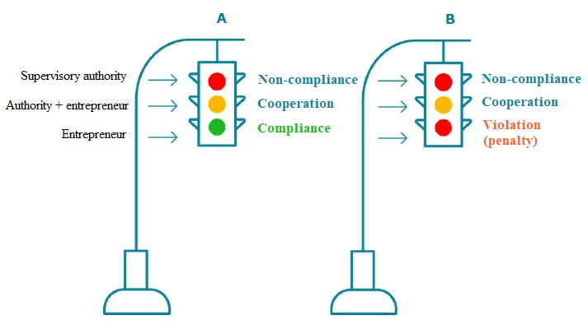

In order to prevent situations when entrepreneurs are using the liberal possibility provided by Latvia to register new undertakings in order avoid the penalty imposed on the undertaking (close the “punished” undertaking and establish a new by continuing the commenced non-compliant practice), in the future the policy-makers need to think of solutions which would impose restrictions on the persons with such history of activity to carry out commercial activity, for example, by paying in a deposit, or to prohibit the possibility to engage in commercial activity after a certain number of violations.

New undertakings
If the authority is aware that an undertaking has recently commenced its activity, it has to be given a possibility to mend its ways without applying any sanctions in cases of insignificant violations committed for the first time in order to establish a positive and cooperation-oriented culture between the new merchant and supervisory authorities already from the beginning. Concurrently, it must be assessed whether such strategy may be applied to severe violations which cause or, according to the opinion of the supervisory authority, could cause a large threat or severe consequences.

Voluntary activities for the prevention of a violation
Where possible, the authorities shall firstly promote voluntary activities by allowing the merchants themselves to prevent the detected non-compliances and carry out the necessary corrective activities. If the violation is insignificant and does not cause threat to health, life or other significant public interests, and the undertaking has undertaken to eliminate the violation, the authorities shall asses the usefulness of the commencement of the administrative violation case. It must be taken into account that the commencement of the administrative case is a difficult process which causes high costs also for the authority, therefore also an application of a warning within the framework of the administrative process is a heavy and resource-intensive mechanism. Instead, the authorities must use other, more effective mechanisms for the achievement of the compliance by concurrently also saving resources. The authorities shall facilitate and support voluntary activities of the entrepreneurs for the fulfilment of the obligations specified for them (including the development of guidelines and good practice for manufacturing and the provision of services).

In the cases when a violation of consumer rights is detected, the Consumer Rights Protection Centre may encourage the merchant to carry out voluntary actions, for example, in the field of advertising and unfair commercial practice a proposal to submit a written commitment to eliminate the violation is offered to the merchant. If a merchant has submitted a written commitment and has appropriately implemented all measures within the specified time period, the Consumer Rights Protection Centre shall not take a decision and apply a fine. The Consumer Rights Protection Centre has developed internal guidelines in the field of commercial practice and advertising on how to detect the severity of a violation and depending on that the necessary actions are taken. Written commitments provided by entrepreneurs are available on the website of the CRPC.

Additional way how to promote voluntary actions on the part of entrepreneurs is to promote the development of good practice standards or internal control systems within undertakings as a method for the self-control of compliance of the undertaking. Accordingly, if the undertaking itself detects non-compliance and eliminated it by notifying the authorities thereof, the authorities shall assess the necessity to apply a penalty and in, the cases where it is possible, the penalty shall not be applied.

Corruption risk reduction in decision taking
Authorities shall develop plans for corruption risk reduction. Also in order to promote uniform attitude towards entrepreneurs, authorities shall determine clear criteria for the performance of inspections and application of penalties which provide a possibility not to apply the penalty under certain circumstances. For example, for the purpose of the transparency of the penalties applied it must be ensured that the inspectors who are performing inspections do not singly take decisions to apply penalties.

The system established within the State Environmental Service provides that an inspection is carried out by one employee, however a decision in the administrative violation case is taken by another employee of the authority. Inspection results are discussed with the direct manager, jointly deciding which non-compliances are to be regarded as insignificant and which are significant. Such approach excludes subjectivity.

II. Customer oriented activity

1. Provision of information and consulting

1.1. Explanation of applicable requirements and e-tools

- availability of the authority for the provision of explanations;
- clear, easy accessible and understandable information on the website;
- explanatory guidelines, for example an entrepreneur’s manual;
- informing of new requirements and “tolerance time period” for their implementation;
- use of modern technologies to reach the target audience;
- check-lists and self-control possibilities.

Availability of the authority
A significant criterion for raising the awareness of applicable requirements in the sector is the availability of the authority in provision and explanation of this information. The authority which is oriented on good management must be capable and ready to cooperate with the sector in creation, understanding and implementation of the requirements. Thus the availability of the authority for quick gaining of information not only helps to quickly address the problematic situations occurred, but also reduces the number of potential violations.
Availability means not only the availability of information on the requirements of laws and regulations, but also convenient way for its obtaining. Especially in sectors where the requirements are very complicated and hard to understand it would be necessary to ensure a possibility to receive a qualitative consultation from an expert of the sector via telephone or in presence, by allocating a sufficient part of the working hours of the personnel for such activity (depending on the interests of customers). Written explanations of norms to entrepreneurs shall be provided within the shortest possible time without reaching the maximum due date for the provision of a reply laid down in the Law on Submissions.
In order to promote that Latvia is chosen for the commencement of business by an increasing number of residents and start-ups of other countries, the availability of the information necessary for commencing and conducting business should be developed, for example, also in English.

By using the performance indicators of the quality management system processes on the operation of the Call Centre, after an accurate analysis improvements were introduced in the Register of Enterprises thus achieving the implementation of good practice standard – now the Call Centre replies to 90 % of customer calls on average (previously 28–60 %, whereas the good practice standard is 85 %). When preparing documents, customers turn to the Call Centre for support and information in 38 % of cases.
It has an objective to introduce the following good practice in the customer service hours in presence: to serve customers within 5–10 minutes. Now it is possible to make an appointment with the Register of Enterprises at a time which is convenient for the customer (appointment in advance, available on the website) and to receive the whole service within 10 minutes on average (including waiting and servicing time).

Websites
An important channel for the transfer of information is the websites of supervisory authorities, therefore it is essential that the information included therein can be quickly found, is easy to perceive and current (information is published operatively and on regular basis), moreover, the topicality of the information is a keyword for this communication channel. If the website of the authority is user-friendly, it helps to save resources for both the entrepreneurs and authorities, as there is no need for additional consultations.
The establishment of the desires and needs of the sector regarding the information to be published on websites must be ensured to the extent possible, and also comprehensibility, ease of finding and convenience of the posted information must also be examined.
Often a quick and effective method for finding out the necessary information and educating the entrepreneurs is the creation of sections for questions and replies and opinions where the authorities post frequently asked questions and their opinions/reports. Compilation and posting of such opinions provides a better understanding of the attitude of the authority regarding different issues, helps the entrepreneurs to find the necessary information faster and authorities to save time resources by providing replies to each submitter individually to repeating questions.

The Central Statistical Bureau has established a section on its website “For Respondents”. The information necessary not only for the submission of reports, but also replies to frequently asked questions, contact information, confidentiality provisions are compiled therein. In sub-section My surveys the information on reports to be submitted by a respondent and deadlines for their submission, information on responsible statistician with whom the respondent may consult during completion of the form is posted.

A possibility to subscribe for news on a website of authorities would ensure receipt of information in the e-mail of an entrepreneur with a certain regularity which the entrepreneur can review at time convenient for him or her. If the competence of the authority is broad, a possibility to choose particular fields on which to receive news would be useful.

Guidelines as an entrepreneur’s manual
Often entrepreneurs face the problem to understand all the requirements applicable to their activity. In more complicated fields that are important for a large number of merchants, guidelines could be developed which would explain the requirements applicable to the relevant field in a simple and easily understandable wording. For the guidelines to reach the target audience and be as effective as possible, it is recommended to involve the sector and specialists thereof in the their development. The guidelines must be published on the website of the authority in an easily accessible location, and also, within its limits, the merchants operating in the relevant field must be informed about the availability of such guidelines, for example, by organising informative workshops. Authorities shall also work on the promotion of the guidelines developed by the European Union authorities in order to inform entrepreneurs of the resources available for explaining the requirements.

The Consumer Rights Protection Centre has developed guidelines in several fields which help to explain the applicable requirements to entrepreneurs. For example, guidelines in the field of electronic communication explain both the principles of fair commercial practice and just regulations for drawing up an agreement. In turn, guidelines for the safety of skiing tracks were been supplemented with explanations during inspections and recommendations which ensured significant improvement of situation in the sector. Associations of the sector and specialists of this field took part in the development of guidelines which guaranteed better applicability thereof.

Educational workshops and training
Explanation of the requirements of the legislation in presence with a possibility for entrepreneurs to ask questions to experts is an effective way how to promote knowledge and understanding of the regulation of the sector. Modern technological capabilities also allows to save resources of authorities and organise distance workshops which are transmitted online, and also to post recordings of workshops on websites in order for them to be viewed by those who could not arrive on site.
For the workshops to be as effective as possible, it is recommended to organise them together with sectoral associations or to use them for disseminating the information on the event.

Self-control tools
Check-lists as a self-check possibility help the entrepreneurs to be aware of the requirements applicable to their field. Electronic tools could be posted on the websites of authorities which provide the possibility for entrepreneurs to carry out self-assessment of their own undertaking on regular basis, for example, once a year, through a questionnaire by electronically making notations on the requirements with which the undertaking complies. These questionnaires may be used also by supervisory authorities, when carrying out risk assessment and planning supervision activities. For example, in respect of undertakings which have performed a voluntary self-assessment supervision measures could be reduced (those undertakings which have filled out questionnaires incorrectly or have not provided replies at all shall be examined as priority). In order to avoid the situations when customers learn to fill out questionnaires, it is recommended to review the questions on regular basis.
A motivating means in complying with the requirements of legal acts may be a letter of the authority (warning) regarding a potentially possible inspection in the undertaking by adding a description of the field to be inspected with listing of the applicable norms. Even if the entrepreneur will not know whether there will be an inspection, and will not be aware of the date when it is planned, he or she will be able to check his or her conformity with the requirements and comply with them. Such approach may be a good supplement to thematic inspections which are focused on compliance with particular requirements.

Such approach has been used by the State Labour Inspectorate in its work – before certain thematic inspections it sends electronic letters to e-mails of undertakings including information that increased inspections will be carried out in the relevant field and also attaching also a check-list or questionnaire where an employer may become familiar with those labour protection requirements which will be inspected by the inspector. Even if all undertakings which have received such information are not visited during the inspections, entrepreneurs are motivated to organise their working environment.
Also the Consumer Rights Protection Centre, when commencing implementation of a supervision project, in certain cases sends to all (known) merchants of the sector information on the main requirements of laws and regulations including a call to ensure the conformity. The supervision activities are carried out only within a certain time after such information has been sent. Thus in 2016 the project for the indication of the prices for funeral services was organised – by firstly providing information and recommendations on the determined requirements and calling to submit pricelists of services for assessment. Inspections were carried out only when the pricelists were not submitted.

Reminders of important deadlines
Often the cause of violations related to the extension of licences and permits or submission of reports is the failure of undertakings to pinpoint the deadline within which the particular permit expires or a report is to be submitted. Such situations could be prevented by providing undertakings with the possibility to receive reminders of deadlines, additionally including also the information on particular activities which are to be carried out.

The EDS system maintained by the State Revenue Service is a significant communication channel between the SRS and taxpayers. The system automatically sends letter with calls and reminders to the e-mail addresses of users indicated in the system, for example, of the deadlines for document submission and making of payments.

“Tolerance period” for the introduction of new requirements
When introducing new requirements which foresee significant changes in the present procedures, provision of a sufficient transition period for entrepreneurs in the legal act for transposing new requirements is regarded as a good practice. This transition period should be effectively used to develop an understanding of the new requirements. Understanding of the new requirements is of particular relevance to small merchants who are not able to employ a large number of specialists in order to actively follow changes in regulations. Therefore an active communication work shall be done before coming into force of new requirements, for example, by providing information on home pages of authorities in the news section, informing undertakings during inspections, and also reminding of approaching of the deadline of coming into force of the requirements.
In turn, when carrying out supervision of requirements, it is recommended to comply with the “tolerance” regime which provides for increased consulting activities and, where possible, not to apply penalties in the start-up period. Application of the tolerance regime would be especially significant if a law or regulation does not provide a transition period for the introduction of new requirements or it is too short in order for the sector to be able to be fully prepared for the application of the requirements.

On 1 January 2016 Unfair Retail Trade Practices Prohibition Law came into force which changed the regulation in respect of relations between large traders and suppliers existing until now. In order to discuss the coming into force of the Unfair Retail Trade Practices Prohibition Law in a timely manner (the Law has been adopted by the Saeima on 21 May 2015, came into force on 1 January 2016), the Competition Council met with suppliers, retailers and law supervisors by informing them of the changes to be expected in a timely manner, and also by organising a conference in order to jointly discuss all concerns and to transfer the information to entrepreneurs in a timely manner. Moreover, in order to be able to evaluate the validity of the law during the first year of its operation, including whether the law achieves its objective, the authority invited retailers, producers and suppliers to participate in a questionnaire on their experience with the introduction of the Unfair Retail Trade Practices Prohibition Law and enforcement thereof during the first year of its validity.

1.2. Special offer for new entrepreneurs

- consulting before starting of a business (for example, road maps);
- advisory inspections;
- mentor programmes.

Starting of a business is always a challenge. Ideally a future entrepreneur should find out the requirements which he or she should comply with when conducting business in the selected field. However, often the new entrepreneur is so focused on the business idea and achievement thereof that he or she forgets to find out the requirements.
By taking into account the fact that starting of a business is one of the fields of the assessment Doing Business carried out by the World Bank, special attention should be paid to cooperation between the supervisory authorities and newly-established undertakings by ensuring maximum availability of information, allowing to gradually adapt to the complicated requirements of laws and regulations.
In the State authorities a mentor network for new entrepreneurs could be created which informs and supports a new entrepreneur for at least the first 3 years of existence. For example by attracting one particular specialist from the authority which provides support and consultations adjusted for the needs of the respective merchant. Authority can also cooperate with educational institutions, business incubators, with authorities dealing with granting of financing (IDAL, RSS, CFCA, etc.) by creating a mechanism that would provide support for new entrepreneurs already from the moment when the business idea is being developed.
State authorities may also carry out advisory inspections in new undertakings with the objective of identifying the situation and provision of instructions for ensuring the compliance, helping a merchant to understand the requirements and ensure compliance.
Concurrently, for the supervisory authorities to be able to qualitatively provide new entrepreneurs with information of relevance to them, it is necessary to work with the availability of the information on the field of activity of undertakings.

Consulting before starting or registering business
The most effective and preventative type of consulting of new entrepreneurs is consulting and provision of information on the requirements applicable to the selected field of entrepreneurship before starting of business or registration in special registers/obtaining special licences (permits). Thus the future entrepreneur is informed of the applicable requirements and there is a lesser likelihood of violations in the future.

In order for entrepreneurs to be able conveniently and effectively find out what licences and permits they need to obtain or what administrative requirements they need to meet for different types of economic activity, the Ministry of Economics in cooperation with sectoral ministries and representatives of the Micro and Small Undertakings Committee has developed the first three road maps. In order to create a transparent vision of the requirements governing the field and entrepreneurs would easily get the first impression of the requirements to be complied by them at one place, the road maps may be a useful auxiliary tool in daily work of undertakings.
Explanations for professionals of the fulfilment of the requirements of laws and regulations can be found in the section E-services of the website of the Health Inspectorate where inter alia a separate section is devoted to information on the commencement of activities in the particular field of interest.

Consultations before the starting of a business may be provided in different ways:
- clear and comprehensive information (in simple language) on the home page of the authority which may be supplemented with a summary of frequently asked questions;
- a possibility to quickly clarify the unclear issues via consultation phone number or e-mail;
- a possibility to meet an expert in person or to communicate remotely online, using modern communication means, for example, Skype, chats and similar tools which ensure quick exchange of information.
- individual or joint seminar cycles of authorities which are focused on the audience of new entrepreneurs.

It is essential that communication with authority in this stage is as simple as possible and not overburdened with bureaucratic procedures in order to receive answers to the issues of interest quickly and operatively by providing a possibility for the future entrepreneurs to perform the necessary activities and calculations, to prepare the necessary information and documents, to ascertain its readiness.
The authority, in turn, has a possibility to get to know the information on potential new customers, to reduce the number of potential offenders, and also to assess their information provision channels and their effectiveness, to improve the quality of information provision.

In the Register of Enterprises the practice has been introduced that the public notary shall, before taking a negative administrative deed (decision) and postponing registration, call a customer and encourage to rectify the deficiencies in the submitted documents within the same day. Such customer oriented practice reduces the number of postponing decisions and the customer does not have to address the authorities for several times within the framework of one administrative procedure.

In order to inform entrepreneurs of the applicable requirements or possibilities to acquire information on them, the issuance of so called information packs or manuals at the registration of the undertaking or the provision of information through electronic registers which the entrepreneur must use in his or her work or in communication with State authorities, or e-mails is used. Information may contain indications of the applicable legal acts, main obligations of the entrepreneur, sources of information, supervisory authorities etc. Effectiveness of these tools shall be assessed on regular basis and a dialogue shall be maintained with the entrepreneur on the most convenient and fastest method for the receipt of information.

The State Revenue Service, when registering economic activity in presence, informs entrepreneurs of the possibilities to get familiar with information on tax liabilities on the SRS website, the possibilities to attend a seminar for newly registered taxpayers, and also the possibilities to receive a consultation on tax application issues. However, taking into account the fact that increasingly more entrepreneurs register their economic activity electronically, the SRS plans to send the information on the methodological materials on tax application issues posted on the SRS website, and also a link to the video seminar for newly registered taxpayers posted on the SRS website to the newly registered entrepreneurs in the Electronic Declaration System.

2. Service oriented customer servicing culture

- change of culture in the authority;
- professionalism in all fields;
- training of employees and psychological preparedness.

Culture and behaviour in the authority
In order to increase effectiveness in the work of the supervisory authority, it is important to ensure business like and at the same time respectful, equal and fair attitude towards all customers. Supervision functions should be carried out kindly and responsively by ensuring a nice communication for both parties which forms a favourable atmosphere for discussing violations and their elimination, and also creates a positive first impression of the authority in general. Internally developed rules of procedure for their interactions with customer may help authorities.
When creating a customer oriented public administration, supervisory authorities should emphasize the support to entrepreneurs in their work by ensuring a sufficient and effective supervision in order to promote a fair competition. People are the basis of any business, therefore a lot can be achieved with a smile and positive attitude by motivating entrepreneurs to comply with the requirements, explaining their objective and helping to understand the methods for the achievement of compliance.

Professional employees
Professionalism must form the basis of any public administration authority. It means not only technical competence in the fields of supervision or identification of risks related thereto, but also general skills and knowledge in the effectiveness of activity and performance of inspections, ethics of behaviour, risk management and mutual cooperation. Authorities need to provide financial support for motivating professional employees in order to ensure that trained and competent employees continue the work in the public administration.
As provided for in the guidelines of best practice principles for the performance of supervision and inspections of the Organisation for Economic Co-operation and Development , governments should introduce personal management and training policy which would ensure that:
1) management employees are selected in such way which ensures that they have not only good technical knowledge in the relevant field, but also due professional management skills and experience;
2) an understanding of what is the purpose of ensuring the compliance with legal acts and inspections to be performed, the most effective types of communication with the subject to be supervised in order to promote conformity with the requirements, and also how to assess and categorise the risks, and also understanding of professional ethics and communication culture are formed through training of usual employees without technical knowledge.

Improvement of the work of supervisory authorities includes not only structural and regulatory changes, but often also the change of culture and behaviour (of both the civil servants and the public). Only the entrepreneurs themselves can ensure continuous compliance with requirements, therefore supervisory authorities should cooperate with the sector to be supervised and, where possible, should use cooperation based approach.

Training of employees
Training of employees is important not only in the professional field to maintain a high level of competence and knowledge of authority’s processes, but also in culture and communication ethics, communication with customers and responding to crisis situations. Psychological support to employees who are working with customers, a possibility to get to know how to respond in different situations in the everyday work are equally important.
The Ministry of Economics in cooperation with the Latvian School of Public Administration shall work on the development of a training programme within the framework of the project No. 3.4.2.0/15/I/001of the European Union Structural Funds, Professional Improvement of Human Resources of the State Administration for the Development of Better Regulation in the Field of Support to Small and Medium sized Merchants, implemented by the Latvian School of Public Administration. The purpose of the programme is to create a support mechanism for supervision authorities by ensuring training that is based on the “Consult First” for the employees of authorities to improve cooperation with customers.
“Internal mentors” or long-term employees of the authority who could help new employees to acquire customer service skills and good supervision standards laid down within the authority may be involved in the training of new employees.
The Public Administration Customer Service Manual developed by the State Chancellery can also be used in the training of employees and everyday work – it is also used in training, including in the unified customer service centres.
It would also be important to assess the added value for employees provided by trainings, the level of their acquisition by carrying out inspection or testing if needed.

In order to develop the skills of employees in the field of interrelation and communication,the State Revenue Service and the State Labour Inspectorate have organised several training seminars on conflict resolution, psychological stability and improvement of communication skills of employees in both the written communication and direct interaction with customers.

3. Assessment of an authority (customer satisfaction)

- complaints as a source of information for the improvement of the work of authority;
- authorities shall carry out customer satisfaction studies;
- entrepreneurs are given an opportunity to assess the reply received from the authority;
- regular evaluation of the effectiveness of information channels, being up-to-date.

In order for the authority to be able to follow and improve its cooperation with customers on its own, it would be necessary to carry out regular assessments of the cooperation with customers and analyse the recommendations and criticism provided.

Analysis of complaints concerning the work of an authority
Regardless of the work quality of the authority, they often receive complaints concerning their work (or the work of subordinated authorities). Although complaints are not a pleasant theme, they may provide a useful information on the fields in which the work of authorities may be improved or possible mistakes which may be rectified.
In order to use this useful source of information in an effective manner, the authority should establish a complaint collection and analysis system by identifying in complaints the information that is valuable for the improvement of the work of the authority or rectification of deficiencies of the legislation. In promoting the use of constructive criticism for the improvement of the work of the authority, causing of possible unfavourable consequences to the submitter of a complaint for expressing his or her opinion should be avoided.
If the submitter of a complaint wants to remain anonymous, the website “MazāksSlogs” and application “Futbols” may be used in order for the persons servicing customer could themselves identify the cases when the burden can be reduced or the customer has been footbolised between authorities.

Customer satisfactions studies
It is essential that supervisory authorities carry out the quality assessment of consultations and supervision activities on regular basis. Positive feedback serves as stimulus to continue good practice, whereas criticism may help to detect the directions where improvements are necessary. The work with feedbacks helps to improve the overall image of the authority, as it indicates to the openness and striving to development of the authority.

The Competition Council carries out a survey on public opinion once in two years in order to find out the awareness and opinion of undertakings, lawyer offices, local governments and associations on competition rights, work of the authority, and also to receive information on the wishes of entrepreneurs regarding the future work of the authority. The results of the survey are taken into account when developing the work plan of the authority for the next year in respect of the markets to be supervised, improvement of the operation of the authority and its communication with the public.

Regular work with the assessment provided by customers is a significant aspect when creating good supervision practice. A possibility to submit anonymous feedback or comments about the inspections carried out by the authority or consultations given must be provided for customers. Authorities shall encourage the customers to provide assessment of their work, for example by establishing a simple and easily accessible electronic assessment questionnaire on their website through the use of an automated possibility to assess a telephone conversation with an expert by encouraging to fill in feedback forms after performance of the control. It is essential to indicate that complaints and comments will be used for the improvement of the work of the authority by respecting full confidentiality.
The possibilities to carry out the customer satisfaction surveys in a centralised manner within the public administration shall also be considered in order to ensure the assessment of the work of authority in a unified form according to common criteria by assessing what changes are necessary not only in the work of particular authorities, but in the public administration in general. A useful source of information for reducing the administrative burden of the authorities is the employees of authorities who may identify useless processes in the authority on daily basis the reduction of which could help to save resources of the authority and allow to perform tasks faster and more effectively. In order to ensure anonymity, the possibility for employees to submit proposals on the reduction of the administrative burden of the authority anonymously must be assessed.
A regular survey and analysis of customer satisfaction helps to emphasize the necessity to make amendments to the legislation, therefore the results of customer satisfaction surveys carried out by authorities could be a good source of information also for policy-makers. Whereas, in order to ensure an objective and independent evaluation of the work of authority, an independent expert could be attracted for the performance and analysis of surveys.

Customers respond really well to those cases when they have received assistance on the merits and a qualitative consultation – such cases are emphasized and recognised within the award “Excellent Sample” by the State Chancellery by annually carrying out a survey.

Evaluation of information provision channels and development “up-to-date”
In this digital age the demand for a quick and efficient exchange of information is increasing. Website visitors want to obtain the information of their interest within as short time as possible. This also creates a challenge for supervisory authorities which causes the necessity to evaluate the topicality and comprehensibility of the information provided by them.
Potential information transmission channels have also significantly changed – important that also supervisory authorities are following modern trends and use different types of information transmission accordingly in order to be aware of their target audience as much as possible. Modern technologies provide a possibility to use not only the website of the authority as the main channel for the transfer of information, but also other possibilities for communication, for example, Twitter, Facebook, Youtube, subscription to news, applications, etc.
Concurrently, it is important to carry out evaluation on regular basis whether the type and amount of the provided information has reached the target audience and, where necessary, to exclude from the communication the strategy channels which do not sufficiently perform their functions by developing new channels instead which could promote better customer information.

Conclusion

The principles included in this guideline document compiles examples of good practice which are or could be used by authorities of Latvia to create effective and cooperation oriented supervision, and also to ensure a qualitative transfer of information to entrepreneurs on the applicable requirements. The guidelines have been developed by taking into account the examples and recommendations of foreign good practice.
In order to promote the achievement of the main objective of the “Consult First” – to achieve mutual understanding between entrepreneurs and supervisory authorities by promoting the fulfilment of the laid down requirements the authorities are called to assess their work in accordance with the principles covered by the guidelines and to determine the fields where improvements are necessary.
We hope that the guidelines will be an assistant and adviser in this work by creating customer oriented public administration!
The principles laid down in the guidelines can be used by all State and local government authorities in the improvement of the work effectiveness and communication with customers.
The guidelines “Consult First” are a “live” document which will be moving with the times and technological progress, therefore we will be thankful for recommendations and improvements. Please, send the suggestions to pasts@em.gov.lv.
Sources of Information Used in the Development of the Guidelines:

1) OECD Best Practice Principles for Regulatory Enforcement. Regulatory Enforcement and Inspections, 2014;
2) Best Practice Techniques in Market Surveillance, Prosafe;
3) Good Practices for Business Inspections, Guidelines for Reformers, World Bank Group, 2006;
4) Enforcement Concordat: Good Practice Guide for England and Whales, Department for Trade and Industry, 2003;
5) Model for Improvement of Public Service System, within the framework of the MEPRD ESF project “Improvement of Public Service System”, Riga, 2013;
6) Administrative Procedures and Entrepreneurship Environment in Latvia, GatewayBaltic, 2017.



MINISTRY OF ECONOMICS
Brīvības iela 55, Rīga, LV-1519, Latvia
Telephone number: +371 67 013 107
E-mail: pasts@em.gov.lv



OECD Best Practice Principles for Regulatory Enforcement. Regulatory Enforcement and Inspections, 2014

