**MINISTRY OF HEALTH OF THE REPUBLIC OF LATVIA**

APPROVED

by Order No. 225 of 22 December 2020

of the Ministry of Health of the Republic of Latvia,

Regarding Approval of the National Disaster Medicine Plan

**NATIONAL DISASTER MEDICINE PLAN**

**CONTENTS**

**ABBREVIATIONS** 3

**KEY CONCEPTS OF DISASTER MEDICINE** 5

**1. NATIONAL DISASTER MEDICINE PLAN: INTRODUCTION** 8

**2. DISASTER MEDICAL SYSTEM: FRAMEWORK, OBJECTIVE, AND TASKS** 10

2.1. FRAMEWORK AND OBJECTIVE OF THE DISASTER MEDICAL SYSTEM 10

2.2. TASKS OF THE DISASTER MEDICAL SYSTEM 10

**3. DISASTER MEDICAL SYSTEM: MANAGEMENT** 12

**4. DISASTER MEDICAL SYSTEM: PLANNING** 14

**5. DISASTER MEDICAL SYSTEM: RESPONSE AND ELIMINATION OF CONSEQUENCES** 19

5.1. MANAGEMENT CONTROL OF THE EMERGENCY 22

5.2. MANAGEMENT OF EMERGENCIES IN AN INSTITUTION SUBORDINATE TO THE MOH 25

5.3. MANAGEMENT OF EMERGENCIES IN A HOSPITAL 26

**6. RESOURCES OF THE DISASTER MEDICAL SYSTEM** 27

**7. INTERNATIONAL WARNING AND MONITORING SYSTEMS** 29

**8. INTERNATIONAL ASSISTANCE IN EMERGENCIES** 30

**9. PROVISION OF COMMUNICATIONS IN EMERGENCIES** 31

**10. TRAINING** 32

**11. CRISIS COMMUNICATION** 34

11.1. OBJECTIVE AND PRINCIPLES OF CRISIS COMMUNICATION 34

11.2. MANAGEMENT AND IMPLEMENTATION OF CRISIS COMMUNICATION 34

**LIST OF ANNEXES** 36

# **ABBREVIATIONS**

**ARCC** – Aeronautical Rescue Coordination

**CCUH** – Childrenʼs Clinical University Hospital Centre

**CDPC** – Centre for Disease Prevention and Control

**CEDM of SEM Service** – Centre of Emergency and Disaster Medicine of the SEM Service

**CMC** – Crisis Management Council

**CPDM Law** – Civil Protection and Disaster Management Law

**CRPC** – Consumer Rights Protection Centre

**DM** – disaster medicine

**EC** – European Commission

**ECURIE** – European Community Urgent Radiological Information Exchange

**EMA** – emergency medical assistance

**EMA** – European Medicines Agency[1]

**Eme** – medical sector emergency and public health emergency – jointly emergency

**EPIS** – Epidemic Intelligence Information System

**EWRS** – Early Warning and Response System of the European Commission

**FVS** – Food and Veterinary Service

**HI** – Health Inspectorate

**IAEA** – International Atomic Energy Agency

**IMP** – European Union Regulatory Network Incident Management Plan for Medicines for Human Use

**LRC** – Latvian Red Cross

**LSA** – Latvian Samaritan Association

**MoD** – Ministry of Defence

**MoEPRD** – Ministry of Environmental Protection and Regional Development

**MoFA** – Ministry of Foreign Affairs

**MoH** – Ministry of Health

**MoI OMC** – Operative Management Centre of the Ministry of the Interior

**MoI** – Ministry of the Interior

**MSE** – medical sector emergency

**NAF** – National Armed Forces

**NDM** **Plan** – National Disaster Medicine Plan

**NGO** – non-governmental organisation

**NHS** – National Health Service

**OCMA** – Office of Citizenship and Migration Affairs

**OIE** – World Organisation for Animal Health

**OMC of SEM Service** – Operative Management Centre of the SEM Service

**OMG** – Operative Management Group

**PHE**– public health emergency

**PPE** – personal protective equipment

**PSCUH** – Pauls Stradiņš Clinical University Hospital

**REUH LCID** – Latvian Centre of Infectious Diseases of Riga East Clinical University Hospital

**REUH** – Riga East University Hospital

**SAM** – State Agency of Medicines

**SBDC** – State Blood Donor Centre

**SBG** – State Border Guard

**SCFME** – State Centre for Forensic Medical Examination

**SCP Plan** – State Civil Protection Plan

**SEM Service** – State Emergency Medical Service

**SES RSC** – Radiation Safety Centre of the State Environmental Service

**SFRS** – State Fire and Rescue Service

**SIPCR** – State Inspectorate for Protection of Children’s Rights

**SMC of SEM Service** – Specialised Medicine Centre of the SEM Service

**SMR** – State material reserves

**SOMC** – State Operational Medical Commission

**SP** – State Police

**SSS** – State Security Service

**UN** – United Nations

**UNHCR** – United Nations High Commissioner for Refugees

**WHO IHR** – International Health Regulations of the World Health Organisation

# **KEY CONCEPTS OF DISASTER MEDICINE**

**Affected area** – a specific geographical place for which the World Health Organisation has specified health protection measures in accordance with the International Health Regulations.

**Cleanup** – removal of radioactive substances in order to mitigate radioactive pollution on all types of surfaces, in the bodies of inhabitants, in materials, environmental objects, food, animal feed, and drinking water.

**Crisis communication** – the preparation and application of such strategies and tactics which may prevent or mitigate a significant impact of events on a company or organisation. (Kurt P. Stoker)

**Crisis intervention** – extraordinary psychological assistance the objective of which is to help individuals in a crisis situation in order to restore emotional balance and to reduce a potential psychological trauma.

**Crisis situation** – a situation where a family (person), due to a disaster or due to other circumstances that do not depend on the will of the family (person), is not able to ensure the basic needs on their own and requires psychosocial or material assistance.

**Decontamination** – a procedure by which health protection measures are taken in order to eliminate the presence of infectious or toxic agents or substances endangering public health on the surface of a human or animal body, in or on a product prepared for consumption, on other objects, including vehicles.

**Disaster** – an event which has caused human victims and endangers human life or health, has inflicted harm or caused threats to humans, environment, or property, and also has caused or causes significant material and financial losses and exceeds the everyday capacity of the responsible State and local government authorities to prevent the devastating circumstances of the event.

**Disaster medical equipment** – equipment which is necessary for ensuring emergency medical assistance to victims in emergencies (medical equipment, personal protective equipment, decontamination devices, means of communication, road transport, and material and technical facilities).

**Disaster medical system** – an aggregate of State coordinated measures which are taken by medical treatment institutions and other institutions of the health care sector irrespective of the form of ownership in order to save human lives and to reduce the destructive impact on public health in medical sector emergencies and public health emergencies.

**Disaster medicine** – principles of medical assistance which determine the planning, organising, and ensuring of medical assistance to victims (people who have fallen ill) in emergencies.

**Disinfection** – a procedure by which health protection measures are taken by direct exposure to chemical or physical agents in order to control or destroy infectious agents on human or animal skin surface or in or on luggage, cargo, containers, vehicles, goods, and postal packages.

**Emergency** – a medical sector emergency and public health emergency.

**Emergency medical assistance** – assistance to victims (persons who have fallen ill) in a critical state of danger to life or health, provided by persons specially prepared (trained, equipped) for such cases with relevant qualifications in medicine who, according to such qualifications, have legal liability for their actions or omissions and the consequences of such actions or omissions.

**Emergency situation** – a special legal regime during which the Cabinet has the right, in accordance with the procedures and to the extent laid down in law, to restrict the rights and freedoms of State administration and local government authorities, natural and legal persons, and also to impose additional obligations on them.

**Environmental pollution** – pollution of the environment with chemical, biological, or radioactive substances dangerous to health.

**First aid** – assistance provided to victims (persons who have fallen ill) in a critical state of danger to life or health by persons with or without medical qualifications, within the scope of their knowledge and possibilities irrespective of their proficiency and equipment.

**Management of an emergency** – an aggregate of such managed and coordinated measures of prevention, preparedness, response, elimination of consequences, and also measures of recovery which are taken to ensure the fulfilment of the tasks of the disaster medical system.

**Medical resources** – trained medical personnel and prepared medical and material and technical facilities.

**Medical sector emergency** – a situation when the amount of medical resources immediately available in a medical treatment institution, the administrative territory of a local government, or the State is not sufficient for the current or projected number of victims or persons who have fallen ill.

**Pollution –** pollution of persons or objects with chemical, biological, or radioactive substances dangerous to health.

**Psychological crisis** – a state in which a person perceives the event/situation as an intolerable difficulty that exceeds the current resources and coping mechanisms of the person (Gilliland & James, 1997).

**Psychological first aid** – an aggregate of measures ensured by psychologists to victims in case of an emergency/disaster by providing practical care and support to those who need it (surveying of basic needs of the people in crisis, listening if a person wishes to share his or her trials, mitigating the concerns and helping the victim to feel calmer, taking care that people are safe and protected from potential further harm, provision of information on services and social assistance available (Psychological first aid: Guide for field workers, World Health Organization, 2011)).

**Psychosocial support** – a direction of social work the purpose of which is to help an individual and a family to solve interpersonal problems and problems of the social environment, providing psychological and social support.

**Public health emergency** – an outbreak of an infectious disease or threats of an outbreak thereof with a significant potential of spread that is difficult to control, and also an event or threats of an event of exposure to biological, chemical, or physical factor that is harmful to the health of inhabitants during which the taking of public health protection measures in an enhanced regime and coordinated action of the authorities involved are necessary.

**Public health threat** – the probability of such event which may have an adverse impact on the health of human population, emphasising an event which may spread internationally or may cause particularly harmful and direct threat.

**State Operational Medical Commission** – a consultative and coordinating authority established by the Cabinet the objective of the operation of which is to ensure coordinated action of the authorities of the health sector in an emergency.

**Threat** – a dangerous occurrence, substance, human activity, or circumstance which may cause the loss of life, cause an injury or other damages to health, inflict harm on property, cause the loss of means of subsistence and services, social and economic destabilisation, or inflict harm on the environment.

# **1. NATIONAL DISASTER MEDICINE PLAN: INTRODUCTION**

1. The **National Disaster Medicine Plan** is a document of strategic level which, taking into account the disaster management measures specified in the Civil Protection and Disaster Management Law, determines the responsibility and action of the authorities involved in the management of medical sector emergency and public health emergency within the scope of the disaster medical system.

2. In accordance with the Medical Treatment Law, the **disaster medical system** is an aggregate of State coordinated measures which are taken by medical treatment institutions and other institutions of the health care sector irrespective of the form of ownership in order to save human lives and to reduce the destructive impact on public health in medical sector emergency and public health emergency (hereinafter jointly – the emergency). A more detailed characterisation of each emergency in the health sector is indicated in Figure 1.

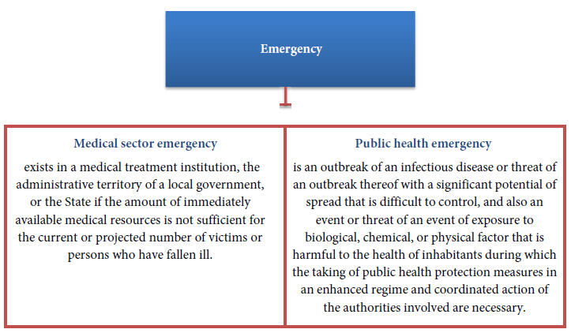

*Figure 1. Division of the Emergency*

3. The National Disaster Medicine Plan has been developed in accordance with Cabinet Regulation No. 948 of 13 December 2011, Regulations Regarding Organisation of the Disaster Medical System.

4. **The National Disaster Medicine Plan** includes:

4.1. management of an emergency, management of emergencies of the institutions subordinate to the Ministry of Health and hospitals;

4.2. action, exchange of information among the concerned authorities in emergencies or in case of the threats thereof (emergency with many victims; in case of dangerous and other infectious diseases; in case of a chemical disaster (accident); in an accident caused by climate impact; in case of a radiation accident; in case of threat of unknown origin; in case of mass influx of asylum seekers; in provision of psychological assistance in an emergency; in involvement of non-governmental organisations in an emergency);

4.3. the resources of the disaster medical system to be used in the State, their amount and layout;

4.4. the number of patients to whom provision of medical assistance in hospitals is possible;

4.5. international warning and monitoring systems;

4.6. involvement of State material reserves in an emergency;

4.7. requesting and receipt of international assistance in an emergency;

4.8. crisis communication;

4.9. organising of training of the disaster medical system.

5. The development and updating of the National Disaster Medicine Plan shall be managed by the State Emergency Medical Service.

6. The National Disaster Medicine Plan shall be updated not less than once a year.

7. The procedures by which the Ministry of Health and the institutions subordinate to the Ministry of Health and hospitals shall implement the responsibility and action specified for them in the National Disaster Medicine Plan shall be determined in the internal regulatory enactments of such institutions and in the disaster medical plans of hospitals.

8. The management preparedness and emergency response regimes (see Sub-paragraphs 30.1 and 30.2) and the criteria for the declaration of an emergency situation in the health sector (see Sub-paragraph 30.3) are determined in the National Disaster Medicine Plan.

9. The documents governing the disaster medical system are indicated in **Annex No. 18 to the National Disaster Medicine Plan**.

# **2. DISASTER MEDICAL SYSTEM: FRAMEWORK, OBJECTIVE, AND TASKS**

# 2.1. FRAMEWORK AND OBJECTIVE OF THE DISASTER MEDICAL SYSTEM

10. **The DM system is a component of the State civil protection system and of the national security system** and the planning thereof is integrated in civil protection, national security, and other plans.

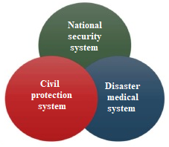

*Figure 2. Framework of the DM system*

11. **The DM system consists of an aggregate of measures** which are implemented by the MoH, the institutions subordinate to the MoH, medical treatment institutions, and other authorities of the health sector with the objective of ensuring the management of the Eme in the health sector.

12. **The objective of the DM system** is to save human lives in the Eme and to mitigate the destructive impact on public health in the context of the civil protection and national security system.

# 2.2. TASKS OF THE DISASTER MEDICAL SYSTEM

13. **Tasks of the DM system:**

13.1. to ensure cooperation of the authorities of the health sector and other organisations in the Eme;

13.2. to organise and ensure EMA in the Eme and disasters, and also in case if the amount of medical assistance required exceeds the resource capacity of the medical treatment institution;

13.3. to survey, plan, maintain, and restore the necessary medical resources in order to ensure the management of the Eme at the level of medical treatment institutions and the State;

13.4. to plan and ensure cooperation with the authorities involved in the management of the Eme;

13.5. to plan and organise the learning of and training in the DM system;

13.6. to manage, coordinate, organise, and control training in the provision of first aid;

13.7. to ensure international cooperation in the management of the Eme;

13.8. to inform the society in due manner of the measures to be taken in case of the Eme in order to ensure the provision of first aid and to mitigate the potential harm to health;

13.9. to carry out recording of the information necessary for ensuring the operation of the DM system.

# **3. DISASTER MEDICAL SYSTEM: MANAGEMENT**

14. The **MoH** shall be responsible for **the organising and management of the DM system**.

15. The **SOMC** established by the Cabinet shall be **the consultative and coordinating authority** which ensures coordinated action of the authorities of the health sector and facilitates the preparedness of the DM system to respond in the Eme, and its operation shall be determined by Cabinet Regulation No. 956 of 13 December 2011, By-law of the State Operational Medical Commission.

16. **The State Secretary of the MoH shall be the head of the SOMC.** The composition of the SOMC shall include representatives from the MoH, NHS, SEM Service, REUH, PSCUH, CCUH, CDPC, SAM, HI, SBDC, and SCFME.

17. **In case of the Eme or the threat thereof, an extraordinary meeting of the SOMC may be convened upon initiative of the State Secretary or another member of the SOMC.** Tasks of the SOMC and members of the SOMC in case of convening an extraordinary meeting are indicated in Paragraphs 49–50 of the NDM Plan.

18. **In case of the Eme or the threat thereof, the State Secretary may convene an emergency steering group of the MoH in which representatives of the institutions subordinate to the MoH and hospitals shall be involved to the extent necessary** in order to coordinate the operation of the authorities of the health sector involved in case of the Eme or the threat thereof. Tasks of the emergency steering group of the MoH are specified in the internal procedures of the MoH which determine the ensuring of continuous operation of the institution in case of the Eme or the threat thereof, and the internal procedures are developed in accordance with the requirements laid down in Paragraph 29 of the NDM Plan.

19. **Ordinary meetings of the SOMC** which take place not less than once a year are convened in order to facilitate the preparedness of the DM system to respond in the event of the Eme. The task of members of the SOMC is to assess the laws and regulations governing the DM system, the NDM Plan, and to provide proposals to the SEM Service for the improvement thereof.

20. In case of the Eme or the threat thereof, the head of the institution shall be responsible for the management of the Eme in institutions subordinate to the MoH and hospitals. Management in institutions subordinate to the MoH and hospitals is indicated in Paragraphs 52–60 of the NDM Plan.

21. **If management of the Eme requires coordinated action and cooperation of State and local government authorities**, **the CMC of the Cabinet may be convened** upon proposal of the SOMC or the Minister for Health.

22. **The Prime Minister shall be the head of the CMC**, the composition of the CMC shall include **the Minister for Health** and eight ministers of other ministries. The functions of the CMC Secretariat shall be performed by the MoI. The operation of the CMC and its convening shall be determined by Cabinet Regulation No. 42 of 18 January 2011, By-law of the Crisis Management Council.

23. The management levels of the Eme, the responsibility of the authorities and institutions involved is indicated in **Figure 3 of the NDM Plan**.

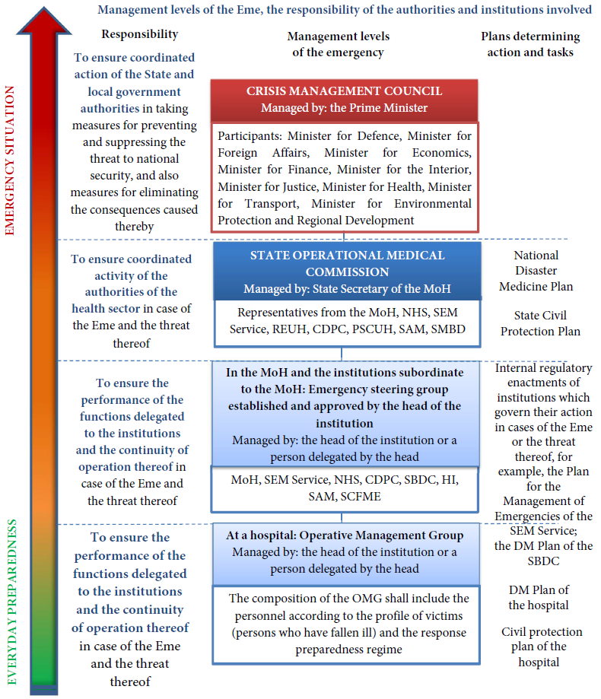

*Figure 3. Management levels of the Eme, the responsibility of the authorities and institutions involved*

# **4. DISASTER MEDICAL SYSTEM: PLANNING**

24. **Preparedness planning of the DM system shall be managed and coordinated by the SEM Service.**

25. In accordance with the requirements of the CPDM Law, **preparedness planning of the DM system is implemented by taking into account the risk evaluation of disasters (threats) possible in the State** which is performed by the responsible ministries by involving the authorities subordinate thereto.

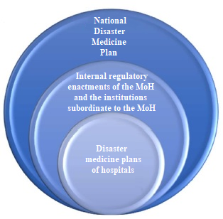26. The following is developed for ensuring the operation of the DM system:

26.1. the National Disaster Medicine Plan;

26.2. the disaster medicine plans of hospitals;

26.3. the internal regulatory enactments of the MoH and the institutions subordinate to the MoH which determine the ensuring of continuous operation of the institution in case of the Eme or the threat thereof.

*Figure 4. Division of the plan into levels*

27. Heads of the hospitals which are specified in **Annex No. 12 to the NDM Plan** shall be responsible for the development and updating of the DM plans of hospitals in accordance with **Annexes No. 8 and No. 22 to the NDM Plan**.

28. Institutions which must have the internal procedures which determine the ensuring of continuous operation of the institution in case of the Eme or the threat thereof shall be as follows:

28.1. the MoH;

28.2. the SEM Service;

28.3. the CDPC;

28.4. the HI;

28.5. the NHS;

28.6. the SAM;

28.7. the SCFME;

28.8. the SBDC.

29. The heads of the institutions referred to in Paragraph 28 of the NDM Plan shall be responsible for the development and updating of the internal procedures. According to the tasks for institutions indicated in the NDM Plan in the Eme and the internal threats specified by the institution for ensuring continuity of the operation, the following information shall be included in the internal procedures:

29.1. a list of potential risks and a summary of the risk assessment;

29.2. receipt and notification of alert signals;

29.3. the procedures for the substitution of personnel;

29.4. taking and notification of the decision on declaration of preparedness or emergency response regime;

29.5. management of the Eme, including the composition and tasks of the emergency steering group of the institution;

29.6. action and tasks of the personnel;

29.7. involvement of the current and additional resources and the management thereof;

29.8. cooperation and exchange of information with other authorities and medical treatment institutions involved;

29.9. cooperation and exchange of information with the authorities of other sectors involved;

29.10. cooperation and exchange of information with the civil protection commission of the local government;

29.11. cooperation with mass media;

29.12. evacuation measures for ensuring continuity of operation of the institution.

30. Preparedness of the DM system in the Eme shall be planned according to the following response regimes and criteria:

30.1. **Preparedness Response Regime (preparedness*):**

**Preparedness Response Regime** is a special operating regime of an institution/hospital which is declared if the available personnel resources, material and technical resources, or other resources to be involved in the management of the Eme **may be insufficient** in order to ensure taking of the necessary response measures when continuing the work of the institution/hospital in everyday operating regime;

30.2. **Emergency Response Regime (Increased Preparedness and Response/Emergency Preparedness and Response[2]):**

**Emergency Response Regime** is a special operating regime of an institution/hospital which is declared if the available personnel resources, material and technical resources, or other resources to be involved in the management of the Eme are insufficient in order to ensure taking of the necessary response measures when continuing the work of the institution/hospital in everyday operating regime;

30.3. **Emergency Situation in the Health Sector:**



**Emergency Situation in the Health Sector** is a state caused by public health threat or a disaster which **conforms to at least three of the following criteria**:

30.3.1. there are human victims or there is a serious threat to human life or health;

30.3.2. the immediately available resources of the responsible State and local government authorities of the health sector are not sufficient for the management of the situation or for the elimination of the consequences caused;

30.3.3. coordinated action of the involved authorities at the level of local governments, the State or international level is necessary;

30.3.4. taking of public health protection measures in an enhanced regime is necessary.

31. **Preparedness of the DM system in the Eme shall be planned according to the types of the possible threats specified in the State:**

31.1. outbreaks and epidemics of influenza and other acute respiratory infections, acute intestinal infections, Hepatitis A, vaccine-preventable infectious diseases, cases/threats of bringing in and spread of enteroviral meningitis, and also dangerous infectious diseases **(Annex No. 2 to the NDM Plan)**;

31.2. outbreaks of poisoning by using food or water containing poisonous/toxic or radioactive substances in nutrition, coming into contact with household chemicals, etc.;

31.3. incidents related to the quality, efficiency, safety of medicinal products and discontinuation in the supply thereof;

31.4. vehicle accidents (accidents of road transport, rail transport, maritime and air transport);

31.5. climate impact (intense heat or cold, storm, heavy rainfalls, icing, blizzard, floods) **(Annex No. 4 to the NDM Plan)**;

31.6. fire (of buildings, forests, peat bogs, etc.);

31.7. release of dangerous chemical, radioactive, or biological substances **(Annexes No. 3, No. 5, No. 6, and No. 21 to the NDM Plan)**;

31.8. accidents in gas supply, water supply, and wastewater systems, damages to energy networks;

31.9. collapse of buildings and structures;

31.10. public disorder, conflicts;

31.11. mass influx of asylum seekers, including refugees **(Annex No. 7 to the NDM Plan)**;

31.12. terrorist attacks, including acts of biological and radiological terrorism **(Annexes No. 2 and No. 5 to the NDM Plan)**;

31.13. internal conflicts, armed conflicts.

32. Threats possible in the State according to the type of their origin are indicated in **Figure 5 of the NDM Plan**.

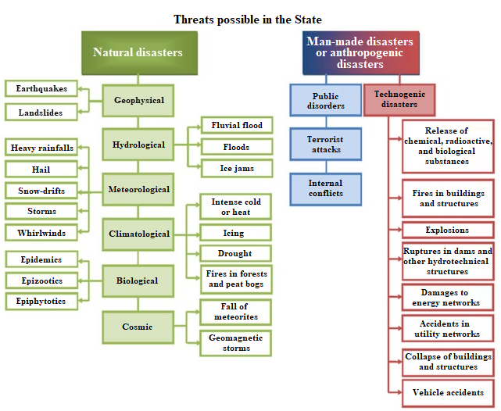

*Figure 5. Threats possible in the State according to the type of their origin Source: Civil Protection and Disaster Management Law*

33. Evaluation of the possible risk of dangerous infectious diseases, their threats, and epidemics of other infectious diseases shall be performed by the CDPC and other responsible authorities specified in the laws and regulations. Preparedness planning and action of the involved authorities is described in **Annex No. 2 to the NDM Plan, Preparedness and Action in Case of Threat and Emergency Caused by an Infectious Disease**. Planning of the pandemic preparedness measures increases the possibility for the prevention or mitigation of the adverse consequences thereof in a timely manner, and also the improvement of cooperation of the authorities in planning of the management of emergencies, including availability of the medical resources. In planning action in case of the COVID-19 pandemic, recommendations for hospitals have been developed in case if the demand for the medical resources might exceed the capacity (for example, the number of beds in intensive care units (hereinafter – ICU) or artificial lung ventilation (hereinafter – ALV) possibilities) which are described in **Annex No. 24 to the NDM Plan, Principles for Distribution of Artificial Lung Ventilation Resources during COVID-19 Pandemic in Latvia**.

34. **Action and response in cases of terrorist attacks have been specified in the plans developed by the Counterterrorism Centre of the SSS:** Response Plan in the Event of a Threat to Land Objects (Counterterrorism Plan “Object”), Response Plan in the Event of a Threat for Civil Aviation Aircrafts and Objects (Counterterrorism Plan “Airplane”), Response Plan in the Event of a Threat to Ships, Ports and Port Facilities (Counterterrorism Plan “Ship”). The abovementioned plans have been classified FOR SERVICE NEEDS.

35. **Management of search and rescue operations in case of an aviation and marine accident is specified in the plans:** Operational Response Plan for Search and Rescue in the Area of Responsibility of the Maritime Rescue Co-ordination Centre (MRCC) and **Operational Response Plan for Search and Rescue Operations of an Aircraft Accident and Victims**.

36. Organising of measures in case of mass influx of asylum seekers shall be coordinated by the MoI in accordance with Cabinet Order No. 312 of 4 July 2012, Regarding the Action Plan for Co-ordinated Action of Institutions in Relation to Possible Mass Influx of Asylum Seekers in Latvia from the Countries Affected by Crisis. This plan determines the aggregate of measures to be taken by the responsible authorities if mass influx of asylum seekers in the State territory is being projected or has been established and the responsible authorities are not able to ensure reception of asylum seekers. **Action within the scope of the DM system in case of mass influx of asylum seekers has been specified in Annex No. 7 to the NDM Plan.**

37. **Provision of psychological assistance in the Eme is organised in accordance with Annex No. 19 of the NDM Plan.** The ministry or local government responsible for the management of the Eme/disaster shall, using the civil protection mechanism, involve psychologists for the provision of first psychological assistance at the site of the event to the extent necessary in the Eme. Psychologists shall work outside the risk zone at the site indicated by the manager of the event.

38. **The NAF shall participate in accident, fire-fighting, and rescue work, and also in taking of emergency measures in emergency situations upon request of the Cabinet, the civil protection commission of the local government, or the SOMC** if the resources at the disposal of the civil protection system for taking of emergency measures are insufficient and attraction of the resources of the NAF significantly accelerates executing of the measures for the elimination of consequences of the events which have caused the emergency situation, reduces the possible losses, or accelerates rescue of humans, or if the armed forces have special equipment at their disposal for the performance of such activities. **The tasks and procedures by which the NAF shall participate in provision of assistance to the civil aviation system shall be determined by the Minister for Defence.**

# **5. DISASTER MEDICAL SYSTEM: RESPONSE AND ELIMINATION OF CONSEQUENCES**

39. The DM system shall be activated in case of the Eme or the threat thereof in accordance with the response regimes and criteria specified in Paragraph 30 of the NDM Plan.

40. The decision on declaration and revocation of the preparedness and emergency response regime in an institution subordinate to the MoH and a hospital shall be taken by the head of the institution, informing the State Secretary of the MoH and the SEM Service thereof.

41. Taking into account the criteria specified in Sub-paragraph 30.3 of the NDM Plan, the SOMC may declare **the Eme in the health sector**. The algorithm for taking the decision to declare the Eme in the health sector has been indicated in **Figure 6 of the NDM Plan**.

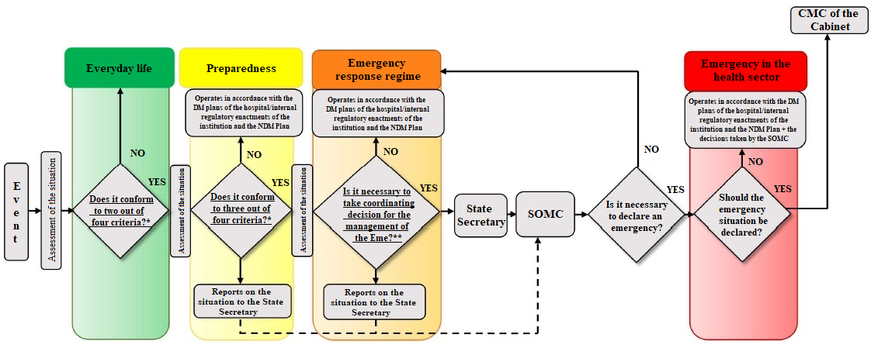

**\* In the Eme the health sector conforms to the following criteria:**

* there are human victims or there is a serious threat to human life or health;
* the immediately available resources of the responsible State and local government authorities of the health sector are not sufficient for the management of the situation or for the elimination of the consequences caused;
* coordinated action of the involved authorities at the level of local governments, the State or international level is necessary;
* taking of public health protection measures in an enhanced regime is necessary.

**\*\* Taking of the decision**

* the responsibility of the head of the hospital/institution exceeds the delegation/authorisation specified in laws and regulations;
* the management measures are related to the attraction of additional financing.

*Figure 6. Algorithm for Taking the Decisions on Declaration of the Emergency in the Health Sector*

42. Responsibility and action, exchange of information among the involved authorities in case of the Eme or the threat thereof, schemes for activation of response are described in **Annexes to the NDM Plan**. The scheme of Annexes to the NDM Plan is indicated in **Figure 7 of the NDM Plan**.

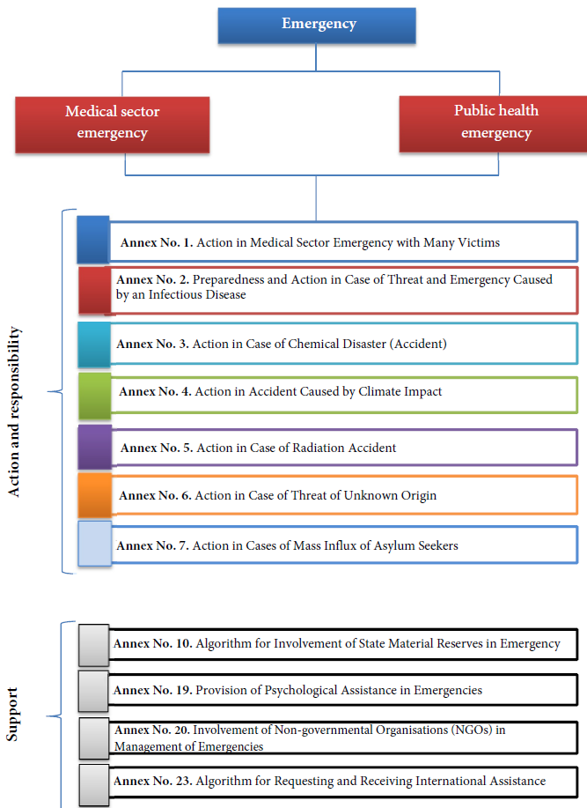

*Figure 7. Scheme of Annexes to the NDM Plan*

43. Depending on the causes of the Eme, other authorities, for example, the SFRS, the SP, the SES, the FVS, the CRPC, national reference laboratories, etc. may also be involved in the management of the Eme.

44. In case of the Eme or the threat thereof, the MoH, the institutions subordinate to the MoH, and hospitals shall cooperate with the civil protection commissions of local governments and other State, local government authorities, services, and non-governmental organisations.

45. The authorities involved in the management of the Eme shall, upon request of the MoH, prepare a report on the event of the Eme, the measures taken and planned. Sample report of the Eme is indicated in **Annex No. 16 to the NDM Plan**.

46. **In situations which are related to cases of the spread of a dangerous infection, biological, chemical, and radioactive agents** the employees who work in the health sector and who may come into direct contact with the dangerous agents **must use PPE**. Recommendations for the use of PPE for persons working in the health sector in case of the spread of a dangerous infection, biological, chemical, and radioactive agents are compiled in **Annex No. 21 of the NDM Plan**.

# 5.1. MANAGEMENT CONTROL OF THE EMERGENCY

47. **Tasks of the MoH:**

47.1. upon receipt of information on the Eme or the threat of the occurrence thereof and in cases when ensuring of continuity of the operation of the MoH is endangered, to act according to the internal procedures developed in accordance with the requirements laid down in Paragraph 29 of the NDM Plan;

47.2. to coordinate the operation of the authorities of the health sector involved in the Eme;

47.3. to compile information on the course of the development of the Eme and prepare proposals to the SOMC for response measures and measures for the elimination of consequences of the Eme;

47.4. to compile information and provide proposals to the SOMC for the involvement and use of the SMR, and also for requesting and use of the assistance of foreign and international organisations in the Eme;

47.5. to organise and coordinate communication measures, including the establishment of an information centre, ensuring unified communication among the institutions subordinate to the MoH/hospitals and cooperation with the authorities of other sectors.

48. **Tasks of the State Secretary of the MoH (chairperson of the SOMC):**

48.1. to inform the Minister for Health;

48.2. if coordination of the operation of the authorities of the health sector in case of the Eme or the threat thereof is necessary, to convene an emergency steering group of the MoH in which representatives of the institutions subordinate to the MoH and hospitals may be involved as necessary, taking into account the type of the threat and the responsibility of the authorities involved;

48.3. upon his or her own initiative or upon initiative of another member of the SOMC, to decide on convening of an extraordinary meeting of the SOMC;

48.4. to assign the responsible department of the MoH to organise the convening of members of the SOMC and to inform the head of the Communication Department of the MoH of organising the work of the SOMC;

48.5. to determine the place of operation of the SOMC;

48.6. to manage the meetings of the SOMC, ensure taking of minutes at meetings of the SOMC and preparation of information for the Minister for Health on the decisions taken by the SOMC;

48.7. to inform the Minister for Health of management of the Eme and the course of the elimination of consequences and of the decisions taken by the SOMC.

49. **Tasks of the SOMC in case of convening an extraordinary meeting:**

49.1. to take coordinating decisions which are binding on the authorities of the health sector in case of the Eme or the direct threat thereof;

49.2. to assess information on the Eme, the causes for the occurrence thereof, the course of development, the availability of resources, the response measures and measures for the elimination of consequences taken/planned;

49.3. if necessary, to create a Media Information Centre which, in cooperation with the authorities involved, provides information on the Eme to mass media;

49.4. to prepare proposals to the Minister for Health for the involvement and use of the SMR in the Eme;

49.5. to prepare and provide proposals to the Minister for Health for requesting and use of assistance of foreign and international organisations in the Eme;

49.6. to assess the usefulness of the medical assistance offered by foreign and international organisations in the Eme;

49.7. to assess and provide proposals for the changes necessary to the laws and regulations for ensuring/taking the measures for the management of the Eme.

50. **Tasks of members of the SOMC** in case of convening an extraordinary meeting according to the competence of the institution/hospital represented:

50.1. to perform risk evaluation;

50.2. to assess the availability of resources;

50.3. to ensure monitoring, analysis of the Eme;

50.4. to provide proposals for the response measures and measures for the elimination of consequences taken/planned;

50.5. to provide proposals for the changes necessary to the laws and regulations, including after elimination of consequences of the Eme;

50.6. after revocation of the Eme, to assess the measures for the elimination of consequences of the Eme taken and, according to the competence, to provide proposals for the improvement of the DMS.

51. Schematic representation of the tasks of members of the SOMC in case of convening an extraordinary meeting is indicated in **Figure 8 of the NDM Plan**.

**Schematic representation of the tasks of members of the SOMC in case of convening an extraordinary meeting**

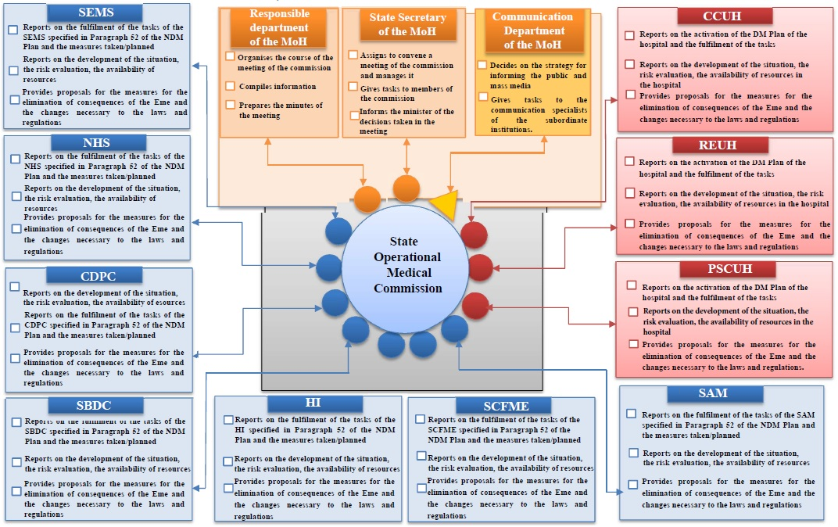

*Figure 8. Tasks of members of the SOMC in case of convening an extraordinary meeting*

# 5.2. MANAGEMENT OF EMERGENCIES IN AN INSTITUTION SUBORDINATE TO THE MOH

52. Tasks of the institutions subordinate to the MoH:

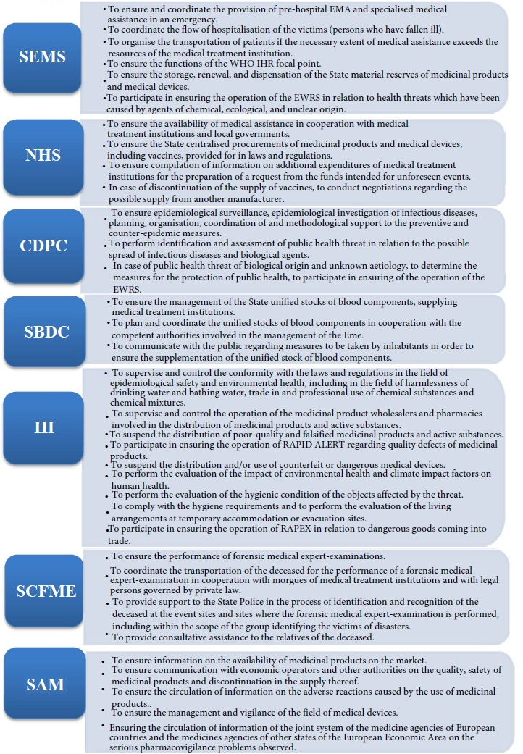

53. Upon receipt of information on the Eme or the threat of the occurrence thereof and in cases when ensuring of continuity of the operation of the institution is endangered, the institution shall act according to the internal procedures developed in accordance with the requirements laid down in Paragraph 29 of the NDM Plan.

54. The head of the institution or another delegated representative of the institution who is a member of the SOMC is entitled to propose convening of an extraordinary meeting of the SOMC upon his or her own initiative.

55. In case of declaration of the Eme in the health sector, institutions shall operate according to the response regime declared by the head of the institution on the basis of the decisions taken by the SOMC.

# 5.3. MANAGEMENT OF EMERGENCIES IN A HOSPITAL

56. Upon receipt of information on the Eme or the threat of the occurrence thereof, with several victims and/or on an event for the management of which taking of the measures for the protection of public health at an enhanced level is necessary, a hospital **shall act according to the DM Plan of the hospital**.

57. The head of the hospital shall take and revoke the decision on the preparedness or emergency response regime specified in Sub-paragraphs 30.1 and 30.2 of the NDM Plan, and also take the decision on convening the operational steering group of the hospital and inform the SEM Service and the State Secretary of the MoH thereof.

58. The head of the hospital may make a proposal to the chairperson of the SOMC for convening of an extraordinary meeting of the SOMC.

59. In case of declaration of the Eme in the health sector, hospitals shall operate according to the response regime declared by the head of the hospital on the basis of the decisions taken by the SOMC.

60. In case of partial or complete evacuation of the hospital, the responsible official specified in the DM Plan of the hospital shall, without delay, inform the State Secretary of the MoH and the SEM service and other responsible services and authorities and shall act according to the DM Plan of the hospital and the Civil Protection Plan/instructions in accordance with that laid down in external regulatory enactments. Action of the hospital specified in the DM Plan of the hospital has been developed in accordance with **Annex No. 22 to the NDM Plan, Recommendations for Organising Evacuation Measures in Hospital**.

# **6. RESOURCES OF THE DISASTER MEDICAL SYSTEM**

61. **The resources of the following institutions for the provision of the principal activity and reserve resources shall be involved in the elimination of consequences of the Eme:**

61.1. resources of the SEM Service;

61.2. resources of such hospitals which ensure the provision of EMA all hours of the day and night;

61.3. resources of the CDPC;

61.4. resources of the SBDC;

61.5. resources of other medical treatment institutions.

62. **The resources of the SEM Service have been compiled in Annex No. 14 to the NDM Plan**; the geographical layout of the units of the SEM Service has been compiled **in Annex No. 15 to the NDM Plan**.

63. **The list of the hospitals which ensure the provision of EMA all hours of the day and night has been compiled in Annex No. 12 to the NDM Plan.**

64. **Resources of hospitals have been compiled in Annex No. 13 to the NDM Plan.**

65. **The following information is compiled in Annex No. 13 to the NDM Plan:**

65.1. the contact details;

65.2. the total number of beds and according to the profiles from the point of view of hospitals;

65.3. the number of medical practitioners according to specialities;

65.4. the capacity for admission of victims in emergencies;

65.5. medical devices;

65.6. personal protective equipment (abbreviated as PPE);

65.7. evacuation resources;

65.8. the infrastructure of hospitals: roads of transportation, etc.;

65.9. other resources (which are necessary for ensuring continuity of operation of the hospital in cases of emergencies).

66. **Medical treatment institutions shall create reserves for ensuring medical assistance in the Eme.** The procedures for the creation and use of medical reserves shall be determined by the head of the medical treatment institution.

67. If, in using the abovementioned resources, it is not possible to ensure the necessary assistance to victims in the Eme and there is the possibility of threats to human health or life, the SEM Service shall attract the SMR, resources of services, authorities of other sectors, NGOs, and also economic operators.

68. **The SMR may be used by the authorities involved in the management of disasters** if the resources at their disposal are insufficient for taking the response measures.

69. Medicinal products, disposable materials, medical devices, special equipment of disaster medicine, and materials and devices for ensuring care of victims shall be stored in the SMR in the storage of the SEM Service.

70. According to the delegation of the MoH, **the director of the SEM Service is entitled to give permission for the use of the SMR** in the cases specified in Section 3, Paragraph one of the Law on the State Material Reserves, except for the provision of humanitarian aid.

71. **The algorithm for the involvement of the SMR in the Eme is described in Annex No. 10 to the NDM Plan.**

72. If necessary, the SEM Service shall organise the use of a helicopter for the transportation of the victims, medical personnel, and medical equipment. **The helicopter landing sites are compiled in Annex No. 9 to the NDM Plan.**

73. **Involvement of non-governmental organisations in the management of the Eme is described in Annex No. 20 to the NDM Plan.**

# **7. INTERNATIONAL WARNING AND MONITORING SYSTEMS**

74. One of the components of suppression and management of public health threats and the Eme is timely identification, supervision, and investigation of the threat, and also receipt, assessment, exchange of information among the responsible authorities at the State and international level, using international warning and monitoring systems.

75. Each Member State of the European Union has an obligation to notify the World Health Organisation and the EC of networks of the early warning and response system established thereby in relation to specific diseases and any public health threats which are related to sudden or unexpected biological, chemical, radiological, or nuclear accidents of international significance, events which have been caused by the same physical agents, or if harm to health is related to the use of food, drinking water, medicinal products, air of the atmosphere, or other environmental factors, and also to ensure the receipt of information on public health threats which might advance to Latvia from other countries.

76. The **SEM Service** shall ensure the functions of the national **WHO IHR** focal point and participate **in ensuring the operation of the EWRS in relation to the health threats which have been caused by agents of chemical, ecological, and unclear origin**.

77. The **CDPC** shall ensure the operation of the **EWRS in relation to notification of warnings in the EWRS regarding cases of threats of biological origin which are caused by infectious diseases, antimicrobial resistance, and infections related to health care**.

78. **The incidents related to medicinal products shall be evaluated by the SAM** and the European Medicines Agency which cooperate according to the mutually signed Memorandum of Understanding and according to the European Union Regulatory Network Incident Management Plan for Medicines for Human Use. The SAM shall participate in **the Rapid Alert system for human Tissues and Cells (RATC), the Rapid Alert system for Blood and Blood Components (RAB), the Rapid Alert system for human organs (CIRCAB), and the Rapid Alert system for the risk-benefit balance unfavourableness of the use of medicinal products**.

79. **The HI** shall participate in the rapid alert system **for safety of non-food products (RAPEX notifications) and quality defects of medicinal products (Rapid Alert notifications) and factors affecting their quality between the European Commission and the Member States**.

# **8. INTERNATIONAL ASSISTANCE IN EMERGENCIES**

80. If it is not possible to ensure the elimination of consequences of the Eme with the resources listed in the DM system, international assistance shall be attracted in accordance with the laws and regulations regarding the procedures for requesting international assistance. **The algorithm for requesting international assistance is indicated in Annex No. 23 to the NDM Plan.**

81. In accordance with Section 24, Clause 1 of the CPDM Law, in case of a disaster or threats thereof, the decision on the request for or provision of international assistance shall be taken by the Cabinet upon the proposal of the disaster management subject or the Cabinet’s own initiative.

82. The government of the Republic of Latvia has entered into contracts regarding cooperation in the field of disaster prevention and elimination of consequences thereof with Lithuania, Estonia, Sweden, Hungary, Belarus, Ukraine, Uzbekistan, the Russian Federation, Azerbaijan, and Georgia, and also different aid mechanisms and resources are available to the Republic of Latvia as the Member State of the EU, UN, NATO, WHO.

83. The SOMC shall provide proposals to the Minister for Health for requesting and use of assistance of foreign and international organisations in the Eme.

84. The SFRS shall ensure circulation of the information related to the receipt of humanitarian aid with the Emergency Response Coordination Centre of the European Commission and the Euro-Atlantic Disaster Response Coordination Centre of NATO. The Ministry of Foreign Affairs shall ensure sending of a request for humanitarian aid to the possible providers of humanitarian aid by using diplomatic channels.

# **9. PROVISION OF COMMUNICATIONS IN EMERGENCIES**

85. **Communications solutions of different types – analogue telephones, mobile telephones, portable wireless sets, the Internet – are used for the management of the Eme. They shall be used for communication among employees of the authorities themselves and among different emergency services and institutions.**

86. Medical treatment institutions shall notify the SEM Service of the Eme or the threat thereof using a phone or portable wireless set and shall duplicate the information using fax or electronically in accordance with the notification procedures laid down in the medical treatment institution in accordance with the requirements of Cabinet Regulation No. 948 of 13 December 2011, Regulations Regarding Organisation of the Disaster Medical System.

87. The basic communications solution of the SEM Service shall be IP telephony (voice communication using Internet connectivity), analogue telephones are used as the reserve communications solution, and mobile telephones and portable wireless sets are used as an additional solution. All portable wireless sets are registered in the network of the MoI, it is not permitted to switch them off or to switch to another conversation group. In using portable wireless sets, it is possible to transfer information to a wide range of users at once and rapidly which may significantly facilitate the management of the Eme and coordinate action of the responsible authorities.

88. The SEM Service has the chat of the Maritime Rescue Co-ordination Centre (MRCC) installed which is used as one of intersectoral communications solutions.

89. During medical transportation by air, communication between the rescue helicopter of the Air Force of the NAF or the State Border Guard and the SEM Service is ensured by using the radio station installed in the helicopter.

90. In cases of the Eme, several institutions are also provided with access to international early warning networks (see Paragraphs 75–79 of the NDM Plan).

91. Depending on the type of the Eme, the decision is taken as to which communication solution should be used both for mutual communication and communication with other authorities involved in the management of the Eme.

92. **The contact details of the institutions included in the National Disaster Medicine Plan are compiled in Annex No. 17 to the NDM Plan.**

# **10. TRAINING**

93. **Planning and implementation of training within the scope of the DM system have three main objectives:**

93.1. **Examination of the DM Plan:** training provides an opportunity to examine whether the activities specified in the DM Plan conform to other external regulatory enactments. For example, whether the authorities have a sufficient legal authorisation for implementation of the activities specified in the Plan, whether the activities specified in the DM Plans are in conformity with the plans of other sectors.

93.2. **Examination of the preparedness of the personnel:** training provides an opportunity to examine whether the personnel has been adequately prepared in order to be able to implement that specified in the DM Plan, i.e. whether the personnel has the necessary knowledge and skills in order to implement the tasks and actions specified in the DM Plans.

93.3. **Examination of the conformity of the resources:** training provides an opportunity to examine what is the capacity and restrictions of the institutions and services involved in the DM system for implementation of the tasks and actions specified in the DM Plans with the current resources.

94. **Training may be theoretical training** in the form of discussions, **practical training** with the imitation of situations, or

**complex training** which combines elements of both trainings mentioned above.

95. The tasks of training arise from the objective of training, however, often the tasks of the DM training brought forward are examination and improvement of cooperation among the authorities involved in the management of the Eme, examination of the preparedness of the persons involved in training for action in the Eme, examination of compatibility of material and technical resources and equipment among the authorities involved in the management of the Eme, etc.

96. With the purpose of improving the preparedness of the DM system for an Eme, **the SEM Service shall, at least once a year within the scope of the DM system, organise training in which any of sections of the NDM Plan is being examined**, and also shall participate in trainings organised by other authorities involved in the disaster management.

97. **Training which may be used for examination of the DM system and/or the NDM Plan:**

97.1. training for the examination of the preparedness and response of the health sector in the Eme or the threat thereof in cooperation with medical treatment institutions, State material reserves;

97.2. intersectoral Eme and civil protection training;

97.3. training in first aid;

97.4. training in medical transportation of victims by air in cooperation with the Air Force of the NAF/State Border Guard;

97.5. EU and NATO training for examinations of the preparedness, action, and cooperation abilities of Member States within the scope of the DM system;

97.6. training for implementation of the requirements of the WHO IHR, etc.

98. **Examples of training topics organised within the scope of the DM system:**

98.1. action in a medical sector emergency with many victims;

98.2. action in case of dangerous and other infectious diseases;

98.3. action in case of a chemical disaster (accident);

98.4. action in case of a radiation accident;

98.5. action in case of threat of unknown origin;

98.6. action in case of an influenza pandemic;

98.7. and others.

99. In addition to training related to the DM system, **the SEM Service shall, on the basis of international guidelines, organise training for medical practitioners regarding DM issues** in order to ensure coordinated and efficient cooperation among the authorities and services involved in the management of the Eme during rescue operations and the Eme.

# **11. CRISIS COMMUNICATION**

# 11.1. OBJECTIVE AND PRINCIPLES OF CRISIS COMMUNICATION

100. **The objective of crisis communication is to inform the public, in a timely (rapid) manner, of a threat or an event, the development of the Eme, and preventive measures** which should be taken in order for the inhabitants to be able to take thought-out decisions, to act adequately, and to reduce the potential harm to health, and also to reduce public panic, to prevent social and economic losses.

101. In implementing crisis communication, the involved authorities of the health sector shall act according to unified principles of communication which provide for:

101.1. ensuring inhabitants with timely, evidence-based, credible, competent, easy-to-comprehend information, avoiding conjectures, assumptions, and unverified information;

101.2. use of the most efficient communication channels for informing the public;

101.3. implementation of coordinated mutual communication of the institutions when informing the public of the measures to be taken in the Eme.

# 11.2. MANAGEMENT AND IMPLEMENTATION OF CRISIS COMMUNICATION

102. In case of the Eme or the threat thereof, the involved authorities of the health sector shall, within the scope of their competence, prepare and submit information to inhabitants according to that specified in the NDM Plan.

103. In case of the Eme or the threat thereof, crisis communication shall be coordinated by the Communication Department of the MoH which ensures unified flow and exchange of information of the authorities involved, and also coordinated cooperation with other authorities involved in crisis communication. The head of the authority shall be responsible for implementation of crisis communication in the particular authority, and he or she may delegate a person responsible for public relations or another responsible person of the authority who takes crisis communication measures according to the competence of the authority.

104.In cases of the Eme, the SOMC shall create the Media Information Centre of the health sector which shall provide information to mass media in cooperation with the authorities involved. The Media Information Centre shall be managed by the Communication Department of the MoH which coordinates crisis communication by involving the authorities within the scope of the competence which ensures unified flow of information.

105. **In the Eme, the SEM Service shall create an information office for communication with inhabitants.**

106. If the Media Information Centre of the ministry managing the event is created at the site of an event for implementation of crisis communication, the responsible authority of the health sector involved in the Eme shall, as necessary, delegate a representative for work therein for coordination of cooperation with mass media.

107. **Action and cooperation of the responsible persons involved in crisis communication is specified in Annex No. 11 to the NDM Plan.**

108. In implementing crisis communication, the responsible authorities shall use the most efficient channels of information (as necessary: mass media, Internet, social networks, information line, information centre, direct contacts with target groups of inhabitants, information intermediaries – non-governmental organisations, State and local government authorities, trading sites, etc.).

109. Informing of inhabitants in cases of disasters, the threats thereof, emergency situations, state of exception, or mobilisation shall take place by using the civil alarm and public address system activated by the SFRS in accordance with that laid down in laws and regulations. Evacuation of inhabitants is declared by using sirens, radio, television, or loudspeakers.

# **LIST OF ANNEXES**

|  |
| --- |
| **No. 1.** Action in Medical Sector Emergency with Many Victims |
| **No. 2.** Preparedness and Action in Case of Threat and Emergency Caused by an Infectious Disease |
| **No. 3.** Action in Case of Chemical Disaster (Accident) |
| **No. 4.** Action in Accident Caused by Climate Impact |
| **No. 5.** Action in Case of Radiation Accident |
| **No. 6.** Action in Case of Threat of Unknown Origin |
| **No. 7.** Action in Cases of Mass Influx of Asylum Seekers |
| **No. 8.** Organisation of Management of Medical Sector Emergency in Hospital (Recommendations) |
| **No. 9.** Helicopter Landing Sites for Ensuring Medical Transportation of Victims by Air |
| **No. 10.** Algorithm for Involvement of State Material Reserves (SMR) in Emergency |
| **No. 11.** Informing, Cooperation, and Delegation Scheme for Communication Specialists in Emergencies |
| **No. 12.** List of Hospitals in which Emergency Medical Assistance is Ensured 24 Hours a Day |
| **No. 13.** Aggregation of Hospital Resources[3] |
| **No. 14.** Resources of the State Emergency Medical Service[4] |
| **No. 15.** Geographical Layout of Units of the State Emergency Medical Service |
| **No. 16.** Report on Emergencies (Sample) |
| **No. 17.** Contact Details of Institutions Included in the National Disaster Medicine Plan[5] |
| **No. 18.** Documents Governing the Disaster Medical System |
| **No. 19.** Provision of Psychological Assistance in Emergencies |
| **No. 20.** Involvement of Non-governmental Organisations (NGOs) in Management of Emergencies |
| **No. 21.** Recommendations for Use of Personal Protective Equipment for Persons Working in the Health Care Sector |
| **No. 22.** Organising of Evacuation Measures in Hospital (Recommendations) |
| **No. 23.** Requesting and Receipt of International Assistance |
| **No. 24.** Principles for Distribution of Artificial Lung Ventilation Resources during COVID-19 Pandemic in Latvia (Recommendations) |

1. Translator’s note: only full name is used in the document
2. *In accordance with Cabinet Regulation No. 948, Regulations Regarding Organisation of the Disaster Medical System*.
3. Restricted access
4. Restricted access
5. Restricted access