Republic of Latvia

Cabinet
Regulation No. 187
Adopted 22 March 2022

Regulations Regarding the Use of the Section of Subterranean Depths of National Significance Dobele Structure

1. The Regulation prescribes the section of subterranean depths of national significance Dobele Structure (hereinafter – the section) and conditions for the use thereof, and also the procedures by which the State Environmental Service issues the licence for the use of subterranean depths.

2. The area of the section is 99.2 square kilometres. Boundary scheme of the section and coordinates of the border points are determined in Annex to the Regulation.

3. The State Environmental Service shall include the following criteria in the rules of the competition for determining the recipient of the licence for performing geological exploration of a section of subterranean depths (hereinafter – the exploration licence):
3.1. experience of the applicant in the performance of geological exploration works;
3.2. programme of exploration works which includes the amounts and terms of the exploration works of the useful properties of subterranean depths of the section (hereinafter – the exploration);
3.3. contract for the civil liability insurance of the performance of works (the existence thereof).

4. In addition to the criteria referred to in Paragraph 3 of this Regulation, the rules of competition may include the criteria specified in Cabinet Regulation No. 696 of 6 September 2011, Procedures for the Issue of Licences for the Use of Subterranean Depths and Authorisations for the Extraction of Widespread Mineral Resources, as well as Procedures for the Lease of the Land of a Public Person for the Use of Subterranean Depths.

5. Information characterising the geological structure of the section and information necessary to the participant in the competition for the compilation of an exploration work programme shall be prepared and issued by valsts sabiedrība ar ierobežotu atbildību “Latvijas Vides, ģeoloģijas un meteoroloģijas centrs” [State limited liability company Latvian Environment, Geology and Meteorology Centre].

6. The State Environmental Service shall issue one exploration licence for the exploration of the entire section.

7. The exploration licence shall have the following annexes:
7.1. the conditions for the exploration of subterranean depths;
7.2. the conditions for the procedures by and term within which the licence recipient submits to the State limited liability company Latvian Environment, Geology and Meteorology Centre the data, samples, and information obtained during the geological exploration;
7.3. a map or plan of the territory where geological exploration is to be performed and coordinates of the border points in the LKS92TM geodesic coordinate system of Latvia.

8. When performing exploration of the section, it is prohibited for the licence recipient to drain the withdrawn groundwater on the surface and groundwater horizons.

9. The licence recipient shall inform the relevant landowner in writing of the place and time for the performance of exploration works at least two weeks prior to the commencement of works.

10. Exploration works that are planned on agricultural land shall be performed within the period when these areas are not taken up by agricultural crops or when the preservation of agricultural crops is possible.

11. After the performance of exploration works, the licence recipient shall restore the areas to such a state that they would be suitable for use in conformity with the type of land use.

12. The licence for the use of the useful properties of subterranean depths shall be issued when the section is geologically explored to a sufficient degree so that its use could be commenced and the exploration data have been transferred to the State limited liability company Latvian Environment, Geology and Meteorology Centre.

13. The exploration licence area shall be determined in the entire territory of the section.

Prime Minister A. K. Kariņš

Minister for Environmental Protection and Regional Development A. T. Plešs

Annex
Cabinet Regulation No. 187
22 March 2022

Boundary Scheme and Coordinates of Border Points of the Section of Subterranean Depths of National Significance Dobele Structure

I. Boundary Scheme

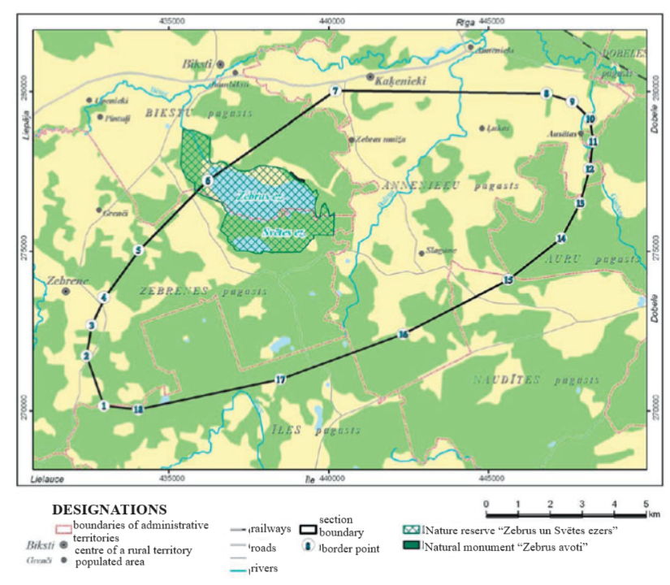

II. Coordinates of Border Points

No. | Border point | X coordinate | Y coordinate
1. | 1 | 270143.6 | 432974.2
2. | 2 | 271721.6 | 432430.2
3. | 3 | 272688.0 | 432592.4
4. | 4 | 273555.9 | 433001.5
5. | 5 | 275022.7 | 434074.6
6. | 6 | 277173.7 | 436168.2
7. | 7 | 280030.4 | 440203.8
8. | 8 | 279934.6 | 446808.5
9. | 9 | 279678.6 | 447609.7
10. | 10 | 279149.4 | 448168.0
11. | 11 | 278439.6 | 448263.1
12. | 12 | 277581.1 | 448154.4
13. | 13 | 276508.9 | 447855.5
14. | 14 | 275407.8 | 447273.1
15. | 15 | 274106.0 | 445622.0
16. | 16 | 272409.2 | 442328.9
17. | 17 | 270984.1 | 438492.0
18. | 18 | 270034.0 | 434052.2

