The Saeima ¹ has adopted and
the President has proclaimed the following law:

On the Compensation of the Part of the Land of the Immovable Property in the Territory of Another Country

Section 1. (1) To compensate the part of the land of the immovable property Gobu sala (cadastre No. 36680050006, registered in the division No. 479 of the Land Register of the rural territory of Liepna, located in the municipality of Alūksne, the rural territory of Liepna) (hereinafter – the immovable property) in the area of 8.2 hectares (the cadastral designation 36680050006) which after the determination of the State border of the Republic of Latvia is located outside the territory of the Republic of Latvia with a plot of land which is vacant and not registered in the Land Register from the land under the jurisdiction of the State at another place.
(2) The land parcel under the jurisdiction of the State in the person of the Ministry of Agriculture in the area of approximately 8.5 hectares (more or less – as much as it will appear after the cadastral survey) with the cadastral designation 36680050014 which is separated from the land parcel under the jurisdiction of the Sate with the cadastral designation 36680050034 and is located in the rural territory of Liepna of the municipality of Alūksne (hereinafter – the granted plot of land) shall be granted as a compensation.

Section 2. The part of land of the immovable property (cadastral designation 36680050006) which is located in the territory of the Republic of Latvia (hereinafter – the remaining plot of land) and the granted plot of land shall be surveyed using the State budget funds and valsts sabiedrība ar ierobežotu atbildību “Latvijas Valsts mērnieks” [the State limited liability company the State Land Surveyor of Latvia] shall include it in the list of the land parcels to be surveyed in 2010, “The Municipality of Alūksne, Ape (the Former Territory of the Alūksne Region)”. The works of land cadastral survey shall be carried out in conformity with the procedures laid down by the Cabinet for the land cadastral survey using the State budget funds.

Section 3. The spatial data of the State Immovable Property Cadastre Information System on the configuration of a plot of land in accordance with the scheme of the borders of the land parcel with cadastral designation 36680050006 (Annex 1 to the Law) and the scheme of the borders of the land parcel with cadastral designation 36680050014 (Annex 2 to the Law) shall be used for drawing up the graphic representation of the borders of the remaining plot of land and granted plot of land.

Section 4. (1) The State Land Service shall register the plan of the borders of the land of the remaining plot of land in the State Immovable Property Cadastre Information System and, on the basis of this Law, submit a request for corroboration to the Land Registry Office for the changing of the right.
(2) The owner of the immovable property shall register the plan of the borders of the granted plot of land in the State Immovable Property Cadastre Information System and, on the basis of this Law, submit a request for corroboration to the Land Registry Office for the entering of the immovable property in the Land Register.
(3) The office fee of the land registers and State fee shall not be collected for conducting the activities referred to in Paragraphs one and two of this Section.

The Law shall come into force on the day following its proclamation.

The Law has been adopted by the Saeima on 9 September 2010.

President V. Zatlers

Rīga, 17 September 2010

Law On the Compensation of the Part of the Land of the Immovable Property in the Territory of Another Country
Annex 1

Scheme of the Borders of the Land Parcel with Cadastral Designation 36680050006

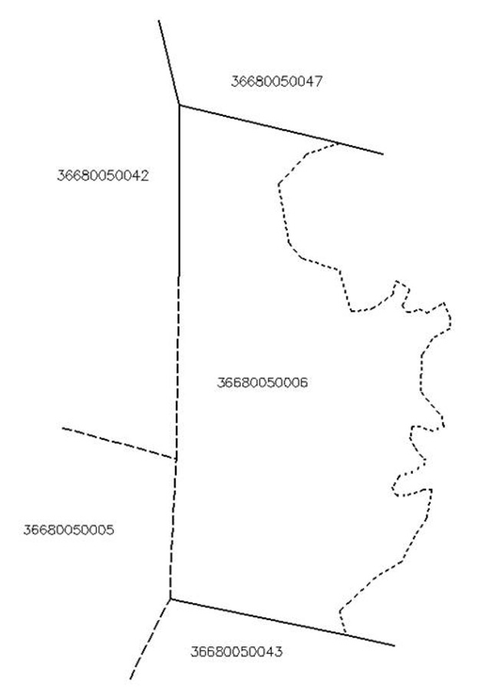

Law On the Compensation of the Part of the Land of the Immovable Property in the Territory of Another Country
Annex 2

Scheme of the Borders of the Land Parcel with Cadastral Designation 36680050014

