Text consolidated by Valsts valodas centrs (State Language Centre) with amending laws of:
31 October 2002 [shall come into force on 1 March 2003];
27 February 2003 [shall come into force on 13 March 2003];
22 June 2006 [shall come into force on 1 January 2007];
14 June 2012 [shall come into force on 1 September 2012];
13 June 2013 [shall come into force on 22 June 2013];
4 December 2014 [shall come into force on 12 December 2014];
10 January 2019 [shall come into force on 16 January 2019];
30 May 2019 [shall come into force on 26 June 2019];
10 December 2020 [shall come into force on 1 January 2021].
If a whole or part of a section has been amended, the date of the amending law appears in square brackets at the end of the section. If a whole section, paragraph or clause has been deleted, the date of the deletion appears in square brackets beside the deleted section, paragraph or clause.

The Saeima¹ has adopted and
the President has proclaimed the following law:

On the State Coat of Arms of Latvia

Section 1. (1) The State coat of arms of Latvia is one of the national symbols of the Republic of Latvia.
(2) Everyone has an obligation to treat the State coat of arms with respect.
[14 June 2012]

Section 2. The greater State coat of arms, the lesser State coat of arms, and the supplemented lesser State coat of arms are used in the Republic of Latvia.
[27 February 2003]

Section 3. (1) The escutcheon of the greater State coats of arms is the party per fess, in base per pale: 1st a golden demi-sun rising, on a blue field, 2nd a red lion turned in the opposite direction on a silver field (Kurzeme, Zemgale), 3rd a silver griffin with a golden tongue and silver sword in the right hand, on a red field (Vidzeme, Latgale). An arc of three golden mullets above the escutcheon. Supporters – a red lion with a golden tongue on the right side and a silver griffin with a golden tongue on the left side – based on two green oak branches tied together by a red-silver-red ribbon in the proportions of the national flag.
(2) The lesser State coat of arms is the escutcheon of the greater State coat of arms with an arc of three golden mullets above the escutcheon.
(3) The supplemented lesser State coat of arms is the lesser State coat of arms embraced on the sides by two green oak branches crossed under the escutcheon.
[27 February 2003]

Section 4. (1) The greater State coat of arms, the lesser State coat of arms, and the supplemented lesser State coat of arms must conform to the description of the relevant coats of arms, and also must primarily coincide with the images appended to the Law in Annex 1 to the Law. The outline of the greater State coat of arms, the outline of the lesser State coat of arms, and the outline of the supplemented lesser State coat of arms must conform to the description of the relevant coats of arms, and also must primarily coincide with the images appended to the Law in Annex 3 to the Law.
(2) The State coat of arms may be executed in any clearly visible way.
(3) The Cabinet shall determine the colours of the heraldic tinctures of the State coat of arms and the coats of arms of Vidzeme, Latgale, Kurzeme, and Zemgale related thereto according to the material and technique, and also the graphic designations of heraldic tinctures. In developing draft Cabinet regulations, the opinion of the State Heraldry Commission on the compliance of the State coat of arms with the requirements of this Law shall be taken into account.
(4) The State Heraldry Commission shall provide an opinion on the compliance of the State coat of arms with the description specified in this Law and the images appended thereto. In providing the opinion, the State Heraldry Commission is entitled to coordinate deviations from the requirements laid down in this Law in relation to the description and appended images of the coat of arms if respect towards the State coat of arms is guaranteed.
(5) The President shall determine the principles for the establishment and the principles for operation of the State Heraldry Commission.
[14 June 2012; 30 May 2019]

Section 5. (1) The following are entitled to use the greater State coat of arms:
1) the President;
2) the Saeima, the Speaker of the Saeima, a committee and sub-committee of the Saeima, and also a member of the Saeima;
3) the Judicial Council, the Constitutional Court, the Supreme Court, and the Office of the Prosecutor General;
4) the Cabinet, a member of the Cabinet;
5) a ministry and the secretariat of a minister for special affairs;
6) the Chancery of the President of Latvia, the Chancellery of the Saeima, the State Chancellery;
7) the State Audit Office;
8) Latvijas Banka, the Financial and Capital Market Commission, the National Electronic Mass Media Council, the Public Electronic Mass Media Council, the Central Election Commission, the Ombudsman, the Public Utilities Commission, the Council of Higher Education, the Central Land Commission (hereinafter – the permanent institution), the Fiscal Discipline Council, and also the Constitution Protection Bureau;
9) the diplomatic and consular mission of the Republic of Latvia.
(2) Also a collegial authority which is managed by the official referred to in Paragraph one of this Section is entitled to use the greater State coat of arms.
[14 June 2012; 13 June 2013; 4 December 2014; 10 December 2020]

Section 6. (1) The following are entitled to use the supplemented lesser State coat of arms:
1) an institution which is subordinate to or under supervision of the Cabinet, a member of the Cabinet, or a ministry;
2) a regional court, a Regional Administrative Court, a district (city) court, the District Administrative Court;
3) a General Registry institution;
4) a prosecutorial institution;
5) a sworn notary;
6) a sworn bailiff;
7) an election commission;
8) an autonomous entity of self-government governed by public law;
9) an Orphan’s and Custody Court in making a certification.
[14 June 2012; 30 May 2019]

Section 7. All other State institutions, such local governments which do not have their own approved coat of arms, institutions of local governments and other public authorities, and also private individuals in documents drawn up thereby in fulfilling a task delegated by the State administration are entitled to use the lesser State coat of arms.
[31 October 2002; 14 June 2012]

Section 8. (1) The greater State coat of arms shall be placed in the premises of the Constitutional Court, the Supreme Court, a regional court, a Regional Administrative Court, a district (city) court, the District Administrative Court, a sworn notary, a sworn bailiff, an Orphan’s and Custody Court, and a General Registry office.
(2) The greater State coat of arms shall be used, in accordance with the laws and regulations, in a State-recognised diploma, certificate, or document attesting to the education which certifies the acquisition of an academic degree, a relevant level of education or level of qualification upon completion of an accredited educational programme.
(3) The greater State coat of arms shall be depicted in a court ruling. The greater State coat of arms shall be used in the official gazette Latvijas Vēstnesis.
(4) The greater State coat of arms shall be used in a personal identification document and a temporary document substituting such document, in a State border sign, the registration certificate of a civil status act.
(5) The State coat of arms shall be used on a banknote and a government security. The State coat of arms shall be used in State honours in accordance with the Law on State Honours.
(6) The authority and official referred to in Sections 5–7 of this Law may use any State coat of arms on the uniform and the insignia of office (also as a component of an emblem) in accordance with the procedures provided for in the laws and regulations.
[14 June 2012; 13 June 2013; 30 May 2019]

Section 8.¹ (1) The authority and official referred to in Sections 5–7 of this Law shall not use another coat of arms, sign, emblem, or logo together with the State coat of arms in the detail area of an administrative document form.
(2) The authority and official referred to in Sections 5–7 of this Law shall use the State coat of arms in the detail area of an administrative document form if it is intended to do so in this area. This provision shall not apply to the permanent institution, an autonomous entity of self-government governed by public law and an institution thereof, a museum, a library, a scientific institute, a medical treatment institution, and an educational institution, and also to that specified in an international document binding on Latvia when the relevant authorities are permitted to use either the State coat of arms in accordance with the provisions of this Law, or an approved coat of arms of their own in accordance with the Law on Coats of Arms, or a sign, emblem, or logo approved by the authority.
(3) The authority and official referred to in Section 5 of this Law are entitled not to indicate other information (for example, the address or means of communication of the author of the document) in the detail area of an administrative document form.
(4) The relevant State coat of arms shall be used, in accordance with the provisions of this Section, in a press briefing, and also in documents by a member of the Saeima, a prosecutor, a judge, a sworn notary, a sworn bailiff, and such official who is entitled to represent an authority or its unit.
[14 June 2012]

Section 8.² (1) The authority and official referred to in Sections 5–7 of this Law may use the relevant State coat of arms in the visual identity and graphic standard (for example, on the building of the authority, in service premises, on vehicles of the authority, in printed work, in certificates of honour, on the website, in the organised events, on business cards, in stamps, seals, representation materials), however, they may not use another coat of arms which is not the State coat of arms, sign, emblem, or logo, except for:
1) the permanent institution, an autonomous entity of self-government governed by public law and an institution thereof, a museum, a library, a scientific institute, a medical treatment institution, an educational institution, an institution of the system of the Ministry of the Interior and the Prison Administration, the Office of the Prosecutor General, the Corruption Prevention and Combating Bureau, State security institutions, the National Armed Forces, and also the Ministry of Defence when it represents itself together or in relation to the National Armed Forces;
2) the case when another coat of arms, sign, emblem, or logo is used in honours of a State authority registered in accordance with the procedures laid down in the laws and regulations or it is provided for in the documents governing the granting or use of the European Union policy instruments or foreign financial assistance or the international commitments of Latvia;
3) the case when the Cabinet has determined the use of a coat of arms other than the State coat of arms, sign, emblem, or logo in events of national significance and for the promotion of international recognisability of the State;
4) electronic and duplicated geospatial information and circulation of geospatial information.
(2) The authority and official referred to in Paragraph one, Clauses 1, 2, and 3 of this Section may concurrently use the State coat of arms and another coat of arms, sign, emblem, or logo in the visual identity and graphic standard. The State coat of arms may also be used concurrently with another coat of arms, sign, emblem, or logo when it is necessary to reflect the participation of several individual authorities and persons in the performance of specific joint activities (for example, on a diploma, when expressing a joint stand in any issue, in a presentation).
(3) The conditions referred to in Paragraphs one and two of this Section shall not apply to the documents of the authority and official referred to in Sections 5–7 of this Law in which the use of the State coat of arms is determined by Section 8.¹ of this Law.
(4) The authority or official referred to in Sections 5–7 of this Law shall determine the business cards of officials and employees of the authority in which the relevant or lesser State coat of arms is to be used.
(5) The Cabinet shall determine a uniform visual identity and graphic standard for the authorities subordinate thereto. In determining it, the opinion of the State Heraldry Commission on the compliance of the State coat of arms with the requirements of this Law shall be taken into account.
[14 June 2012; 13 June 2013; 4 December 2014; 10 January 2019; 30 May 2019]

Section 9. The State coat of arms as an illustrative material may be placed in encyclopaedias, school textbooks, and other issues of scientific, informative nature and also used as a teaching aid. The State coat of arms may be used in the postage payment marks of the Republic of Latvia.
[31 October 2002; 14 June 2012]

Section 10. (1) Private individuals have the right to use the State coat of arms or attributes containing it unless the use of the coat of arms is misleading regarding the legal status of the user and, using the State coat of arms or attributes containing it, the person guarantees proper respect towards the State coat of arms.
(2) Attributes containing the State coat of arms shall be approved in accordance with the procedures laid down in the Law on Coats of Arms.
[14 June 2012]

Section 11.
[31 October 2002]

Section 12. (1) The heads of the institutions referred to in Sections 5–7 of this Law shall be responsible for the compliance with the requirements of this Law in the relevant institutions.
(2) The compliance with the requirements of this Law in public places shall be supervised by the police.
[31 October 2002; 27 February 2003]

Section 13. (1) For the violation of the provisions for the use of the State coat of arms, a fine of up to fifty-six units of fine shall be imposed on heads of institutions of public entities or on legal persons.
(2) For the use of the State coat of arms by misleading regarding the legal status of the user thereof, a fine of up to fifty-six units of fine shall be imposed on natural or legal persons.
(3) For displaying obvious disrespect towards the State coat of arms, a fine of up to one hundred and forty units of fine shall be imposed.
[30 May 2019 / New wording of the Section shall come into force on 1 January 2020. See Paragraph 9 of Transitional Provisions]

Section 14. Administrative offence proceedings for the offences referred to in Section 13 of this Law shall be conducted by the State Police, the municipal police, the administrative commission or sub-commission of a local government.
[30 May 2019 / Section shall come into force on 1 July 2020. See Paragraph 9 of Transitional Provisions]

Section 15. The persons guilty of desecration of the State coat of arms shall be held criminally liable in accordance with the procedures laid down in the law.
[30 May 2019 / Section shall come into force on 1 July 2020. See Paragraph 9 of Transitional Provisions]

Section 16. (1) The liability for the desecration of the State coat of arms or for displaying obvious disrespect towards the State coat of arms shall be imposed regardless of the fact against which visual rendition of the coat of arms desecration was directed or disrespect was displayed.
(2) Deviations from the description of the State coat of arms of Latvia specified in the laws and regulations and discrepancy with the images of Annex 1 or 3 to this Law shall also be considered violation of the provisions for the use of the State coat of arms, except for the cases when such deviations have been coordinated with the State Heraldry Commission.
[30 May 2019 / Section shall come into force on 1 July 2020. See Paragraph 9 of Transitional Provisions]

Transitional Provisions

1. With the coming into force of this Law, the following is repealed:
1) the law of the Latvian SSR of 15 February 1990 On the State Coat of Arms of the Republic of Latvia (Latvijas Padomju Sociālistiskās Republikas Augstākās Padomes un Valdības Ziņotājs, 1990, No. 9);
2) Clauses I, II, V–VIII of the law On Amendments and Supplementations to the Laws of the Latvian SSR On the State Coat of Arms of the Latvian Soviet Socialist Republic, On the National Flag of the Latvian Soviet Socialist Republic, On the National Anthem of the Latvian Soviet Socialist Republic, and in Some Other Legislative Acts of the Latvian SSR (Latvijas Republikas Augstākās Padomes un Valdības Ziņotājs, 1991, No. 5/6);
3) the law On Amendments to Some Legislative Acts in Issues of Symbols (Latvijas Republikas Augstākās Padomes un Valdības Ziņotājs, 1992, No. 13/14);
4) the law On Supplementations to the By-laws On the State Coat of Arms of the Republic of Latvia which Has Been Approved with the Law of 15 February 1990 (Latvijas Republikas Augstākās Padomes un Valdības Ziņotājs, 1993, No. 3/4).

2. [31 October 2002]

3. [27 February 2003]

4. The authority and official referred to in Section 5, Paragraph one of this Law which had the right to use the supplemented lesser State coat of arms until 31 August 2012 but have the right to use the greater State coat of arms from 1 September 2012 shall terminate the use of the supplemented lesser State coat of arms not later than by 31 December 2014.
[14 June 2012]

5. The authorities and officials referred to in Sections 5–7 of this Law for which the provisions for the use of the State coat of arms are specified in other laws as on 1 September 2012 shall apply the provisions of these laws, however, not longer than until 31 December 2014. The Cabinet shall, by 31 December 2013, submit draft laws to the Saeima which ensure coordination of the relevant laws with that specified in this Law.
[14 June 2012]

6. After 1 September 2012, an educational institution may issue the diploma, certificate, or document attesting to the education which is referred to in Section 8, Paragraph two of this Law and in which the supplemented lesser State coat of arms is used, however, not longer than until 31 December 2014.
[14 June 2012]

7. The authority and official referred to in Sections 5–7 of this Law shall ensure the use of the State coat of arms and another coat of arms, sign, emblem, or logo in accordance with the requirements of Sections 8.¹ and 8.² of this Law not later than until 31 December 2014. Until 31 December 2014, it shall be permitted to use also the coat of arms, sign, emblem, or logo of the relevant authority and official in documents, visual identity, and graphic standard if such has been developed by 1 September 2012.
[14 June 2012]

8. The Cabinet shall, not later than by 31 December 2013, issue the regulations provided for in Section 4, Paragraph three and Section 8.², Paragraph five of this Law.
[14 June 2012]

9. The new wording of Section 13, Sections 14, 15, and 16 of this Law shall come into force concurrently with the Law on Administrative Liability.
[30 May 2019]

The Law shall come into force on 1 January 1999.

The Law has been adopted by the Saeima on 19 February 1998.

President G. Ulmanis

Rīga, 5 March 1998

law On the State Coat of Arms of Latvia
Annex 1

Colour Image of the Lesser State Coat of Arms, the Supplemented Lesser State Coat of Arms, and the Greater State Coat of Arms
[31 October 2002; 27 February 2003]

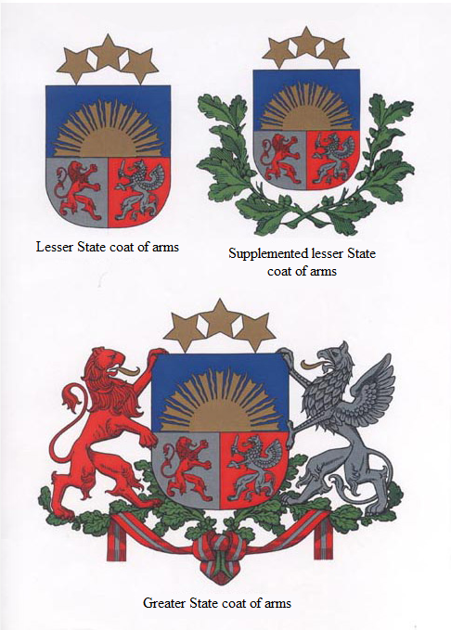

law On the State Coat of Arms of Latvia
Annex 2

Graphic Image of the Lesser State Coat of Arms, the Supplemented Lesser State Coat of Arms, and the Greater State Coat of Arms
[14 June 2012]

law On the State Coat of Arms of Latvia
Annex 3

Outline of the Lesser State Coat of Arms, the Supplemented Lesser State Coat of Arms, and the Greater State Coat of Arms
[31 October 2002; 27 February 2003]

Lesser State coat of arms

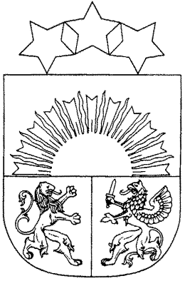

Supplemented lesser State coat of arms

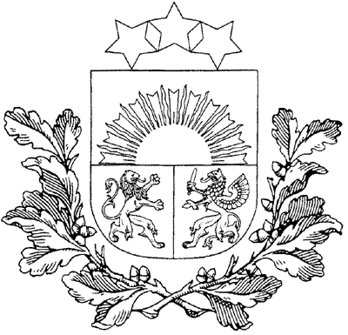

Greater State coat of arms

