Text consolidated by Valsts valodas centrs (State Language Centre) with amending regulations of:
10 June 2008 [shall come into force on 14 June 2008];
29 September 2009 [shall come into force on 3 October 2009];
14 September 2010 [shall come into force on 18 September 2010];
13 August 2013 [shall come into force on 16 August 2013];
2 February 2016 [shall come into force on 12 February 2016];
25 September 2018 [shall come into force on 28 September 2018];
15 January 2019 [shall come into force on 18 January 2019].
If a whole or part of a paragraph has been amended, the date of the amending regulation appears in square brackets at the end of the paragraph. If a whole paragraph or sub-paragraph has been deleted, the date of the deletion appears in square brackets beside the deleted paragraph or sub-paragraph.

Republic of Latvia

Cabinet
Regulation No. 436
Adopted 26 June 2007

Procedures for the Importation and Exportation of Medicinal Products

Issued pursuant to
Section 5, Clause 3 of the Pharmaceutical Law and Section 28 of the law On Procedures for the Legal Trade of Narcotic and Psychotropic Substances and Medicinal Products

I. General Provisions

1. This Regulation prescribes the procedures for the importation of medicinal products (except veterinary medicinal products) into the customs territory of the European Union (hereinafter – the importation of medicinal products) and for the exportation of medicinal products from the customs territory of the European Union (hereinafter – the exportation of medicinal products), as well as the customs control points through which the importation and exportation of substances and medicinal products included in Schedule II and Schedule III of narcotic substances, psychotropic substances and precursors to be controlled in Latvia is permitted.

2. This Regulation shall apply to:
2.1. the importation of such medicinal products which have been registered in the Register of Medicinal Products of the Republic of Latvia or in the centralised authorisation procedure in accordance with Regulation (EC) No 726/2004 of the European Parliament and of the Council of 31 March 2004 laying down Community procedures for the authorisation and supervision of medicinal products for human and veterinary use and establishing a European Medicines Agency (hereinafter – Regulation No 726/2004 of the European Parliament and of the Council);
2.2. the importation of such medicinal products that have not been registered in the Register of Medicinal Products of the Republic of Latvia or in the centralised authorisation procedure in accordance with Regulation (EC) No 726/2004 of the European Parliament and of the Council, but have been registered in third countries (hereinafter – the unregistered medicinal products from third countries);
2.3. the importation of medicinal products carried out by budget institutions or public benefit organisations in accordance with Council Regulation (EC) No 1186/2009 of 16 November 2009 setting up a Community system of reliefs from customs duty;
2.4. the importation of the samples of medicinal products, including substances used as reference substances for testing of medicinal products (hereinafter – the samples of reference standards);
2.5. the exportation of medicinal products;
2.6. the importation and exportation of investigational medicinal products.
[10 June 2008; 14 September 2010]

2.¹ In free ports, special economic zones, and places referred to in Section 9, Paragraph two of the Customs Law, distribution of medicinal products shall be subjected to supervision according to this Regulation.
[2 February 2016]

3. This Regulation shall not apply to:
3.1. the importation of medicinal products from European Economic Area States or the exportation of medicinal products to European Economic Area States;
3.2. the importation and exportation of medicinal products, which is carried out by a natural person (a traveller);
3.3. the importation and exportation of medicinal products in postal consignments.
[14 September 2010]

4. The importation and exportation of medicinal products referred to in Paragraph 2 of this Regulation (including medicinal products in the composition of which there are substances included in Schedule II (narcotic medicinal products) and substances included in Schedule III (psychotropic medicinal products) of narcotic substances, psychotropic substances and precursors to be controlled in Latvia) is permitted through the customs control points that have been laid down in the laws and regulations regarding the determination of the State border crossing and location of border control points and border crossing points at the State border of the Republic of Latvia, and in which the importation and exportation of non-food goods and products subject to control by the Food and Veterinary Service.
[29 September 2009]

5. The importation and exportation of medicinal products shall be controlled by the customs authorities in accordance with the Customs Law and the relevant laws and regulations that govern the procedures for customs clearance and customs control.

5.¹ The Health Inspectorate shall carry out market surveillance of medicinal products for human use and take the measures provided for a market surveillance authority in accordance with the requirements specified in Regulation (EC) No 765/2008 of the European Parliament and of the Council of 9 July 2008 on setting out the requirements for accreditation and market surveillance relating to the marketing of products and repealing Regulation (EEC) No. 339/93 (hereinafter – Regulation No 765/2008 of the European Parliament and of the Council).
[2 February 2016]

6. The Food and Veterinary Service shall perform the functions in accordance with:
6.1. Regulation No 765/2008 of the European Parliament and of the Council;
6.2. Article 8 of the Council Regulation (EC) No 953/2003 of 26 May 2003 to avoid trade diversion into the European Union of certain key medicines (hereinafter – Council Regulation No 953/2003);
6.3. Article 14 of Regulation (EC) No 816/2006 of the European Parliament and of the Council of 17 May 2006 on compulsory licensing of patents relating to the manufacture of pharmaceutical products for export to countries with public health problems (hereinafter – Regulation No 816/2006 of the European Parliament and of the Council).
[29 September 2009; 2 February 2016]

7. A customs warehouse where medicinal products are planned to be stored shall need an opinion of the Health Inspectorate on compliance of the warehouse with the requirements for storage of the medicinal products according to the guidelines for good distribution practice of medicinal products published by the European Commission (available in the official language on the website of the State Agency of Medicines).
[29 September 2009; 2 February 2016]

8. The owner or the possessor (hereinafter – the possessor of medicinal products) of the freight of medicinal products shall:
8.1. submit an instruction to the customs warehousekeeper in which the requirements for the storage of medicinal products have been indicated. The customs warehousekeeper shall ensure conditions for the storage of medicinal products in the customs warehouse according to the instructions of the possessor of medicinal products and requirements for storage of medicinal products according to the guidelines for good distribution practice of medicinal products published by the European Commission (available in the official language on the website of the State Agency of Medicines);
8.2. cover the expenditures that are related to the ensuring of the conditions of the storage of medicinal products in the customs warehouse;
8.3. ensure free access to the storage area of medicinal products in the places referred to in Section 9, Paragraph two of the Customs Law to the officials of the Food and Veterinary Service and the Health Inspectorate, as well as to the officials of the customs authorities. The responsible person of the possessor of medicinal products has the responsibility to declare the medicinal products to the Food and Veterinary Service control.
[10 June 2008; 29 September 2009; 14 September 2010; 2 February 2016]

9. An accompanying document, issued by the relevant foreign country, shall accompany the freight of medicinal products that is imported by the possessor of medicinal products, in which the following information shall be indicated:
9.1. the date of the supply of medicinal products, name of the medicinal products, pharmaceutical form, strength or concentration of the medicinal products and the manufacturing batch number and amount of each medicinal product supplied, the firm name and address of the supplier of the medicinal products (consignor), the firm name of the manufacturer of the medicinal products, the name of the country of manufacture of the medicinal products and the firm name and address of the consignee of the medicinal products;
9.2. the price for which the medicinal products have been sold to the consignee of the medicinal products.
[13 August 2013]

10. If the possessor of medicinal products on the basis of a contract uses transport services, which are provided by another person (hereinafter – the commercial carrier), for the importation of freight, then the commercial carrier in addition to the requirements laid down in Paragraph 9 of this Regulation shall provide a contract in the customs authority that is drawn up between the possessor of medicinal products and the commercial carrier regarding the provision of transport services or an authorisation of the possessor of medicinal products to perform the relevant activity.

II. Importation of Medicinal Products

11. Medicinal products may be imported by a person who, according to the laws and regulations regarding the procedures for the licensing of pharmaceutical activity, has a special authorisation (licence) issued by the State Agency of Medicines for the manufacturing or importation of medicinal products with the authorised activity – importation of medicinal products (this shall not refer to unregistered medicinal products, samples of medicinal product, and transit of medicinal products – freight of medicinal products that are imported from the third countries to the places referred to in Paragraph 2.¹ of this Regulation and exported to the third countries). Investigational medicinal products may be imported by a person, in the special authorisation (licence) for the manufacturing/importation of medicinal products of whom it is indicated that the importation of the investigational medicinal products is permitted. The special authorisation (licence) for the manufacturing/importation of medicinal products issued by the State Agency of Medicines shall not be necessary for the freight of medicinal products that is imported from third countries on the basis of the licence for the manufacturing/importation of medicinal products issued by the competent authority of another European Union Member State, and that is transported in transit (including placing in a customs warehouse) through the territory of Latvia.
[2 February 2016]

12. A person who is involved in the activities for the performance of which the special authorisation (licence) for the manufacturing/importing of medicinal products (hereinafter – the importer of medicinal products) is necessary shall ensure the fulfilment of the following requirements:
12.1. the imported medicinal products, including the investigational medicinal products, have been manufactured in compliance with the requirements that are equivalent to or higher than the principles and guidelines of good manufacturing practice specified in the Pharmaceutical Law and laws and regulations regarding the procedures for the manufacturing and control of medicinal products;
12.2. the manufacturer of medicinal products shall have a relevant authorisation for the manufacture of medicinal products in the relevant state;
12.3. at least one responsible official with the relevant education and professional experience (hereinafter – the qualified person) shall be permanently and continuously at the disposal thereof. The State Agency of Medicines shall be immediately, but not later than within five days, notified in writing regarding the change of the qualified person;
12.4. a personnel shall be at the disposal thereof that conforms to the requirements laid down in the laws and regulations regarding the manufacture of medicinal products;
12.5. a possibility to access the premises of the importer of medicinal products at any time shall be ensured to officials of the State Agency of Medicines and the Health Inspectorate;
12.6. shall ensure the qualified person with a possibility to fulfil the requirements referred to in Paragraphs 14, 15 and 16 of this Regulation (in relation to investigational medicinal products – the requirements referred to in Paragraphs 21 and 22 of this Regulation), for example, by placing at the disposal thereof the necessary facilities;
12.7. the principles and guidelines of good manufacturing practice that have been specified in the laws and regulations regarding the manufacture and control of medicinal products shall be complied with in the quality control and batch release of the imported medicinal products;
12.8. in the distribution of medicinal products, principles of good distribution practice of medicinal products prescribed in the guidelines for good distribution practice of medicinal products published by the European Commission (available in the official language on the website of the State Agency of Medicines) shall be followed. The requirements laid down in the laws and regulations regarding the performance of the clinical trial of medicinal products shall be complied with in relation to investigational medicinal products.
[2 February 2016; 25 September 2018 / New wording of Sub-paragraph 12.2 shall come into force on 31 January 2022. See Paragraph 2 of Amendments]

13. The education and professional experience of a qualified person shall conform to the criteria of qualification and professional experience that have been determined in the laws and regulations regarding the manufacture and control of medicinal products.

14. A qualified person, without prejudice to his or her relationship with the importer of medicinal products, shall be liable for the performance of a complete qualitative analysis and quantitative analysis of the active substances of each batch of medicinal products (also if the medicinal products have been manufactured within the European Community (the European Union and European Economic zone States), exported to third countries and re-imported), as well as shall carry out all the other tests and checks that are necessary to ensure the quality of the medicinal products in accordance with the requirements of the medicinal product registration documentation. The quality control of medicinal products shall not be carried out for the imported medicinal product batches that have undergone such controls in some other Member State of the European Community, and the medicinal products have been supplied from another Member State together with a control report, signed by a qualified person.

15. The quality control of the medicinal products referred to in Paragraph 14 of this Regulation may be avoided if the medicinal products are imported from the states that have entered into a mutual recognition agreement with the European Community on the conformity assessment of good manufacturing practice for medicinal products and it shall be provided for in this agreement that the testing of each batch of medicinal products is carried out in the exporting country (the qualitative and quantitative analysis). In such case, the certificate of the batch of medicinal products referred to in Paragraph 34 of this Regulation shall accompany each batch of the imported medicinal products.
[2 February 2016]

15.¹ The exception referred to in Paragraph 15 of this Regulation shall apply only to the manufacturing activities or pharmaceutical forms that are indicated in the agreement between the European Union and the respective state.
[2 February 2016]

16. A qualified person shall certify the batches of medicinal products in all cases by making precise entries in a registration logbook or in an equivalent document provided for that purpose and by certifying with a signature that each batch of the medicinal products has been manufactured and controlled in conformity with the requirements referred to in Paragraphs 13 and 15 of this Regulation. The registration logbook or the equivalent document shall be kept up to date as certain activities are carried out and shall be kept at the undertaking at least for five years since the performance of the last entry, ensuring access to such logbook or document to the officials of the State Agency of Medicines and the Health Inspectorate.
[2 February 2016]

16.¹ If the medicinal products are provided for placing on the market of the European Union, the qualified person shall ensure that the packaging of the relevant medicinal products has safety features referred to in Article 3(2)(a) and (b) of Commission Delegated Regulation (EU) 2016/161 of 2 October 2015 supplementing Directive 2001/83/EC of the European Parliament and of the Council by laying down detailed rules for the safety features appearing on the packaging of medicinal products for human use (hereinafter – Delegated Regulation No 2016/161).
[15 January 2019 / Paragraph shall be applied from 9 February 2019 in compliance with the transitional measures specified in Articles 48 and 50 of Delegated Regulation No 2016/161. See Paragraph 56.²]

17. In order to carry out the quality control of the medicinal products referred to in Paragraph 14 of this Regulation, the quality control laboratory of another person may be used (hereinafter – the contract acceptor), if the importer of medicinal products and the contract acceptor enter into a written contract, observing the requirements of Paragraphs 18, 19 and 20 of this Regulation.

18. The contract shall clearly define the obligations of the parties, in particular, the observance of the principles and guidelines of good manufacturing practice to be followed by the contract acceptor, as well as the way in which the qualified person who is responsible for the certification of each batch, shall fulfil his or her obligations.

19. The contract acceptor shall ensure the fulfilment of the following requirements:
19.1. if a written authorisation has not been received from the importer of medicinal products, the contract acceptor shall not subcontract with a third person regarding the work, which in conformity with the contract referred to in Paragraph 17 of this Regulation has been entrusted to the contract acceptor;
19.2. shall comply with the principles and guidelines of good manufacturing practice that have been specified in the laws and regulations regarding the manufacture and control of medicinal products, as well as shall subject oneself to the control of the State Agency of Medicines.

20. Prior to entering into a contract regarding performance of the quality control of medicinal products, the importer of medicinal products shall ensure that a statement is provided by the State Agency of Medicines regarding the compliance of the laboratory with the requirements of good manufacturing practice that have been laid down in the Guide to good manufacturing practice for medicinal products and for investigational medicinal products of the European Commission.
[10 June 2008]

21. In relation to the investigational medicinal products, which have been manufactured in third countries, the qualified person shall be responsible that each batch of the medicinal products is manufactured and checked in conformity with the principles and guidelines of good manufacturing practice (that are at least equivalent to that specified in the European Union), as well as in accordance with the product specification and information that has been indicated by the sponsor in the submission to the State Agency of Medicines in order to receive the authorisation for the clinical trial of medicinal products. The qualified person shall ensure the performance of analyses, tests and checks for each batch of preparation of the investigational medicinal products that are the comparator product from the third country and that have been registered, but may not obtain a documentary authorisation that each batch has been manufactured in conditions that are at least equivalent with the principles and guidelines of good manufacturing practice, in order to certify that the quality thereof conforms with the information that has been provided by the sponsor to the State Agency of Medicines in order to receive an authorisation for the trial of medicinal products.

22. The qualified person in all cases shall make precise entries in the registration logbook or in another equivalent document provided for that purpose in relation to the investigational products and shall certify with a signature that each batch of the medicinal products conforms to the requirements of Paragraph 21 of this Regulation. The registration logbook or the equivalent document shall be kept up to date as certain activities are carried out and shall be kept at the undertaking at least for five years since the performance of the last entry, ensuring access to the officials of the State Agency of Medicines to the referred to logbook or document.

23. The analytical control (the qualitative and quantitative analysis) of the investigational medicinal products that are imported from third countries shall not be compulsory.

24. The special authorisation (licence) for the manufacturing/importation of medicinal products referred to in Paragraph 11 of this Regulation shall apply only to the medicinal products (regarding the investigational medicinal products – to the types of medicinal products and pharmaceutical forms) that have been indicated by the importer of medicinal products in the submission to obtain the special authorisation (licence) for the manufacturing/importation of medicinal products and that, when issuing the referred to special authorisation (licence), have been included by the State Agency of Medicines in the data base in accordance with the laws and regulations laying down the procedures for licensing of the pharmaceutical activity.
[2 February 2016]

25. Importer of medicinal products may import narcotic and psychotropic medicinal products that have been indicated in the submission to obtain the special authorisation (licence) for the manufacturing or importation of medicinal products and that, when issuing the referred to special authorisation (licence), have been included by the State Agency of Medicines in the data base in accordance with the laws and regulations laying down the procedures for licensing of the pharmaceutical activity if for the importation of the respective medicinal products, according to the law On Procedures for the Legal Trade of Narcotic and Psychotropic Substances and Medicinal Products, there is a respective authorisation for each case issued by the State Agency of Medicines in accordance with the requirements of the Commission on Narcotic Drugs of the U.N. Economic and Social Council. The requirements specified in the law On Procedures for the Legal Trade of Narcotic and Psychotropic Substances and Medicinal Products shall be complied with in addition to the requirements for the importation of narcotic and psychotropic medicinal products laid down in this Regulation.
[2 February 2016]

26. The budget institution or the public benefit organisation referred to in Sub-paragraph 2.3 of this Regulation may import from third countries non-prescription medicinal products that have been included in the Register of Medicinal Products of the Republic of Latvia or that have been centrally registered in accordance with Regulation No 726/2004 of the European Parliament and of the Council.

III. Importation of the Samples of Medicinal Products and Unregistered Medicinal Products from Third Countries

27. Unregistered medicinal products may be imported from third countries by a person to whom an authorisation for the distribution of the unregistered medicinal products for individually granted medicinal products has been issued by the State Agency of Medicines according to the procedures laid down in the laws and regulations regarding the distribution and quality control of medicinal products.
[2 February 2016]

27.¹ Unregistered narcotic and psychotropic medicinal products from the third countries may be imported by a person who, in addition to the requirements referred to in Paragraph 27 of this Regulation for the importation of the respective medicinal products according to the law On Procedures for the Legal Trade of Narcotic and Psychotropic Substances and Medicinal Products, has a respective authorisation for each case issued by the State Agency of Medicines in accordance with the requirements of the Commission on Narcotic Drugs of the U.N. Economic and Social Council.
[2 February 2016]

28. Samples of medicinal products may be exported from the third countries in the following cases:
28.1. for submitting to the State Agency of Medicines in relation to registration of medicinal products;
28.2. for use in scientific research;
28.3. for use in education;
28.4. for use in testing as the samples of reference standards.
[2 February 2016]

28.¹ Samples of medicinal products (except for the samples of narcotic and psychotropic medicinal products) may be imported from the third countries by a person to whom an authorisation for the importation of the samples of medicinal products to the Republic of Latvia has been issued by the State Agency of Medicines (Annex 1). After the importation of the number of packaging units of medicinal products referred to in the authorisation, a new authorisation shall be needed for a recurrent importation of medicinal products.
[2 February 2016]

28.² Samples of narcotic and psychotropic medicinal products may be imported by the person who, according to the law On Procedures for the Legal Trade of Narcotic and Psychotropic Substances and Medicinal Products, has a respective authorisation for each case issued by the State Agency of Medicines in accordance with the requirements of the Commission on Narcotic Drugs of the U.N. Economic and Social Council.
[2 February 2016]

29. In order to obtain an authorisation for the importation of the samples of medicinal products, the authorisation requester shall submit an application to the State Agency of Medicines in conformity with the requirements laid down in Annex 2 to this Regulation, in which the necessity of the importation of the samples of medicinal products is justified.

30. The State Agency of Medicines shall verify whether the information provided conforms to the requirements laid down in this Regulation within five working days after receipt of the application referred to in Paragraph 29 of this Regulation. If the information provided is incomplete or incorrect, the State Agency of Medicines shall request in writing additional information.

31. The State Agency of Medicines shall take a decision to refuse to issue the authorisation for the importation of the samples of medicinal products, if the information requested (justification) has not been received from the submitter of the application within one month after the request of additional information referred to in Paragraph 29 of this Regulation.

32. The State Agency of Medicines shall take a decision to issue the authorisation for the importation of the samples of medicinal products in accordance with the procedures laid down in the Administrative Procedure Law.

32.¹ The expenditures which are related to the issue of an authorisation for the importation of the samples of medicinal products shall be covered by the submitter of the application according to the price list of the paid services provided by the State Agency of Medicines. The State Agency of Medicines shall issue an authorisation for the importation of the samples of medicinal products or its duplicate to the applicant for the authorisation in the form of an electronic document within three working days after taking of the decision by sending it to the electronic mail address indicated in the application. An authorisation or duplicate thereof in the form of a printed document shall be issued upon a request within three working days for an additional fee according to the price list of the paid services provided by the State Agency of Medicines.
[13 August 2013; 2 February 2016]

IV. Exportation of Medicinal Products

33. Medicinal products, including investigational medicinal products, may be exported by a person who, according to the laws and regulations regarding the procedures for licensing of the pharmaceutical activity, has received a special authorisation (licence) for the manufacturing or importation of medicinal products or a special authorisation (licence) for the wholesale distribution of medicinal products for human use in which the condition of special activity – export of medicinal products – has been indicated, or a special authorisation (licence) for opening (activity) a drug wholesaler, and also a person who has the right to represent the licence holder. The special authorisation (licence) for the manufacturing/importation of medicinal products issued by the State Agency of Medicines shall not be necessary for the freight of medicinal products that is exported to third countries on the basis of an authorisation for the manufacturing/importation of medicinal products issued by a competent authority of another European Union Member State, and that is transported in transit through the territory of Latvia.
[2 February 2016]

33.¹ Narcotic and psychotropic medicinal products may be exported by a person who, in addition to the special authorisations (licences) referred to in Paragraph 33 of this Regulation, has an authorisation for the exportation of the respective medicinal products corresponding to the requirements of the Commission on Narcotic Drugs of the U.N. Economic and Social Council and issued by the State Agency of Medicines for each case in accordance with the procedures specified in the law On Procedures for the Legal Trade of Narcotic and Psychotropic Substances and Medicinal Products.
[2 February 2016]

33.² The person who exports medicinal products shall ensure the following:
33.² 1. the requirements specified in the guidelines for good distribution practice of medicinal products which are published by the European Commission (available in the official language on the website of the State Agency of Medicines) are complied with;
33.² 2. the medicinal products are supplied to such persons in the third countries who are entitled to receive them for the wholesale distribution or delivery thereof to population in the third countries. For all supplies of medicinal products, a document shall be enclosed where the following is indicated:
33.² 2.1. the date of supply;
33.² 2.2. the name of the medicinal product, the form and strength or concentration of the medicinal product;
33.² 2.3. the supplied quantity (for each medicinal product);
33.² 2.4. the name and address of the consignee and supplier;
33^{.2} 2.5. the number of each medicinal product manufacturing batch delivered.
[2 February 2016]

34. If a manufacturer registered in Latvia exports medicinal products to a country which has entered into a mutual recognition agreement of medicinal product good manufacturing practice conformity assessments with the European Community a certificate of the batch of medicinal products, signed by a qualified person, in which information has been indicated in accordance with Annex 3 to this Regulation shall be attached to each batch of the medicinal products to be exported.

35. The State Agency of Medicines on the basis of an application of the medicinal product’s manufacturer, exporter or the competent authority of the importing country shall issue the following:
35.1. a certificate of the pharmaceutical product (Annex 4). A product, within the meaning of this Paragraph, shall be such medicinal products in the final pharmaceutical form thereof intended for humans and the active substances for the use in such pharmaceutical forms, which, in accordance with the procedures laid down in the laws and regulations governing pharmaceutical activities, have been subject to control in the exporting country and in the importing country. The product certificate shall conform to the form recommended by the World Health Organisation (WHO) and shall determine the status of the product, as well as the status of the certificate requester in the exporting country. The certificate shall be intended only for a product of one type;
35.2. a statement of licensing status of the pharmaceutical product (Annex 5). This statement shall be intended for a representative of the importer of medicinal products, who participates in international offers (tenders) in accordance with the requirements of the invitation. This statement shall denote that the specific medicinal products have been registered in the Republic of Latvia (exporting state) and they are permitted to be distributed. Upon request of the applicant and the medicinal product registration owner, if they are different persons, the State Agency of Medicines shall issue the certificate of a pharmaceutical product referred to in Sub-paragraph 35.1 of this Regulation for each product referred to in the statement.
[13 August 2013]

35.¹ The State Agency of Medicines, on the basis of a submission by the manufacturer of medicinal products or active substance (product) registered in Latvia or a request of the competent authority of the third country, shall issue a product certificate in an abridged format – a pharmaceutical product certificate or free trade certificate (hereinafter – abridged certificate). The abridged certificate shall be issued per one product type (in Latvian and English). If one medicinal product has different strengths, they shall be considered as one type product. If one medicinal product has different pharmaceutical forms (for example, pellets, solution), a separate application shall be submitted and the abridged certificate shall be issued for each pharmaceutical form.
[29 September 2009]

35.² An abridged certificate shall be drawn up, taking into account the requirements of the third country specified in the submission insofar as they are not in contradiction with the guidelines of the World Health Organisation (WHO) for the certification scheme on the quality of pharmaceutical products moving in international commerce. The abridged certificate shall provide at least the following information:
35.²1. the certificate name: “Pharmaceutical Product Certificate” or “Free Trade Certificate” in conformity with the requirements of the third country;
35.²2. the product name. Strength (quantity of active substance(-s)
per strength, volume and mass unit) and pharmaceutical form shall be specified for medicinal products. The international non-proprietary name (INN) shall be specified for the active substance, or, if there is not any, the chemical name. The registration number, registration date and term of validity, if any has been determined, shall be determined for the medicinal products registered in Latvia;
35.²3. the product composition. Strength per one strength unit (packaging unit) shall be specified for the active substance;
35.²4. the name of the manufacturer (the firm name of the merchant), unified registration number in the Commercial Register, legal address, name, number, issuer, date of issue, term of validity of the special permit (licence) (if any) and address of the production unit;
35.²5. the given name, surname or firm name and legal address of the person responsible for placing on the market of the medicinal product (applies to the medicinal products registered in Latvia);
35.²6. the given name, surname or firm name and legal address of the person in whose name it is intended to register medicinal products (applies to the medicinal products submitted for registration in Latvia or in another country);
35.²7. if medicinal products are under registration procedure, it shall be specified. If it is intended to register medicinal products, “not intended to be registered for placing on the market in Latvia” or “intended only for exportation” shall be indicated. If it is not permitted to distribute the medicinal products or active substance in Latvia, the relevant reason shall be specified, for example, “registration suspended”, “registration annulled” or “registration refused”. “Not to be registered” or “intended only for exportation” shall be indicated for the active substance;
35.²8. a certification that the relevant product may be freely sold on the market of the particular third country in accordance with the requirements laid down in the laws and regulations of the relevant country and on the basis of quality specifications of the particular manufacturer (specify the name) and that the particular manufacturer subject to regular inspection and certification procedure of good manufacturing practice (specify the frequency of performance of inspections in accordance with the procedures laid down in the laws and regulations regarding manufacture and control of medicinal products) is responsible for the quality of the referred-to product.
[29 September 2009]

35.³ It shall be determined in an abridged certificate that the quality specification of the compliant product has been drawn up on the basis of the quality indicators of the European Pharmacopoeia and the quality specification of the manufacturer of the active substance, if the requester of an abridged certificate has stipulated the necessity of such information in a submission justifying it with the requirements of the third country. The referred to information need not be specified, if the product has a conformity certificate issued by the European Directorate for the Quality of Medicines and Healthcare.
[29 September 2009]

35.⁴ A copy of the description of the medicinal product, instructions for use and labelling shall be appended to an abridged certificate. The referred to requirement shall not apply to the abridged certificate form which is issued for an active substance.
[29 September 2009]

36. In order to receive the certificate of a pharmaceutical product referred to in Sub-paragraph 35.1 of this Regulation, the manufacturer of medicinal products shall submit an application to the State Agency of Medicines, in which the following shall be indicated:
36.1. the given name, surname or firm name and address, as well as contact information (telephone, fax and electronic mail address) of the applicant for a certificate;
36.2. the status of the applicant for a certificate:
36.2.1. manufactures the dosage form;
36.2.2. packages and labels the dosage form, which is manufactured by another independent manufacturer;
36.2.3. is involved in none of the activities referred to in Sub-paragraphs 36.2.1 and 36.2.2 of this Regulation;
36.3. if the applicant for a certificate is not a manufacturer of the dosage form, the company and address of the manufacturer of the dosage form shall be indicated;
36.4. the name, strength and dosage form of the product:
36.4.1. in Latvia;
36.4.2. in other states;
36.5. the name of the active substances (by using the international non-proprietary name (INNs) or national non-proprietary name) and the amount thereof in one strength;
36.6. a full composition, including excipients (the quantitative composition shall also be indicated if a consent with the product registration certificate owner has been attached);
36.7. whether the product has been registered in Latvia;
36.8. whether the product is distributed in Latvia;
36.9. the number of the product registration certificate and date of issue (if necessary, whether the registration certificate is provisional, or the product has not yet been approved shall be indicated);
36.10. the given name and address of the medicinal product registration owner;
36.11. the status of the medicinal product registration owner in accordance with Sub-paragraphs 36.2.1, 36.2.2 and 36.2.3 of this Regulation;
36.12. if the medicinal product registration owner is not the manufacturer of the pharmaceutical form, the firm name and address of the manufacturer of the pharmaceutical form shall be indicated and a document certifying that the medicinal product registration owner agrees to make such information available to the public shall be attached;
36.13. if the registration certificate is not requested for the product, one of the following reasons why it is not necessary shall be indicated:
36.13.1. the product has been created only for special medical treatment, mostly for the treatment of tropical diseases which are not endemic in Latvia;
36.13.2. the product has been reformulated with a view to improving the stability thereof under tropical conditions;
36.13.3. the product has been reformulated to exclude excipients in the composition thereof not approved for use in the state of importation;
36.13.4. the product has been reformulated in order to create another maximum possible strength limit for an active substance;
36.13.5. other reasons (specify which);
36.14. if the status of the medicinal product registration owner or the applicant for a certificate conforms with the status referred to in Sub-paragraph 36.2.2 or 36.2.3 of this Regulation (especially if a foreign manufacturer is involved in the manufacture of the product), the applicant for a certificate shall submit information to the State Agency of Medicines, in which the conformity of each party involved in the manufacture in relation to each stage of the manufacturing process and the final product are determined, as well as the type and amount of the control carried out by each party.
[13 August 2013]

37. In order to receive the statement of licensing status of pharmaceutical product referred to in Sub-paragraph 35.2 of this Regulation, a person shall submit an application to the State Agency of Medicines, in which the following shall be indicated:
37.1. the given name, surname or firm and address, as well as contact information (telephone, fax and electronic mail address) of the applicant for a certificate;
37.2. the state of importation;
37.3. the name of the product, strength and pharmaceutical form, the name of the active substances (by using the international non-proprietary names (INNs) or national non-proprietary names) and the amount thereof in one strength, the number of the registration certificate and date of issue. If the product has not been registered, “not required” or “not requested”, or “under consideration”, or “refused” shall be indicated as appropriate.
[13 August 2013]

37.¹ In order to receive the abridged certificate referred to in Paragraph 35.¹ of this Regulation, a manufacturer of medicinal products registered in Latvia shall submit a submission to the State Agency of Medicines. The application shall indicate:
37.¹1. the given name, surname or firm name and address, as well as contact information (telephone, fax and electronic mail address) of the applicant for the certificate;
37.¹2. the third country, the competent institution and the requirements to be specified in the abridged certificate, as well as the requirements of the third country for the validity of the certificate of good manufacturing practice, if any have been determined;
37.¹3. the information referred to in Sub-paragraphs 35.²1, 35.²2, 35.²3, 35.²4, 35.²5, 35.²6 and 35.¹7 of this Regulation. If medicinal products have been submitted for registration, the country (countries) where the application for registration has been submitted shall be specified. If the product has not been registered in Latvia, the country (countries)
in which the product has been registered shall be specified;
37.¹4. if the information referred to in Paragraph 35.³ of this Regulation is to be included in the abridged certificate, the quality specification of the product shall be appended to the submission. The quality specification (specifications) of the manufacturer of active substance (substances) shall also be submitted for the medicinal products.
[29 September 2009; 13 August 2013]

38. The State Agency of Medicines shall issue the product certificate and the statement of licensing status of the pharmaceutical product referred to in Paragraph 35 of this Regulation within 30 days after receipt of the application. The expenditure associated with the issue of the product certificate shall be covered by the submitter of the application in accordance with the price list of the paid services provided by the State Agency of Medicines. The State Agency of Medicines shall issue the certificate and the statement of licensing status of the pharmaceutical product in the form of an electronic document, sending it to the electronic mail address indicated in the application. The certificate and statement or its duplicate shall be issued in the form of a printed document upon a request within three working days for an additional fee in accordance with the price list of the paid services provided by the State Agency of Medicines.
[13 August 2013; 2 February 2016]

38.¹ The State Agency of Medicines shall issue the abridged certificate referred to in Paragraph 35.¹ of this Regulation within 30 days after receipt of a submission. If the product certificate referred to in Sub-paragraph 35.1 of this Regulation has been issued for the product and repeat assessment of good manufacturing practice or assessment of the data referred to in Paragraph 35.³ of this Regulation is not necessary, the State Agency of Medicines shall issue the abridged certificate referred to in Paragraph 35.¹ of this Regulation within 10 days after receipt of the submission. The expenditure associated with the issue of the abridged certificate shall be covered by the submitter of the application in accordance with the price list of the paid services of the State Agency of Medicines.
[29 September 2009; 2 February 2016]

38.² The State Agency of Medicines shall issue the abridged certificate in the form of an electronic document, sending it to the electronic mail address indicated in the application. The certificate and statement or its duplicate shall be issued in the form of a printed document upon a request within three working days for an additional fee in accordance with the price list of the paid services provided by the State Agency of Medicines.
[13 August 2013; 2 February 2016]

38.³ An application for the issue of the statement of the product certificate referred to in Sub-paragraph 35.1 of this Regulation, the statement of the product licensing status referred to in Sub-paragraph 35.2 of this Regulation and the abridged certificate referred to in Paragraph 35.¹ of this Regulation may be submitted in the form of an electronic document, preparing it in accordance with the laws and regulations regarding drawing up of electronic documents.
[13 August 2013]

39. If an inspection of the manufacturing site of the active substance and conformity assessment of good manufacturing practice of the active substance is necessary for the issue of the certificate referred to in Sub-paragraph 35.1 of this Regulation for the product that is an active substance for the use in pharmaceutical form, the applicant for a certification shall request the State Agency of Medicines to carry out the conformity assessment of the manufacturing of the active substances. The referred-to inspection shall be carried out and the certificate of good manufacturing practice shall be issued by the State Agency of Medicines in accordance with the procedures laid down in the laws and regulations regarding the manufacture and control of medicinal products.
[10 June 2008]

39.¹ Should an inspection of the manufacturing site of the product and conformity assessment of good manufacturing practice need to be made for issuing the abridged certificate referred to in Paragraph 35.¹ of this Regulation, the applicant for a certification shall request the State Agency of Medicines to carry out the conformity assessment of good manufacturing practice and to issue the certificate of good manufacturing practice. Such inspection shall be carried out and the certificate of good manufacturing practice shall be issued by the State Agency of Medicines in accordance with the procedures laid down in the laws and regulations regarding the manufacture and control of medicinal products.
[29 September 2009]

V. Supervision and Sanctions

40. The Food and Veterinary Service shall:
40.1. control the conformity of the importation of medicinal products with the requirements laid down in Paragraphs 6, 8, 9, 10, 11, 24 and 25 of this Regulation;
40.2. control the conformity of conditions for transportation and storage of medicinal products with the requirements for storage and transportation of medicinal products in the areas referred to in Section 9, Paragraph two of the Customs Law in accordance with the guidelines for good distribution practice of medicinal products published by the European Commission (available in the official language on the website of the State Agency of Medicines);
40.3. provide information to the Health Inspectorate regarding the violations of the requirements laid down in this Regulation.
[10 June 2008; 29 September 2009; 14 September 2010; 2 February 2016]

41. The Food and Veterinary Service, on the basis of a deed drawn up by an official of the Food and Veterinary Service, is entitled to take a decision and to suspend the further importation of medicinal products:
41.1. in accordance with Section 27 of Regulation No 765/2008 of the European Parliament and of the Council if the following is established:
41.1.1. the accompanying documents of the freight do not conform with the requirements laid down in Paragraph 9 of this Regulation or the medicinal products cannot be identified (there is no labelling);
41.1.2. the imported medicinal products have not been indicated in the data base of the State Agency of Medicinal Products in conformity with the laws and regulations regarding the procedures for the issue, suspension, variation and revocation of the special authorisation (licence) for pharmaceutical activity;
41.1.3. the medicinal products do not have the relevant importation authorisation referred to in Paragraphs 27 and 28 of this Regulation;
41.1.4. the requirements for storage and transportation of medicinal products according to the guidelines for good distribution practice of medicinal products published by the European Commission (available in the official language on the website of the State Agency of Medicines) have been violated;
41.1.5. the expiry date of the medicinal products has ended;
41.1.6. the consignor and the consignee of the freight of the medicinal products cannot be identified;
41.2. in accordance with Article 8 of the Council Regulation No 953/2003, if it has been determined that the imported medicinal products are the tiered price products that have been included in Annex 1 to the Council Regulation No 953/2003;
41.3. in accordance with Article 14 of the Council Regulation No 816/2006, if there are grounds for suspecting that the importation prohibition in relation to the medicinal products that have been manufactured in accordance with a compulsory licence laid down in Article 13(1) of the Council Regulation No 816/2006 has been breached;
41.4. if the special authorisation (licence) for pharmaceutical activity issued to a merchant who imports the medicinal products referred to in Sub-paragraph 41.1.2 of this Regulation is not in force;
41.5. if the rapid alert statement of the Health Inspectorate regarding a suspected quality defect and withdrawal of medicinal products from the market applies to the imported medicinal products in accordance with the laws and regulations regarding the procedures for the distribution and quality control of medicinal products;
41.6. if there are suspicions regarding possible falsified medicinal products.
[10 June 2008; 29 September 2009; 13 August 2013; 2 February 2016]

42. The Food and Veterinary Service shall inform in writing the Health Inspectorate regarding the decision taken on the day of taking of the decision, but not later than within three working days.
[10 June 2008; 29 September 2009]

43. The medicinal products, regarding which a decision referred to in Paragraph 41 of this Regulation has been taken, shall be located in the customs warehouse, which has the statement of the Health Inspectorate referred to in Sub-paragraph 51.2 of this Regulation (if the conditions for the storage of medicinal products conform with the specification of the medicinal products).
[10 June 2008]

44. If the Food and Veterinary Service has taken the decision referred to in Paragraph 41 of this Regulation, after the final clarification of the conditions the Health Inspectorate shall take a decision on revocation of the suspension of the importation of medicinal products or on prohibition of the importation of medicinal products and shall notify the Food and Veterinary Service and the State Agency of Medicines regarding the decision taken on the day of taking of the decision. If the Sate Pharmaceutical Inspection takes a decision to revoke the importation suspension, the Food and Veterinary Service shall inform the customs authorities on the day of the receipt of the referred-to decision that it is permitted to apply the customs procedure – release for free circulation.
[10 June 2008; 29 September 2009]

45. [2 February 2016]

46. The expenditures associated with the disposal or re-exportation of the specific freight of medicinal products shall be covered by the person to whom the prohibition of placing of medicinal products on the market (the possessor of the medicinal products) provided for in Regulation No 765/2008 of the European Parliament and of the Council refers.
[2 February 2016]

47. The State Agency of Medicines shall control the conformity of the importer of medicinal products with the requirements laid down in Paragraphs 12, 14, 15, 16, 17, 18, 19, 20, 21, 22 and 23 of this Regulation in accordance with the laws and regulations regarding the procedures for the manufacture and control of medicinal products.

48. The importer of medicinal products shall provide the following data during the control to the officials of the Sate Agency of Medicines:
48.1. data regarding the quality control of each batch of the medicinal products (that has been carried out in the countries of the European Economic Area (EEA)) in accordance with the medicinal product registration documentation;
48.2. all copies of the control reports approved by a qualified person regarding immunological preparations and medicinal products derived from human blood or plasma.

49. The Health Inspectorate, based on a notification of the State Agency of Medicines, shall be entitled to suspend the importation of the medicinal products referred to in a file of the special authorisation (licence) of the importer for specific or all medicinal products or, by evaluating each case separately in cooperation with the State Agency of Medicines, to decide on suspension of the importation of medicinal products if:
49.1. the quality control of the medicinal products and the batch release do not conform to the requirements laid down in Paragraphs 14, 15 and 16 of this Regulation;
49.2. a qualified person does not carry out the obligations laid down in Paragraphs 14, 15 and 16 of this Regulation (in relation to the investigational medicinal products – Paragraphs 21 and 22 of this Regulation);
49.3. the importer of medicinal products during the period of control does not provide the data and information laid down in Paragraph 48 of this Regulation;
49.4. the importer of medicinal products performs its pharmaceutical activities in the area (address) and premises that are not indicated in the respective special authorisation (licence) and submission for receipt thereof, as well as in the file of the licence;
49.5. the importer of medicinal products imports the medicinal products that are not indicated in the respective submission for receipt of the special authorisation (licence) and file of the licence (this shall not refer to samples of medicinal products and unregistered medicinal products);
49.6. the importer of medicinal products has no qualified personnel whose qualification and professional experience correspond to the requirements laid down in the laws and regulations regarding the procedures for the manufacturing and control of medicinal products;
49.7. manufacturing of the imported medicinal products or active substances in medicinal products does not comply with the requirements for good manufacturing practice of medicinal products or active substances;
49.8. medicinal products or active substances of medicinal products are falsified.
[10 June 2008; 2 February 2016]

50. The State Agency of Medicines shall fulfil the obligations of the competent supervisory authority referred to in Article 19 of Regulation No 726/2004 of the European Parliament and of the Council in relation to medicinal products that in accordance with the referred to Regulation have been registered in the centralised licensing procedure and have been imported from third countries.

51. The Health Inspectorate shall:
51.1. monitor whether the distribution and transportation of medicinal products in the areas referred to in Paragraph 2.¹ of this Regulation are in accordance with the requirements laid down in this Regulation, laws and regulations regarding the distribution of medicinal products, and the guidelines for good distribution practice of medicinal products published by the European Commission (available in the official language on the website of the State Agency of Medicines);
51.2. check the place of storage of medicinal products upon a request of the warehousekeeper (owner) and provide an opinion to the warehousekeeper (owner) regarding the conformity thereof with the requirements of good distribution practice of medicinal products laid down in the guidelines for good distribution practice of medicinal products published by the European Commission (available in the official language on the website of the State Agency of Medicines). The customs warehousekeeper (owner) shall submit such statement to the Food and Veterinary Service in accordance with the laws and regulations regarding the activity of a customs warehouse;
51.3. is entitled to request and receive information, which is related to the fulfilment of this Regulation, from the State Agency of Medicines, the Food and Veterinary Service and other competent State institutions;
51.4. provide the necessary information to the State Agency of Medicines, the Food and Veterinary Service and other competent State institutions;
51.5. inform the European Commission regarding all decisions that have been taken in accordance with the fulfilment of the requirements of Council Regulation No 953/2003;
51.6. inform the European Commission regarding any decisions in relation to the confiscation or disposal of products that have been taken in accordance with Regulation No 816/2006 of the European Parliament and of the Council.
[10 June 2008; 29 September 2009; 14 September 2010; 2 February 2016]

52. The officials of the relevant institutions shall not disclose commercial secrets of the controlled person, which have become known to them during the performance of their duties in accordance with this Regulation.

53. The Health Inspectorate, the State Agency of Medicines, the Food and Veterinary Service and the customs authorities shall ensure, according to the competence thereof, prompt mutual exchange of information, as well as, in order to prevent the diversion of medicinal products to illegal circulation, provide information to the law enforcement institutions and the Ministry of Health on the facts that have come to their knowledge.
[10 June 2008; 29 September 2009]

53.¹ The Health Inspectorate, the State Agency of Medicines and the Food and Veterinary Service shall co-operate according to the competence thereof in order to ensure that medicinal products which are imported and which are not provided for placing on the market of the European Union do not enter circulation, if there are justified suspicions that they are falsified.
[13 August 2013]

53.² The customs authorities shall notify the Health Inspectorate and the State Agency of Medicines without delay, if there are suspicions regarding possible falsified medicinal products.
[13 August 2013]

VI. Closing Provisions

54. Cabinet Regulation No. 88 of 27 February 2001, Regulations regarding the Import, Export and Distribution of Medicinal Products and Requirements for the Opening and Operation of Medicinal Product Wholesalers, (Latvijas Vēstnesis, 2001, No. 35, 52; 2003, No. 114; 2004, No. 69), is repealed.

55. The medicinal product wholesalers to which, on the day of coming into force of this Regulation, the special authorisation (licence) for the opening (operation) of a medicinal product wholesale establishment with a condition of special activity – the importation of medicinal products into Latvia from a state that is not located in the European Economic Area and the authorisation issued by the State Agency of Medicines has been issued, are entitled to import medicinal products until the receipt of the special authorisation (licence) for the manufacturing/importation of medicinal products referred to in the laws and regulations laying down the procedures for the issue, suspension, variation and revocation of the special authorisation (licence) for pharmaceutical activity, but not longer than until 1 January 2008.

56. The sponsor to which, on the day of coming into force of this Regulation, the authorisation for the introduction of medicinal products for a clinical trial for human use has been issued by the State Agency of Medicines, is entitled to import the investigational medicinal products until the receipt of the special authorisation (licence) for the manufacturing/importation of the medicinal products referred to in the laws and regulations laying down the procedures for the issue, suspension, variation and revocation of the special authorisation (licence) for pharmaceutical activity, but not longer than until 1 January 2008.

56.¹ The requirement which applies to the issue of the documents referred to in Paragraphs 32.¹, 38, 38.² and 38.³ of this Regulation in the form of a printed document for an additional fee shall be applicable from 1 July 2014.
[13 August 2013]

56.² Paragraph 16.¹ of this Regulation shall be applied from 9 February 2019 in compliance with the transitional measures specified in Articles 48 and 50 of Delegated Regulation No 2016/161.
[15 January 2019]

57. This Regulation shall come into force on 1 August 2007.

Informative Reference to the European Union Directives
[29 September 2009; 13 August 2013; 25 September 2018 / Paragraph 7 of the Reference shall come into force on 31 January 2022. See Paragraph 2 of Amendments]

This Regulation contains legal norms arising from:
1) [25 September 2018 / See Paragraph 2 of Amendments];
2) Directive 2001/83/EC of the European Parliament and of the Council of 6 November 2001 on the Community code relating to medicinal products for human use;
3) [25 September 2018 / See Paragraph 2 of Amendments];
4) Directive 2004/27/EC of the European Parliament and of the Council of 31 March 2004 amending Directive 2001/83/EC on the Community code relating to medicinal products for human use;
5) Commission Directive 2005/28/EC of 8 April 2005 laying down principles and detailed guidelines for good clinical practice as regards investigational medicinal products for human use, as well as the requirements for authorisation of the manufacturing or importation of such products (Text with EEA relevance);
6) [25 September 2018 / See Paragraph 2 of Amendments];
7) Commission Directive (EU) 2017/1572 of 15 September 2017 supplementing Directive 2001/83/EC of the European Parliament and of the Council as regards the principles and guidelines of good manufacturing practice for medicinal products for human use.

Prime Minister A. Kalvītis

Acting for the Minister for Health, Minister for Welfare D. Staķe

Annex 1
Cabinet Regulation No. 436
26 June 2007
[2 February 2016]

Authorisation for the Importation of the Samples of Medicinal Products into the Republic of Latvia

STATE AGENCY OF MEDICINES

(legal address, telephone number, fax number, electronic mail address)

Rīga

No.
(date)

On the basis of decision No. ______ of the State Agency of Medicines of ________________
(date)
on issue of the authorisation for the importation of the samples of medicinal products from the third countries

(name, type, registration number of the legal person)

(submission for receipt of permit No. |  | ),
 | (registration number in the State Agency of Medicines, date of submission and registration)

the importation of the following samples of medicinal products is permitted in the Republic of Latvia from third countries:

Name of the sample of medicinal products, dosage form, strength, size of packaging | Number of the samples of medicinal products | Purpose of use of the samples of medicinal products | It is allowed to receive the samples of medicinal products | Medicinal product manufacturer, state
1 | 2 | 3 | 4 | 5

Director of the State Agency of Medicines
(given name, surname, signature)

Place for a seal

Date

Notes.
1. In a Table’s column or row, which is not completed, draw a dash.
2. In column 3 of the Table, the purpose of use of the samples of medicinal products – “Submission to the State Agency of Medicines in relation to registration of medicinal products”, “Use in science”, “Use in education”, or “Use in testing of medicinal products as the samples of reference standards” shall be indicated.
3. In column 4 of the Table, the person to whom the authorisation owner is entitled to distribute the samples of medicinal products referred to in the authorisation shall be indicated by including an indication:
3.1. “To the applicant for the receipt of the medicinal product registration certificate” and its name and state;
3.2. “To the medicinal products registration owner” and its name and state;
3.3. “To the scientific research institution” and its name, number of the taxpayer certificate of the State Revenue Service in the State Revenue Service Value Added Tax Taxable Persons Register;
3.4. “To the educational institution” and its name, number of the taxpayer certificate of the State Revenue Service in the State Revenue Service Value Added Tax Taxable Persons Register;
3.5. “To the testing laboratory” and its name, number of the taxpayer certificate of the State Revenue Service in the State Revenue Service Value Added Tax Taxable Persons Register.
4. The detail of the document “signature” and “place for a seal” shall not be completed if the electronic document has been drawn up in accordance with the laws and regulations regarding drawing up of electronic documents.

Annex 2
Cabinet Regulation No. 436
26 June 2007
[2 February 2016]

Submission for the Receipt of the Authorisation for the Importation of the Samples of Medicinal Products into the Republic of Latvia

Hereby we ask the State Agency of Medicines to issue an authorisation for the importation of samples of medicinal products into the Republic of Latvia from the third countries with an aim (mark as appropriate with an X):

to submit them to the State Agency of Medicines in relation to registration of medicinal products
to use them in scientific studies
to use them in education
to use them in testing of medicinal products as the samples of reference standards

We want to receive the authorisation in a printed form (mark as appropriate with an X):

yes
no

Part I
Information regarding the applicant and medicinal products

1. Applicant:
1.1. name

Number of the value added taxpayer certificate of the State Revenue Service in the State Revenue Service Value Added Tax Taxable Persons Register

1.2. legal address

1.3. address of the place of operation

 | 1.4. telephone number |  | fax number

1.5. electronic mail address

2. Medicinal product samples:
2.1. name

2.2. form of the medicinal product

2.3. active ingredient and strength or concentration

2.4. package size

2.5. registration number in the Medicinal Product Register of Latvia (for registered medicinal products)

2.6. amount of packaging (number)

3. Consignor of the samples of medicinal products, its address, telephone number, fax number, electronic mail address

4. Medicinal product manufacturer:
4.1. name

4.2. legal address and address of the workplace of the undertaking

 | 4.3. telephone number |  | fax number

5. Contact person regarding the submission (given name, surname, telephone number, fax number, electronic mail address)

Part II
Appended Documents

(mark as appropriate with an X, indicate the number of pages appended)

1. A certification that the samples of medicinal products have been received from the manufacturer of medicinal products (if the samples are imported for the registration of medicinal products) or from a person who has the right to distribute medicinal products in the exporting state
2. A certification that the samples of medicinal products are intended for submission to the State Agency of Medicines in relation to registration of medicinal products
3. A certification that the samples of medicinal products are intended for the use in a scientific research
(name of the research and the address of the place of the research)
4. A certification that the samples of medicinal products are intended for the use for educational purposes
(name and location of the educational institution, speciality (study programme))
5. A certification that the samples of medicinal products are intended for the use in testing of medicinal products as the samples of reference standards

I, |  | ,
 | (given name, surname, position of the responsible official (an authorised representative of the applicant))
certify that the information provided by me is true.

Responsible official (authorised representative of the applicant)
(position, given name, surname, signature)

Date

Date of receipt of the submission in the State Agency of Medicines

Notes.
1. In a column or row, which is not completed, draw a dash.
2. If the form is sent without using electronic data media, the applicant shall sign each page appended to the form.
3. If the submission is drawn up on several pages, the responsible official shall sign each page.
4. The documents’ detail “signature” shall not be completed if the electronic document has been prepared in accordance with the laws and regulations regarding drawing up of electronic documents.

Annex 3
Cabinet Regulation No. 436
26 June 2007

Batch Certificate of a Pharmaceutical Product

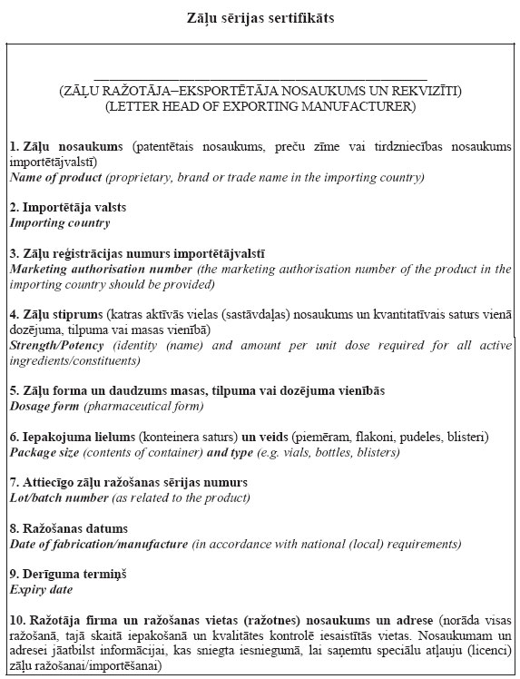
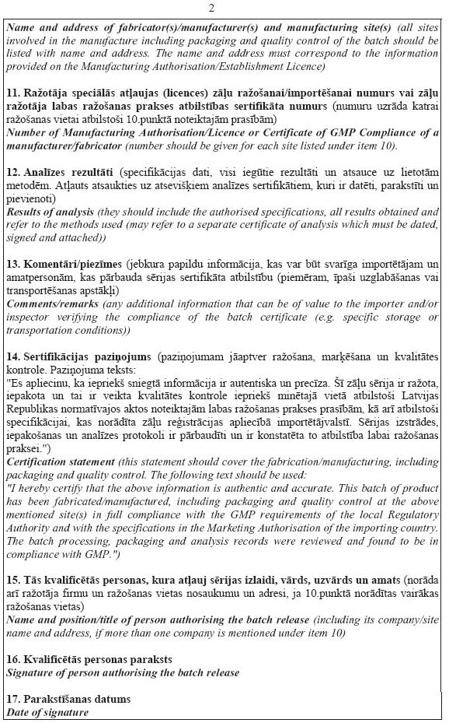

Acting for the Minister for Health, Minister for Welfare D. Staķe

Annex 4
Cabinet Regulation No. 436
26 June 2007
[13 August 2013]

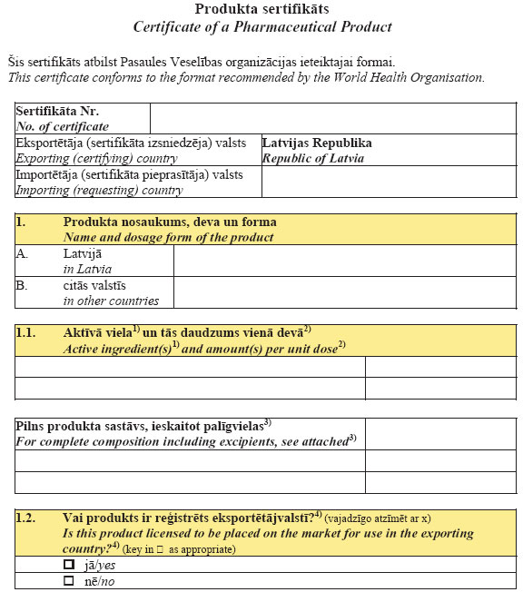
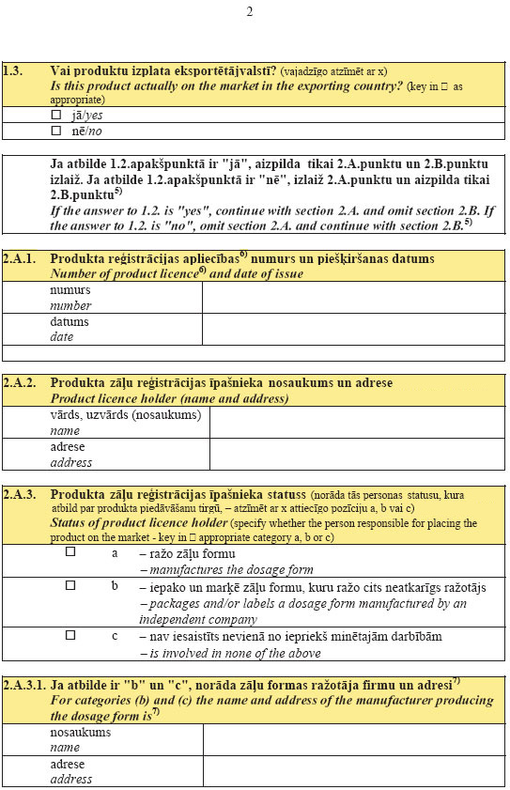
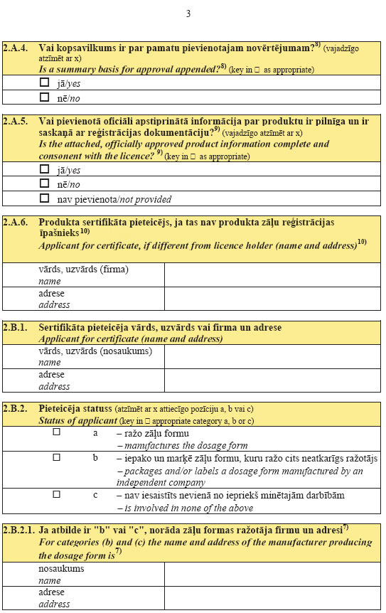
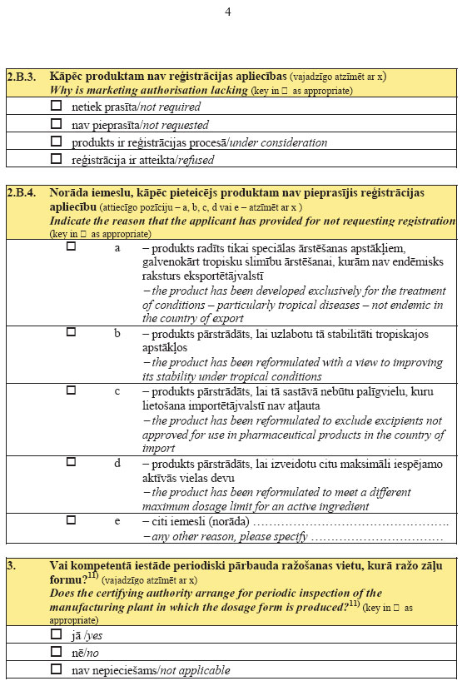
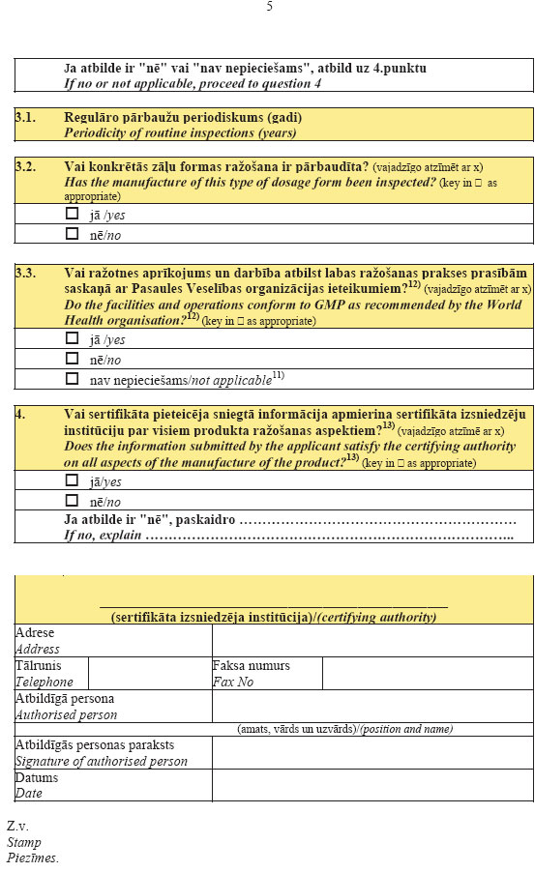
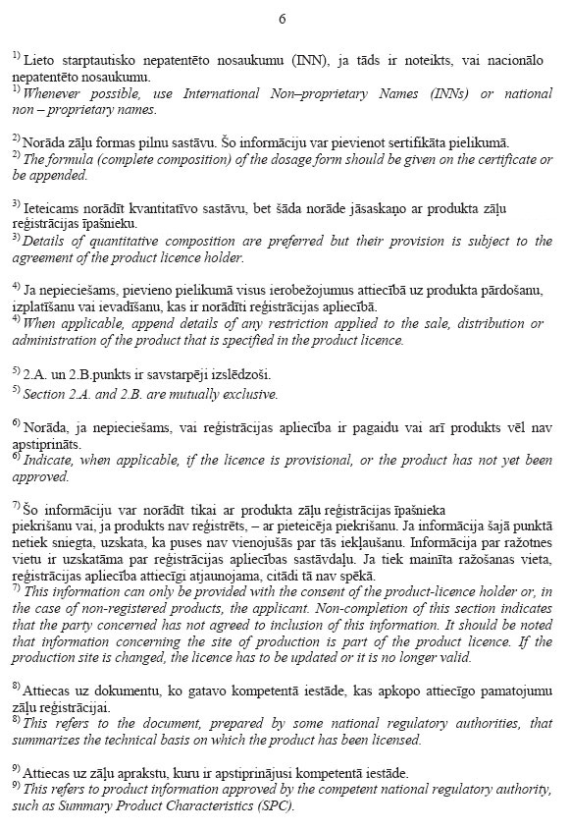
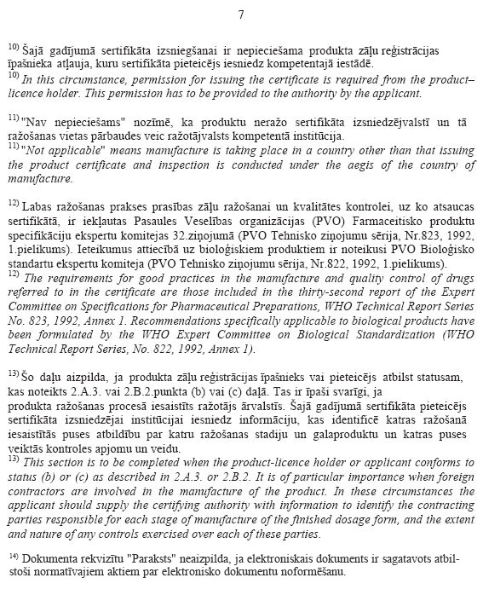

Acting for the Minister for Health, Minister for Welfare D. Staķe

Annex 5
Cabinet Regulation No. 436
26 June 2007
[13 August 2013]

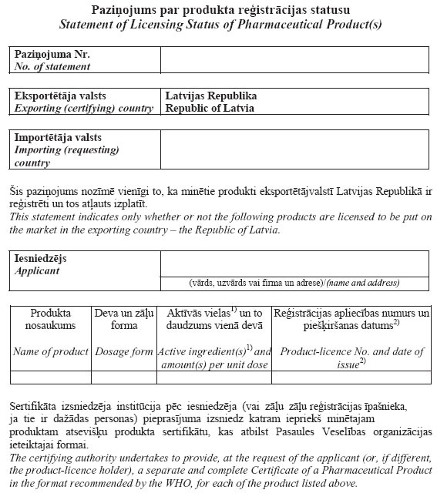
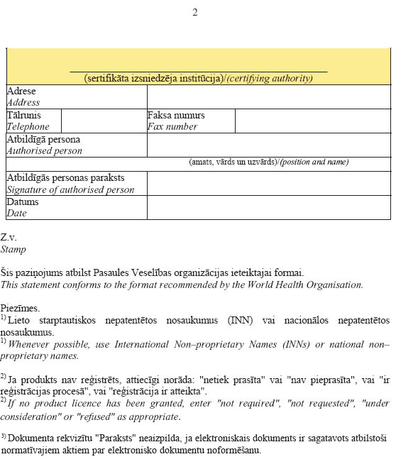

Acting for the Minister for Health, Minister for Welfare D. Staķe

