Text consolidated by Valsts valodas centrs (State Language Centre) with amending regulations of:
18 August 2009 [shall come into force from 22 August 2009];
4 September 2012 [shall come into force from 8 September 2012];
20 February 2018 [shall come into force from 24 February 2018].
If a whole or part of a paragraph has been amended, the date of the amending regulation appears in square brackets at the end of the paragraph. If a whole paragraph or sub-paragraph has been deleted, the date of the deletion appears in square brackets beside the deleted paragraph or sub-paragraph.

Republic of Latvia

Cabinet
Regulation No. 992
Adopted 20 December 2005

Regulations Regarding the Seaman’s Discharge Book

Issued pursuant to
Section 27, Paragraph four of the Maritime Administration and Marine Safety Law

I. General Provisions

1. This Regulation prescribes the information to be included in the seaman’s discharge book and the procedures by which the Registry of Seamen of the State joint stock company Maritime Administration of Latvia (hereinafter – the Registry of Seamen) shall draw up, issue, exchange, seize, cancel, recognise as invalid and account for seaman’s discharge books.

2. The holder of the seaman’s discharge book is responsible for its keeping and shall not permit the illegal use thereof.

3. The issue of seaman’s discharge books is a paid service, for which the tariffs shall be determined in accordance with Section 6, Paragraph two of the Maritime Administration and Marine Safety Law.

II. The Content and Design of a Seaman’s Discharge Book

4. A seaman’s discharge book shall be prepared according to a uniform specimen (Annex 1). Entries in a seaman’s discharge book shall be made in compliance with the requirements prescribed in the document DOC 9303, Machine Readable Travel Documents, of the International Civil Aviation Organisation (ICAO).

5. Digital images of the seafarer’s face and signature shall be placed in the main data page of the seaman’s discharge book, together with the following information regarding the seafarer:
5.1. given name and surname;
5.2. citizenship;
5.3. personal identity number;
5.4. date and place of birth;
5.5. sex, height and distinguishing marks;
5.6. at the discretion of the seafarer – number and date of issue of the seafarer’s qualification document;
5.7. at the discretion of the seafarer – residential address of the seafarer;
5.8. at the discretion of the seafarer – persons to be notified in the event of an accident (given name, surname, relationship, address).
[18 August 2009; 4 September 2012; 20 February 2018]

6. The following information regarding a seaman’s discharge book shall be indicated on the main data page of the seaman’s discharge book:
6.1. type and country code;
6.2. number;
6.3. date of issue;
6.4. term of validity;
6.5. issuing authority.

7. The main data page of a seaman’s discharge book shall include a machine readable zone. The machine readable zone shall indicate the seafarer’s given name and surname without diacritical marks.
[20 February 2018]

8. In addition the following information shall be indicated in a seaman’s discharge book:
8.1. [18 August 2009];
8.2. record of sea service;
8.3. official entries by official representatives of Latvia and foreign states;
8.4. the address, telephone and fax number, e-mail address of the Registry of Seamen (issuing authority).

9. In the seaman’s discharge book, the given name and surname of the seafarer shall be indicated in accordance with the data of the Population Register.
[20 February 2018]

10. Entries in the seaman’s discharge book shall be made by the Registry of Seamen, except for the entries in the field “Record of sea service”. The field “Record of sea service” shall be completed by the master of the ship and the entry shall be certified with a signature and seal of the ship. The competent officials of Latvia or foreign states shall make entries in the field “Official notes made by authorized persons of Latvia or foreign countries” on the crossing of the border of the relevant foreign state.
[18 August 2009; 20 February 2018]

11. [4 September 2012]

12. The Registry of Seamen shall, in the process of drawing up a seaman’s discharge book, examine the information submitted by the person, including information regarding the person’s criminal record. The Registry of Seamen has the right to request explanations and additional documents confirming that the person is a seafarer, and shall certify the veracity of the information submitted by the person.

III. Issue of a Seaman’s Discharge Book

13. A seafarer who wishes to receive or exchange the seaman’s discharge book shall submit and present to the Registry of Seamen the documents referred to in Paragraph 15 or 15.¹ of this Regulation. The Registry of Seamen shall prepare an application for the receipt of the seaman’s discharge book (hereinafter – the application) through the use of all the information available in State information systems and at the disposal of the Registry of Seamen. By signing the application, the seafarer certifies the accuracy of the information indicated therein.
[20 February 2018]

14. In order to acquire the digital image of the face of the seafarer to be included in the seaman’s discharge book, the Registry of Seamen shall make a photograph or in exceptional cases that have occurred due to technical reasons request the seafarers to submit a photograph which corresponds to the requirements laid down in the laws and regulations regarding personal identity documents. The image of the signature of the seafarer to be included in seaman’s discharge book shall be acquired by the seafarer placing his or her signature on the sensor of the signature capturing device. The signature in the seaman’s discharge book is the seafarer’s personal name written with his or her own hand in the full or short form.
[20 February 2018]

15. In order to receive or exchange the seaman’s discharge book, a seafarer (except for the seafarers referred to in Paragraph 15.¹ of this Regulation) shall submit to the Registry of Seamen a statement (Annex 2) of the person authorised by the owner of the ship which registered is the Latvian Ship Register or the merchant who provides recruitment and placement services in manning the ship’s crew (hereinafter together ‒ the merchant) which certifies that the seafarer shall be employed on a ship, or of a maritime educational institution (hereinafter – the educational institution) which certifies that the person is an educatee, and shall present the originals of the following documents:
15.1. the personal identification document of a citizen or non-citizen of Latvia or issued by the competent authorities of a foreign country, travel document of a refugee or a stateless person, or a person who has been granted with an alternative status issued by the Republic of Latvia, and a document issued by the Office of Citizenship and Migration Affairs that certifies the right of permanent residence;
15.2. the seafarer’s qualification document (if such has not been registered in the certification database of the Registry of Seamen or its authenticity has not been verified). The aforementioned requirement does not apply to the service personnel of a passenger ship, ship repairman or the person for whom qualification requirements have not been laid down in the laws and regulations regarding certification of seafarers;
15.3. the document certifying the acquisition of the recognised training programme “Basic Safety Training” (if such has not been registered in the certification database of the Registry of Seamen or its authenticity has not been verified);
15.6. the seaman’s discharge book, which has reached its expiry date or which the seafarer wishes to exchange, or which has to be handed over to the Registry of Seamen in accordance with Chapter IV of this Regulation (if the seaman’s discharge book has been issued to the seafarer).
[20 February 2018]

15.¹ In order to receive or exchange the seaman’s discharge book, the person who has been employed on the ship for the performance of specific tasks (for example, an employee of the shipping company) shall submit to the Registry of Seamen the request of the employer which certifies that the person is employed on the ship for the performance of specific tasks and shall present the documents referred to in Sub-paragraphs 15.1, 15.3 and 15.4 of this Regulation.
[20 February 2018]

16. After signing the application in the Registry of Seamen, the seaman’s discharge book shall be issued within the following time periods:
16.1. under ordinary procedures – within seven working days;
16.2. under urgent procedures (at the request of the seafarer) – within two working days;
16.3. if the seaman’s discharge book has been lost (in the cases referred to in Paragraph 22 of this Regulation) or the seaman’s discharge book has been cancelled in accordance with the procedures specified in Sub-paragraphs 27.5 or 27.6 of this Regulation – within one month;
16.4. if an additional examination of the criminal record of the person or the verification of the authenticity of the submitted documents is necessary – within one month.
[18 August 2009; 20 February 2018]

16.¹ If the seaman’s discharge book is not taken out within two months after the date of its issue, the Registry of Seamen shall destroy the respective seaman’s discharge book, and the seafarer shall initiate a new application procedure for the receipt of the seaman’s discharge book in accordance with Chapter III of this Regulation, including making the payment for the service.
[20 February 2018]

17. The seaman’s discharge book shall be re-issued to a person who is employed in a foreign shipping company which does not have a representation in the Republic of Latvia, if the person is registered in the certification database of the Registry of Seamen, based on a written request of the foreign shipping company.
[20 February 2018]

17.¹ For citizens and non-citizens of Latvia who are studying an accredited and recognised maritime education programme in a foreign country that is a Member State of the International Maritime Organisation, a seaman’s discharge book shall be issued on the basis of a statement issued by the foreign educational institution.
[4 September 2012; 20 February 2018]

18. When the seaman’s discharge book is issued to citizens and non-citizens of Latvia, it shall have the following term of validity:
18.1. if the person receives the seaman’s discharge book for the first time, – five years;
18.2. if the person receives the seaman’s discharge book repeatedly – 10 years;
18.3. if the person’s seaman’s discharge book has been cancelled in accordance with Paragraphs 27of this Regulation – five years;
18.4. for the person referred to in Paragraph 15.¹, service personnel of a passenger ship, ship repairman or person for whom qualification requirements have not been laid down in the laws and regulations regarding certification of seafarer – the time period specified in the employment contract, but for not longer than five years.
[18 August 2009; 20 February 2018]

19. For educatees who study in a higher and secondary maritime education programme, the seaman’s discharge book shall be issued for five years from the of commencing the studies, whereas for educatees who study in a maritime vocational further education programme – for one year.
[20 February 2018]

20. The seaman’s discharge book shall be issued to refugees, stateless persons, persons to whom an alternative status has been granted and foreigners for the validity term of the document certifying the right to permanent residence, but for not longer than five years.
[18 August 2009; 4 September 2012]

IV. Exchange of the Seaman’s Discharge Book

21. The Registry of Seamen shall exchangethe seaman’s discharge book (issue a new one) prior to the end of the validity term indicated in Chapter III of this Regulation, if:
21.1. the validity of the seaman’s discharge book shall expire during a planned voyage;
21.2. the information indicated in Paragraph 5 of this Regulation regarding the seafarer has changed;
21.3. an inaccuracy in the records has been found;
21.4. there is no place for new entries in the seaman’s discharge book;
21.5. the seaman’s discharge book is damaged (has mechanical or other damage, due to which it is impossible to identify the person or to read the information indicated in the seaman’s discharge book);
21.6. notes not provided for in laws and regulations have been made in the seaman’s discharge book.
[4 September 2012]

V. Recognition of the Seaman’s Discharge Book as Invalid

22. If the seaman’s discharge book has been lost, stolen or destroyed, the seafarer shall inform the Registry of Seamen thereof in writing. In case of stealing, the seafarer shall additionally submit to the Registry of Seamen the notice of a law enforcement institution. The Registry of Seamen shall recognise the lost, stolen or destroyed seaman’s discharge book as invalid. The seaman’s discharge book which has not been submitted to the Registry of Seamen in accordance with the procedures laid down in Paragraph 30 of this Regulation shall also be recognised as invalid.
[20 February 2018]

23. The seaman’s discharge book becomes invalid for use, if:
23.1. the information referred to in Sub-paragraph 5.1, 5.2, 5.3 or 5.4 of this Regulation has changed, and the seaman’s discharge book has not been exchanged within 30 days;
23.2. information regarding the death of the seafarer has been received.
[20 February 2018]

24. The Registry of Seamen shall include the information regarding invalid seaman’s discharge books in the State information system “Register of Invalid Documents”.
[4 September 2012]

VI. Refusal to Issue the Seaman’s Discharge Book

25. The Registry of Seamen shall not issue the seaman’s discharge book, if:
25.1. all the necessary documents have not been submitted or the seafarer refuses to submit the requested explanations, which are related to the receipt of the seaman’s discharge book;
25.2. the seafarer has submitted invalid documents;
25.3. the seafarer has been found guilty of committing a serious or very serious crime by a court judgment, and the criminal record has not been extinguished or set aside;
25.4. the seafarer or merchant, or educational institution has provided false information;
25.5. [20 February 2018];
25.6. the issuing authority does not certify the authenticity of the documents referred to in Sub-paragraphs 15.2 and 15.3 of this Regulation.
[18 August 2009; 4 September 2012]

VII. Seizure of the Seaman’s Discharge Book

26. The Registry of Seamen shall seize the seaman’s discharge book, if:
26.1. there are suspicions of the falsification of the seafarer’s qualification document, maritime education document, seaman’s discharge book, maritime qualification, medical certificate or certifying document of other seafarer’s qualifications (for example, training certificates) – until receipt of the reply from the competent authority;
26.2. use of an invalid seaman’s discharge book has been determined.
[18 August 2009; 4 September 2012]

VIII. Cancellation of the Seaman’s Discharge Book

27. The Registry of Seamen shall cancel the seaman’s discharge book, if:
27.1. the circumstances on the basis of which the person has received the seaman’s discharge book no longer exist or have changed;
27.2. the seafarer has been found guilty of committing a serious or very serious crime by a court judgment, and the criminal record has not been extinguished or set aside;
27.3. the seafarer, merchant or educational institution has provided false information;
27.4. [20 February 2018];
27.5. falsification of the seafarer’s documents referred to in Sub-paragraph 26.1 of this Regulation has been found;
27.6. the issuing authority does not certify the authenticity of the document on the basis of which the seaman’s discharge book has been issued;
27.7. corrections or unauthorised entries have been made in the seaman’s discharge book.
[18 August 2009; 4 September 2012; 20 February 2018]

IX. Decision on the Refusal to Issue, Seizure and Cancellation of the Seaman’s Discharge Book

28. The Registry of Seamen shall inform a seafarer in writing of the decision on the refusal to issue a seaman’s discharge book, seizure or cancellation of the seaman’s discharge book.

29. If a seaman’s discharge book is cancelled in the case referred to in Sub-paragraph 27.3, 27.5, 27.6 or 27.7 of this Regulation, the Registry of Seamen shall indicate in the decision the time period after which the seafarer is entitled to receive a new seaman’s discharge book. This time period shall not exceed three years.
[18 August 2009; 20 February 2018]

30. A seafarer shall hand in the seaman’s discharge book to the Registry of Seamen within 15 days after entering into effect of the decision on the cancellation of the seaman’s discharge book.

31. The Registry of Seamen shall notify the decision on the seizure and cancellation of the seaman’s discharge book to the ship owner or operator, on whose ship the relevant person is employed, or to the merchant which provides recruitment and placement services in ship crew manning.
[4 September 2012]

32. The decisions taken by the Registry of Seamen may be contested with the Director of the State joint stock company Maritime Administration of Latvia in accordance with the procedures laid down in the Administrative Procedure Law. The decision of the Director of the State joint stock company Maritime Administration of Latvia may be appealed to a court.
[18 August 2009]

X. Accounting of Seamen’s Discharge Books

33. The Registry of Seamen shall account for the seaman’s discharge book forms received and used, as well as the seaman’s discharge books, which have been issued, recognised as invalid, exchanged, seized and cancelled.

XI. Closing Provisions

34. Cabinet Regulation No. 279 of 27 May 2003, Regulations Regarding the Information to be Included in a Seaman’s Discharge Book and the Procedures for Using a Seaman’s Discharge Book, is repealed.

35. Seaman’s discharge books which have been issued up to the day of coming into force of this Regulation shall be valid up to the end of the term of validity indicated therein.

36. This Regulation shall come into force on 1 January 2006.

Prime Minister A. Kalvītis

Minister for Transport A. Šlesers

Annex 1
Cabinet Regulation No. 992
20 December 2005

Specimen of a Seaman’s Discharge Book

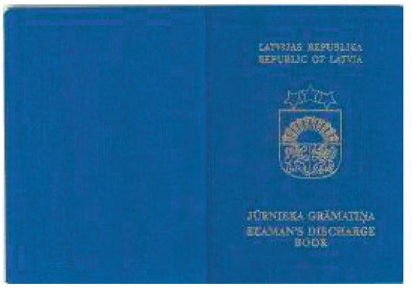

(Page 1)
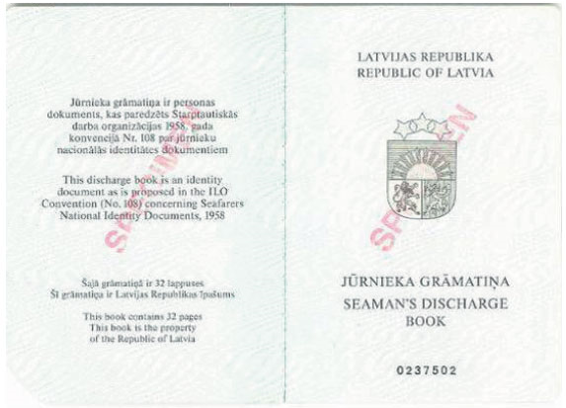

(Page 2)
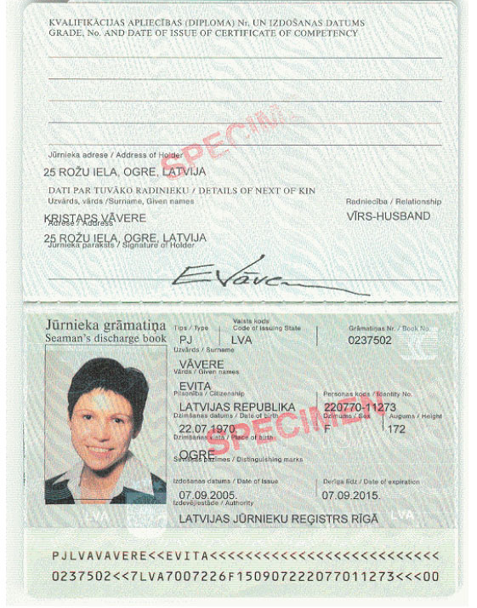

(Pages 3 and 4)
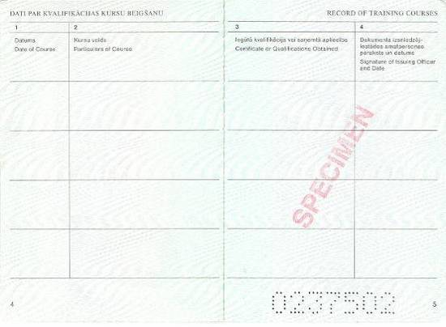

(Pages 5–13)
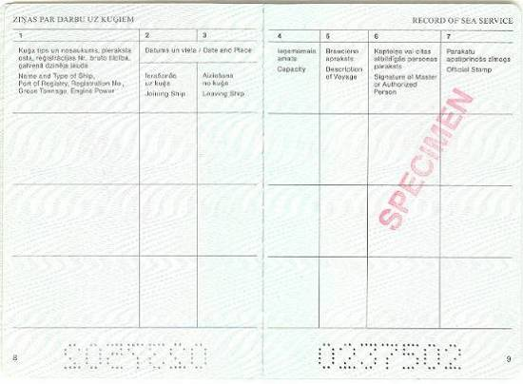

(Pages 14–16)
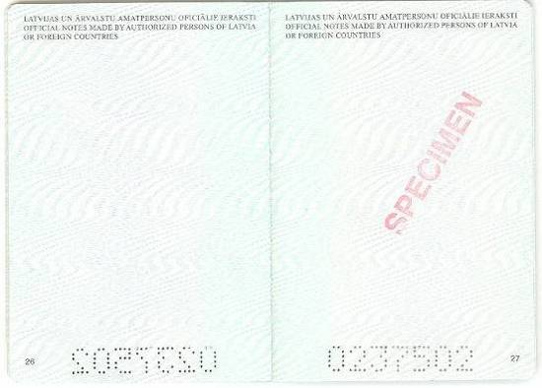

(Page 17)
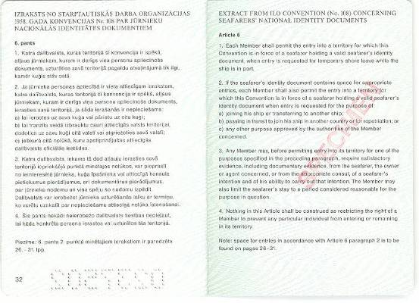

Minister for Transport A. Šlesers

Annex 2
Cabinet Regulation No. 992
20 December 2005
[20 February 2018]

Sample Statement for the Receipt of the Seaman’s Discharge Book

Area for the details of the document
(name, registration number, address, telephone number, e-mail address of the author of the document)

Statement for the Receipt of the Seaman’s Discharge Book

on ___ ______ 20___ |  |  | No.

I hereby acknowledge that
(given name, surname, and personal identity number)

is employed in the position of
(name of the position)
is planned to be employed in the position of
(name of the position)

on the ship
(ship's name*)

has commenced studies on
(date of commencing the studies)

in the educational programme
(name of the educational programme).

The statement is intended for submission to the Registry of Seamen of the State joint stock company Maritime Administration of Latvia for the receipt of the seaman’s discharge book and is valid for two months from the days of its issue.
Person having the signatory power/
head of the educational institution
(position, given name, surname, signature)

Note. * Must be completed for the service personnel of a passenger ship.

Annex 3.
Cabinet Regulation No. 992
20 December 2005

SEAFARER’S REGISTRATION CARD
[20 February 2018]

Annex 4
Cabinet Regulation No. 992
20 December 2005

Instructions Regarding Photographs for Drawing Up the Seaman’s Discharge Book
[20 February 2018]

