Republic of Latvia

Cabinet
Regulation No. 764
Adopted 22 December 2015

Regulations Regarding the Sample Forms of the Registration Procedure of Designs and the Sample Registration Certificate Thereof

Issued pursuant to
Section 15, Paragraph ten and Section 25, Paragraph four of the Law on Designs

1. This Regulation prescribes the sample forms necessary for the registration procedure of designs and the sample form of a registration certificate of a design (hereinafter – the certificate).

2. The following sample forms are determined:
2.1. an application for the registration of a design (Annex 1);
2.2. a submission for the registration renewal of a design (Annex 2);
2.3. a statement of transfer of a design (Annex 3);
2.4. a certificate of transfer of a design (Annex 4);
2.5. a power of attorney for the registration procedure of a trade mark with the Patent Office (Annex 5).

3. The certificate (Annex 6) shall consist of covers, front page, one or several pages of images of a design and annex page. The size of the certificate shall conform to an A4 format page.

4. On the cover of the certificate (Paragraph 1 of Annex 6) or on the first page of the electronic certificate (Paragraph 2 of Annex 6) the following elements shall be placed:
4.1. in the background – grid;
4.2. in the upper part – the image of the supplemented lesser State coat of arms, below it – the inscriptions “THE REPUBLIC OF LATVIA” and “REGISTRATION CERTIFICATE OF A DESIGN”;
4.3. in the middle part – the text “The Patent Office of the Republic of Latvia certifies that the design included in this certificate is included in the State Register of Designs with No. D<00000>” (the number shall be printed according to the particular case);
4.4. below the text on the left side – the image of the ribbon in the colours of the national flag of Latvia and seal impress of the Patent Office;
4.5. at the bottom on the left side – the registration date and place of issue;
4.6. at the bottom on the right side – signature details (position name “Director of the Patent Office”, the signature of the Director of the Patent Office (for the electronic certificate – the indication “The document has been signed with a safe electronic signature and contains time stamp”) and the given name, surname).

5. The following shall be placed on the front page of the certificate (Paragraph 3 of Annex 6) under the details:
5.1. explanation of the Patent Office regarding the provisions of the Law on Designs in respect of coming into force of the rights to a design, the time period for the registration of the design, and the renewal of the registration, and also the obligation of the owner of the design to notify the Patent Office regarding amendments to the data which apply to the registration of the design;
5.2. the data included in the State Register of Designs which refer to the particular registration.

6. An image or images of a design shall be placed in the page of images of a design (Paragraph 4 of Annex 6). The necessary number of pages of images of the design shall be used. The images shall be numbered with a two position figure in which the sequence number of the particular design and the sequence number of the image in respect of this design (for example, the third image of the first design – 1.03; the second image of the sixth design – 6.02) are indicated.

7. An explanation in Latvian and English regarding the codes specified in World Intellectual Property Organisation (WIPO) Standard ST.80: Bibliographic data relating to industrial designs, which are used for bibliographic data identification of a design, shall be included in the annex page (Paragraph 5 of Annex 6).

8. The certificate shall be sewn through and certified with the seal of the Patent Office.

9. Cabinet Regulation No. 702 of 13 September 2005, Regulations Regarding a Sample Registration Certificate of a Design, (Latvijas Vēstnesis, 2005, No. 147; 2013, No. 223), is repealed.

10. The Regulation shall come into force on 1 January 2016.

Prime Minister Laimdota Straujuma

Minister for Justice Dzintars Rasnačs

Annex 1
Cabinet Regulation No. 764
22 December 2015

Application for the Registration of a Design

SHALL BE COMPLETED BY THE PATENT OFFICE | RECEIPT No. | DATE OF RECEIPT

TO THE PATENT OFFICE
  OF THE REPUBLIC OF LATVIA
  7/70, Citadeles Street
  Riga, LV-1010
  Latvia
  Phone: +371 67099600
  Fax: +371 67099650
  I REQUEST TO REGISTER A DESIGN
  DESIGN APPLICATION
  CODE OF THE APPLICANT |  | [ ]
 |  | APPLICATION FOR ONE DESIGN
 |  | COMBINED APPLICATION  NUMBER OF DESIGNS IN THE APPLICATION

*NAME OF THE PRODUCT IN WHICH IMPLEMENTATION OR INCLUSION OF THE DESIGIN IS INTENDED
LOCARNO CLASSIFICATION INDEX
*APPLICANT(-S) (FORESEEABLE OWNER(-S) OF THE DESIGN)  (FOR LEGAL PERSONS – FULL NAME; FOR NATURAL PERSONS – GIVEN NAME, SURNAME)
  * ADDRESS, COUNTRY (CODE)

* DESIGNER(-S) (GIVEN NAME, SURNAME) |  | * ADDRESS, COUNTRY (CODE)
 THE DESIGNER (DESIGNERS) HAS (HAVE) REFUSED FROM THE RIGHT TO BE MENTIONED OR HAS (HAVE) REQUESTED THAT HE OR SHE IS NOT MENTIONED

PLEASE, DETERMINE THE PRIORITY OF THE DESIGN
 CONVENTION PRIORITY
DOC. No. |  | COUNTRY (CODE) |  |  | DATE (DD.MM.YYYY)
 EXHIBITION PRIORITY; DOCUMENT TYPE
 |  |  |  |  | DATE (DD.MM.YYYY)
 PLEASE, POSTPONE THE PUBLICATION FOR MONTHS
REPRESENTATIVE (GIVEN NAME, SURNAME) |  |  |  |  | ADDRESS, COUNTRY (CODE)
GENERAL POWER OF ATTORNEY |  |  |  |  | PHONE
*ADDRESS FOR CORRESPONDENCE (GIVEN NAME, SURNAME OR FIRM NAME OF THE ADDRESSEE)
  *ADDRESS, POSTAL CODE
  PHONE
  FAX
E-MAIL

 AFTER REGISTRATION OF THE DESIGN I WOULD LIKE TO RECEIVE ALL FURTHER INFORMATION AND DOCUMENTS ELECTRONICALLY TO THE INDICATED E-MAIL ADDRESS

 I WOULD LIKE TO RECEIVE THE REGISTRATION CERTIFICATE ELECTRONICALLY TO THE INDICATED E-MAIL ADDRESS
APPENDED
1.  2.  3.  4.  5.  6.  7.  8. |  IMAGES OF THE DESIGN   DESCRIPTION OF THE DESIGN   PRODUCT SAMPLE   POWER OF ATTORNEY   DOCUMENT OF PRIORITY RIGHTS   TRANSLATIONS OF DOCUMENTS   STATEMENT ON TRANSFER OF RIGHTS OR SIMILAR DOCUMENT   OTHER DOCUMENTS (SPECIFY): ** |  |  | COPIES
1.  2.  3.  4.  5.  6.  7.  8. |  |  |  | ON PAGES  ON PAGES
* SIGNATURE OF THE APPLICANT/REPRESENTATIVE |  |  | GIVEN NAME, SURNAME, POSITION
DATE OF FILLING IN (DD.MM.YYYY)

* – TO BE PROVIDED MANDATORILY.
** – WHEN PAYING, THE DATA WHICH CLEARLY AND UNMISTAKABLY IDENTIFY THE APPLICATION FOR THE REGISTRATION OF A DESIGN AND THE ACTION FOR WHICH PAYMENT IS BEING MADE SHALL BE PROVIDED.

Minister for Justice Dzintars Rasnačs

Annex 2
Cabinet Regulation No. 764
22 December 2015

Submission for the Registration Renewal of a Design

  TO THE PATENT OFFICE OF THE REPUBLIC OF LATVIA
  7/70, Citadeles Street
  Riga, LV-1010
  Latvia
  Phone: +371 67099600
  Fax: +371 67099650
  REQUEST FOR RENEWAL OF DESIGN REGISTRATION
  APPLICANT CODE |  | [ ]

PLEASE, RENEW THE REGISTRATION OF A DESIGN
REGISTRATION NUMBER  D |  | APPLICATION DATE (DD.MM.YYYY) |  |  |  |  |  |  | APPLICATION NUMBER (NOT MANDATORY)  D- -
OWNER OF THE DESIGN  (FOR LEGAL PERSONS – FULL NAME; FOR NATURAL PERSONS – GIVEN NAME, SURNAME) |  |  |  |  |  |  |  |  |  | ADDRESS, COUNTRY (CODE)
DESIGNS FOR WHICH REGISTRATION RENEWAL IS NECESSARY
(MARK ONLY ONE OF THE OPTIONS)

 RENEWAL IS NECESSARY FOR ALL DESIGNS INCLUDED IN THE REGISTRATION
 RENEWAL IS NECESSARY ONLY FOR THE FOLLOWING DESIGNS INCLUDED IN THE REGISTRATION:

REPRESENTATIVE (GIVEN NAME, SURNAME) |  |  |  |  |  |  |  |  | ADDRESS, COUNTRY (CODE)
REGISTRATION No. OF THE GENERAL POWER OF ATTORNEY |  |  |  |  |  |  |  |  | PHONE
ADDRESS FOR CORRESPONDENCE  (GIVEN NAME, SURNAME OR FIRM NAME OF THE ADDRESSEE) |  |  |  |  |  |  |  |  | ADDRESS, POSTAL CODE
E-MAIL |  |  |  |  |  |  |  |  | PHONE
 I WOULD LIKE TO RECEIVE FURTHER INFORMATION AND DOCUMENTS ELECTRONICALLY TO THE INDICATED E-MAIL ADDRESS |  |  |  |  |  |  |  |  | FAX
APPENDED:  1.  POWER OF ATTORNEY |  |  |  | 2.  OTHER DOCUMENTS (SPECIFY):*
SIGNATURE OF THE OWNER/REPRESENTATIVE |  |  |  |  |  | GIVEN NAME, SURNAME, POSITION
DATE OF FILLING IN (DD.MM.YYYY)

* – WHEN PAYING, THE REGISTRATION NUMBER OF THE DESIGN AND THE ACTION FOR WHICH THE PAYMENT IS BEING MADE SHALL BE PROVIDED.

Minister for Justice Dzintars Rasnačs

Annex 3
Cabinet Regulation No. 764
22 December 2015

Statement of Transfer of a Design

TRANSFER DOCUMENT OF DESIGN |  | TO THE PATENT OFFICE OF THE REPUBLIC OF LATVIA  7/70, Citadeles Street  Riga, LV-1010  Latvia  Phone: +371 67099600  Fax: +371 67099650

We, the transferor(s) and the transferee(s), hereby certify with signatures that the ownership rights to registration(s) and/or application(s) are transferred by this statement.

The statement applies to the following registration(s) and/or application(s):

Registration number(s):
Application number(s):

Transferor(s):

for legal persons – full name; for natural persons – given name, surname

address, country (code)

Transferee(s)

for legal persons – full name; for natural persons – given name, surname

address, country (code)

Signature(s) of the transferor(s)

given name, surname, position, signature

Place of signing date (DD.MM.YYYY)

Signature(s) of the transferee(s)

given name, surname, position, signature

Place of signing date (DD.MM.YYYY)

 Appended additional pages

Minister for Justice Dzintars Rasnačs

Annex 4
Cabinet Regulation No. 764
22 December 2015

Certificate of Transfer of a Design

CERTIFICATE OF TRANSFER  OF DESIGN | TO THE PATENT OFFICE  OF THE REPUBLIC OF LATVIA  7/70, Citadeles Street  Riga, LV-1010  Latvia  Phone: +371 67099600  Fax: +371 67099650

We, the transferor(s) and the transferee(s), hereby certify with signatures that the ownership rights to registration(s) and/or application(s) are transferred according to the agreement entered into by the parties.

The certificate applies to the following registration(s) and/or application(s):
Registration number(s):
Application number(s):

Transferor(s):

for legal persons – full name; for natural persons – given name, surname

address, country (code)

Transferee(s):

for legal persons – full name; for natural persons – given name, surname

address, country (code)

Signature of the transferor(s)

given name, surname, position, signature

Place of signing date (DD.MM.YYYY)

 Appended additional pages

Minister for Justice Dzintars Rasnačs

Annex 5
Cabinet Regulation No. 764
22 December 2015

Power of Attorney for the Registration Procedure of a Trade Mark with the Patent Office

AUTHORISATION | TO THE PATENT OFFICE  OF THE REPUBLIC OF LATVIA  7/70, Citadeles Street  Riga, LV-1010  Latvia  Phone: +371 67099600  Fax: +371 67099650
  TO BE COMPLETED BY THE PATENT OFFICE | No. of the Power of Attorney

I (We)

,
for legal persons – full name, for natural persons – given name, surname

,
address, country (code)

hereby authorise

given name, surname; address, country (code)

to represent me (us) in the Patent Office of the Republic of Latvia (mark only one of three options)
 in all record-keeping proceedings of designs, including withdrawal of the application (s), refusal from the registration (s), and also revocation of an objection, submission of counter-objections, recognition of the objection, and entering into an amicable settlement
 in all record-keeping proceedings of designs, except for the following:
 in the following record-keeping proceedings of designs:

in respect of (mark only one of two options):

 all present and future applications and/or registrations of designs
 the following applications and/or registrations of designs:

 Substitution is allowed  Substitution is not allowed

given name, surname, position, signature

Place of signing date (DD.MM.YYYY)

Minister for Justice Dzintars Rasnačs

Annex 6
Cabinet Regulation No. 764
22 December 2015

SAMPLE REGISTRATION CERTIFICATE OF A DESIGN

1. Cover of the certificate

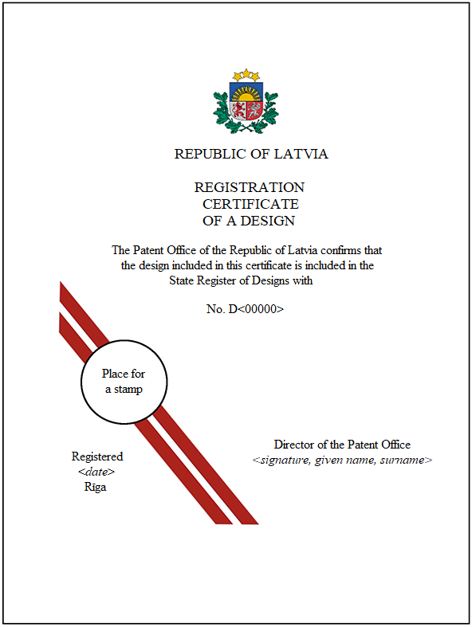
2. The first page of the electronic certificate

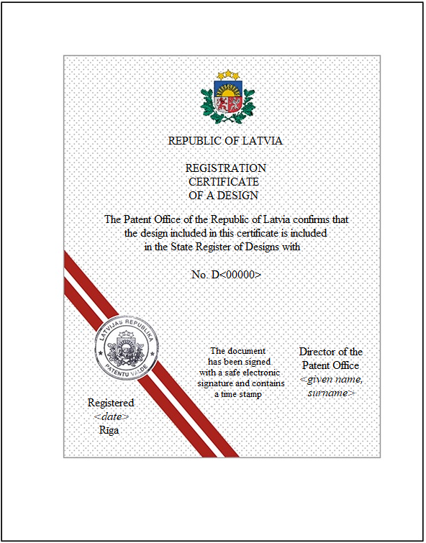

3. Front page of the certificate

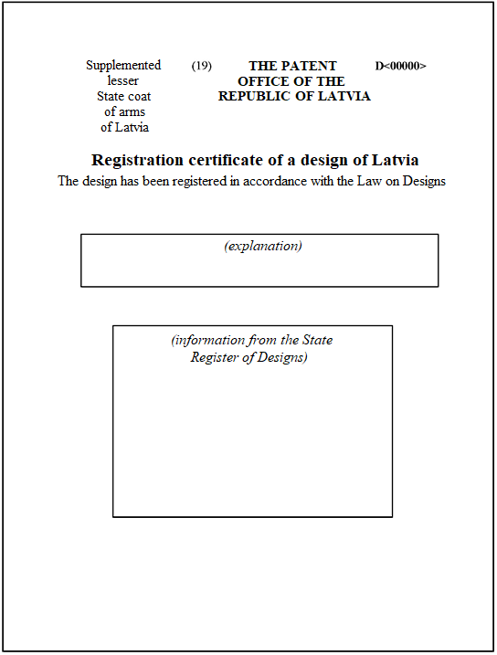

4. Page of the design images (sample)

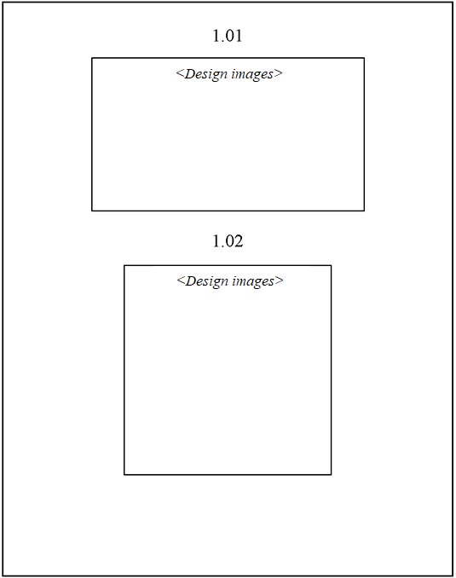

5. Annex page

Starptautiski pieņemtie kodi (INID kodi), kas izmantoti dizainparauga bibliogrāfisko datu identificēšanai saskaņā ar Pasaules Intelektuālā īpašuma organizācijas standartu ST.80 "Rekomendācijas par dizainparaugu bibliogrāfiskajiem datiem"
Internationally Agreed Numbers for the Identification of Bibliographic Data (INID Codes) According to the World Intellectual Property Organization's Standard ST.80 "Recommendation Concerning Bibliographic Data Relating to Industrial Designs"
(11) Reģistrācijas numurs – Registration number
(15) Reģistrācijas datums – Registration date
(19) Iestāde, kas reģistrējusi dizainparaugu –
Identification of the authority registering the industrial design
(21) Pieteikuma numurs – Application number
(22) Pieteikuma datums – Filing date of the application
(23) Izstādes prioritātes dati – Exhibition priority data
(28) Dizainparaugu skaits kompleksajā reģistrācijā –
Number of designs included (in case of multiple registration)
(30) Konvencijas prioritātes dati:
pieteikuma numurs, pieteikuma datums, valsts kods –
Convention priority data:
application number, filing date, code of country
(51) Dizainparaugu starptautiskās klasifikācijas
(Lokarno klasifikācijas – LOC) indeksi: klase, apakšklase –
Indication of International Classification for Industrial Designs (Locarno Classification – LOC): class, subclass
(54) Izstrādājuma(-u) nosaukums(-i) –
Indication of product(s) covered
(62) Dati par sākotnējo pieteikumu, no kura šis pieteikums nodalīts –
Data of the initial application from which the present application has been divided up
(72) Dizainers(-i), valsts kods – Designer(s), code of country
(73) Īpašnieks(-i), adrese, valsts kods –
Name and address of the owner(s), code of country
(74) Pārstāvis (patentpilnvarotais, dizainparaugu aģents), adrese –
Representative (attorney, design agent), address

Minister for Justice Dzintars Rasnačs

