Text consolidated by Valsts valodas centrs (State Language Centre) with amending regulations of:
28 January 2014 [shall come into force on 31 January 2014];
7 January 2021 [shall come into force on 14 January 2021].
If a whole or part of a paragraph has been amended, the date of the amending regulation appears in square brackets at the end of the paragraph. If a whole paragraph or sub-paragraph has been deleted, the date of the deletion appears in square brackets beside the deleted paragraph or sub-paragraph.

Republic of Latvia

Cabinet
Regulation No. 80
Adopted 24 January 2006

Regulations Regarding the Minimum Safe Manning of Ships

Issued pursuant to
Section 11, Paragraph four of the Maritime Administration and Marine Safety Law

I. General Provisions

1. The Regulation prescribes the procedures for the recruitment of the minimum safe manning on Latvian ships.
[7 January 2021]

2. Recruitment of a ship's crew shall take place in accordance with Regulations V-14.1 and V-14.2 of the International Convention for the Safety of Life at Sea, 1974 (hereinafter – SOLAS 74 Convention), the International Convention on Standards of Training, Certification and Watchkeeping for Seafarers, 1978 (as amended) (hereinafter – STCW Convention) and the International Convention on Standards of Training, Certification and Watchkeeping for Fishing Vessel Personnel, 1995 (hereinafter – STCW-F Convention), the Maritime Labour Convention, 2006, and the International Ship and Port Facility Security Code, 2004.
[28 January 2014]

II. Minimum Safe Manning of a Ship

3. For ships engaged in international voyages the minimum safe manning of a ship shall be recruited in accordance with the norms of the minimum safe manning of ships engaged in international voyages laid down in Annex 1 to this Regulation.
[7 January 2021]

4. For fishing vessels and ships not engaged in international voyages the minimum safe manning of a ship shall be recruited in accordance with the norms of the minimum safe manning of fishing vessels, coasters and inland water vessels laid down in Annex 2 to this Regulation.
[7 January 2021]

4.¹ For vessels of the State Border Guard the minimum safe manning of a ship shall be determined by the shipowner in the internal rules of its institution, coordinating the composition of crew members with valsts akciju sabiedrība “Latvijas Jūras administrācija” [State joint stock company Maritime Administration of Latvia] (hereinafter – the Maritime Administration of Latvia).
[7 January 2021]

5. The following shall be included in the minimum safe manning of passenger ships in addition to that laid down in Paragraph 3 or 4 of this Regulation:
5.1. a certified head of the passenger service, if the number of passengers exceeds 50;
5.2. one steward per 50 passengers.

6. If there are 100 crew members on board the ship or more and the ship is engaged in international voyages for more than 72 hours, in addition to that laid down in Paragraph 3 of this Regulation the minimum safe manning shall include a certified doctor.
[28 January 2014]

6.¹ On ships without a certified doctor there must be at least one seaman who in addition to his basic duties is also responsible for medical care and issuance of medicinal products, or at least one seaman who is competent in rendering first aid. The persons who are responsible for medical care on board the ship, but have not acquired the qualification of a doctor must acquire a programme of medical care training courses in accordance with the requirements of the standard of Code A-VI/4-2 of the STCW Convention. The seafarers who are designated to first medical aid must acquire a programme of first aid training courses in accordance with the requirements of standard A-VI/4-2 of the Code of the STCW Convention.
[28 January 2014]

7. If a ship's crew consists of 10 crew members or more, in addition to that laid down in Paragraph 3 or 4 of this Regulation the minimum safe manning of a ship shall include a certified cook. If a ship's crew consists of less than 10 crew members and there is no certified cook in the crew, then any person who is preparing meals in the galley must be trained or instructed in conformity with the requirements of the Maritime Labour Convention, 2006, regarding food and personal hygiene, as well as handling and storage of food on board the ship.
[28 January 2014]

8. If the duration of a ship voyage does not exceed 24 hours until the next port, a lesser number of crew members may be on board the ship during such voyage than laid down in Annexes 1 and 2 to this Regulation, if the number of crew members has been coordinated with the Maritime Administration of Latvia.
[7 January 2021]

8.¹ A fishing vessel registered in the Latvian Ship Register shall be commanded by a skipper who has the minimum qualification laid down in Cabinet Regulation No. 895 of 22 November 2005, Regulations Regarding Certification of Seafarers.
[28 January 2014]

III. Minimum Safe Manning Certificate

9. The Maritime Administration of Latvia shall issue a minimum safe manning certificate (hereinafter – the certificate) (Annex 3) according to the tonnage of the ship, main propulsion power, trading area and operation mode. The certificate shall not be issued to vessels of the State Border Guard, laid-up ships, and fishing boats.
[7 January 2021]

10. In order to receive a certificate, a shipowner shall submit a completed specific application form (Annex 4) to the Maritime Administration of Latvia.

11. If the shipowner, upon evaluating the minimum safe manning norms for a ship laid down in Annex 1 or 2 to this Regulation, considers them inappropriate for the particular ship, trading area, or other conditions and wants to determine another minimum safe manning, he or she shall indicate it in the application and, if necessary, submit additional documents to the Maritime Administration of Latvia certifying the ability of the crew to ensure safety of navigation and protection of the environment, operation of the ship and dealing with emergency situations, provision of ship security and safety functions, and also conformity with the work and rest time norms laid down in the international legal acts referred to in Paragraph 2 of this Regulation.
[28 January 2014; 7 January 2021]

11.¹ If due to the special nature of operation the ship is periodically in demurrage, in addition the minimum safe manning of the ship during demurrage shall be indicated in the certificate.
[28 January 2014]

12. The Maritime Administration of Latvia shall, within three working days, examine the application of the shipowner, evaluate the organisation of the relevant ship service, the specific features of the equipment and operation of the ship, the ability of the crew to comply with the requirements of hours of work and hours of rest, the ship safety management and protection measures, and also the qualification level of the crew and take the decision to issue the certificate.
[7 January 2021]

13. The term of validity of the certificate is five years. The term of validity of the certificate for ships under technical supervision of the Maritime Safety Inspectorate of the Maritime Administration of Latvia shall be linked to the term of validity of the trade certificate. The term of validity of the certificate for ships under technical supervision of classification societies (recognised organisations) shall be linked to the term of validity of the classification certificate.
[28 January 2014; 7 January 2021]

14. A shipowner may contest the decision on the minimum safe manning of a ship in accordance with the procedures laid down in the Administrative Procedure Law, submitting a respective submission to the director of the Maritime Administration of Latvia within a month after taking of the decision.

15. If the structure of a ship, ship equipment or provisions for operation, and also the shipowner or shipping company are changed, the certificate shall cease to be in effect. In such case the shipowner shall submit a new application and receive a new certificate.
[7 January 2021]

IV. Responsibility of a Shipowner and Master of the Ship

16. A shipowner has an obligation to ensure recruitment of a ship’s crew at least according to the norms of the minimum safe manning laid down for the ship, and also to create conditions for the ship’s crew to be able to comply with the requirements for hours of work and hours of rest according to the work and watch schedule of the ship’s crew.
[7 January 2021]

17. The recruitment norms of the minimum safe manning laid down for the ship do not exempt the shipowner and master of the ship from responsibility for ship, human and environmental safety, and also for recruitment of the ship’s crew according to the actual navigation circumstances and conditions.
[7 January 2021]

V. Closing Provisions
[28 January 2014]

18. Until 31 December 2016 a person who holds the qualification provided for in Regulation II/4 or II/5 of the STCW Convention may hold the position of an able seafarer deck on board the ships referred to in Annex 1 to this Regulation.

19. Until 31 December 2016 a person who holds the qualification provided for in Regulation III/4 or III/5 of the STCW Convention may hold the position of an able seafarer engine on board the ships referred to in Annex 1 to this Regulation.

Acting for the Prime Minister – Minister for Health G. Bērziņš

Acting for the Minister for Transport – Minister for the Interior Dz. Jaundžeikars

Annex 1
Cabinet Regulation No. 80
24 January 2006

Norms for the Minimum Safe Manning of Ships Engaged in International Voyages
[7 January 2021]

I. Master and Deck Crew on Passengers Ships

No. | Grades/capacities | Regulation of the STCW Convention of the qualification certificate | Number
 |  |  | 3000 gross tonnage (hereinafter – GT) and upwards | 500 GT−3000 GT | up to 500 GT
1. | Master | II/2, IV/2 | 1 | 1 | 1 (II/3¹)
2. | Chief mate | II/2, IV/2 | 1 | 1 | −
3. | Officer in charge of a navigational watch | II/1, IV/2 | 3 | 2 | 1 (II/3²)
4. | Able seafarer deck | II/5 | 3 | 3 | 2
5. | Rating forming part of a navigational watch | II/4 | 3 | 1 | −

Notes.
¹ When navigating outside the Baltic Sea, the qualification shall conform to Regulation II/2 of the STCW Convention.
² When navigating outside the Baltic Sea, the qualification shall conform to Regulation II/1 of the STCW Convention.

II. Master and Deck Crew on Cargo¹ Vessels

No. | Grades/capacities | Regulation of the STCW Convention of the qualification certificate | Number
 |  |  | 5000 GT and upwards | 2000 GT−5000 GT | 500 GT−2000 GT | up to 500 GT
1. | Master | II/2, IV/2 | 1 | 1 | 1 | 1 (II/3²)
2. | Chief mate | II/2, IV/2 | 1 | 1 | 1 | −
3. | Officer in charge of a navigational watch | II/1, IV/2 | 2 | 1 (2³) | 1⁴ | 1 (II/3⁶)
4. | Able seafarer deck | II/5 | 3 | 2 | 1 | −
5. | Rating forming part of a navigational watch | II/4 | 1 (2⁵) | 1 (2⁵) | 1 | 2

Notes.
¹ The category of cargo vessels shall also include sea tugboats.
² When navigating outside the Baltic Sea, the qualification shall conform to Regulation II/2 of the STCW Convention.
³ For chemical tankers. This position may be reduced accordingly if the shipowner provides a justification that it is not possible to ensure a separate cabin for the officer in charge of a navigational watch. In such case the trading area is restricted to navigation in the Baltic Sea and the Northwest European Waters.
⁴ This position may be disregarded if the shipowner provides a justification that it is not possible to ensure a separate cabin for the officer in charge of a navigational watch. In such case the trading area is restricted to navigation in the Baltic Sea and the Northwest European Waters.
⁵ For chemical tankers.
⁶ When navigating outside the Baltic Sea, the qualification shall conform to Regulation II/1 of the STCW Convention.

III. Master and Crew on Ships up to 500 GT with the Distance from the Port of Refuge of up to 150 Nautical Miles¹

No. | Grades/capacities | Regulation of the STCW Convention of the qualification certificate | Number
 |  |  | up to 50 GT | up to 200 GT | up to 500 GT
1. | Master | II/3, IV/2² | 1 | 1 | 1
2. | Officer in charge of a navigational watch | II/3, IV/2² | 1³ | 1³ | 1³
3. | Officer in charge of an engineering watch⁴ | III/1 | 1 | 1 | 1
4. | Rating forming part of a navigational watch | II/5 or II/4 | 1 | 1 | 2 (1⁵)

Notes.
¹ These norms shall not apply to tugs engaged in mooring, pulling, or pushing operations, and also to ships carrying more than 12 passengers.
² The master and the officer in charge of a navigational watch may have the Long Range Radio Operator’s Certificate (if the ship is not subject to the requirements of Chapter IV of the SOLAS 74 Convention). When navigating only in the sea area A1, the master and the officer in charge of a navigational watch may have the Short Range Radio Operator’s Certificate (if the ship is not subject to the requirements of Chapter IV of the SOLAS 74 Convention).
³ For ships with the duration of the voyage of up to 14 hours this position may be disregarded.
⁴ This position may be disregarded for a ship:
a) for which the main propulsion power is less than 750 kW, and also if the automation level of the ship allows to operate the ship without a permanent watch in the engine-room provided that one of the officers has completed courses regarding the operation of the engine of the relevant type;
b) which is equipped with two independent main engines;
c) which has only one main engine, in conformity with the following requirements:
– the duration of the voyage is up to 14 hours;
– a good weather forecast for the planned voyage (wind force – not more than six, state of the sea – not more than five);
– the port (place) of refuge may be reached in six hours.
⁵ For ships with the duration of the voyage of up to 14 hours.

IV. Ship Engine-room Crew¹

No. | Grades/capacities | Regulation of the STCW Convention of the qualification certificate | Number
 |  |  | main propulsion power 6000 kW and upwards |  | main propulsion power 3000 kW−6000 kW |  | main propulsion power 750 kW-3000 kW |  | main propulsion power less than 750 kW
 |  |  | attended | unattended | attended | unattended | attended | unattended | attended | unattended
1. | Chief engineer officer | III/2 or III/3 depending on the main propulsion power | 1 | 1 | 1 | 1 | 1 | 1 | − | −
2. | Second engineer officer | III/2 | 1 | 1 | 1 | 1 | − | − | − | −
3. | Officer in charge of an engineering watch | III/1 | 2 | 1 | 1 | − | 1 | − | 2² | 1^{2, 3}
4. | Electro-technical officer on a ship | III/6 | 1⁴ | 1⁴ | 1⁴ | 1⁴ | − | − | − | −
5. | Able seafarer engine | III/5 | 2 | 1 | 1 | 1 | 1 | 1 | − | −
6. | Rating forming part of an engine-room watch | III/4 | 1 | 1 | 1 | − | − | − | − | −
7. | Electro-technical rating | III/7 | 2⁵ | 1⁵ | − | − | − | − | − | −

Notes.
¹ Operations in the engine room under provisions for Unattended Machinery Space is permitted, if the automation level conforms to the requirements of Section E of Part I-2 of the SOLAS 74 Convention.
² This position may be held by an engineer officer on ships with the main propulsion power less than 750 kW who has been certified in accordance with Paragraph 61 of Cabinet Regulation No. 895 of 22 November 2005, Regulations Regarding Certification of Seafarers.
³ An officer in charge of an engineering watch may be replaced with a qualified rating forming part of an engine-room watch if the trading area is restricted to navigation in the Baltic Sea and Northwest European Waters only. In such case the Maritime Administration of Latvia shall assess the safe operation possibilities of the marine power plant on the basis of the previous operation experience of the ship.
⁴ In cases if the ship has an electric propulsion system.
⁵ For passenger ships.

Annex 2
Cabinet Regulation No. 80
24 January 2006

Norms for the Minimum Safe Manning of Fishing Vessels, Coasters and Inland Water Vessels
[7 January 2021]

I. Fishing Vessels

1. The master and deck crew¹ on board fishing vessels in unlimited fishing area outside the Baltic Sea

No. | Grades/capacities | Regulation of the STCW Convention or the STCW-F Convention of the qualification certificate or the minimum qualification in accordance with Cabinet Regulation No. 895 of 22 November 2005, Regulations Regarding Certification of Seafarers | Number
1.1. | master | Qualification determined in STCW-F Convention II/1 according to the ship length or qualification determined in STCW Convention II/2² | 1
1.2. | chief mate³ | Qualification determined in STCW-F Convention II/2 or STCW Convention II/2² | 1
1.3. | officer in charge of a navigational watch | Qualification determined in STCW-F Convention II/2 according to the ship length or qualification determined in STCW Convention II/1² | 1  (2 if the GT of the ship >3000)
1.4. | rating forming part of a navigational watch | Qualification determined in Paragraph 145 or in STCW Convention II/4 or qualification determined in STCW Convention II/5 | 2  (3 if the GT of the ship >3000)

Notes.
¹ The master and all mates must have the certificate of the universal Global Maritime Distress and Safety System (GMDSS) operator.
² If the master or mate has a qualification document conforming to the STCW Convention, then this document must contain an entry regarding an authorisation to work on fishing vessels.
³ This position may be disregarded if the shipowner provides sufficient justification regarding operating the ship in accordance with the international requirements regarding minimum safe manning and conformity with the work and rest time laid down in international legal acts.

2. The engine-room crew on fishing vessels with main propulsion power exceeding 3000 kW, in an unlimited fishing area outside the Baltic Sea

No. | Grades/capacities | Regulation of the STCW Convention or the STCW-F Convention of the qualification certificate or the minimum qualification in accordance with Cabinet Regulation No. 895 of 22 November 2005, Regulations Regarding Certification of Seafarers | Number
 |  |  | attended | unattended
2.1. | chief engineer officer | Qualification determined in STCW-F Convention II/5 or STCW Convention III/2 | 1 | 1
2.2. | second engineer officer | Qualification determined in STCW-F Convention II/5 or STCW Convention III/2 | 1 | 1
2.3. | officer in charge of an engineering watch | Qualification determined in STCW-F Convention II/5 or STCW Convention III/1 | 1 | −
2.4. | rating forming part of an engine-room watch | Qualification determined in Paragraph 146 or in STCW Convention III/4 or qualification determined in STCW Convention III/5 | 2 | 1

3. Crew of the engine-room for fishing vessels with the main propulsion power up to 3000 kW in an unlimited fishing area outside the Baltic Sea

No. | Grades/capacities | Regulation of the STCW Convention or the STCW-F Convention of the qualification certificate or the minimum qualification in accordance with Cabinet Regulation No. 895 of 22 November 2005, Regulations Regarding Certification of Seafarers | Number
 |  |  | attended | unattended
3.1. | chief engineer officer | Qualification determined in STCW-F Convention II/5 or STCW Convention III/3 | 1 | 1
3.2. | officer in charge of an engineering watch | Qualification determined in STCW-F Convention II/5 or STCW Convention III/1 | 1 | 1
3.3. | rating forming part of an engine-room watch | Qualification determined in Paragraph 146 or in STCW Convention III/4 or qualification determined in STCW Convention III/5 | 1 | −

4. Crew on fishing vessels of length up to 45 metres and with an unlimited duration of the voyage in the Baltic Sea

No. | Grades/capacities | Regulation of the STCW Convention or the STCW-F Convention of the qualification certificate or the minimum qualification in accordance with Cabinet Regulation No. 895 of 22 November 2005, Regulations Regarding Certification of Seafarers | Number
4.1. | master¹ | Qualification determined in STCW-F Convention II/1 or STCW Convention II/3² according to the GT of the ship | 1
4.2. | officer in charge of a navigational watch¹ | Qualification determined in STCW-F Convention II/2 or STCW Convention II/1², or STCW Convention II/3² according to the GT of the ship | 1
4.3. | engineer | Qualification determined in Paragraph 136, 137, 138, 139, 140, 141, or 142 according to the main propulsion power or qualification determined in Paragraph 61, or in STCW Convention III/3 or STCW-F Convention II/5 | 1
4.4. | rating forming part of a navigational watch or fisherman | Qualification determined in Paragraph 144 or 145 or qualification determined in STCW Convention II/4 or in STCW Convention II/5 | 1

Notes.
¹ The master and the officer in charge of a navigational watch must have the GMDSS General Operator’s Certificate or the Long Range Radio Operator’s Certificate.
² If the master or mate has a qualification document conforming to the STCW Convention, then this document must contain an entry regarding an authorisation to work on fishing vessels.

5. Crew for fishing vessels of length of up to 45 metres and with the duration of the voyage of up to 16 hours¹ in the Baltic Sea and the Gulf of Riga

No. | Grades/capacities | Regulation of the STCW Convention or the STCW-F Convention of the qualification certificate or the minimum qualification in accordance with Cabinet Regulation No. 895 of 22 November 2005, Regulations Regarding Certification of Seafarers | Number
5.1. | master² | Qualification determined in STCW-F Convention II/1 or STCW Convention II/3³ according to the GT of the ship | 1
5.2. | engineer | Qualification determined in Paragraph 136, 137, 138, 139, 140, 141, or 142 according to the main propulsion power or qualification determined in Paragraph 61, or in STCW Convention III/3 or STCW-F Convention II/5 | 1
5.3. | rating forming part of a navigational watch or fisherman | Qualification determined in Paragraph 144 or 145 or qualification determined in STCW Convention II/4 or in STCW Convention II/5 | 1

Notes.
¹ Upon application and justification of the shipowner.
² The master must have the GMDSS Restricted Operator’s Certificate or Short Range Radio Operator’s Certificate.
³ If the master has a qualification document conforming to the STCW Convention, then this document must contain an entry regarding an authorisation to work on fishing vessels.

II. Coasters Engaged in Near-coastal Navigation

6. Master and deck crew

No. | Grades/capacities | Regulation of the STCW Convention of the qualification certificate | Number
 |  |  | 500 GT and upwards | up to 500 GT
6.1. | master | Qualification determined in II/2 or II/3 according to the GT of the ship | 1 | 1
6.2. | officer in charge of a navigational watch | Qualification determined in II/1 or II/3 according to the GT of the ship | 1 | 1
6.3. | able seafarer deck | II/5 | 1 | −
6.4. | rating forming part of a navigational watch | II/4 | 1 | 1

Note. The master and the officer in charge of a navigational watch must have the GMDSS General Operator’s Certificate or the Long Range Radio Operator’s Certificate (if the ship is not subject to the requirements of Chapter IV of the SOLAS 74 Convention). When navigating only in the sea area A1, the master and the officer in charge of a navigational watch must have the GMDSS Restricted Operator’s Certificate or Short Range Radio Operator’s Certificate (if the ship is not subject to the requirements of Chapter IV of the SOLAS 74 Convention).

7. Engine-room crew

No. | Grades/capacities | Regulation of the STCW Convention of the qualification certificate | Number
 |  |  | main propulsion power 3000 kW and upwards |  | main propulsion power 750 kW-3000 kW |  | main propulsion power less than 750 kW
 |  |  | attended | unattended | attended | unattended | attended | unattended
7.1. | chief engineer officer | III/2 or III/3 depending on the main propulsion power | 1 | 1 | 1 | 1 | − | −
7.2. | second engineer officer | III/2 | 1 | 1 | − | − | − | −
7.3. | officer in charge of an engineering watch | III/1¹ | 1 | − | 1 | − | 2² | 1²
7.4. | electro-technical officer on a ship | III/6 | 1⁴ | 1⁴ | − | − | − | −
7.5. | able seafarer engine | III/5 | 1 | 1 | − | − | − | −
7.6. | rating forming part of an engine-room watch | III/4 | − | − | 1³ | 1³ | − | −
7.7. | electro-technical rating | III/7 | − | − | 1⁴ | − | − | −

Notes.
¹ This position may be held by an engineer officer on ships with the main propulsion power less than 750 kW who has been certified in accordance with Paragraph 61 of Cabinet Regulation No. 895 of 22 November 2005, Regulations Regarding Certification of Seafarers.
² An officer in charge of an engineering watch may be replaced with an able seafarer engine.
³ For ships engaged in near-coastal navigation with the duration of the voyage of up to 12 hours this position may be disregarded.
⁴ In cases if the ship has an electric propulsion system.

III. Inland Water Vessels

8. Master and crew¹

No. | Grades/capacities | The minimum qualification in accordance with Cabinet Regulation No. 895 of 22 November 2005, Regulations Regarding Certification of Seafarers | Number²
8.1. | master³ | Qualification determined in Paragraph 175, 176, 177, or 178 according to the tonnage of the ship or qualification determined in STCW Convention corresponding to the tonnage | 1
8.2. | engineer | Qualification determined in STCW Convention corresponding to the restrictions on main propulsion power or power determined in Paragraph 179.¹, 180, 180.¹, 181, or 182 | 1
8.3. | seaman | Qualification determined in Paragraph 183 or in STCW Convention II/4 or in STCW Convention II/5 | 1
8.4. | engine-room rating⁴ | Qualification determined in Paragraph 184 or in STCW Convention III/4 or in STCW Convention III/5 | 1

Notes.
¹ On board ships with GT less than 20 and the main propulsion power less than 40 kW the crew may be reduced, including only the master therein.
² On board ships with GT less than 300 and the main propulsion power less than 1500 kW the crew may be reduced, including specialists therein who hold joint qualification documents.
³ The master must have the GMDSS Short Range Radio Operator’s Certificate.
⁴ For ships with the main propulsion power less than 750 kW, as well as if the automation level of the ship allows operating the ship without constant watch in the engine-room, this position may be disregarded.

Annex 3
Cabinet Regulation No. 80
24 January 2006
[28 January 2014; 7 January 2021]

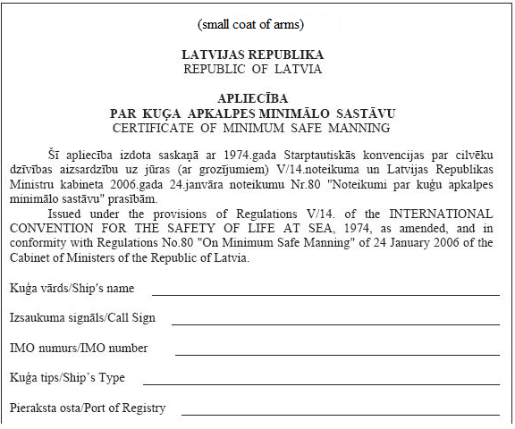

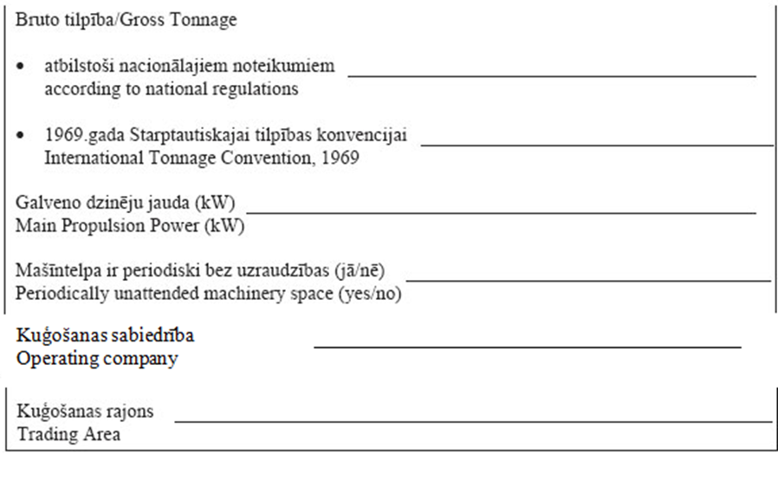

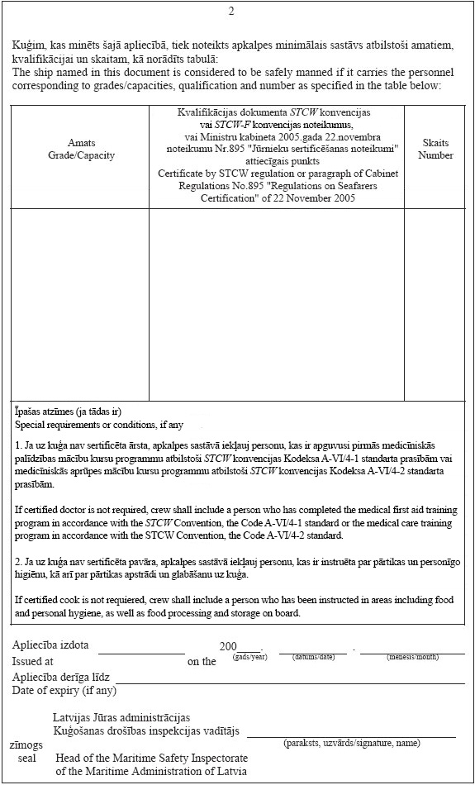

Acting for the Minister for Transport – Minister for the Interior Dz. Jaundžeikars

Annex 4
Cabinet Regulation No. 80
24 January 2006
[7 January 2021]

Application for the Receipt of the Certificate

1. | Ship's name
2. | IMO No.
3. | GT
4. | Total power of main engines, kW
5. | Ship's type
6. | Shipping company/shipowner
7. | Trading area and duration of voyage
8. | Is the engine-room of the ship periodically unattended? (yes/no)
9. | Will the minimum safe manning of a ship be able to efficiently ensure navigational watches and look-out? (yes/no)
10. | Will the minimum safe manning of a ship be able to efficiently ensure the requirements of the ship security plan? (yes/no/not applicable)
11. | Will the minimum safe manning of a ship be able to efficiently ensure the requirements of the safety management system of the ship? (yes/no/not applicable)
12. | Proposals for the minimum safe manning of a ship¹
12.1. | Minimum Safe Manning of a Ship

Grades/capacities | Regulation of the STCW Convention or the STCW-F Convention of the qualification certificate or the relevant paragraph of Cabinet Regulation No. 895 of 22 November 2005, Regulations Regarding Certification of Seafarers | Number
Special notes (if any)

12.2. Planned work and watch schedule of the minimum safe manning of a ship²

Grades/capacities | Planned daily working hours at sea |  | Planned daily working hours at port |  | Total daily rest hours³
 | watch  (from–until) | duties after watch  (from–until) | watch  (from–until) | duties after watch  (from–until) | at sea | at port

Notes.
¹ This section shall be completed if the proposed minimum safe manning of a ship differs from the norms for the minimum safe manning of a ship indicated in Cabinet Regulation No. 80 of 24 January 2006, Regulations Regarding the Minimum Safe Manning of Ships, or the relevant information is requested by the Maritime Safety Inspectorate of the State joint stock company Maritime Administration of Latvia.
² This section shall not be completed for passenger ships or ro-ro passenger ships which are engaged in international voyages, for fishing vessels of length of up to 45 metres and with the duration of the voyage of up to 16 hours in the Baltic Sea and in the Gulf of Riga, and for inland water vessels.
³ The planned minimum rest period may not be less than 10 hours in any 24-hour period and 77 hours in any seven-day period. The minimum rest period shall be applicable in accordance with the Maritime Code which includes the requirements of the Maritime Labour Convention of 2006 (MLC, 2006), and also with any applicable collective agreement which has been registered or authorised in accordance with the abovementioned Convention and the International Convention on Standards of Training, Certification and Watchkeeping for Seafarers of 1978 (STCW Convention).

Contact person
Contact details
(telephone, e-mail)
Signature*
Date*

Note. * The details of the document “signature” and “date” shall not be completed if the electronic document has been drawn up in accordance with the laws and regulations regarding drawing up of electronic documents.

