Republic of Latvia

Cabinet
Regulation No. 927
Adopted 5 October 2010

Regulations Regarding Specific Stability Requirements for Ro-ro Passenger Ships

Issued pursuant to
Section 11, Paragraph nine of the Maritime Administration and Marine Safety Law

I. General Provisions

1. The Regulation prescribes specific stability requirements (Annex 1) for ro-ro passenger ships (as specified in Regulation II-2/3 of the 1974 International Convention for the Safety of Life at Sea and the 1988 Protocol thereto (as amended) (hereinafter – the SOLAS Convention)) which carry more than 12 passengers (every person, except for the master of the ship, the members of the ship’s crew, or other persons who are employed or are hired on the ship for the needs of such ship, and children under one year of age) and are engaged on a regular service on international voyages from or to the ports of Latvia in order to improve the survivability of such type of ships in case of collision damage and to provide a high level of safety for passengers and crew.

2. The Maritime Safety Inspectorate (hereinafter – the Inspectorate) of valsts akciju sabiedrība “Latvijas Jūras administrācija” [State stock company Maritime Administration of Latvia] or a recognised ship classification society with which the Maritime Administration of Latvia has entered into an authorisation contract (hereinafter – the classification society) shall check that ro-ro passenger ships (regardless of the flag State of such ships), upon commencing voyages from or to the ports of Latvia, fully comply with the requirements of this Regulation.

II. Significant Wave Height

3. The significant wave height (h_{s}) (the average height of the highest third of wave height observed over a given period) shall be used for determining the height of water level on the car deck, upon applying the requirements laid down in Annex 1 to this Regulation.

4. Such value of significant wave height shall be determined for the relevant sea area that the probability of exceeding it within a year would not be more than 10 %.

III. Sea Areas

5. Sea areas crossed by ro-ro passenger ships which ensure regular voyages (series of trips, performing services of operations between the same two or more ports which is implemented either according to a published timetable or so regularly or frequently that they constitute a recognisable systematic series of trips) to the ports of Latvia and the values of significant wave height applicable to such areas comply with Annex 1 to the Agreement concerning specific stability requirements for ro-ro passenger ships undertaking regular scheduled international voyages between or to or from designated ports in North West Europe and the Baltic sea of 28 February 1996 (hereinafter – the Stockholm Agreement).

6. If the port State is not a member state of the Stockholm Agreement, the international agreements that are in force in the Republic of Latvia shall determine the sea areas and the values of significant wave height applicable therein. If the ship crosses several sea areas in its route, the ship must comply with the specific stability requirements for the highest value of significant wave height identified for these areas.

7. Information on the sea areas and the values of significant wave height applicable therein shall be published by the Maritime Administration of Latvia on its website (www.jurasadministracija.lv), and also the relevant information and the publication website thereof shall be notified to the European Commission.

IV. Specific Stability Requirements and Introduction Thereof

8. In addition to the requirements of Regulation II-I/B/8 of the SOLAS Convention relating to watertight subdivision and stability of a ship in a damaged condition, all ro-ro passenger ships referred to in Paragraph 1 of this Regulation must comply with the specific stability requirements laid down in Annex 1 to this Regulation.

9. Compliance with the SOLAS Convention shall be considered equivalent to compliance with the requirements of Annex 1 to this Regulation for ro-ro passenger ships performing operations exclusively in sea areas where the significant wave height is equal to or lower than 1.5 metres.

10. The Inspectorate or the classification society, upon controlling the fulfilment of the requirements referred to Annex 1 to this Regulation, shall take into account the guidelines specified in Annex 2 to this Regulation, insofar as this is practicable and compatible with the design of the relevant ship.

11. A new ro-ro passenger ship (a ship the keel of which is laid or which is at a similar stage of construction (stage at which construction works of the relevant ship begins or assembly of such ship has commenced comprising at least 50 tonnes or 1 % of the estimated mass of structural material, whichever is less) on or after 1 October 2004) shall comply with the specific stability requirements that are laid down in Annex 1 to this Regulation. Ro-ro passenger ships which are not new ships, except for the ships to which Paragraph 8 of this Regulation applies, shall ensure the compliance with the requirements referred to in Annex 1 to this Regulation.

V. Certificates

12. All ro-ro passenger ships that fly the flag of Latvia shall carry a certificate issued by the Inspectorate or the classification society confirming ship’s compliance with the specific stability requirements laid down in Chapter IV of and Annex 1 to this Regulation.

13. Compliance of a ship shall be evaluated and a certificate shall be issued in accordance with Chapter 2 of Annex 1 to this Regulation.

14. The certificate referred to in Paragraph 12 of this Regulation may be combined with other related certificates and it shall indicate the value of significant wave height up to which the ship can comply with the specific stability requirements. This certificate shall remain valid if the ship operates in an area with the same or a lower significant wave height.

15. Latvia acting in the capacity of a host State shall recognise the certificates of other European Union Member States issued in accordance with Directive 2003/25/EC of the European Parliament and of the Council of 14 April 2003 on specific stability requirements for ro-ro passenger ships, and also the certificates of third countries issued in accordance with the Stockholm Agreement.

VI. Seasonal and Short-term Period Operations

16. If a shipping company that ensures regular voyages on a year-round basis wishes to introduce additional ro-ro passenger ships to operate for a shorter period on that service, it shall notify the Maritime Administration of Latvia and the competent authorities of the host State or States not later than a month before involvement of the abovementioned ships in the relevant voyages.

17. If a shipping company wishes to operate a regular seasonal service for a time period that does not exceed six months a year, such company shall notify the Maritime Administration of Latvia and the competent authorities of the port States not later than three months before such operation takes place.

18. If the operations referred to in Paragraph 17 of this Regulation are performed when the significant wave height is lower than the value of the significant wave height determined for this sea area, the value of the significant wave height applicable for this shorter time period shall be used for determining the height of water level on the deck in accordance with international agreements that are in force in the Republic of Latvia.

19. A certificate confirming ship’s compliance with the requirements of this Regulation as provided for in Paragraphs 12 and 15 of this Regulation in accordance with international agreements that are in force in the Republic of Latvia shall be carried on a ro-ro passenger ship which commences operations in accordance with Paragraphs 17 and 18 of this Regulation.

VII. Closing Provision

20. Ro-ro passenger ships which are not new ships and which comply with the requirements referred to Paragraph 8 of this Regulation on the day of coming into force of this Regulation shall ensure the compliance with the requirements laid down in Annex 1 to this Regulation not later than by 1 October 2015.

Informative Reference to European Union Directive

The Regulation contains legal norms arising from:
1) Directive 2003/25/EC of the European Parliament and of the Council of 14 April 2003 on specific stability requirements for ro-ro passenger ships;
2) Commission Directive 2005/12/EC of 18 February 2005 amending Annexes I and II to Directive 2003/25/EC of the European Parliament and of the Council on specific stability requirements for ro-ro passenger ships.

Prime Minister V. Dombrovskis

Acting for the Minister for Transport – Minister for Environment R. Vējonis

Annex 1
Cabinet Regulation No. 927
5 October 2010

Specific Stability Requirements for Ro-ro Passenger Ships and Model Test Method

1. Specific Stability Requirements for Ro-ro Passenger Ships

1. In addition to the requirements of Regulation II-I/B/8 of the SOLAS Convention relating to watertight subdivision and stability in damaged condition, all ro-ro passenger ships must comply with the requirements of this Annex:
1.1. compliance with the requirements of Regulation II-I/B/8.2.3 of the SOLAS Convention shall be ensured, taking into account the effect of a hypothetical amount of sea water to have accumulated on the first deck above the design waterline of the ro-ro cargo space or the special cargo space assumed to be damaged (Regulation II-2/3 of the SOLAS Convention) (hereinafter – the damaged ro-ro deck). The other requirements of Regulation II-I/B/8 of the SOLAS Convention need not be complied with in the application of the stability requirements referred to in this Annex. The amount of sea water which might accumulate shall be calculated as follows:
1.1.1. the level of water at a definite height above the lowest point of the deck edge of the damaged compartment of the deck shall be taken into account;
1.1.2. when the deck edge of the damaged compartment is submerged, a fixed height above the still water surface at all heel and trim angles shall be used in the calculation:
1.1.2.1. 0.5 m if the residual freeboard (f_{r}) (the minimum distance between the damaged ro-ro deck and the final waterline at the location of the damage without taking into account the effect of the accumulated water on the damaged ro-ro deck) is 0.3 m or less;
1.1.2.2. 0.0 m if the residual freeboard (f_{r}) is 2.0 m or more;
1.1.2.3. intermediate values to be determined by linear interpolation if the residual freeboard (f_{r}) is above 0.3 m but less than 2.0 m;
1.2. when a high-efficiency drainage system is installed, the Maritime Safety Inspectorate may allow a reduction in the height of the water surface;
1.3. for ships in geographically defined restricted areas of operation, the Maritime Safety Inspectorate may reduce the height of the water surface specified in accordance with Sub-paragraph 1.1 of this Annex by substituting such height of the water surface with the following:
1.3.1. 0.0 m if the significant wave height (h_{s}) in the area concerned is 1.5 m or less;
1.3.2. according to the value specified in Sub-paragraph 1.1 of this Annex if the significant wave height (h_{s}) in the area concerned is 4.0 m or above;
1.3.3. the intermediate value which is determined by linear interpolation if the significant wave height in the area concerned is above 1.5 m but less than 4.0 m provided that all of the following conditions are fulfilled:
1.3.3.1. the Maritime Safety Inspectorate is satisfied that the exceedance probability of the significant wave height in the area concerned is not more than 10 %;
1.3.3.2. the area of operation and, if applicable, the part of the year for which a certain value of wave height (h_{s}) has been established are entered on the certificates;
1.4. the Maritime Safety Inspectorate may not apply the requirements of Sub-paragraph 1.1 or 1.3 of this Annex and accept proof established by model tests carried out in accordance with Chapter 2 of this Annex and that justify that the ship will not capsize with the assumed extent of damage as provided in Regulation II-1/B/8.4 of the SOLAS Convention in the worst location (Paragraph 1.1) in an irregular seaway;
1.5. the certificates of the ship must contain a reference to acceptance of the results of the model test which comply with the requirements of Sub-paragraph 1.1 or 1.3 of this Annex and the significant wave height used in the model tests;
1.6. the information which is supplied to the master in accordance with Regulations II-1/B/8.7.1 and II-1/B/8.7.2 of the SOLAS Convention to ensure the compliance with Regulations II-1/B/8.2.3 to II-1/B/8.2.3.4 shall be applied unchanged for such ro-ro passenger ships that have been approved according to these requirements.

2. The following conditions shall be taken into account to assess the effect of the accumulated sea water on the damaged ro-ro deck:
2.1. a transverse or longitudinal bulkhead shall be considered intact if all parts thereof lie inboard of vertical surfaces on both sides of the ship which are situated at a distance from the shell plating that is equal to one-fifth of the breadth of the ship (B/5), as defined in Regulation II-1/2 of the SOLAS Convention, and measured at right angles to the centreline at the level of the deepest subdivision load line;
2.2. if the hull of a ship is structurally partly widened to ensure the compliance with the requirements of this Annex, the resulting increase of the value of one fifth of the breadth thereof shall be used in all calculations but shall not govern the location of existing bulkhead penetrations, piping systems, and other systems which was acceptable also prior to the widening;
2.3. the tightness of transverse or longitudinal bulkheads which is taken into account as effective to confine the accumulated sea water in the compartment concerned in the damaged ro-ro deck shall be compatible with the drainage system and shall withstand hydrostatic pressure according to the results of the damage calculation. Such bulkheads must be at least 4 m in height if the height of water is less than 0.5 m. In such cases the height of the bulkhead shall be calculated, using the following formula:

Bh = 8 hw, where

Bh – the height of the bulkhead;
hw – the height of water.

In any event, the height of the bulkhead must not be less than 2.2 m. For ships with hanging car decks, the minimum height of the bulkhead shall be not less than the height to the underside of the hanging deck when in its lowered position;

2.4. if the ship has special arrangements (for example, full-width hanging decks and wide side casings), other bulkhead heights may be accepted on the basis of detailed model tests;
2.5. the effect of the volume of the assumed accumulated sea water shall not be taken into account for any compartment of the damaged ro-ro deck, if such a compartment has on each side of the deck freeing ports which are evenly distributed along the sides of the compartment and which comply with all of the following conditions:
2.5.1. the total area of freeing ports on each side of the deck has been calculated, using the following formula:

A ≥ 0.31 x l where

A – the total area of freeing ports on each side of the deck (m²);
l – the length of the compartment (m);

2.5.2. if the ship has the worst damage, it shall maintain a residual freeboard of at least 1.0 m without taking into account the effect of the assumed volume of water on the damaged ro-ro deck;
2.5.3. freeing ports shall be located within the height of 0.6 m above the damaged ro-ro deck and the lower edge of the ports shall be within 2 cm above the damaged ro-ro deck;
2.5.4. freeing ports shall be fitted with closing devices or flaps in order to prevent water entering the ro-ro deck whilst allowing water which might accumulate on the deck to drain;
2.6. when a bulkhead above the ro-ro deck is assumed damaged, both compartments bordering the bulkhead shall be assumed flooded to the same height of water surface as calculated in accordance with Sub-paragraph 1.1 or 1.3 of this Annex.

3. The significant wave height shall be determined in accordance with Annex 1 to the Stockholm Agreement in compliance with Chapter III of Cabinet Regulation No. 927 of 5 October 2010, Regulations Regarding Specific Stability Requirements for Ro-ro Passenger Ships. The Maritime Administration of Latvia shall determine the significant wave height for ships which are intended to be operated only for a shorter season through an agreement with the other country whose port is included in the route of the ship.

2. Model Test Method

2.1. Objectives

4. In the stability tests referred to in Sub-paragraph 1.4 of this Annex, the ship must be capable of withstanding a sea state with irregular waves in accordance with Annex 1 to the Stockholm Agreement if the ship has the worst damage (as provided in Regulation II-1/B/8.2.3.2 of the SOLAS Convention) in the worst location in the possibly worst-damage-case scenario.

2.2. Ship Model

5. The ship model must comply with the actual ship for both outer configuration and internal arrangement, in particular all damaged spaces, which may have an effect on the process of flooding and shipping of water. The test shall represent the worst damage case. An additional test is required for damage on an even keel midship if the worst damage location according to the standard of the SOLAS Convention is outside the range ± 10 % L_{pp} from the midship. This additional test is only required when the ro-ro spaces are assumed to be damaged.

6. The ship model shall comply with the following parameters:
6.1. the distance between perpendiculars (L_{pp}) shall be at least 3 m;
6.2. the hull shall be thin enough in areas where thickness thereof may have an influence on the test results;
6.3. the characteristics of motion shall be modelled properly to the motion of the actual ship, paying particular attention to scaling of radii of mass inertia in roll and pitch motions. Draught, trim, heel, and centre of gravity shall be the same as for the ship with the worst damage;
6.4. main design features (for example, watertight bulkheads, air escapes above and below the bulkhead deck) which can result in asymmetric flooding shall be modelled properly as far as practicable to represent the real situation;
6.5. the shape of the damage opening shall be as follows:
6.5.1. rectangular side profile with the width specified in Regulation II-1/B/8.4.1 of the SOLAS Convention and unlimited vertical extent;
6.5.2. isosceles triangular profile in the horizontal plane with the height equal to B/5 in accordance with Regulation II-1/B/8.4.2 of the SOLAS Convention.

2.3. Procedure for Experiments

7. The ship model shall be tested in a long-crested irregular seaway which is defined by the Jonswap spectrum, ensuring the significant wave height (h_{s}) specified in Sub-paragraph 1.3 of this Annex and the following peak enhancement factor (γ) and peak period (T_{p}):
7.1. T_{p} = 4√h_{s}, γ = 3.3;
7.2. T_{p} equal to the roll resonant period for the damaged ship without water on deck at the specified loading condition but not higher than 6√h_{s}, γ = 1.

8. The ship model must be free to drift and placed in beam seas (90 ° heading) with the damage hole facing the oncoming waves. The ship model need not be restrained in a manner to resist capsize. If the ship model is upright in flooded condition, one degree of heel towards the damage shall be given.

9. At least five experiments for each peak period shall be carried out. The test period for each run shall be of such duration that a stationary state has been reached, but shall be run for not less than 30 minutes in full-scale time. A different wave realisation train shall be used for each test.

10. If none of the experiments result in inclination of the ship model towards the damage, the following additional experiments shall be carried out in order to demonstrate the survival capability against capsize in both directions in the best possible way:
10.1. additional experiments shall be repeated five times in each of the conditions referred to in Sub-paragraphs 7.1 and 7.2 of this Annex;
10.2. the model shall be given an additional one angle of heel towards the damage and the additional experiments shall be repeated two times in both conditions referred to in Sub-paragraphs 7.1 and 7.2 of this Annex.

11. The tests shall be carried out for the following damages:
11.1. the worst damage with regard to the area under the curve of righting level (GZ) according to the SOLAS Convention;
11.2. the worst midship damage case with regard to the residual freeboard in the midship area if provided for in Sub-paragraph 2.1 of this Annex.

2.4. Survival Criteria

12. The ship shall be considered as surviving if a stationary state is reached for the successive test runs as provided for in Paragraph 9 of this Annex. Angles of roll of more than 30 ° against the vertical axis if fixed more frequently than in 20 % of the rolling cycles or steady heel greater than 20 ° should be taken as capsizing events even if a stationary state is reached.

2.5. Test Approval

13. Proposals for ship model test programmes shall be submitted to the Maritime Administration of Latvia for approval. It should be taken into account that lesser cases of damage may create a worst-case scenario.

14. The test procedure shall be documented by means of a report and a video or other visual record, ensuring the necessary information on the ship and test results.

Acting for the Minister for Transport – Minister for Environment R. Vējonis

Annex 2
Cabinet Regulation No. 927
5 October 2010

Guidelines for the Application of the Specific Stability Requirements and Model Tests

1. Applicability

Upon applying the specific stability requirements laid down in Annex 1 to Cabinet Regulation No. 927 of 5 October 2010, Regulations Regarding Specific Stability Requirements for Ro-ro Passenger Ships (hereinafter – the Regulation), insofar as this is practicable and compatible with the design of the relevant ship, the Maritime Safety Inspectorate or the classification society shall comply with the guidelines specified in this Annex.

No. | Stability requirements in accordance with Annex 1 to the Regulation | Guidelines for the application of the stability requirements
1. | Paragraph 1 | All ro-ro passenger ships shall comply with the requirements of the SOLAS Convention in respect of residual stability. It applies to all passenger ships constructed on or after 29 April 1990. It is the application of this requirement that defines the residual freeboard (f_{r}) necessary for the calculations provided for in Paragraph 2 of this Annex
2. | Sub-paragraph 1.1 | 2.1. This paragraph shall apply to a hypothetical amount of water accumulated on the bulkhead (ro-ro) deck. It shall be assumed that the water has entered the deck via a damage opening. This paragraph requires that the ship in addition to complying with all requirements of the SOLAS Convention shall further comply with that part of the criteria of the SOLAS Convention which is contained in Points 2.3 to 2.3.4 of Regulation II-1/B/8, taking into account a defined amount of water on deck in calculations. For this calculation no other requirements of Regulation II-1/B/8 shall be taken into account. For example, the ship shall not, for this calculation, comply with the requirements for the angles of equilibrium or non-submergence of the margin line
 |  | 2.2. The accumulated water shall be added as a liquid load with one common surface inside all compartments which are assumed flooded on the car deck. The height of water level (h_{w}) on deck shall depend on the residual freeboard (f_{r}) after damage and shall be measured in way of the damage (see Figure 1). The residual freeboard is the minimum distance between the damaged ro-ro deck and the final waterline (after equalisation measures if any have been taken) in way of the assumed damage after examining all possible damage scenarios in determining the compliance with the requirements of the SOLAS Convention. No account shall be taken of the effect of the hypothetical volume of water assumed to have accumulated on the damaged ro-ro deck when calculating (f_{r}).
 |  | 2.3. If residual freeboard (f_{r}) is 2.0 m or more, it shall be assumed that no water has accumulated on the ro-ro deck. If residual freeboard (f_{r}) is 0.3 m or less, the height of water level shall be assumed to be 0.5 m. Intermediate heights of water level are obtained by linear interpolation (see Figure 2).
3. | Sub-paragraph 1.2 | The means for drainage of water shall be considered as effective only if such means are of a capacity to prevent large amounts of water from accumulating on the deck, i.e., many thousands of tonnes per hour which is far beyond the capacities fitted at the time of the adoption of this Regulation. Such high efficiency drainage systems may be developed and approved in the future (based on guidelines to be developed by the International Maritime Organisation (hereinafter – the IMO)).
4. | Sub-paragraph 1.3 | 4.1. The amount of water accumulated on deck may, in addition to any reduction referred to in Paragraph 2 of this Annex, be reduced for operations in geographically defined restricted areas. Such areas shall be determined in conformity with the significant wave height defining the abovementioned area in accordance with Chapter III of the Regulation
 |  | 4.2. If the significant wave height (h_{s}) in the area concerned is 1.5 m or less, it shall be assumed that no additional water has accumulated on the damaged ro-ro deck. If the significant wave height in the relevant area is 4.0 m or more, the height of the assumed accumulated water shall be the value which is calculated in accordance with Paragraph 2 of this Annex. Intermediate values shall be determined by linear interpolation (see Figure 3)
 |  | 4.3. The water level (h_{w}) shall be kept constant; therefore, the amount of added water shall be variable as it is dependent upon the heeling angle and whether at any particular heeling angle the deck edge is immersed or not (see Figure 4). It must be taken into account that the assumed permeability of the car deck spaces is to be taken as 90 % (Circular No. 649 of the Maritime Safety Committee (hereinafter – the MSC) of the IMO (MSC/Circ.649)), whereas other assumed flooded spaces permeabilities shall be determined in accordance with the SOLAS Convention
 |  | 4.4. If the calculations which are made in order to demonstrate the compliance with this Regulation relate to a significant wave height less than 4.0 m, it shall be recorded on the passenger ship safety certificate
5. | Sub-paragraphs 1.4 and 1.5 | As an alternative to complying with the new stability requirements which are specified in Paragraph 2 or 4 of this Annex, the Maritime Safety Inspectorate or the classification society may accept proof of compliance obtained via model tests. The model test requirements are detailed in Part II of Annex 1 to the Regulation. Guidelines for carrying out the model tests are contained in Part II of this Annex
6. | Sub-paragraph 1.6 | Requirements of the SOLAS Convention which limit operational curve(s) (KG or GM) may not be applicable if, in accordance with the Regulation, it is assumed that water has accumulated on deck and it may be necessary to determine revised limiting curve(s) which take into account the effects of the added water. Therefore, calculations corresponding to an adequate number of operational draughts and trims shall be carried out.  Note. Revised limiting operational KG/GM curves may be derived by iteration, whereby the minimum excess GM resulting from damage stability calculations with water on deck is added to the input KG (or deducted from the GM), which is used to determine the damaged freeboards (f_{r}), according to which the quantities of water on deck are determined, this process being repeated until the excess GM becomes negligible. It is anticipated that operators would begin such an iteration with the maximum KG and minimum GM which complies with reasonable indicators of operation and would manipulate the resulting deck bulkhead arrangement in order to minimise the excess GM that is derived from damage stability calculations with water on deck
7. | Sub-paragraph 2.1 | As for damage cases specified in the SOLAS Convention, bulkheads inboard of the B/5 line shall be considered intact in the event of side collision damage
8. | Sub-paragraph 2.2 | If side structural sponsons are fitted in order to enable the compliance with the requirements of Regulation II-1/B/8 and as a consequence there is an increase in the breadth (B) of the ship and the B/5 distance of the ship from the side of the ship, such modification shall not cause the relocation of the existing structural parts or penetrations of the main transverse watertight bulkheads below the bulkhead deck (see Figure 5)
9. | Sub-paragraph 2.3 | 9.1. Existing transverse or longitudinal bulkheads/barriers which confine the movement of assumed accumulated water on the damaged ro-ro deck shall not be strictly watertight. Minor leakage may be permitted if the water drainage conditions allow to prevent an accumulation of water on the other side of the bulkhead or barrier. If scuppers become inoperative as a result of a loss of positive difference of water levels, other means of passive drainage of water must be provided
9.2. The height (B_{h}) of transverse and longitudinal bulkheads/barriers shall be not less than 8 × h_{w} metres, where h_{w} is the height of the accumulated water which is calculated, taking into account the residual freeboard and significant wave height (as referred to in Paragraphs 2 and 4 of this Annex). However, the height of the bulkhead/barrier must not be less than the greater of these values:
a) 2.2 metres
b) the height between the bulkhead deck and the lower point of the underside of the intermediate or hanging car decks when these are in their lowered position. It shall be taken into account that any gaps between the top edge of the bulkhead and the underside of the plating must be plated-in in the transverse or longitudinal direction (see Figure 6).
Bulkheads/barriers with a height less than that specified above may be accepted if model tests are carried out in accordance with Part II of this Annex in order to confirm that the alternative design ensures appropriate requirements of survivability in accordance with the SOLAS Convention. Such height of the bulkhead/barrier shall be determined that is sufficient to prevent progressive flooding within the required stability range. Such stability range shall not be prejudiced by model tests.
Note. The abovementioned range may be reduced to 10 degrees provided the corresponding area under the curve is increased (as referred to in IMO MSC 64/22).
10. | Sub-paragraph 2.5.1 | The area "A" shall apply to permanent openings. It shall be taken into account that the freeing ports option is not suitable for ships which require the buoyancy of the whole or part of the superstructure in order to meet the relevant criteria. The freeing ports shall be fitted with closing flaps to prevent water entering, but allowing water to drain. Such flaps must operate automatically and they must not restrict water outflow to a significant degree. The fitting of additional openings shall compensate any significant efficiency reduction so that the required area is maintained
11. | Sub-paragraph 2.5.2 | The minimum distance from the lower edge of the freeing port to the damaged waterline shall be at least 1.0 m for the freeing ports to be considered effective. The calculation of the minimum distance shall not take into account the effect of any additional water on deck (see Figure 7)
12. | Sub-paragraph 2.5.3 | Freeing ports must be sited as low as possible in the side bulwark or shell plating. The lower edge of the freeing port opening shall not be higher than 2 cm above the bulkhead deck but the upper edge of the opening – not higher than 0.6 m (see Figure 8).  Note. Spaces to which Sub-paragraph 2.5 of Annex 1 to the Regulation applies, i.e., spaces which are fitted with freeing ports or similar openings shall not be included as intact spaces in the determination of the intact and damage stability curves
13. | Sub-paragraph 2.6 | 13.1. The specified extent of damage shall be applied along the length of the ship. Depending on the requirements of the SOLAS Convention as regards the subdivision, the damage may not affect any bulkhead or may only affect a bulkhead below the bulkhead deck or only bulkhead above the bulkhead deck or various combinations of the bulkhead.
 |  | 13.2. All transverse and longitudinal bulkheads/barriers which constrain the assumed accumulated amount of water must be secured when the ship is at sea
 |  | 13.3. If the transverse bulkhead/barrier is damaged, the accumulated water on deck shall have a common surface level on both sides of the damaged bulkhead/barrier at the height h_{w} (see Figure 9)
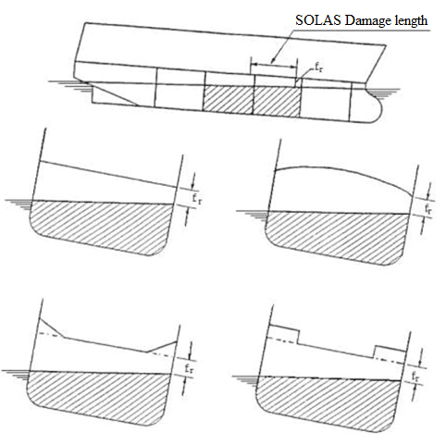

Figure 1 SOLAS Damage length

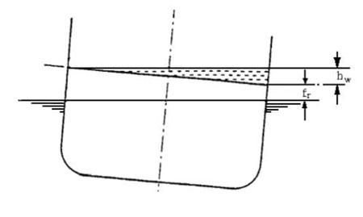
Figure 2

1. If residual freeboard (f_{r}) = 2.0 m, the height of water level on deck (h_{w}) = 0.0 m.
2. If residual freeboard (f_{r}) < 0.3 m, the height of water level on deck (h_{w}) = 0.5 m.

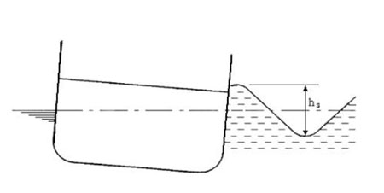
Figure 3

1. If the significant wave height (h_{s}) = 4.0 m, the height of water level on deck shall be calculated as indicated in Figure 3.
2. If the significant wave height (h_{s}) < 1.5 m, the height of water level on deck (h_{w}) = 0.0 m.

Example.
If residual freeboard (f_{r}) = 1.15 m and the significant wave height (h_{s}) = 2.75 m, the height of water (h_{w}) = 0.125 m.
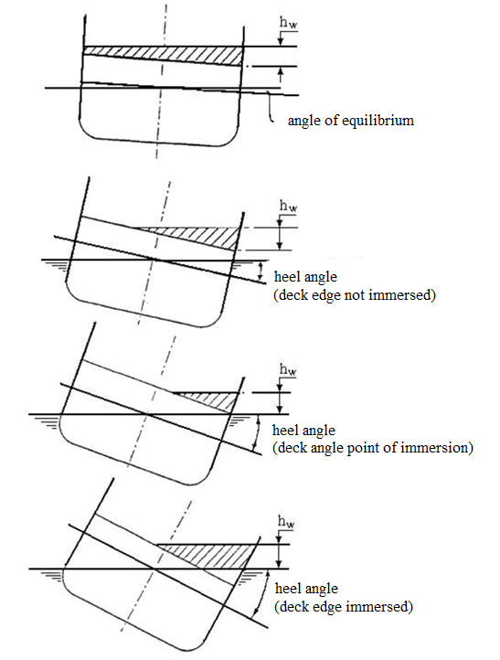

Figure 4

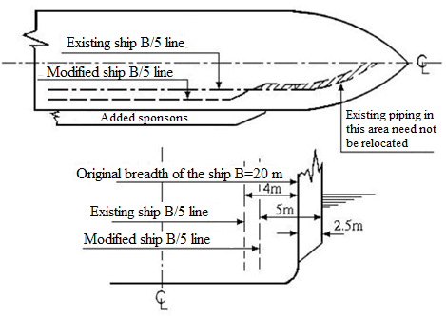
Figure 5
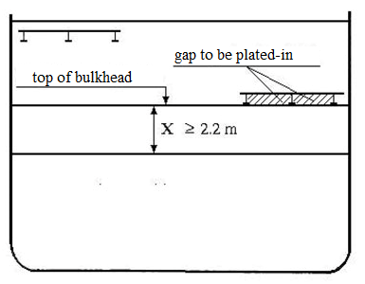
Figure 6

Example 1. Ship without hanging car decks
Height of water on deck = 0.25 m
Minimum required height of barrier = 2.2 m
Example 2. Ship with hanging deck (in the way of the barrier)
Height of water on deck = 0.25 m
Minimum required height of barrier = x

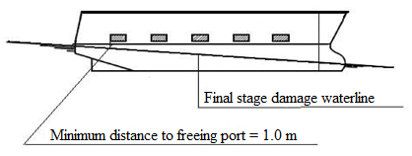

Figure 7

Minimum distance between freeboard and freeing port = 1.0 m

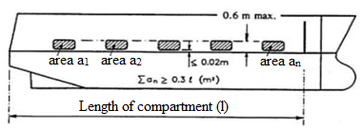

Figure 8

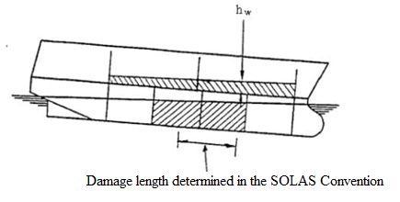

Deck edge not immersed
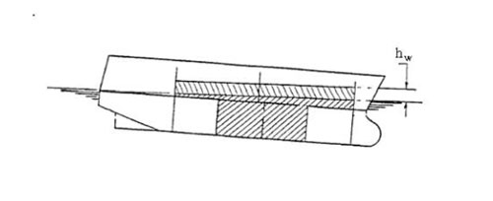
Deck edge immersed

Figure 9

2. Model Testing

2.1. Objectives

1. The purpose of these guidelines is to ensure uniformity in the methods which are used in the construction and verification of the model, and also in the performance of the model tests and analyses of the results. There are no specific guidelines for Sub-chapter 2.1 “Objectives” of Annex 1 to the Regulation.

2.2. Ship Model

2. The material of which the model is made is not important, provided that the model both in the intact and damaged condition is sufficiently rigid to ensure that hydrostatic properties thereof are the same as those of the actual ship and also that the flexural response of the hull in waves is negligible.

3. It is important to ensure that the damaged compartments are modelled as accurately as practicably possible in order to be able to determine the volume of floodwater.

4. Since ingress of water (even small amounts) into the intact parts of the model affects its behaviour, measures must be taken to ensure that this ingress does not occur.

5. It has been observed in model tests which involve the worst damages provided for in the SOLAS Convention near the bow and the stern of the ship that progressive flooding was not possible because of the tendency of the water on deck to accumulate near the damage opening and to flow out. Such models are able to survive very high sea states, while they capsize with less onerous damages, as provided for in the SOLAS Convention, away from the bow and stern. In order to prevent it, a limit of ± 35 % shall be introduced.

6. In addition to the metacentric height (hereinafter – the GM) and freeboard which are important parameters in the survivability of passenger ships, the area under the residual stability curve is also another major factor. When choosing the worst damage provided for in the SOLAS Convention to ensure the compliance with the requirements of this Paragraph, the worst damage shall be considered as such which corresponds at least to the area under the residual stability curve.

7. As scale effects play an important role in the behaviour of the model during tests, it is important to ensure reduction thereof to the minimum. The model must be as large as possible in order to ensure easier construction of the details of damaged compartments. It is recommended that the model length is three metres or corresponds to the scale of 1:40, choosing the largest value.

8. The model in way of the assumed damages shall be as thin as practically possible in order to adequately represent the amount of floodwater and its centre of gravity. The thickness of the hull shall not exceed 4 mm. Since it is complicated to construct a model hull and also the elements of primary and secondary subdivision in way of the damage with sufficient detail, due to these constructional limitations it may not be possible to calculate accurately the assumed permeability of the space.

9. The vertical extent of the model can affect the results when tested dynamically, therefore, the ship model shall be constructed at least at three upper structure heights above the bulkhead (freeboard) deck so that the large waves of the wave train do not break over the model.

10. Draughts shall be verified in the intact condition and the draughts of a damaged model shall also be accurately measured for correlation with those that are derived from the damaged stability calculation. Tolerance shall be + 2 mm for each approved draught. After measuring the damaged draughts, it may be necessary to make adjustments to the permeability of the damaged compartment by either introducing intact volumes or by adding weights. It is important to ensure that the centre of gravity of the floodwater is accurately represented. In this case, any adjustments shall be performed in compliance with the adequate safety requirements in accordance with the SOLAS Convention.

11. If the model must be fitted with barriers on deck and the barriers are less than the height indicated, the model must be fitted with closed circuit television (CCTV) so that any splashing over and any accumulation of water on the undamaged area of the deck can be monitored. In such case a video recording of the event shall form part of the test records. The tightness of transverse or longitudinal bulkheads which is taken into account as effective to confine the assumed accumulated sea water in the compartment concerned in the damaged ro-ro deck shall be at least 4 m in height, unless the height of water is less than 0.5 m. In such cases the height of the bulkhead may be calculated, using the following formula:

Bh = 8 hw, where

Bh – the height of the bulkhead;
hw – the height of water.

In any event, the minimum height of the bulkhead shall not be less than 2.2 m. For ships with hanging car decks, the minimum height of the bulkhead shall be not less than the height to the underside of the hanging deck when in its lowered position.

12. In order to ensure that the model motion represents those of the actual ship, the model is both inclined and rolled in the intact condition so that the intact GM and the mass distribution of the ship are verified. The transverse radius of gyration of the actual ship shall be within the range from 0.35 B to 0.4 B and the longitudinal radius of gyration shall be within the range from 0.2 L to 0.25 L.

Note. While inclining and rolling the model in the damaged condition may be accepted as a check for the purpose of verifying the residual stability curve, such tests shall not be accepted in lieu of the intact tests.

13. It shall be assumed that the ventilators of the damage compartment of the actual ship are adequate for unhindered flooding and movement of the floodwater. Upon trying to scale down the ventilating arrangements of the actual ship, undesirable scale effects may be introduced in the model. In order to prevent that, it is recommended to construct the ventilating arrangements to a larger scale than that of the model, ensuring that this does not affect the flow of water on the car deck.

14. It is considered that a representative damage shape conforms to a cross section of the striking ship in the bow region. The 15 ° angle is based in a study of the cross section at a distance of B/5 from the bow for ships of different types and sizes. The isosceles triangular profile of the prismatic damage shape is that corresponding to the load waterline. If side casings of width less than B/5 are fitted and in order to avoid any possible scale effects, the damage length in way of the side casings shall not be less than 25 mm.

15. In the original model test method of Resolution 14 of the 1995 Conference of the SOLAS Convention the effect of heeling induced by passenger crowding, launching a survival craft, wind and turning of the ship was not considered even though this effect is part of the SOLAS Convention. Results from an investigation suggest that this effect should be considered when retaining the minimum of 1 ° heel towards the damage. The heeling due to turning is not taken into consideration.

16. If there is a margin between the GM in the actual loading conditions compared to the GM limiting curve specified in the SOLAS Convention, the Maritime Administration of Latvia may accept that such a margin is taken advantage of in the model test. In such cases the GM limiting curve shall be adjusted. The adjustment may be carried out, using the following formula:

d = dS – 0,6(dS – dLS) where

dS – the subdivision draught;
dLS – the ship’s draught without flooding.

The adjusted curve is a straight line between the GM used in the model test at the subdivision draught and the intersection of the curve specified in the SOLAS Convention and draught d.

2.3. Procedure for Experiments

17. Wave spectrum:
17.1. the JONSWAP spectrum shall be used as it describes fetch and duration limited seas which correspond to the majority of the conditions worldwide. It is important that not only the peak period of the wave train is verified but also that the zero crossing period is correct;
17.2. the wave spectrum shall be recorded and documented in every test run. Measurements shall be taken at the probe closest to the wave-making machine.

18. The model shall be equipped so that its motions (roll, heave, and pitch) and its condition (heel, sinkage, and trim) could be monitored and recorded throughout the test. An acceptable margin shall be introduced due to the reason that it is not possible to set absolute limits for significant wave heights, peak periods, and zero crossing periods.

19. The towing carriage to which the mooring system is attached shall follow the model at its actual drifting speed to avoid interference of the mooring system with the ship dynamics. In the case of irregular waves the drift speed will not be constant. A constant carriage speed would result in low frequency and large amplitude drift oscillations which may affect the behaviour of the model.

20. A sufficient number of tests in different wave trains shall be necessary in order to ensure statistical reliability. A minimum number of 10 runs shall be considered to provide a reasonable level of reliability.

2.4. Survival Criteria

21. There are no guidelines for Sub-chapter 2.4 “Survival Criteria” of Annex 1 to the Regulation.

2.5. Test Approval

22. The following documents shall form part of the report to be submitted to the Maritime Administration of Latvia:
22.1. damage stability calculations for mid-ship damage and worst damage specified in the SOLAS Convention (if they differ);
22.2. general arrangement drawing of the model together with details of the construction and instrumentation;
22.3. measurements of inclining experiments and radii of gyration;
22.4. nominal and measured wave spectrum (at the three different locations for a representative realisation and for the tests with the model from the probe closest to the wave maker);
22.5. representative record of model motions, attitude, and drift;
22.6. relevant video recordings.

Note. The representatives of the Maritime Administration of Latvia shall certify all tests.

Acting for the Minister for Transport – Minister for Environment R. Vējonis

