Text consolidated by Valsts valodas centrs (State Language Centre) with amending regulations of:

28 June 2011 [shall come into force from 14 July 2011];

25 September 2012 [shall come into force from 29 September 2012].

If a whole or part of a paragraph has been amended, the date of the amending regulation appears in square brackets at the end of the paragraph. If a whole paragraph or sub-paragraph has been deleted, the date of the deletion appears in square brackets beside the deleted paragraph or sub-paragraph.

Republic of Latvia

Cabinet

Regulation No. 657

Adopted 20 July 2010

**Procedures for Issuing or Refusal to Issue a Licence for Goods of Strategic Significance and Other Documents Related to the Circulation of Goods of Strategic Significance**

*Issued pursuant to*

*Section 5, Paragraphs twelve and fourteen, Section 6, Section 7,*

*Paragraph four, and Section 12, Paragraph nine of*

*the Law On the Circulation of Goods of Strategic Significance*

*[25 September 2012]*

**I. General Provisions**

1. This Regulation prescribes:

1.1. the procedures for issuing or refusal to issue an expert statement, an end-use statement, and an import certificate;

1.2. the procedures for issuing, refusal to issue, suspending or annulment a licence for goods of strategic significance and a delivery verification certificate;

1.3. the procedures for licensing and handling of goods not listed in the lists of goods of strategic significance;

1.4. the procedures for issuing a certificate of military manufacturer.

*[25 September 2012]*

2. Within the meaning of this Regulation documents related to the circulation of goods of strategic significance are:

2.1. an export licence;

2.2. a general export licence;

2.3. an import licence;

2.4. a transit licence;

2.5. a general transit licence;

2.6. a general State export licence;

2.7. a transfer licence (between the European Union Member States);

2.7.1 a global transfer licence;

2.7.2 a general transfer licence;

2.8. an international import certificate (hereinafter – import certificate);

2.9. an end-use statement;

2.10. a delivery verification certificate;

2.11. an expert statement;

2.12. a certificate of military manufacturer.

*[28 June 2011; 25 September 2012]*

3. The forms of the licences abovementioned in Paragraph 2 of this Regulation shall conform to Annexes III a and III c of Council Regulation (EC) No 428/2009 of 5 May 2009 setting up a Community regime for the control of exports, transfer, brokering and transit of dual-use items (hereinafter – Regulation No 428/2009).

**II. Issuance of an Import Certificate and an End-use Statement**

4. In order to obtain an import certificate (Annex 1) for the import of goods of strategic significance from a non-Union country or an end-use statement (Annex 2), the subject of circulation of goods of strategic significance shall submit the following to the Committee for Control of Goods of Strategic Significance (hereinafter – the Committee):

4.1. a submission, in which the information necessary for filling in the import certificate or end-use statement is included, indicating the firm name of the merchant or the given name, surname of the person, the unified registration number of the merchant with the Commercial Register or the personal identity number, the name and quantity of goods to be brought in, the country, from which the goods are brought in;

4.2. a copy of the special permit (licence) for individual types of commercial activities (if such is necessary in accordance with the Law On the Circulation of Goods of Strategic Significance);

4.3. a transaction agreement or an exporter certification regarding readiness to perform transaction;

4.4. a proof that the State fee for the issuance of the import certificate or end-use statement has been paid.

5. If the information abovementioned in Sub-paragraph 4.1 of this Regulation is not sufficient for taking of a decision, the Committee is entitled to request additional information.

6. The Committee shall examine the documents submitted for receipt of an import certificate or end-use statement within 15 working days and shall issue the import certificate or end-use statement to the subject of circulation of goods of strategic significance, or take a decision to refuse to issue them.

7. If the grounds for refusal to issue an import certificate or end-use statement is classified information, the Committee shall protect such information in accordance with the Law On Official Secret.

8. An import certificate or end-use statement shall be drawn up in three copies on a special colour raster form. One copy of the import certificate or end-use statement shall be stored in the record-keeping of the Committee, the second copy shall be stored in the record-keeping of the subject of circulation of goods of strategic significance, and the third copy shall be sent by the subject of circulation of goods of strategic significance to the export control institutions of the exporting country.

9. The import certificate or end-use statement shall be issued to the subject of circulation of goods of strategic significance or its official. The abovementioned documents may be used only by the subject of circulation of goods of strategic significance referred to in the import certificate or end-use statement.

10. Foreign end-use statement of goods of strategic significance is valid, if it contains the information indicated in Annex 2 to this Regulation. If the Committee has justified doubts regarding identity of the end-user, the Committee shall request a certification of the export control authority of the respective country.

**III. Issuance of a Licence for the Export, Import, Transit, Transfer, General Export, General Transit, and Global Transfer of Goods of Strategic Significance**

*[28 June 2011 / The new wording of the title shall come into force on 30 June 2012. See Paragraph 3 of amendments]*

11. In order to obtain a licence for the export, import, transit, transfer, general export, general transit, or global transfer of goods of strategic significance, the subject of circulation of goods of strategic significance shall submit to the Committee:

11.1. an application – declaration of the licence application for the export, import, transit, transfer, general export, general transit, or global transfer of goods of strategic significance (Annex 3);

11.2. a copy of the special permit (licence) for individual types of commercial activities (if such is necessary in accordance with the Law On the Circulation of Goods of Strategic Significance);

11.3. a foreign import certificate or end-use statement, or a document equivalent thereof – only for the export of goods of strategic significance, transfer from Latvia and transit transactions;

11.4. a copy of the agreement or an invoice, on the basis of which a transaction with goods of strategic significance is performed;

11.5. a proof that the State fee for the issuance of a licence for the export, import, transit, transfer, general export, or general transit of goods of strategic significance has been paid.

*[28 June 2011 / Amendments to Paragraph shall come into force on 30 June 2012. See Paragraph 3 of amendments]*

12. If the information in the documents abovementioned in Paragraph 11 of this Regulation is incomplete or doubtful, the Committee is entitled to request additional information.

13. The applicant may send the documents abovementioned in Paragraph 11 of this Regulation to the Committee, using fax or electronic mail. Prior to obtaining of the licence for the export, import, transit, transfer, general export, general transit, or global transfer of goods of strategic significance the applicant shall present original copies of the respective documents to the Committee.

*[28 June 2011 / Amendment to Paragraph shall come into force on 30 June 2012. See Paragraph 3 of amendments]*

14. The Committee shall examine the documents submitted for obtaining of the licence for the export, import, transit, transfer, general export, general transit, or global transfer of goods of strategic significance within a month after their receipt and shall issue the licence for the export, import, transit, transfer, general export, general transit, or global transfer of goods of strategic significance or take a decision to refuse to issue the licence.

*[28 June 2011 / Amendment to Paragraph shall come into force on 30 June 2012. See Paragraph 3 of amendments]*

15. If additional verification of the information provided by the subject of circulation of goods of strategic significance is necessary, the Committee shall extend the time period for the issuance of the licence for the export, import, transit, transfer, general export, general transit, or global transfer of goods of strategic significance and shall notify the applicant thereof in writing. In such case the Committee shall take a respective decision within a month after sending the notification.

*[28 June 2011 / Amendment to Paragraph shall come into force on 30 June 2012. See Paragraph 3 of amendments]*

16. If the grounds for refusing the issuance of a licence for the export, import, transit, transfer, general export, general transit, or global transfer of goods of strategic significance is classified information, the Committee shall protect such information in accordance with the Law On Official Secret.

*[28 June 2011 / Amendment to Paragraph shall come into force on 30 June 2012. See Paragraph 3 of amendments]*

17. The Committee is entitled not to issue a licence for the export, transit, general export, or general transit, to suspend the operation of the abovementioned licences or to annul licences, if emergency conditions (including armed conflicts or warfare) have arisen in the country, to which the goods referred to in the Common Military List of the European Union are exported or moved in transit.

18. If, in examining the information provided by the subject of circulation of goods of strategic significance, it is necessary to perform an expert-examination of goods or to request information from Latvian or foreign authorities and the reply has not been received within the extended time period for examination of the application, the Committee shall repeatedly extend the time period for taking of the decision until receipt of the respective information and shall notify the subject of circulation of goods of strategic significance thereof in writing.

19. The Committee shall inform the Security Police, the State Revenue Service, the Commission of the European Union, the European Council, the European Union Member States, and the respective international export control authorities regarding the decision to refuse to issue the licence.

19.1 The Committee shall issue the licence for global transfer of goods of strategic significance for transfers of the goods referred to in the Common Military List of the European Union to one or several European Union Member States. The goods or category of goods, the consignees or category of consignees, as well as the receiving country are indicated in the licence for global transfer of goods of strategic significance.

*[28 June 2011 / Paragraph shall come into force on 30 June 2012. See Paragraph 3 of amendments]*

20. If the subject of circulation of goods of strategic significance has expressed a wish in the declaration of the licence application to receive the licence for the export, import, transit, transfer, general export, general transit, or global transfer of goods of strategic significance in printed form, the licence for transfer of goods of strategic significance shall be prepared on a special colour raster form in three copies, the export, import, and general export licence – on a colour raster form in four copies, and the transit and general transit licence – on a colour raster form in five copies. The following activities shall be performed with copies of licences for the export, import, transit, transfer, general export, or general transit of goods of strategic significance:

20.1. the subject of circulation of goods of strategic significance or carrier shall submit one copy of the licence at the border crossing point to officials of the customs authority. Two copies shall be submitted for transit – at the border crossing point of export and import. The respective official of the customs authority shall indicate the date, the actual quantity of goods brought out or brought in on the respective copy and shall approve it with a stamp. A copy of the licence shall be stored in the record-keeping of the customs institution. The original copy of the licence shall be submitted to the Committee for accounting in accordance with the procedures stipulated by the State Revenue Service;

20.2. one copy with notes of officials of the customs authority shall be sent together with goods to the end-user;

20.3. one copy with notes of officials of the customs authority shall be stored in the record-keeping and archives of the subject of circulation of goods of strategic significance;

20.4. a copy of the licence shall be stored in the record-keeping of an inland customs institution;

20.5. export licences issued in other European Union Member States shall be photocopied at the border crossing point and stored in the record-keeping of the customs institution;

20.6. in carrying goods with a general export or general transit licence, the subject of circulation of goods of strategic significance shall submit a copy of the licence to the customs institution and inform the Committee regarding each export or transit transaction.

*[28 June 2011]*

20.1 A licence for the export, import, transit, transfer, general export, general transit, or global transfer of goods of strategic significance shall be prepared in the form of an electronic document in accordance with the laws and regulations regarding drawing up of electronic documents and sent to the subject of circulation of goods of strategic significance and the State Revenue Service. Once a quarter the State Revenue Service shall provide information to the Committee in electronic form regarding the licences for the export, import, transit, general export, and general transit of goods of strategic significance handled.

*[28 June 2011 / Paragraph shall come into force on 1 September 2011. See Paragraph 2 of amendments]*

21. A licence for the export, import, transfer, transit, general export, general transit, or global transfer of goods of strategic significance shall be issued to the subject of circulation of goods of strategic significance or its official. The abovementioned licences may be used by the respective subject of circulation of goods of strategic significance only.

*[28 June 2011 / Amendment to Paragraph shall come into force on 30 June 2012. See Paragraph 3 of amendments]*

22. The term of validity of a licence for the export, import, transfer, and transit of goods of strategic significance shall be six months. The term of validity of a general export and general transit licence shall be one year. The term of validity of a global transfer licence shall be three years.

*[28 June 2011 / Amendment to Paragraph shall come into force on 30 June 2012. See Paragraph 3 of amendments]*

23. If it is necessary to extend the term of validity of a licence for the export, import, transit, transfer, general export, general transit, or global transfer of goods of strategic significance, the subject of circulation of goods of strategic significance shall submit an application to the Committee. An application regarding extension of the term of validity of the licence shall be submitted no later than five working days prior to the end of the previous term of validity of the licence. The quantity of goods carried and to be carried shall be repeatedly indicated in the application.

*[28 June 2011 / Amendment to Paragraph shall come into force on 30 June 2012. See Paragraph 3 of amendments]*

24. The Committee shall extend the term of validity of a licence for the export, import, transit, transfer, general export, general transit, or global transfer of goods of strategic significance by re-issuing the licence with a respective note regarding extension. The unused licences for the export, import, transit, transfer, general export, general transit, or global transfer of goods of strategic significance or import certificates shall be returned to the Committee within three months after expiry of their term of validity

*[28 June 2011 / Amendments to Paragraph shall come into force on 30 June 2012. See Paragraph 3 of amendments]*

25. The Committee shall indicate the intended border crossing point of goods of strategic significance and the inland customs institution in the respective licence.

**IV. Issuance of a General State Export and General Transfer Licence**

*[28 June 2011 / The new wording of the title shall come into force on 30 June 2012. See Paragraph 3 of amendments]*

26. The Committee shall issue and approve a general State export licence (Annex 4) upon its initiative for export of dual-use goods referred to in Annex I to Regulation No 428/2009 to non-Union countries.

27. The Committee shall publish the general State export licence in the official gazette, indicating the category and section of the goods referred to in Annex I to Regulation No 428/2009, as well as the country or countries, to which export of such goods is permitted.

28. The general State export licence may be used by a subject of circulation of goods of strategic significance who is a citizen of the Republic of Latvia or a legal person registered in the Republic of Latvia. In order to perform an export transaction according to the licence, the subject of circulation of goods of strategic significance shall send accompanying documents of goods to the specialist for the identification of goods of strategic significance of the Committee, using electronic means of communication, and receive his or her decision – the goods do not require a licence.

29. The general State export licence may not be used, if:

29.1. an arms embargo is imposed in the period of operation of the licence to the indicated country, which has been accepted by a joint position or joint action adopted by the Council, or an OSCE decision, or an arms embargo, which has been determined by a binding resolution of the United Nations Security Council, as well as in the case, if the exporter is aware that the particular goods may be fully or partially used in relation to the development, production, handling, operation, maintenance, storage, detection, identification or dissemination of chemical, biological or nuclear weapons or other nuclear explosive devices or the development, production, maintenance or storage of missiles capable of delivering such weapons;

29.2. the final recipient of goods is a military authority;

29.3. if armed conflicts have arisen in the country indicated in the licence or this country has commenced warfare.

30. The Committee is entitled to decide on suspending or annulment of the licence, if the circumstances abovementioned in Sub-paragraph 29.1 or 29.3 of this Regulation have taken place in any of the countries of the consignee indicated in the permit.

30.1 The Committee shall issue a general transfer licence (Annex 4.1 ) upon its initiative, determining the goods referred to in the Common Military List of the European Union, which may be sent to any European Union Member State, if:

30.1 1. the consignee is an armed forces unit of the Member State or a contracting institution in the field of defence, which performs a procurement for exclusive needs of the armed forces of the Member State;

30.1 2. the consignee is a merchant, which has received a certificate of military manufacturer of the Ministry of Defence (Annex 4.2 );

30.1 3. the transfer is intended for demonstration, evaluation, or exhibition of goods;

30.1 4. the purpose of transfer is technical maintenance and repair of goods and the consignee is the initial supplier of defence-related products.

*[28 June 2011 / Paragraph shall come into force on 30 June 2012. See Paragraph 3 of amendments]*

30.2 The Committee shall publish the general transfer licence in the official gazette.

*[28 June 2011 / Paragraph shall come into force on 30 June 2012. See Paragraph 3 of amendments]*

30.3 In order to receive a transfer of goods from another European Union Member State according to the general transfer licence, the subject of circulation of goods of strategic significance must have a certificate of military manufacturer of the Ministry of Defence. The abovementioned certificate shall be issued, if the subject conforms to the following criteria:

30.3 1. the merchants, which manufacture defence-related products or partially finished defence-related products, consisting of parts and (or) systems and sub-systems purchased from third parties in order to place them on the market with their name or brand, have certified experience in the field of defence;

30.3 2. no infringements related to export restrictions to third countries have been detected;

30.3 3. [25 September 2012];

30.3 4. experienced managers (managers with at least one-year experience in a managing office in the field of commercial activities with defence-related products) are employed at the merchant;

30.3 5. at least two managing employees of the highest level who are personally responsible for transfers and export, are appointed, and the office may not cause a conflict of interests.

*[28 June 2011]*

30.4 In order to perform a transaction according to the general transfer licence, the subject of circulation of goods of strategic significance, using electronic means of communication, shall send accompanying documents of goods to the specialist for the identification of goods of strategic significance of the Committee and receive an opinion that the goods are sent according to the general transfer licence. The supplier shall store accounting documents for three years after the end of such calendar year when the goods were sent. The abovementioned documents shall be submitted to the Committee upon request.

*[28 June 2011 / Paragraph shall come into force on 30 June 2012. See Paragraph 3 of amendments]*

**IV1. Issuance of a Certificate of Military Manufacturer**

*[25 September 2012]*

30.5 The Ministry of Defence shall create a commission for the issuance of a certificate of military manufacturer. The commission shall consist of no less than five officials.

30.6 The commission shall issue the certificate of military manufacturer (Annex 4.2) to such merchants, which conform to the criteria referred to in Paragraph 30.3 of this Regulation and which have a valid special permit (licence) issued by the Ministry of Defence for commercial activities with the goods referred to in the Common Military List of the European Union.

30.7 In order to receive the certificate of military manufacturer, the merchant shall submit an application to the commission for receipt of the certificate of military manufacturer (Annex 6) and the following information:

30.7 1. a description regarding experience of the merchant in work with products or partially finished products, which are related to defence and placed on the market with the name or brand of the merchant;

30.7 2. the address of the manufacturing unit, in which the merchant is making defence-related products or partially finished defence-related products;

30.7 3. a list, in which the merchant indicates the persons referred to in Sub-paragraphs 30.3 4 and 30.3 5 of this Regulation (the office and personal identity number of each person shall be indicated). A description of experience of each person referred to in the list with defence-related products shall be appended to the list.

30.8 The commission shall request information from the Ministry of Foreign Affairs regarding whether such infringements of the merchant have been detected, which are related to export restrictions to third countries.

30.9 After examination of the application the commission shall take a decision to issue a certificate of military manufacturer or to refuse to issue it, if the merchant does not conform to the criteria referred to in Paragraph 30.3 of this Regulation. The term of validity of the certificate shall not exceed five years.

30.10 The commission shall take a decision to issue a certificate of military manufacturer or to refuse to issue it in accordance with the Administrative Procedure Law.

30.11 The merchant is entitled to commence respective commercial activities after receipt of the certificate of military manufacturer. The merchant shall obtain the certificate of military manufacturer in the form of an electronic document in accordance with the laws and regulations regarding drawing up of electronic documents. If the merchant has expressed a wish to receive the certificate of military manufacturer in printed form, the commission shall prepare it in printed form, and the merchant shall receive it at the Ministry of Defence.

30.12 The Ministry of Defence shall perform accounting of the certificates of military manufacturer issued.

30.13 If the certificate of military manufacturer has been lost, the merchant shall inform the commission thereof in writing within three working days and submit a written application for the issuance of a duplicate of the certificate. The application shall include an explanation why the duplicate is necessary.

30.14 The commission shall, within three working days after receipt of the application abovementioned in Paragraph 30.13 of this Regulation, issue a duplicate of the certificate of military manufacturer to the merchant at the Ministry of Defence.

30.15 If the persons indicated in the list referred to in Sub-paragraph 30.7 3 of this Regulation have changed, the merchant shall, within three working days after occurrence of changes, submit an updated list to the commission and a description of experience of the persons newly included in the list with defence-related products. The commission shall check whether amendments made to the list do not affect the conformity of the merchant with the criteria abovementioned in Paragraph 30.3 of this Regulation.

30.16 If the information indicated in the certificate of military manufacturer has changed, the merchant shall submit a respective application to the commission within three working days after occurrence of the changes. Documents certifying changes shall be appended to the application. The commission shall, within three working days, prepare the certificate of military manufacturer in the form of an electronic document in accordance with the laws and regulations regarding drawing up of electronic documents, in conformity with the term of validity laid down for the certificate initially issued, and issue it to the merchant. If the merchant has expressed a wish to receive the certificate of military manufacturer in printed form, the commission shall prepare it in printed form, and the merchant shall receive it at the Ministry of Defence.

30.17 The Ministry of Defence shall publish information regarding the issued certificates of military manufacturer in the official gazette, update the list of merchants to which the certificate of military manufacturer has been issued, and no less than once a year inform the European Commission, the European Parliament, other European Union Member States and the Control Committee of Strategic Goods thereof.

**V. Goods Subject to Licensing**

31. Licensing of export of dual-use goods is prescribed in Regulation No 428/2009. In addition to the requirements laid down in Regulation the licence shall be required for transit, brokering transactions, and import of dual-use goods to Latvia (except import of computer hardware), but not for import to another European Union Member State through Latvia.

32. In accordance with the Law On the Circulation of Goods of Strategic Significance a licence is required for any export, import, transit, brokering, or transfer transaction with the goods referred to in the Common Military List of the European Union and the National List of Goods and Services of Strategic Significance of Latvia, except transit and export for the goods referred to in Section 10A905 of the National List of Goods and Services of Strategic Significance of Latvia.

33. In order to receive a licence for transfer of firearms and ammunition or explosives, the subject of circulation of goods of strategic significance shall submit to the Committee a document of prior consent for transfer of firearms and ammunition between the European Union Member States or a document of prior consent for transfer of explosives between the European Union Member States. The abovementioned documents of prior consent shall be issued in accordance with the Cabinet regulation regarding the procedures, by which the State Police shall issue documents of prior consent for transfer of firearms and ammunition or explosives between the European Union Member States.

34. The subject of circulation of goods of strategic significance shall establish an internal control service in order to assess the conformity of export, import, transferable, or transit goods with the lists of goods of strategic significance, or appoint a responsible person for the performance of such task and inform the Committee thereof.

**VI. Issuance of a Delivery Verification Certificate and an Expert Statement**

35. In order to receive a delivery verification certificate (Annex 5) or proof that the abovementioned goods have been imported in the territory of the Republic of Latvia, the subject of circulation of goods of strategic significance shall submit an application to the Committee. The following information shall be indicated in the application:

35.1. information regarding goods;

35.2. customs documents certifying import of goods into the Republic of Latvia;

35.3. proof that the State fee for the issuance of a delivery verification certificate has been paid.

36. The delivery verification certificate shall be prepared in three copies on a special colour raster form. One copy of the delivery verification certificate shall be stored in the record-keeping of the Committee, the second copy shall be stored in the record-keeping of the subject of circulation of goods of strategic significance, and the third copy shall be sent by the subject of circulation of goods of strategic significance to the export control institutions of the exporting country.

37. Natural and legal persons have the right to receive an expert statement at the Committee that the respective goods are not goods of strategic significance. In order to receive the abovementioned statement, the person shall submit a written application to the Committee and information regarding goods or sample of goods, as well as a proof that the State fee for the issuance of an expert statement has been paid.

38. An expert statement for components, devices, and spare parts of aircraft shall be valid for a month from the day of issuance. For other goods the term of validity of the expert statement is unlimited, and it shall be valid for any transaction with goods, which by name, technical data, codes of the Combined Nomenclature for goods, or other codes for goods conform to the abovementioned goods, unless after issuance of the statement the respective goods are included in lists of goods of strategic significance.

39. The expert statement shall be prepared in two copies on a special colour raster form. One copy shall be stored in the record-keeping of the Committee, the second copy shall be stored in the record-keeping of the person.

40. In performing the regular export, import, transfer, or transit transaction of the goods referred to in the expert statement, the person shall submit a copy of the export statement to the customs authority, presenting the original.

**VII. Licensing of Goods Not Listed in the Lists of Goods of Strategic Significance**

41. The customs institutions shall detain the respective goods in accordance with the requirements of Article 4(5) of Regulation No 428/2009 regarding control of the goods not listed in Annex 1 thereto and, using fax or electronic mail, shall send the accompanying documents of goods and customs documents to the Committee for taking of a decision regarding the necessity of a licence.

42. If the Committee decides that the goods, which are not listed in the lists of goods of strategic significance, require an export or transit licence, the Committee shall notify the subject of circulation of goods of strategic significance and the State Revenue Service thereof.

*[28 June 2011]*

43. Activities of the subject of circulation of goods of strategic significance, which are not listed in the lists of goods of strategic significance, prior to receipt of the notification referred to in Paragraph 42 of this Regulation are not deemed an infringement of this Regulation.

**VIII. Refusals for the Issuance of Licences for Export, Transit, and Brokering Transactions of the Goods of the Common Military List of the European Union**

44. The Committee is entitled to refuse the issuance of a licence for export, transit, and brokering transactions to the goods of the Common Military List of the European Union, including sending of software and technologies, using means of electronic communication, on the basis of the following criteria:

44.1. the international obligations of Latvia and the duty to conform to the arms embargo imposed by the United Nations Organization, the European Union, and the Organization on Security and Cooperation in Europe;

44.2. the international obligations of Latvia arising from the Nuclear Non-Proliferation Treaty of 1 July 1968, the Convention on the Prohibition of the Development, Production and Stockpiling of Bacteriological (Biological) and Toxin Weapons and on their Destruction of 10 April 1972, as well as the Convention on the Prohibition of the Development, Production, Stockpiling and Use of Chemical Weapons and on their Destruction of 3 September 1992;

44.3. the obligations of Latvia not to export land mines of any kind;

44.4. the obligations of Latvia in relation to participation in the Hague Code of Conduct and Ballistic Missile Non-Proliferation.

45. Export and transit licences shall not be issued, if any of the following criteria exist in relation to the recipient country of goods:

45.1. the Committee has detected that in the recipient country of goods:

45.1.1. the military technology or equipment intended for export or transit has been or will be used in internal repressions or armed conflicts;

45.1.2. the military technology or equipment intended for export or transit has been or will be used in aggression against another country or for maintaining territorial claims, as well as for other inhumane purposes;

45.1.3. the military technology or equipment intended for export or transit has been or will be used for purposes, which support or promote terrorism and internationally organised crime;

45.1.4. the military technology or equipment will be directed from the recipient country or re-exported to an undesirable end-user or for an undesirable end-use;

45.2. structures of the United Nations Organization, the European Union or the European Council has detected serious violation of human rights in the recipient country of goods.

46. In taking a decision to refuse to issue a licence, the Committee shall take into account:

46.1. whether the recipient country fulfils the obligations in the fields of non-proliferation of weapons and in other fields of control and disarmament – whether it has signed, ratified and is implementing the armament control and disarmament conventions referred to in Sub-paragraph “b” of the first criterion of the Code on Conduct on Arms Export of the European Union;

46.2. the participation of the recipient country in peacekeeping measures of the United Nations Organization or other peacekeeping measures;

46.3. technical possibilities of the recipient country to use the military technology or equipment to be sent;

46.4. the ability of the recipient country to implement an efficient export control.

47. The Committee shall inform the Commission and the European Union Member States regarding requests of export or transit licences, which have been refused in accordance with the criteria referred to in this Regulation, and shall explain reasons for refusal. In deciding on issuance of a licence in the case, if another Member State has refused a licence for an identical transaction within the last three years, the Committee shall at first consult with the respective Member State or Member States, which issued the refusal. If after consultations the Committee decides to permit export, it shall inform the Member State which issued the refusal, explaining the reasons in detail.

48. A decision on transfer of any military technologies or equipment to another country shall be taken by the Committee. The Committee shall refuse the issuance of a licence and not permit transfer in transit or export of military technologies or equipment, if a transaction involving it had happened or a respective agreement had been entered into.

49. The Committee shall observe confidentiality in relation to refusals and any consultations and shall not use the information obtained for the promotion of unfair competition. The Committee shall disclose the data and information obtained only in accordance with the procedures laid down in the laws and regulations regarding freedom of information.

50. Export and transit licences shall be issued on the basis of information previously obtained and verified regarding the actual handling of goods in the recipient country. In order to issue the respective licence, the end-user certificate or an equivalent document, or the official permit of the recipient country shall be verified. In evaluating applications for requests of a licence for export or transit of military technologies or equipment in order to for them to be manufactured by the third countries, the Committee shall particularly take into account the potential use of finished products in the country of manufacture and the fact that the finished products may be directed or exported to undesirable end-users, in relation to which an arms proliferation embargo has been determined.

51. The Committee shall apply the criteria referred to in this Regulation and the consultation procedure abovementioned in Paragraph 47 of this Regulation also to Member States in relation to dual-use goods and technologies, which are referred to in Annex I to Regulation No 428/2009, if end-users of such goods and technologies are the armed forces, internal army or similar units of the recipient country.

52. The Committee shall confidentially distribute annual reports on export of military technologies and equipment to other European Union Member States.

**Informative Reference to European Union Directives**

*[28 June 2011; 29 September 2012]*

This Regulation contains legal norms arising from:

1) Council Directive 91/477/EEC of 18 June 1991 on control of the acquisition and possession of weapons;

2) Directive 2008/51/EC of the European Parliament and of the Council of 21 May 2008 amending Council Directive 91/477/EEC on control of the acquisition and possession of weapons;

3) Directive 2009/43/EC of the European Parliament and of the Council of 6 May 2009 simplifying terms and conditions of transfers of defence-related products within the Community;

4) Commission Directive 2010/80/EU of 22 November 2010 amending Directive 2009/43/EC of the European Parliament and of the Council as regards the list of defence-related products;

5) Commission Directive 2012/10/EU of 22 March 2012 amending Directive 2009/43/EC of the European Parliament and of the Council as regards the list of defence-related products.

Acting for the Prime Minister – Minister for Transport K. Gerhards

Minister for Foreign Affairs A. Ronis

**Annex 1**

Cabinet Regulation No. 657

20 July 2010

**Sample of the International Import Certificate**

**of the Republic of Latvia**

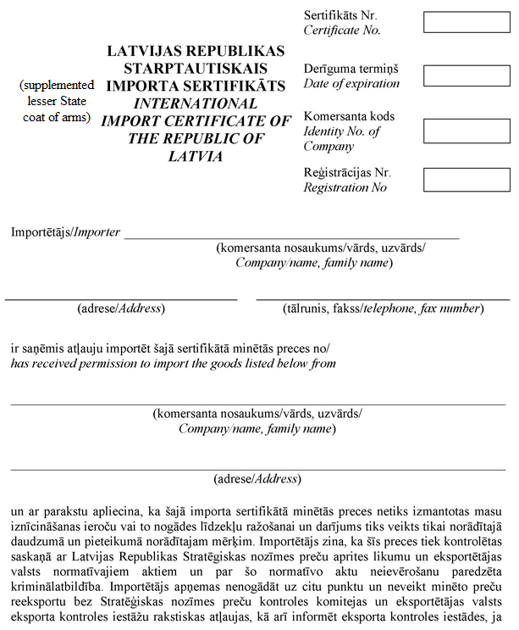

[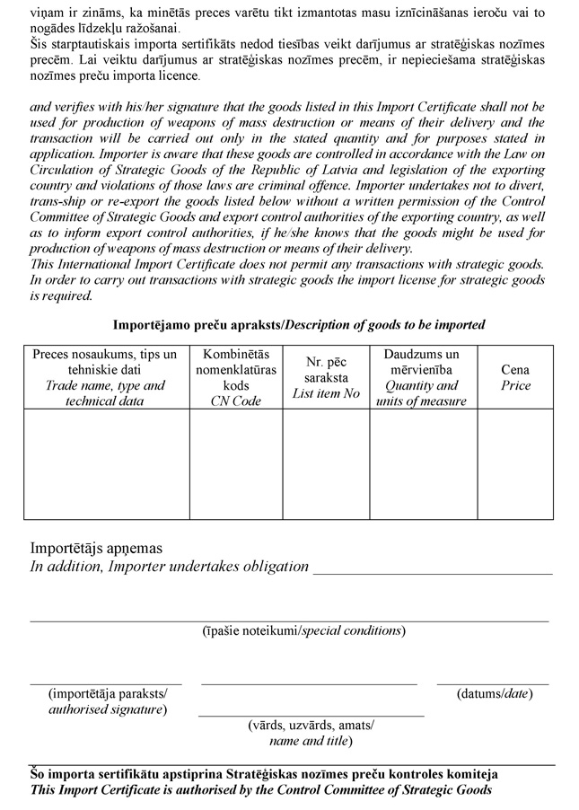](http://www.likumi.lv/wwwraksti/2010/122/BILDES/N_657/N657-PIEL_1.DOC)

[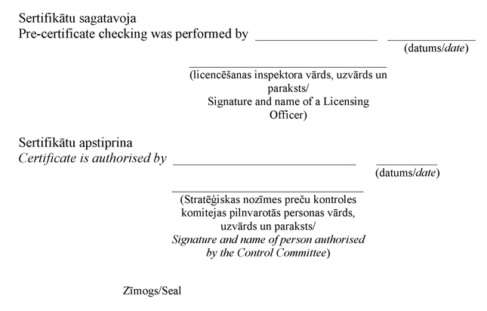](http://www.likumi.lv/wwwraksti/2010/122/BILDES/N_657/N657-PIEL_1.DOC)

Minister for Foreign Affairs A. Ronis

**Annex 2**

Cabinet Regulation No. 657

20 July 2010

**Sample of the End-use Certificate of Goods of Strategic Significance**

[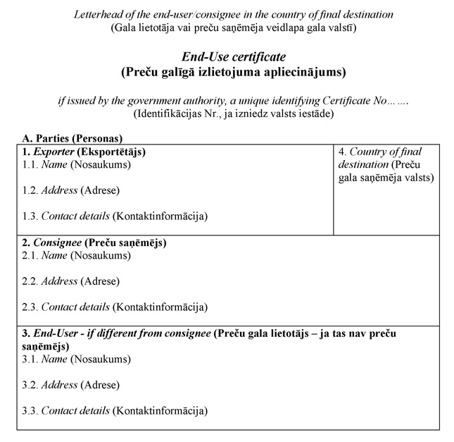](http://www.likumi.lv/wwwraksti/2010/122/BILDES/N_657/N657-PIEL_2.DOC)

[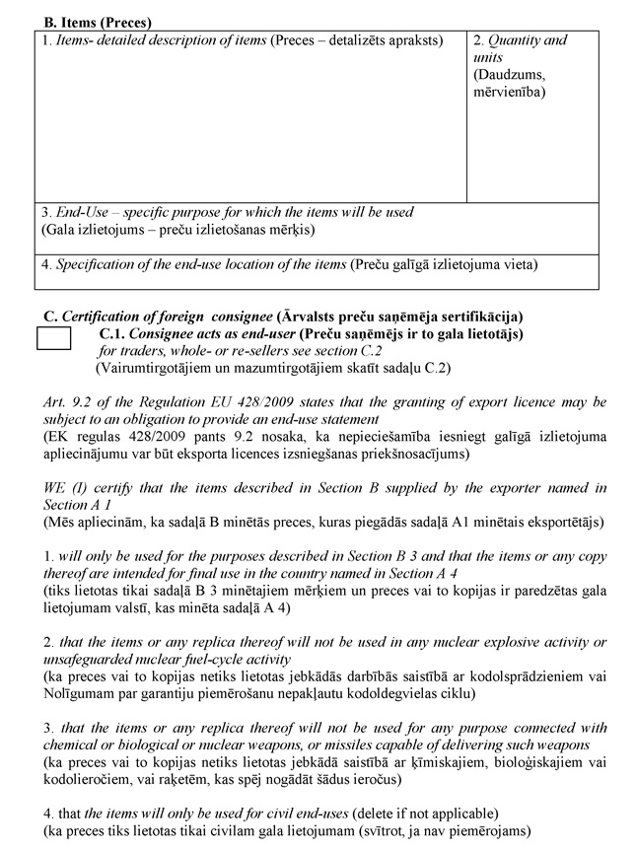](http://www.likumi.lv/wwwraksti/2010/122/BILDES/N_657/N657-PIEL_2.DOC)

[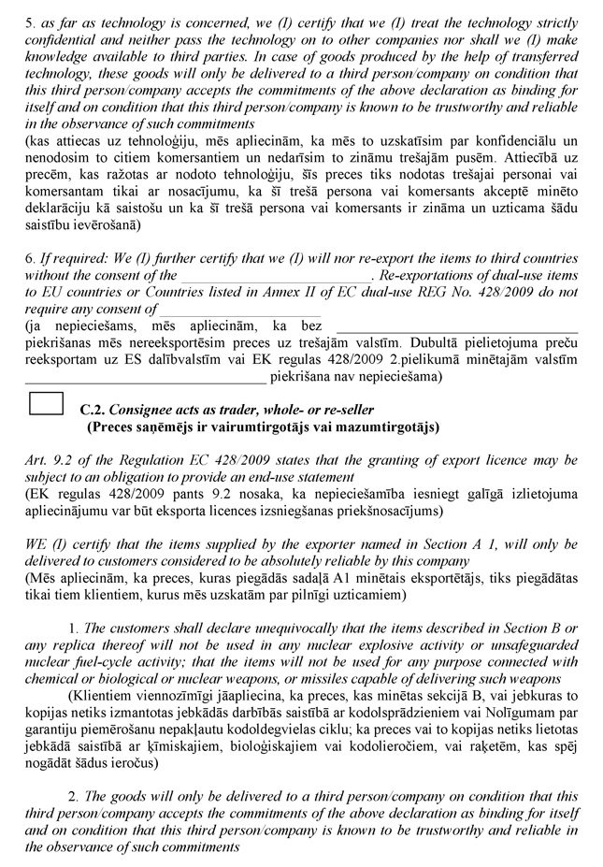](http://www.likumi.lv/wwwraksti/2010/122/BILDES/N_657/N657-PIEL_2.DOC)

[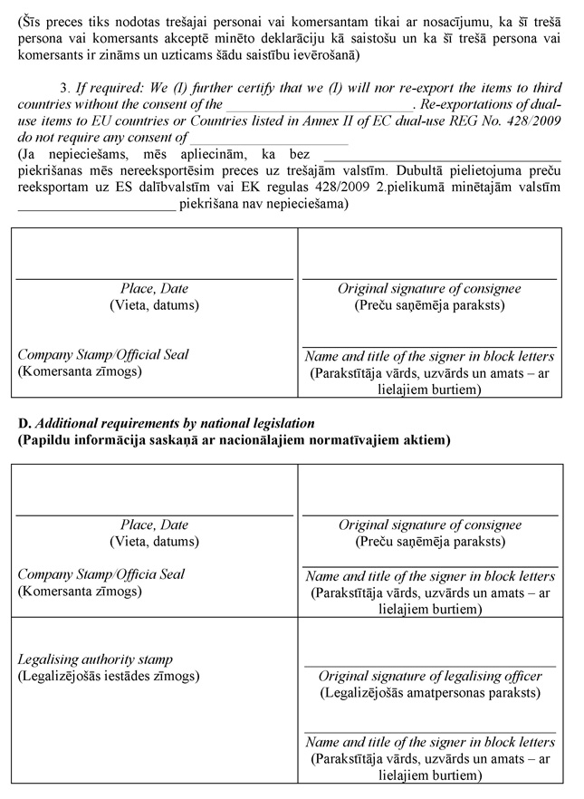](http://www.likumi.lv/wwwraksti/2010/122/BILDES/N_657/N657-PIEL_2.DOC)

Minister for Foreign Affairs A. Ronis

**Annex 3**

Cabinet Regulation No. 657

20 July 2010

*[28 June 2011 / Amendments to Annex shall come into force on 30 June 2012. See Paragraph 3 of amendments]*

To the Committee for Control of Goods of Strategic Significance

(address, telephone, fax of the Committee for Control of Goods of Strategic Significance)

___________________________________________________________________________

(given name, surname of the requester or name of the commercial company/institution)

Declaration of a Licence Application for the Export, Import, Transit, Transfer, General Export, General Transit, or Global Transfer of Goods of Strategic Significance

I request to issue (mark as appropriate)

 export licence



 import licence



 transit licence



 transfer licence



 general export licence



 general transit licence



 global transfer licence



for the following goods:

|  |  |  |  |  |  |
| --- | --- | --- | --- | --- | --- |
| No. | Name of goods  (type, kind, article No., and technical data, for chemical substances – CAS* number) | Combined Nomenclature code | No. of the list of goods of strategic significance | Quantity and units of measurement | Sum and currency |
|  |  |  |  |  |  |
|  |  |  |  |  |  |
|  |  |  |  |  |  |
|  |  |  |  |  |  |
|  |  |  |  |  |  |
|  |  |  |  |  |  |
|  |  |  |  |  |  |
|  |  |  |  |  |  |
|  |  |  |  |  |  |
|  |  |  |  |  |  |
|  |  |  |  |  |  |
|  |  |  |  |  |  |

Note. * Chemical Abstract Service number

1. Origin of goods (mark as appropriate): Latvia □ European Union □ other □

|  |  |
| --- | --- |
| 2. Type of transfer of goods |  |
|  | (indicate which) |

|  |  |  |  |  |  |
| --- | --- | --- | --- | --- | --- |
| 3. Border control points | Bringing in | |  | Bringing out |  |
|  | |  | (name) |  | (name) |

|  |  |
| --- | --- |
| 4. Inland customs institution |  |

5. The following documents appended to the declaration of the application

|  |  |  |
| --- | --- | --- |
| No. | Name of the document | Issuer, No., and date of the document |
| 1. | Copy of the registration certificate/passport |  |
| 2. | Copy of the agreement or invoice |  |
| 3. | End-use statement of goods |  |
| 4. | Import certificate of the importing country (permit, licence, or equivalent document) |  |
| 5. | Export licence of the exporting country (permit or other equivalent document) |  |
| 6. | Certificate of goods (passport, description) |  |

6. Information regarding the applicant of the licence

|  |  |
| --- | --- |
| Firm name (or institution) of the merchant/given name, surname of the person |  |
| Address (legal and actual) |  |
| Unified registration No. of the merchant in the Commercial Register/personal identity number |  |
| Issuer of the special licence for commercial activities |  |
| No., term of validity of the special licence for commercial activities |  |
| Telephone, fax, electronic mail address |  |
| Position and surname of the head of the commercial company (or institution) |  |
| Surname and telephone of the contact person |  |
| Authorised person and term of validity of the power of attorney |  |

7. Consignor of goods (if the consignor is the requester of the licence, mark “see Paragraph 6”)

|  |  |
| --- | --- |
| Name/given name, surname |  |
| Address |  |
| Telephone, fax |  |

8. Carrier of goods (if the carrier is the requester of the licence, mark “see Paragraph 6”)

|  |  |
| --- | --- |
| Name/given name, surname |  |
| Address |  |
| Telephone, fax |  |

9. Consignee of goods (if the consignee is the applicant of the licence, mark “see Paragraph 6”)

|  |  |
| --- | --- |
| Name/given name, surname |  |
| Address |  |
| Telephone, fax |  |

10. End-user of goods (if the end-user is the applicant of the licence, mark “see Paragraph 6”, if the consignee is the consignee, mark “see Paragraph 9”)

|  |  |
| --- | --- |
| Name/given name, surname |  |
| Address |  |
| Telephone, fax |  |

|  |  |
| --- | --- |
| 11. The commercial companies (or institutions) referred to in Paragraphs 7, 8, 9, and 10 (mark as appropriate)  11.1. the applicant has known and trustworthy transaction partners  11.2. their reputation is not known to the applicant | |
| 12. Goods will be used |  |
| 13. Goods (mark as appropriate)  13.1. will not be used in any relation to chemical, biological, or nuclear weapons and means for their delivery  13.2. probably, could be used in relation to chemical, biological, or nuclear weapons and means for their delivery | |

14. The applicant undertakes to inform the Committee for Control of Goods of Strategic Significance regarding any changes in the information provided in the declaration of the application, as well as if he has become aware that goods could be used in relation to chemical, biological, or nuclear weapons and means for their delivery.

15. The applicant will not perform re-export of imported goods, as well as will not transfer them to third parties without the permission of the Committee for Control of Goods of Strategic Significance.

16. The applicant is aware of the laws and regulations of the Republic of Latvia in the field of control of goods of strategic significance and of the liability laid down in laws for non-conformity with the such laws and regulations, as well as is aware of liability for provision of false information.

|  |  |  |  |  |
| --- | --- | --- | --- | --- |
|  |  |  |  |  |
| (date) |  | (given name and surname) |  | (signature and seal) |

Note. The details of the document “date” and “signature and seal” shall not be completed if the electronic document has been prepared in accordance with the laws and regulations regarding the drawing up of electronic documents.

Minister for Foreign Affairs A. Ronis

**Annex 4**

Cabinet Regulation No. 657

20 July 2010

Committee for Control of Goods of Strategic Significance

(address, telephone, fax of the Committee for Control of Goods of Strategic Significance)

**Sample of the General State Export Licence**

This is the general State export licence in accordance with Article 9(2) of Regulation No 428/2009

1. Term of validity of the licence _________________________________________________

2. The licence applies to the following goods ________________________________________

3. The licence is valid for export to the following countries _____________________________

4. Conditions and requirements __________________________________________________

Minister for Foreign Affairs A. Ronis

**Annex 4.1**

Cabinet Regulation No. 657

20 July 2010

*[28 June 2011 / Annex shall come into force on 30 June 2012. See Paragraph 3 of amendments]*

**Committee for Control of Goods of Strategic Significance**

(address, telephone, fax of the Committee for Control of Goods of Strategic Significance)

**General Transfer Licence**

This is the general transfer licence in accordance with Article 5(2) of the Directive 2009/43/EC of the European Parliament and of the Council.

1. Transfer for the needs of the armed forces of the Member States.

a) The licence applies to the following sections of the goods referred to in Annex to Directive:

___________________________________________________________________________

b) Conditions and requirements: _________________________________________________

2. Transfer to an undertaking certified in accordance with Article 9 of Directive.

a) The licence applies to the following sections of the goods referred to in Annex to Directive:

___________________________________________________________________________

b) Conditions and requirements: _________________________________________________

3. Transfer for demonstration, assessment, or exhibition of goods.

a) The licence applies to the following sections of the goods referred to in Annex to Directive:

___________________________________________________________________________

b) Conditions and requirements: _________________________________________________

4. Transfer for technical service and repair of goods.

a) The licence applies to the following sections of the goods referred to in Annex to Directive:

___________________________________________________________________________

b) Conditions and requirements: _________________________________________________

The licence is valid for transfers to all European Union Member States.

**Annex 4.2**

Cabinet Regulation No. 657

20 July 2010

*[28 June 2011; 25 September 2012]*

**CERTIFICATE**

(issued in accordance with Directive 2009/43/EC of the European Parliament and of the Council of 6 May 2009 simplifying terms and conditions of transfers of defence-related products within the Community)

Certificate No. _________

Recipient, ,

|  |  |  |  |  |
| --- | --- | --- | --- | --- |
|  | (firm name of the merchant) | | | |
| registration number of the merchant | | | , | |
| address of the merchant | | | | , |
|  | | (street, house number, postal code, city) | | |

conforms to the requirements referred to in Article 9(2) of Directive 2009/43/EC, as defined

|  |
| --- |
|  |

(national legal act, by which Article 9 is transposed)

The certified merchant and the manufacturing units indicated thereby are entitled to receive defence-related products for its manufacturing, service, and repair needs according to general transfer licences issued by other Member States.

Addresses of manufacturing units

|  |
| --- |
|  |
|  |

The certificate provides the opportunity to receive defence-related products included in the Common Military List of the European Union, except the following categories:

___________________________________________________________________________

|  |  |
| --- | --- |
| The conditions of the certificate are laid out in |  |
|  | (the respective legal act) |

The certificate is valid from ________ to ___________

|  |  |  |
| --- | --- | --- |
|  |  |  |
| (place of issuance) |  | (date of issuance) |

|  |  |  |  |
| --- | --- | --- | --- |
| The person responsible for certification |  |  |  |
|  | (given name, surname) |  | (signature) |

Note. In order to move defence-related products in the European Union, the manufacturers must have a special permit (licence) issued by the Ministry of Defence for commercial activities with the goods referred to in the Common Military List of the European Union

**Annex 5**

Cabinet Regulation No. 657

20 July 2010

[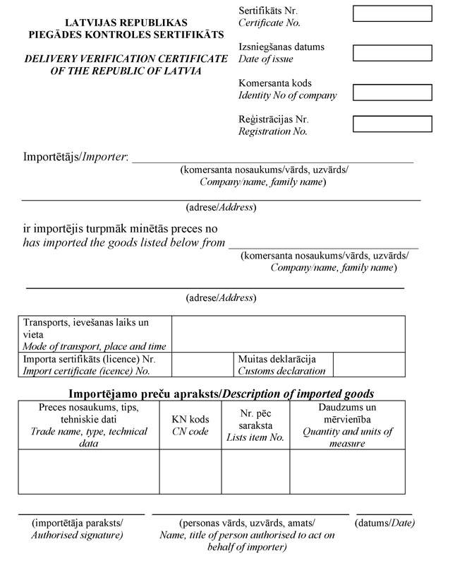](http://www.likumi.lv/wwwraksti/2010/122/BILDES/N_657/N657-PIEL_5.DOC)

[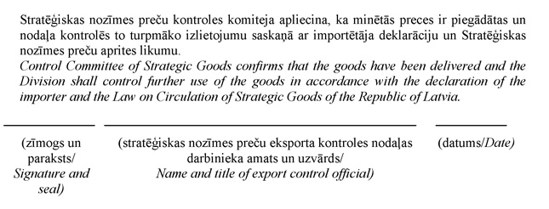](http://www.likumi.lv/wwwraksti/2010/122/BILDES/N_657/N657-PIEL_5.DOC)

Minister for Foreign Affairs A. Ronis

**Annex 6**

Cabinet Regulation No. 657

20 July 2010

*[25 September 2012]*

**Application for the Receipt of a Certificate of Military Manufacturer**

|  |  |  |
| --- | --- | --- |
| I request to issue | |  |
|  | (firm name, registration number, legal address, telephone number, and electronic mail address of the merchant) | |

|  |  |
| --- | --- |
|  | the certificate of military manufacturer. |

http://www.vestnesis.lv/wwwraksti/BILDES/KVADRATS.GIFMark with an x, if the certificate is required in printed form.

Appended (mark the appended information with an x):

http://www.vestnesis.lv/wwwraksti/BILDES/KVADRATS.GIFDescription regarding experience of the merchant in work with products or partially finished products, which are related to defence and placed on the market with the name or brand of the merchant

http://www.vestnesis.lv/wwwraksti/BILDES/KVADRATS.GIF Address of the manufacturing unit, in which the merchant is making defence-related products or partially finished defence-related products

http://www.vestnesis.lv/wwwraksti/BILDES/KVADRATS.GIF List, in which heads of the merchant whose experience in a managing position in the field of commercial activities with defence-related products is at least one year, and high-level managing employees, who are personally responsible for transfers and exports (the position and personal identity number of each person shall be indicated). A description of experience of each person listed in the list with defence-related products shall be appended to the list.

|  |  |
| --- | --- |
| http://www.vestnesis.lv/wwwraksti/BILDES/KVADRATS.GIF |  |
|  | (other documents appended) |

|  |  |  |  |
| --- | --- | --- | --- |
| Merchant |  |  |  |
|  | (given name, surname of the representative) |  | (signature*) |
|  |  |  |  |
| (date*) |  |  | Place for a seal* |

Note. * The details of the document “signature”, “date”, and “place for a seal” shall not be completed if the electronic document has been drawn up in accordance with the laws and regulations regarding drawing up of electronic documents.