Text consolidated by Valsts valodas centrs (State Language Centre) with amending regulations of:
8 September 2009 [shall come into force from 16 September 2009];
30 January 2018 [shall come into force from 2 February 2018].
If a whole or part of a paragraph has been amended, the date of the amending regulation appears in square brackets at the end of the paragraph. If a whole paragraph or sub-paragraph has been deleted, the date of the deletion appears in square brackets beside the deleted paragraph or sub-paragraph.

Republic of Latvia

Cabinet
Regulation No. 523
Adopted 19 July 2005

Procedures for Bringing the Body of a Deceased Human into the State or Taking It out of the State, Conveying, Storing, Burying or Cremating the Body of a Deceased Human who has Died from an Infectious Disease, and for Conducting a Mandatory Pathologic-Anatomical Investigation to Refine Diagnosis after the Death of a Patient

Issued pursuant to
Section 29 of the Epidemiological Safety Law

I. General Provision

1. This Regulation prescribes the procedures for bringing the body of a deceased human into the State or taking it out of the State, conveying, storing, burying or cremating the body of a deceased human who has died from an infectious disease, and for conducting a mandatory pathologic-anatomical investigation to refine diagnosis after the death of a patient.

II. Bringing the Body of a Deceased Human into the State and Taking It out of the State

2. In order to bring the body of a deceased human into Latvia from another country, a permit issued by a competent authority of the relevant country to convey the body of the deceased human shall be required. If a country from which the body of the deceased human is brought does not have such authority and it is impossible to obtain a permit to convey the body of the deceased human, a statement issued by a medical treatment institution, a medical practitioner or a law enforcement institution which indicates the cause of death shall be required.
[8 September 2009; 30 January 2018]

3. In order to take out the body of a deceased human from Latvia, a permit issued by the Health Inspectorate to convey the body of the deceased human shall be required (Annex).
[8 September 2009]

4. If the body of a deceased human is conveyed from another country through Latvia in transit, a permit issued by the Health Inspectorate to convey the body of the deceased person shall not be required.
[8 September 2009]

5. In order to obtain a permit to convey the body of a deceased person, the following documents shall be submitted to the Health Inspectorate:
5.1. an application;
5.2. a statement issued by a medical treatment institution on the cause of death which indicates the code of the cause of death in accordance with the International Statistical Classification of Diseases and Related Health Problems (the ICD – 10th rev.) or a death certificate which indicates the cause of death and code thereof in conformity with the International Statistical Classification of Diseases and Related Health Problems (the ICD – 10th rev.);
5.3. a statement issued by a burying merchant on the following:
5.3.1. the body of a deceased human is placed in a coffin in conformity with the requirements of Paragraph 7 of this Regulation;
5.3.2. the coffin only contains the body of a deceased human and his or her personal belongings which are buried or cremated together with the body.
[8 September 2009]

6. A permit to convey the body of a human being shall be completed in the Latvian language and in one of the official languages of the Council of Europe, but the cause of death shall be written in the Latvian language, as well as the English and French languages or encrypted by the code referred to in Sub-paragraph 5.2 of this Regulation.

7. In order to bring the body of a deceased person into Latvia or take it out of Latvia, it shall be placed in a hermetically sealed coffin which is filled with a liquid absorbing material (dry sawdust, small timber shavings, peat). If necessary, the coffin shall be equipped with a special device which ensures balance between the internal and external air pressure and purifies the air escaping from the coffin. A wooden coffin shall have the following:
7.1. walls with a thickness of at least 20 mm if a soldered zinc coffin or a coffin of another disintegrating material is put therein;
7.2. walls with a thickness of at least 30 mm if it is covered by plates of soldered zinc (or another disintegrating material) from the outside.

8. It is allowed to bring the body of a deceased human into Latvia or take it out of Latvia by road transport, rail, air or water transport by placing a coffin in luggage compartment of the relevant vehicle. The coffin shall be placed in a compact wooden box which does not resemble coffin by shape and marked with internationally recognised packaging marking which indicates that this cargo must be handled with care.

9. The Health Inspectorate shall not issue a permit to take the body of a deceased human out of the State if the requirements referred to in Paragraphs 5 and 7 of this Regulation are not complied with.
[8 September 2009]

III. Conveyance, Storage, Burial or Cremation of the Body of a Deceased Human who has Died from an Infectious Disease

10. If the cause of death of a human is smallpox, cholera, plague, Siberian ulcer, viral haemorrhagic fevers (including Ebola viral disease, Lassa fever, Marburg viral disease, Crimean-Congo haemorrhagic fever), severe acute respiratory syndrome (hereinafter – the SARS) or a dangerous infectious disease, having re-emerged, or there is professionally substantiated suspicion of any of them, a specialist of the Health Inspectorate shall inform the persons involved in the conveyance, storage, burial or cremation and disinfection measures of the body of a deceased human about the requirements of epidemiological safety, including the use of protective clothing and personal protective equipment.
[8 September 2009]

11. If the cause of death of a human is an infectious disease not referred to in Paragraph 10 of this Regulation, a medical practitioner shall inform the next of kin of the deceased human about precautionary measures (compliance with personal hygiene requirements) which must be complied with when handling the body of the deceased person.

12. If the cause of death of a human is any of the infectious diseases referred to in Paragraph 10 of this Regulation or there is professionally substantiated suspicion of any of them, the body of a deceased human shall be placed in a plastic sack and transported by an ambulance vehicle to the Pathology Centre of the Limited Liability Company Riga East Clinical University Hospital.
[8 September 2009]

13. The body of a deceased human shall be stored in a pathology ward, a mortuary, a room for storage of deceased humans or an institution of forensic medical expert examination at a temperature not exceeding 6 ºC.

14. If there is suspicion of the cause of death, the body of a deceased human shall be given to the next of kin for burial or cremation after receipt of the results of laboratory test by ensuring strict isolation and storage of the body. If the results of laboratory test confirm that the cause of death is the infectious diseases referred to in Paragraph 10 of this Regulation, the body of the deceased human shall be buried or cremated in accordance with the requirements of this Regulation. If the results of laboratory test fail to confirm the infectious diseases referred to in Paragraph 10 of this Regulation, the body of the deceased human shall be given to the next of kin for burial or cremation.

15. If the cause of death is the infectious diseases referred to in Paragraph 10 of this Regulation, the body of a deceased human shall be wrapped in a sheet impregnated with means of disinfection, placed in a coffin, and the coffin shall be disinfected from the outside. The body of the deceased human shall be conveyed for burial or cremation in a closed coffin which is secured against opening.

16. If the cause of death of a human is smallpox, plague, Siberian ulcer, viral haemorrhagic fevers (including Ebola viral disease, Lassa fever, Marburg viral disease, Crimean-Congo haemorrhagic fever), SARS or a dangerous infectious disease, having re-emerged, the closed coffin with the body of the deceased human and the rest of the content thereof shall be cremated.

17. If the cause of death is cholera, rabies or another infectious disease not referred to in Paragraph 10 of this Regulation, the body of a deceased human shall be buried or cremated.

18. The body of a deceased human shall be buried or cremated not earlier than 24 hours after the death. This time period may be shortened if the pathologic-anatomical investigation or forensic medical examination of the body of the deceased human has been conducted.

19. The body of a deceased human shall be buried in a cemetery.

20. Costs associated with the means of disinfection and protective clothing which are necessary to bury or cremate the body of a deceased human shall be covered from the financial resources allocated for such purpose in the State budget. Costs incurred by medical treatment institutions shall be covered by medical treatment institutions themselves.

21. Costs associated with the conveyance and burial of the body of a deceased human shall be covered by the next of kin of the deceased or another person who assumes such costs voluntarily, but, in their absence, a local government within the territory of which the last place of residence of the deceased is declared, unless other laws and regulations stipulate otherwise. If the place of residence is not declared, the costs shall be covered by a local government within the territory of which the fact of death of the deceased is established or from which the deceased is transported to a medical treatment institution prior to the death.

IV. Pathologic-anatomical Investigation of the Body of a Deceased Human who has Died from an Infectious Disease

22. If there is substantiated suspicion that the possible cause of death is an infectious disease, the pathologic-anatomical investigation of the body of a deceased human shall be mandatory.

23. The body of a deceased human who has died from an infectious disease shall only be subject to the pathologic-anatomical investigation (except for the cases referred to in Paragraph 12 of this Regulation) in a pathology ward of a medical treatment institution or forensic medical institution by using personal protective equipment in accordance with the requirements for a hygienic and counter-epidemic regimen of a medical treatment institution.

24. Instruments, protective clothing and other objects which have come into contact with the body, tissues, organs and biological fluids of a deceased human shall be disinfected.

Prime Minister A. Kalvītis

Minister for Health G. Bērziņš

Annex
Cabinet Regulation No. 523
19 June 2005
[8 September 2009]

Permit to Convey the Body of a Deceased Human

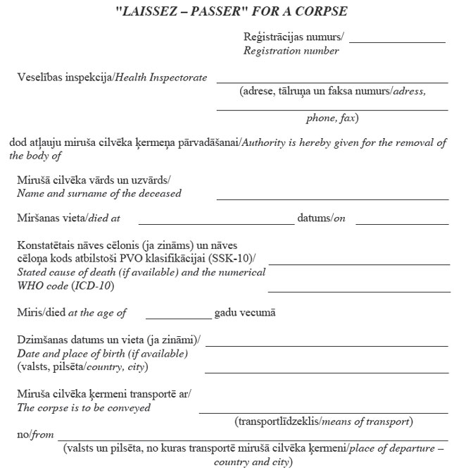
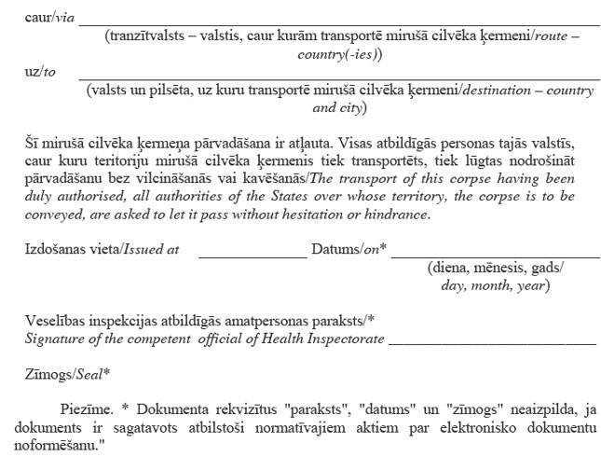

Note. * The details of the document “signature”, “date” and “place for seal” shall not be completed if the electronic document has been drawn up in accordance with the laws and regulations regarding drawing up of electronic documents.

