Republic of Latvia

Cabinet
Regulation No. 550
Adopted 14 August 2012

Regulations Regarding the State Border Strip, the Borderland and the Border Area, as well as Samples of Indication Signs and Information Signs of the Border Area, the Borderland and the State Border Strip, and the Procedures for Installing Them

Issued pursuant to
Section 13, Paragraph one, Section 15, Paragraph one,
Section 19, Paragraph one and Section 21
of the State Border Law of the Republic of Latvia

I. General Provision

1. This Regulation prescribes the State border strip, the borderland of the external land border and the border area of the Republic of Latvia, as well as samples of indication signs and information signs of the State border strip, the borderland and the border area, and the procedures for installing them.

II. Territories of the State Border Strip, Borderland and Border Area of the Republic of Latvia

2. The width of the State border strip of the Republic of Latvia is:
2.1. 12 metres with the Republic of Belarus;
2.2. 12 metres with the Russian Federation;
2.3. 6 metres with the Republic of Estonia;
2.4. 5 metres with the Republic of Lithuania.

3. The borderland is determined in the following administrative territories and territorial units of the border area along the external land border of the Republic of Latvia:
3.1. in the municipality of Alūksne:
3.1.1. in Liepna rural territory or pagasts;
3.1.2. in Pededze rural territory or pagasts;
3.2. in the municipality of Baltinava;
3.3. in the municipality of Cibla:
3.3.1. in Blonti rural territory or pagasts;
3.3.2. in Līdumnieki rural territory or pagasts;
3.4. in the municipality of Dagda:
3.4.1. in Bērziņi rural territory or pagasts;
3.4.2. in Ķepova rural territory or pagasts;
3.4.3. in Šķaune rural territory or pagasts;
3.5. in the municipality of Daugavpils:
3.5.1. in Demene rural territory or pagasts;
3.5.2. in Saliena rural territory or pagasts;
3.5.3. in Skrudaliena rural territory or pagasts;
3.6. in the municipality of Kārsava:
3.6.1. in Goliševa rural territory or pagasts;
3.6.2. in Malnava rural territory or pagasts;
3.6.3. in Salnava rural territory or pagasts;
3.7. in the municipality of Krāslava:
3.7.1. in Indra rural territory or pagasts;
3.7.2. in Kaplava rural territory or pagasts;
3.7.3. in Piedruja rural territory or pagasts;
3.7.4. in Robežnieki rural territory or pagasts;
3.8. in Briģi rural territory or pagasts, municipality of Ludza;
3.9. in the municipality of Viļaka:
3.9.1. in Medņeva rural territory or pagasts;
3.9.2. in Šķilbēni rural territory or pagasts;
3.9.3. in Vecumi rural territory or pagasts;
3.9.4. in Žīguri rural territory or pagasts;
3.10. in the municipality of Zilupe:
3.10.1. in Pasiene rural territory or pagasts;
3.10.2. in Zaļesje rural territory or pagasts.

4. The border area is determined in the following administrative territories and territorial units of the border area along the external land border of the Republic of Latvia:
4.1. in the municipality of Aglona:
4.1.1. in Aglona rural territory or pagasts;
4.1.2. in Grāveri rural territory or pagasts;
4.1.3. in Kastuļina rural territory or pagasts;
4.1.4. in Šķeltova rural territory or pagasts;
4.2. in the municipality of Alūksne:
4.2.1. in the town of Alūksne;
4.2.2. in Alsviķi rural territory or pagasts;
4.2.3. in Annas rural territory or pagasts;
4.2.4. in Jaunalūksne rural territory or pagasts;
4.2.5. in Jaunannas rural territory or pagasts;
4.2.6. in Jaunlaicene rural territory or pagasts;
4.2.7. in Liepna rural territory or pagasts;
4.2.8. in Maliena rural territory or pagasts;
4.2.9. in Mālupe rural territory or pagasts;
4.2.10. in Mārkalne rural territory or pagasts;
4.2.11. in Pededze rural territory or pagasts;
4.2.12. in Veclaicene rural territory or pagasts;
4.2.13. in Ziemers rural territory or pagasts;
4.3. in the municipality of Balvi:
4.3.1. in the town of Balvi;
4.3.2. in Balvi rural territory or pagasts;
4.3.3. in Bērzkalne rural territory or pagasts;
4.3.4. in Bērzpils rural territory or pagasts;
4.3.5. in Briežuciems rural territory or pagasts;
4.3.6. in Krišjāņi rural territory or pagasts;
4.3.7. in Kubuļi rural territory or pagasts;
4.3.8. in Lazduleja rural territory or pagasts;
4.3.9. in Tilža rural territory or pagasts;
4.3.10. in Vectilža rural territory or pagasts;
4.3.11. in Vīksna rural territory or pagasts;
4.4. in the municipality of Baltinava;
4.5. in the municipality of Cibla:
4.5.1. in Blonti rural territory or pagasts;
4.5.2. in Cibla rural territory or pagasts;
4.5.3. in Līdumnieki rural territory or pagasts;
4.5.4. in Pušmucova rural territory or pagasts;
4.5.5. in Zvirgzdene rural territory or pagasts;
4.6. in the municipality of Dagda:
4.6.1. in Andrupene rural territory or pagasts;
4.6.2. in Andzeļi rural territory or pagasts;
4.6.3. in Asūne rural territory or pagasts;
4.6.4. in Bērziņi rural territory or pagasts;
4.6.5. in Dagda rural territory or pagasts;
4.6.6. in the town of Dagda;
4.6.7. in Ezernieki rural territory or pagasts;
4.6.8. in Konstantinova rural territory or pagasts;
4.6.9. in Ķepova rural territory or pagasts;
4.6.10. in Svariņi rural territory or pagasts;
4.6.11. in Šķaune rural territory or pagasts;
4.7. in the municipality of Daugavpils:
4.7.1. in Ambeļi rural territory or pagasts;
4.7.2. in Biķernieki rural territory or pagasts;
4.7.3. in Demene rural territory or pagasts;
4.7.4. in Kalkūne rural territory or pagasts;
4.7.5. in Laucesa rural territory or pagasts;
4.7.6. in Līksna rural territory or pagasts;
4.7.7. in Maļinova rural territory or pagasts;
4.7.8. in Medumi rural territory or pagasts;
4.7.9. in Naujene rural territory or pagasts;
4.7.10. in Saliena rural territory or pagasts;
4.7.11. in Skrudaliena rural territory or pagasts;
4.7.12. in Svente rural territory or pagasts;
4.7.13. in Tabore rural territory or pagasts;
4.7.14. in Vecsaliena rural territory or pagasts;
4.7.15. in Višķi rural territory or pagasts;
4.8. in Daugavpils City;
4.9. in Šēdere rural territory or pagasts, Ilūkste municipality;
4.10. in the municipality of Kārsava:
4.10.1. in Goliševa rural territory or pagasts;
4.10.2. in the town of Kārsava;
4.10.3. in Malnava rural territory or pagasts;
4.10.4. in Mežvidi rural territory or pagasts;
4.10.5. in Mērdzene rural territory or pagasts;
4.10.6. in Salnava rural territory or pagasts;
4.11. in the municipality of Krāslava:
4.11.1. in Auleja rural territory or pagasts;
4.11.2. in Indra rural territory or pagasts;
4.11.3. in Izvalta rural territory or pagasts;
4.11.4. in Kalnieši rural territory or pagasts;
4.11.5. in Kaplava rural territory or pagasts;
4.11.6. in Krāslava rural territory or pagasts;
4.11.7. in the town of Krāslava;
4.11.8. in Kombuļi rural territory or pagasts;
4.11.9. in Piedruja rural territory or pagasts;
4.11.10. in Robežnieki rural territory or pagasts;
4.11.11. in Skaista rural territory or pagasts;
4.11.12. in Ūdrīši rural territory or pagasts;
4.12. in the municipality of Ludza:
4.12.1. in Briģi rural territory or pagasts;
4.12.2. in Cirma rural territory or pagasts;
4.12.3. in Isnauda rural territory or pagasts;
4.12.4. in Istra rural territory or pagasts;
4.12.5. in Ludza rural territory or pagasts;
4.12.6. in Nirza rural territory or pagasts;
4.12.7. in Ņukši rural territory or pagasts;
4.12.8. in Pilda rural territory or pagasts;
4.12.9. in Pureņi rural territory or pagasts;
4.12.10. in Rundēni rural territory or pagasts;
4.13. in the municipality of Rēzekne:
4.13.1. in Bērzgale rural territory or pagasts;
4.13.2. in Dricāni rural territory or pagasts;
4.13.3. in Gaigalava rural territory or pagasts;
4.13.4. in Ilzeskalna rural territory or pagasts;
4.13.5. in Kaunata rural territory or pagasts;
4.13.6. in Lendži rural territory or pagasts;
4.13.7. in Nautrēni rural territory or pagasts;
4.13.8. in Stružāni rural territory or pagasts;
4.14. in the municipality of Rugāji:
4.14.1. in Lazdukalni rural territory or pagasts;
4.14.2. in Rugāji rural territory or pagasts;
4.15. in the municipality of Viļaka:
4.15.1. in Kuprava rural territory or pagasts;
4.15.2. in Medņeva rural territory or pagasts;
4.15.3. in Susāji rural territory or pagasts;
4.15.4. in Šķilbēni rural territory or pagasts;
4.15.5. in Vecumi rural territory or pagasts;
4.15.6. in the town of Viļaka;
4.15.7. in Žīguri rural territory or pagasts;
4.16. in the municipality of Zilupe:
4.16.1. in Lauderi rural territory or pagasts;
4.16.2. in Pasiene rural territory or pagasts;
4.16.3. in Zaļesje rural territory or pagasts;
4.16.4. in the town of Zilupe.

III. Samples of the Indication Signs of the State Border Strip, the Borderland and Border Area of the Republic of Latvia and the Procedures for Installing Them

5. The beginning and the end of the border area shall be indicated with corresponding road signs on roads in accordance with the laws and regulations governing the field of road traffic.

6. The beginning and the end of the borderland shall be indicated:
6.1. on road in accordance with the laws and regulations governing the field of road traffic;
6.2. in the area with information signs “Borderland” (Annex 1).

7. The borderland shall be indicated in the area, taking into account the location of the populated areas, sites for public events, roads and sites of active commercial activities in the immediate vicinity of the State border, as well as in conformity with the administrative-territorial division.

8. Information signs, which mark the borderland, shall be installed by the State Border Guard taking into account the peculiarities of the area, the relief, the network of roads, firebreaks and paths, natural and man-made landmarks or constructions in such a way they would ensure unmistakable visual identification of the borderland in the area.

9. The State border strip of the Republic of Latvia shall be marked with the following information signs (Annex 2):
9.1. a tape “STOP! State border”;
9.2. a plate “STOP! State border”;
9.3. a pole “STOP! State border”;
9.4. a buoy “STOP! State border”.

10. The information signs of the State border strip shall be installed directly by the border zone in those places where the State land border is determined, or by the banks of rivers, streams and canals along which the State border is determined.

IV. Closing Provision

11. This Regulation shall come into force on 1 September 2012.

Prime Minister V. Dombrovskis

Minister for the Interior R. Kozlovskis

Annex 1
Cabinet Regulation No. 550
14 August 2012

Information Signs “Borderland”

1. Tape with the inscription in Latvian “PIEROBEŽAS JOSLA AIZLIEGTS UZTURĒTIES BEZ PASES UN CAURLAIDES” (Figure 1) at the border of the Republic of Latvia with the Russian Federation and with the Republic of Belarus. The tape shall be yellow and 150 mm wide. The inscription “PIEROBEŽAS JOSLA” shall be on the upper part of the tape in one line in black letters, the height of the letters shall be 30 mm; the inscription “AIZLIEGTS UZTURĒTIES BEZ PASES UN CAURLAIDES” shall be on the lower part of the tape in two lines in red letters, the height of the letters shall be 18 mm.

PIEROBEŽAS JOSLA
AIZLIEGTS UZTURĒTIES
BEZ PASES UN CAURLAIDES

Figure 1.

2. Tape with the inscription in Russian “ПРИГРАНИЧНАЯ ПОЛОСА/БЕЗ ПАСПОРТА И ПРОПУСKА НАХОДИТЬСЯ ЗАПРЕЩЕНО” (Figure 2) at the border of the Republic of Latvia with the Russian Federation and with the Republic of Belarus. The tape shall be yellow and 150 mm wide. The inscription “ПРИГРАНИЧНАЯ ПОЛОСА” shall be on the upper part of the tape in one line in black letters, the height of the letters shall be 30 mm; the inscription “БЕЗ ПАСПОРТА И ПРОПУСKА НАХОДИТЬСЯ ЗАПРЕЩЕНО” shall be on the lower part of the tape in two lines in red letters, the height of the letters shall be 8 mm.

ПРИГРАНИЧНАЯ ПОЛОСА
БЕЗ ПАСПОРТА И ПРОПУСKА
НАХОДИТЬСЯ ЗАПРЕЩЕНО

Figure 2.

3. Tape with the inscription in English “BORDERLAND FORBIDDEN TO STAY WITHOUT PASSPORT AND PERMIT” (Figure 3) at the border of the Republic of Latvia with the Russian Federation and with the Republic of Belarus. The tape shall be yellow and 150 mm wide. The inscription “BORDERLAND” shall be on the upper part of the tape in one line in black letters, the height of the letters shall be 30mm; the inscription “FORBIDDEN TO STAY WITHOUT PASSPORT AND PERMIT” shall be on the lower part of the tape in two lines in red letters, the height of the letters shall be 18 mm.

BORDERLAND
FORBIDDEN TO STAY WITHOUT PASSPORT AND PERMIT

Figure 3.

Minister for the Interior R. Kozlovskis

Annex 2
Cabinet Regulation No. 550
14 August 2012

Information Signs “STOP! State border”

1. Tape with the inscription in Latvian, Russian and English “STĀT! Valsts robeža”, “СТОЙ! Государственная граница”, “STOP! State boder” (Figure 1) at the border of Latvia with Russia and with Belarus . The tape shall be yellow and 150 mm wide. The inscription in Latvian and English shall be in two lines in black letters. The inscription in Russian shall be in three lines in black letters. The height of the letters of the upper text shall be 40 mm, the height of the first letter of the lower text – 18 mm and the height of the remaining letters – 13 mm. The distance between the inscriptions shall be 50 cm.

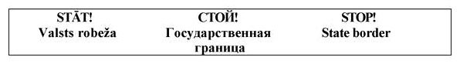

Figure 1.

2. Plate with the inscription on both sides in Latvian, Russian and English “STĀT! Valsts robeža”, “СТОЙ! Государственная граница”, “STOP! State border” (Figure 2) at the border of Latvia with Russia and with Belarus. The plate shall be orange and 80 x 60 cm. A picture of a red hand shall be on the upper part of the plate and beneath the inscriptions in Latvian, Russian and English in black letters. The inscription in Latvian and English shall be in two lines. The inscription in Russian shall be in three lines. The height of the letters of the upper text shall be 70 mm, the height of the first letter of the lower text – 50 mm and the height of the remaining letters – 40 mm. The height of the picture of the hand shall be 150 mm. The lower part of the plate shall contain three signs of prohibition, their diameter 9 cm.

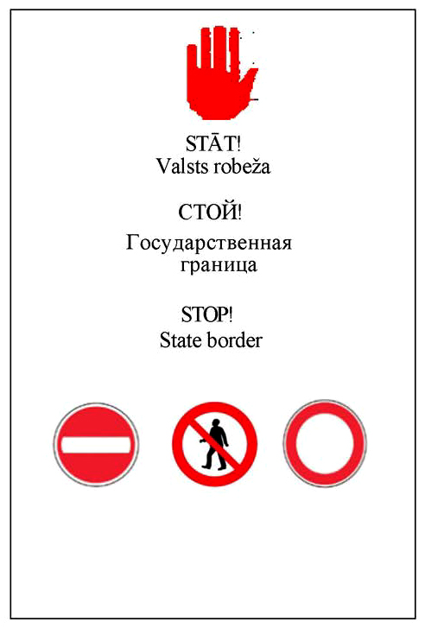

Figure 2.

3. Pole (Figure 3) at the border of Latvia with Russia and with Belarus. The pole shall be cylindrical (height – 200 cm, diameter 5-10 cm), triangular (200 x 5-10 cm) or square (200 x 5-10 cm), without any inscriptions. Two red bands – each 5 cm wide – shall be on the surface of the pole, one band at a distance of 15 cm from the top of the pole and the other at a distance of 100 cm from the top of the pole.

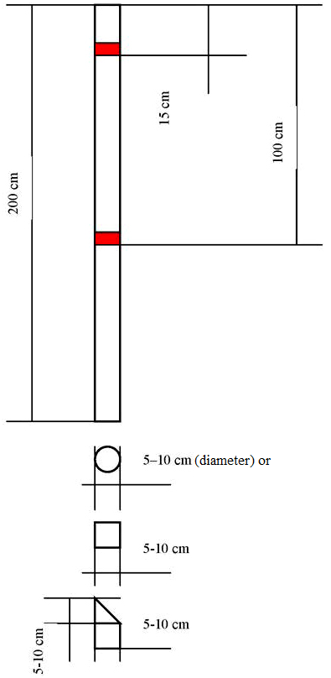

Figure 3.

4. Buoy with the inscription in Latvian “STĀT! Valsts robeža” or in Russian “СТОЙ! Граница” (Figure 4) at the border of Latvia with Russia and with Belarus. The buoy shall be yellow and cylindrically shaped. Two red bands – each 5 cm wide – shall be on the surface of the buoy. One band shall be at a distance of 15 cm from the top of the buoy and the other at a distance of 130 cm from the top of the buoy. The inscription “10 m” or “10 м” shall be above the upper red band. The vertical inscription in Latvian “STĀT! Valsts robeža” or in Russian “СТОЙ! Граница” in black letters shall be placed between the red bands; the height of the large letters shall be 70 mm and the height of the small letters – 40 mm.

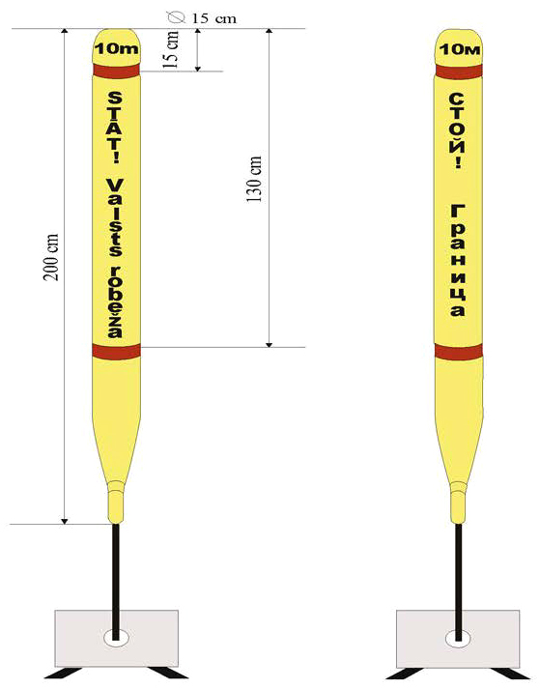

Figure 4.

Minister for the Interior R. Kozlovskis

