REPUBLIC OF LATVIA
GOVERNMENT REPORT

on

Convention No. 129
Concerning Labour Inspection in Agriculture (1969)

during the period of time from 1 June 2014 to 1 June 2017

The Simplified Government Report is developed by taking into account the Convention and the requirements referred to in Annex III – Explanatory Note Concerning the Preparation of Reports on Ratified Conventions – of the Committee of Experts on the Application of Conventions and Recommendations

1. Information regarding changes in laws and regulations and implementation thereof, which affect the application of the Convention, and information regarding the nature and objective of the changes

We inform that during the time period from 1 June 2014 (the previous Government Report on Convention No. 81) to 1 June 2017 the following amendments have been made to the laws and regulations of the Republic of Latvia, which affect the implementation of the rules laid down by the Convention:

1. During the reference period a number of amendments were effected to the Law on Remuneration of Officials and Employees of State and Local Government Authorities relating to the working and rest time conditions, work remuneration conditions for the persons employed in the public sector. This regulation also applies to the staff of the State Labour Inspectorate (hereinafter – the SLI).
In view of the considerable amount of amendments they are not discussed in this Report but the latest wording of the Law is appended to the Report.

2. On 7 April 2015 amendments were made to Cabinet Regulation No. 803 of 29 September 2008, Labour Protection Requirements when Coming into Contact with Carcinogenic Substances at Workplaces. The purpose of the Amendments is to specify the requirements and terminology in accordance with the legal acts of the European Union on classification and labelling of chemical substances in order to ensure the health and safety of employees. The definition of carcinogenic substances was redefined, providing a more accurate explanation regarding diversity of carcinogenic substances. On the basis of Directive 2014/27/EU of the European Parliament and of the Council of 26 February 2014 amending Council Directives 92/58/EEC, 92/85/EEC, 94/33/EC, 98/24/EC and Directive 2004/37/EC of the European Parliament and of the Council, in order to align them to Regulation (EC) No 1272/2008 on classification, labelling and packaging of substances and mixtures (hereinafter – Directive 2014/27/EU), the terms “preparation” and “product” have been replaced with the term “mixture” in the Regulation. Also a more accurate formulation for jobs involving exposure to dust, fumes and sprays produced during the roasting or electro-refining of cupro-nickel mattes was specified in the Regulation.

3. In order to transpose the requirements of Directive 2014/27/EU, on 7 April 2015 amendments were made to Cabinet Regulation No. 660 of 2 October 2007, Procedures for the Performance of Internal Supervision of the Work Environment. The term “products” was replaced with the term “mixtures” in the Regulation. Concurrently several biological risk factors were specified in which employment of pregnant women and women who are breastfeeding was prohibited, narrowing the factors and imposing a prohibition in relation to biological agents of risk groups 2, 3, and 4 in accordance with the requirements of Paragraph 2 of Part A of Annex 1 to Directive 92/85/EEC. The abovementioned requirement was reviewed, taking into account that causing of an illness under exposure to the biological agents of risk group 1 is unlikely, as well as exposure to agents cannot be linked to human illness. Thus, the rights of pregnant women and women who are breastfeeding to work with biological agents of risk group 1 are not being restricted. In accordance with the requirements of Regulation No 1272/2008 the term “nature of effects” (or R Phrases) has been replaced with the term “hazard statement” (or H Phrases). In order to meet the requirements of Regulation No 1272/2008 and also accordingly Directive 2014/27/EU, substances with R Phrases have been deleted from Annex 2 to Regulation No. 660, replacing them with substances with H Phrases. In order to harmonise the terminology according to the labour protection requirements for work with carcinogenic substances, the description of jobs involving exposure to dust, fumes and sprays produced during the roasting or electro-refining of cupro-nickel mattes which may cause risk to the safety and health of pregnant women and women who are breastfeeding, was updated.

4. On 7 April 2015 amendments were made to Cabinet Regulation No. 325 of 15 May 2007, Labour Protection Requirements when Coming in Contact with Chemical Substances at Workplaces. These amendments were also made in order to transpose the requirements of Directive 2014/27/EU. The Regulation specifies more accurately the chemical substances and mixtures to which the requirements of this Regulation apply, providing for hereinafter that they conform to the criteria laid down in Regulation No 1272/2008 for classification in any of physical or health hazard classes. On the basis of amendments to the law On Conformity Assessment which came into force on 18 June 2013, the requirements for conformity assessment bodies which perform accreditation of laboratories were updated. Taking into account the chemical substances existing in the work environment of enterprises of Latvia to which employees are exposed in their everyday work and which may affect their health, as well as the scientific studies and discoveries, the list of occupational exposure to chemical substances (Annex 1 to the Regulation) was supplemented with cut-off values of occupational exposure for propane gas, peat dust and rock wool dust. In order to facilitate finding of the particular chemical substances, the list of synonyms of chemical substances in Annex 2 to the Regulation was supplemented.

5. In order to transpose the requirements of Directive 2014/27/EU, on 7 April 2015 amendments were made to Cabinet Regulation No. 400 of 3 September 2002, Labour Protection Requirements for Use of Safety Signs. On the basis of the terminology used in the Chemical Substances Law and Regulation No 1272/2008 the term “preparations” in the text of the Regulation was replaced with the term “mixtures”. Paragraph 24 of the Regulation has been reworded, ensuring the use of designations according to the hazard pictograms included in the Globally Harmonized System of Classification and Labelling of Chemicals (GHS) of the United Nations Economic Commission for Europe also for such chemical substances or mixtures for designation of which safety signs had not been provided for previously. Concurrently Paragraphs 24 and 32 of the Regulation were updated, providing for a possibility to use the pictograms specified in Annex V of Regulation No 1272/2008 in labelling of chemical substances. On the basis of Directive 2014/27/EU the Regulation was supplemented with new Paragraph 32.1, specifying additional ways for designation of fluid chemical substances. According to amendments to the System of Classification and Labelling of Chemicals (GHS) and taking into account that GHS does not provide for labelling of chemical substances with the designation “harmful or irritating substance” anymore, changes in Annex 2 to the Regulation were made, deleting Paragraph 4.18 which designated a harmful or irritating substance. In turn, the sign included in Paragraph 4.9 of the Regulation “general hazard” was supplemented with a note that it will be permitted to use the sign for warning regarding hazardous chemical substances or mixtures only in order to designate the places with stocks of hazardous substances or mixtures.

6. On 18 March 2014 Cabinet Regulation No. 143, Labour Protection Requirements when Working at Height, were adopted and came into force on 1 September 2014. Prior to adoption of this Cabinet Regulation general requirements for working at height (exceeding 1.5 m) were determined in Chapter V of Cabinet Regulation No. 526 of 9 August 2002, Labour Protection Requirements when using Work Equipment and Working at Height, including separate requirements when using scaffolding, ladder and using ropes for working at height. Taking into account the comparatively high number of accidents which are related to falling from height, as well as the opinion of specialists in the labour protection field, steeplejacks and specialists of working at height, a new regulatory enactment (Regulation No. 143) was drafted, including more accurate and clear requirements therein for working at height and the work equipment to be used, thus improving the conformity with the requirements and preventing accidents at workplaces.
The Regulation applies to working at places which are at height of at least 1.5 m from the ground or any other safe surface, including work underground, if a fall is possible, on scaffoldings, ladder, roofs, as well as using ropes and fastenings. Such requirements are specified in the Regulation which should be taken into account when organising work at height, including upon assessing the work environment risks and determining the work to be performed at height, determining the most appropriate means for the creation of safe conditions, as well as determining works which are related to increased hazard (work of a steeplejack and work of an individual climber). The Regulation includes the requirements for the use of collective protective equipment, personal protective equipment, specific elements of work equipment, as well as different types of ladder (for example, portable, hook, folding). Specific requirements are specified in relation to the erection and use of scaffoldings, work on roofs, as well as use of ropes and fastenings.

7. On 13 October 2015 Cabinet Regulation No. 584, Labour Protection Requirements for the Protection of Employees against the Risks in the Work Environment Arising from Electromagnetic Fields, were adopted. This Regulation came into force on 1 July 2016. The Regulation was drafted in order to transpose the requirements of Directive 2013/35/EU of the European Parliament and of the Council of 26 June 2013 on the minimum health and safety requirements regarding the exposure of workers to the risks arising from physical agents (electromagnetic fields). The Regulation provides for measures which protect the employees against the risks arising from exposure to electromagnetic fields in the work environment. It includes an obligation of the employer to perform determination of exposure to electromagnetic fields and assessment of the risk caused, as well as an obligation to take measures for the prevention or reduction of the risks arising from electromagnetic fields. Also an obligation of the employer to ensure mandatory health examinations for the employees who are subjected to radiation of electromagnetic fields is provided for in order to detect health disorders caused by electromagnetic fields as soon as possible. The Regulation determines the action of the employer for health protection of employees of a special risk group – adolescents, pregnant women, women in postnatal period, employees who have been implanted with an active or passive medical device (for example, electric cardiac pacemakers) or employees who use medical devices to be attached to the body (for example, insulin pumps).

2. Statistical information or other type of information and notifications required by the Convention

2.1. Structural changes in the SLI

In 2015 structural changes were implemented in the SLI in order to efficiently use the personnel resources and to ensure co-ordinated and efficient operation of Zemgale Regional Labour Inspectorate. In 2015 Consultative Centre in Bauska began operating, and it was established in order for the employees, employers and other interested persons to better access the SLI. The current structure of the SLI is presented in the picture.

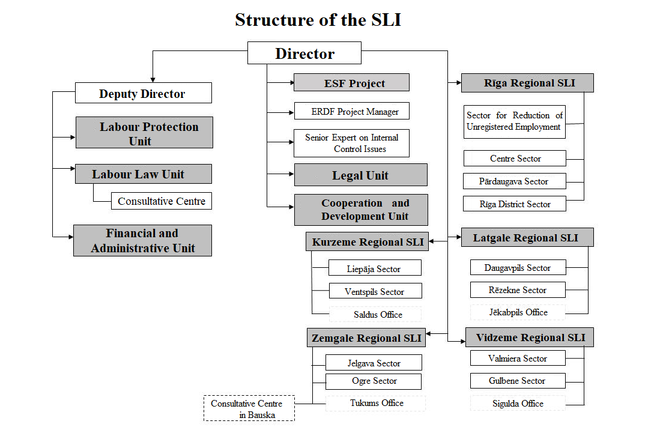
2.2. Statistical Information

Agriculture A01 (growing of crops, farming of animals, hunting and related activities)
Year | Number of surveys | Number of enterprises* | Number of employees**(total for the industry (A) agriculture, forestry and fishery) | Number of accidents |  |  | Number of persons suffering from occupational disease registered for the first time
 |  |  |  | in total | severe | fatal
2014 | 458 | 23,221 (including 12,132 – self-employed persons) | 66,300 | 40 | 9 | 2 | 44
2015 | 492 | 22,992 (including 12,054 – self-employed persons) | 71,100 | 46 | 6 | 1 | 32
2016 | 356 | - | 68,700 | 51 | 5 | 5 | 30
* Data of the Central Statistical Bureau (CSB) in section related to the division of economically active statistical units according to the main types of activity (statistical units of the market sector, NACE Rev. 2).
** Data of the Central Statistical Bureau (CSB) in section related to the division of employees according to the type of economic activity and gender (NACE Rev. 2).

Main Causes of Accidents in Agriculture (A01)

Year  Causes | 2014 | 2015 | 2016
Occupational safety provisions or instructions have not been observed | 24 | 22 | 14
Insufficient attention | 8 | 18 | 14
Unsatisfactory instruction and training of employees | 11 | 3 | 8
Safety equipment or personal protective equipment is not used | 1 | 4 | 2
Unacceptable or inappropriate work methods used | 3 | 1 | 1
Violence (offences) | 1 | 2 | 3

Factors Causing Occupational Diseases for Persons Suffering from Occupational Disease Registered for the First Time in Agriculture (A01)

Year  Factor causing occupational disease | 2014 | 2015 | 2016
Chemical factor (100000000) | 0 | 0 | 1
Physical factors (200000000) | 8 | 7 | 5
Biological factors (300000000) | 0 | 1 | 0
Bio-mechanical factors (4000000000) | 36 | 24 | 21
Psychosocial factors (5000000000) | 0 | 0 | 0
Industrial factors, materials and production (6000000000) | 0 | 0 | 1
Other causal factors (9999999999) | 0 | 0 | 0

Results of Checks Organised in Agriculture (A01)

 | 2014 | 2015 | 2016
Number of orders | 235 | 227 | 142
Number of violations | 1,134 | 1,204 | 746
Number of administrative sanctions | 75/161 | 75/193 | 61/171
Amount of administrative sanctions (EUR) | 25,751.50 | 31,238 | 21,028.50
Objects where activity is suspended | 0 | 1 | 0

3. Replies to the comments of the Committee of Experts on the Application of the Convention

3.1. Article 6(1)(b), Article 13 of the Convention

In 2014 the SLI organised a topical check in agricultural enterprises during which 122 surveys were carried out. As a result of surveys 89 orders were issued for elimination of 350 violations detected, in turn, administrative sanctions were not imposed. The following most widespread problems were detected after the topical agricultural check implemented:
- in one third of the enterprises surveyed the work environmental risk assessment was not carried out during the last year, the plan of labour protection measures was not drawn up, and employees were not informed regarding the work environment risk factors, as well as mandatory health examinations were not performed for employees;
- agricultural enterprises frequently do not perform technical maintenance of agricultural machinery, as well as quite often there is no sufficient documentary evidence regarding regular technical maintenance of machinery and equipment;
- the violations of the laws and regulations governing labour protection detected in agricultural enterprises show that employers must still pay great attention to supervision of work, co-operate with employees and labour protection specialists in order to improve the work environment.
Taking into account that agriculture is a sensitive industry in which both fatal accidents and accidents with severe trauma happen comparatively often, as well as there is high risk of unregistered employment, agricultural enterprises will also henceforth remain under special supervision of the SLI. It should be noted that in 2016 a meeting was organised with representatives of agricultural organisations (the Ministry of Agriculture, the Council for Co-operation of Agricultural Organisations, and the Farmers Parliament) in order to discuss issues regarding conformity with the labour protection requirements in the sector. During the meeting decisions were made on joint measures for increasing awareness of employers of the agricultural sector regarding labour protection issues.
In 2015 and 2016 topical checks in the agricultural sector were not organised, the next topical check in the sector will be implemented in the second half of 2017.

3.2. Article 9(3) of the Convention

In order to ensure qualitative and efficient activity of the SLI, experience, knowledge and skills of officials in applying their knowledge in practice is of great importance. In 2014 within the scope of the ESF project “Improvement of Capacity of the State Employment Agency” the SLI implemented training in three dedicated sectoral programmes, including training regarding the agricultural sector. 11 officials of the SLI participated in training regarding the agricultural sector. In the second half of 2017 it is intended to train 12 officials of the SLI in training regarding the agricultural sector, attracting the funding from the ESF project “Improvement of Practical Introduction and Supervision of Laws and Regulations governing Labour Protection”.

3.3. Articles 15(b) and 21 of the Convention

In order to ensure efficient State supervision and control of the area of employment legal relationships and labour protection, the SLI determines the annual total number of checks in enterprises. All sectors are included in the total number of checks, including agricultural sector as one of the most dangerous sectors as regards the number of accidents. The SLI carries out both preventive and extraordinary surveys (investigation of accidents, examination of submissions, drawing up of the hygienic characterisation of the work environment) during which attention is paid to conformity with the requirements of the laws and regulations regarding labour protection. Within three years (from 2014 to 2016) the SLI has carried out 1306 surveys in the agricultural sector as a result of which 604 orders were issued for elimination of 3084 violations, as well as 211 administrative sanctions were imposed for 525 violations detected. In turn, in the first half of 2017 133 surveys were carried out, 47 orders were issued for elimination of 218 violations, as well as 22 sanctions were imposed for 46 violations detected.
Upon analysing the statistical data on accidents at work, it should be concluded that the number of accidents in the agricultural sector has a tendency to grow. In total 40 accidents at work happened in the agricultural sector in 2014, 46 accidents in 2015, and 51 accidents in 2016. Taking into account these indicators, a topical check in the agricultural sector is planned in the second half of 2017.

3.4. Articles 26 and 27 of the Convention

General information is included in the annual reports of the SLI, including information regarding the topical checks carried out by the SLI. If a topical check in agriculture has taken place in the relevant reporting year, then detailed information regarding the results of the topical check is included in the annual report, including regarding the number of surveys, violations detected, and sanctions. Specific statistical information which is not available in the annual report of the SLI, is available when turning to the SLI officials. The statistical data requested by the Convention are included in Section 2 of this report.

4. Note regarding organisations of employers and employees to whom copies of the simplified report have been sent

In accordance with Article 23, Part two of the Constitution of the ILO copies of this report have been sent to:
1) the Employers’ Confederation of Latvia;
2) the Free Trade Union Confederation of Latvia.

Appended:
1) Law on Remuneration of Officials and Employees of State and Local Government Authorities (available in Latvian);
2) Cabinet Regulation No. 803 of 29 September 2008, Labour Protection Requirements when Coming into Contact with Carcinogenic Substances at Workplaces (available in Latvian);
3) Cabinet Regulation No. 660 of 2 October 2007, Procedures for the Performance of Internal Supervision of the Work Environment (available in Latvian);
4) Cabinet Regulation No. 325 of 15 May 2007, Labour Protection Requirements when Coming in Contact with Chemical Substances at Workplaces (available in Latvian);
5) Cabinet Regulation No. 400 of 3 September 2002, Labour Protection Requirements for Use of Safety Signs (available in Latvian);
6) Cabinet Regulation No. 143 of 18 March 2014, Labour Protection Requirements when Working at Height (available in Latvian);
7) Cabinet Regulation No. 584 of 13 October 2015, Labour Protection Requirements for the Protection of Employees against the Risks in the Work Environment Arising from Electromagnetic Fields (available in Latvian).

Date: ____ _____________ 2017 | Signature: __________________

Jānis Reirs
Minister for Welfare

